The Development of a Local Wisdom-Based Pop-Up Book: An Effort to Enhance Critical Thingking Skills and Cultural Appreciation Character among Elementary School Students.
Wahyu Tri Utami¹, Joko Sulianto², Joko Siswanto³
¹ Universitas PGRI Semarang; wtu1993@gmail.com
² Universitas PGRI Semarang; jokosulianto@upgris.ac.id
² Universitas PGRI Semarang; jokosiswanto@upgris.ac.id

ARTICLE INFO |  | ABSTRACT
Keywords:  Pop-Up book;  Local wisdom;  IPAS;  Critical Thingking;  Elementary education. |  | This study aims to develop a Pop-Up Book learning media integrating Rembang local wisdom for Science and Social Studies (IPAS) instruction on the theme of cultural diversity to enhance the critical thinking skills and cultural appreciation of fourth-grade elementary students. The research employed a Research and Development (R&D) approach using the ADDIE model, which includes the stages of analysis, design, development, implementation, and evaluation. The participants consisted of two experts (material and media), two teachers, and 30 students from elementary schools in Rembang Regency. Data were collected through validation sheets, practicality questionnaires, and pretest–posttest assessments. The results revealed that the Pop-Up Book reached a validity level of 95% (very valid), practicality scores of 90% (teachers) and 97.3% (students), and an effectiveness score (N-Gain) of 0.68, categorized as moderate to high. These findings indicate that the developed Pop-Up Book is feasible, practical, and effective in improving students’ critical thinking skills and motivation. Moreover, incorporating elements of Rembang local wisdom into learning media enables students to connect learning content with their cultural environment, thereby promoting meaningful, contextual, and character-based learning experiences.
Article history:
Received 2021-08-14
Revised 2021-11-12
Accepted 2022-01-17
 |  | This is an open access article under the CC BY-NC-SA license.
Corresponding Author:
Wahyu Tri Utami
Universitas PGRI Semarang; wtu1993@gmail.com

- INTRODUCTION

Elementary education plays a central role in shaping students’ character, thinking skills, and national identity. The currently implemented Merdeka Curriculum emphasizes competency-based and contextual learning, in which students are expected not only to master factual knowledge but also to analyze, evaluate, and make independent decisions. The subject of Science and Social Studies (IPAS) is designed to help students understand both the natural environment and social phenomena around them.

According to Dalimunthe (2023), IPAS learning is presented in an integrated manner and structured based on students’ real-life conditions while considering their age and cognitive development. However, in practice, IPAS instruction in elementary schools remains largely conventional, dominated by lecture methods and lacking interactive media that connect with students’ real experiences (Wahyuni and Dewi, 2022). This condition results in low student engagement and suboptimal development of critical thinking skills.

Critical thinking is one of the 21st-century competencies that must be cultivated from the elementary level (Hidayat and Fadhilah, 2018). Learning that merely emphasizes memorization hinders students from developing the ability to analyze information, compare ideas, and reflectively draw conclusions about cultural differences (Firmansyah and Lidiawati, 2019). Therefore, learning media that stimulate students’ cognition and encourage active interaction during learning are urgently needed.

One of the effective media to achieve this is the Pop-Up Book, which presents attractive three-dimensional visuals and allows students to interact directly through activities such as opening, sliding, or folding its parts. Research by Sari and Kurniawati (2021) revealed that using Pop-Up Books significantly improves elementary students’ learning outcomes. Similarly, Lestari and Kurniasih (2020) found that Pop-Up Books enhance student engagement and enthusiasm during learning activities.

However, the effectiveness of learning media is determined not only by its form but also by the cultural relevance of its content. Integrating local wisdom into learning media has been shown to strengthen students’ cultural identity and character from an early age (Susanti and Rahmawati, 2019). Culturally-based learning also supports the realization of the Pancasila Student Profile, particularly in the dimensions of global diversity and national culture (Anggraeni and Setiawan, 2020). Further, Pramudiani and Wulandari (2021) found that local wisdom–based learning media can increase students’ motivation and learning outcomes.

Rembang, a region in Central Java, possesses rich cultural heritage such as Lasem batik, the sedekah laut tradition, and the exemplary values of Raden Ajeng Kartini, all of which hold strong potential for integration into learning materials. Putri and Suryani (2022) demonstrated that regional culture–based Pop-Up Books can increase learning interest and strengthen students’ affection for their local heritage. Moreover, Ramadhan and Utami (2023) confirmed that Pop-Up Books influence not only cognitive development but also affective and social attitudes.

Based on these findings, there is a need for innovative learning media that are visually engaging, culturally contextual, and capable of developing students’ critical thinking skills. Therefore, this study focuses on developing a Pop-Up Book learning media based on Rembang local wisdom for IPAS instruction on the topic of cultural diversity among fourth-grade elementary students. The development follows the ADDIE model (Analysis, Design, Development, Implementation, Evaluation) to produce media that are content-valid, practical for teachers to use, and effective in enhancing students’ critical thinking skills.

Learning media play a central role in the learning process as they serve as a bridge between teachers, materials, and students, making learning more effective and enjoyable. The proper use of media facilitates students’ understanding of abstract concepts by presenting them in a more concrete and engaging way, which is essential for developing critical thinking skills (Agil and Wati, 2022). In the context of science instruction, materials that often require conceptual understanding can be supported through visual and manipulative media, enabling students to observe and compare phenomena more concretely.

One type of learning media that has gained increasing attention is the Pop-Up Book a three-dimensional book in which elements “pop up” when the pages are opened. This medium is not only visually appealing but also provides kinesthetic and multisensory experiences that can strengthen students’ understanding. Studies developing Pop-Up Books have shown that they effectively enhance students’ learning motivation (Sinta, Murniviyanti, and Riyanti, 2022), improve students’ responses to learning materials (Fatimah, Supangat, and Sinensis, 2022), and serve as effective visual aids in subjects such as history (Lestari, Nafis, and Nur, 2021). Because Pop-Up Books provide concrete visual stimuli, local narratives, and manipulative elements, they are particularly suitable for use with cultural content such as cultural diversity.

Local wisdom is a crucial aspect of learning media development. Cultural values, traditional stories, artifacts, and local practices not only serve as supplementary content but also enrich students’ learning experiences, making lessons more relevant to their daily lives. The integration of local wisdom in learning allows students to develop cultural identity and foster pride in their local heritage. In cultural diversity learning at the elementary level, local wisdom can serve as a concrete resource for comparing, analyzing, and evaluating different cultural practices processes that are integral to critical thinking.

Cultural diversity learning in elementary schools aims to broaden students’ understanding of various cultures, cultivate tolerance, and instill character values, including respect for differences. Effective instructional approaches incorporate contextual learning resources and the use of creative and authentic media. For example, a study on the Internalization of Cultural Diversity through Character Education in Elementary Schools found that cultural diversity materials integrated with character education values strengthen students’ social awareness (Alifia, Salma, Arifin, and Istianti, 2021).

Critical thinking for fourth-grade elementary students includes the ability to analyze information, evaluate evidence, draw conclusions, compare alternatives, and solve contextual problems. Experimental and classroom action research have demonstrated that instructional models such as inquiry learning, problem-based learning, and media-assisted approaches that provide concrete stimuli (visual or manipulative) are effective in improving students’ critical thinking scores (Dilla, 2023; Agil and Wati, 2022). For instance, the study Video-Based Learning Strengthens Critical Thinking in Elementary Science Classes showed that the use of videos in science learning significantly enhanced students’ critical thinking compared to conventional methods (Agil and Wati, 2022).

The relationship between the use of local wisdom–based Pop-Up Books and the improvement of critical thinking skills can be explained through several mechanisms. This media provides authentic local cultural contexts that stimulate students’ analytical questioning; enables manipulative activities and visualization that strengthen analytical skills; offers cross-cultural comparisons that foster evaluation and reflection; and facilitates discussion and collaboration. Recent studies have shown that developing learning media through expert validation, user testing, and revisions based on feedback results in effective tools that improve students’ critical thinking and learning motivation.

Therefore, this study focuses on developing a Pop-Up Book based on Rembang local wisdom for cultural diversity topics, designed with explicit critical thinking activities (guided questions, cultural comparisons, and case studies), validated for content and media quality, and tested among fourth-grade elementary students. It is expected that such media can significantly enhance students’ critical thinking skills compared to traditional instruction without the use of this type of media.
- METHODS

This study employed the Research and Development (R&D) method using the ADDIE development model, which consists of five main stages: Analysis, Design, Development, Implementation, and Evaluation. The ADDIE model was selected because it is systematic, flexible, and relevant for producing feasible, practical, and effective learning products suitable for elementary education (Aldoobie, 2015; Branch, 2020). The main objective of this research was to develop a Pop-Up Book learning media based on Rembang local wisdom for Science and Social Studies (IPAS) instruction on Cultural Diversity, and to test its validity, practicality, and effectiveness in enhancing fourth-grade students’ critical thinking skills in elementary schools.

This research adopted a mixed-methods approach, combining qualitative and quantitative techniques to obtain comprehensive and in-depth data. The qualitative approach was used to collect descriptive data through observations, interviews, and validations from media and material experts, while the quantitative approach was applied to measure the media’s effectiveness through students’ pretest and posttest scores on critical thinking skills, which were then analyzed statistically. This approach aligns with Creswell and Plano Clark’s (2018) view that mixed methods provide stronger understanding of educational phenomena by combining the depth of qualitative data with the generalizability of quantitative data.

The research design followed the ADDIE model developed by Molenda (2015), consisting of five sequential but iterative phases. The Analysis stage was conducted to identify students’ and teachers’ needs for engaging and contextual learning media, the characteristics of fourth-grade students, the IPAS curriculum, and potential Rembang local wisdom that could be integrated into the learning content. Data were gathered through classroom observations, interviews with teachers and students, and curriculum document reviews. The results of this stage formed the foundation for designing relevant learning media.

The Design stage focused on creating the media blueprint, including storyboard preparation, visual layout design for the Pop-Up Book, and the development of learning activities supporting critical thinking skills. The media design incorporated Rembang’s local culture, such as Lasem batik, the Sedekah Laut (sea offering) tradition, and Wayang Bengkong performances. This stage also involved constructing research instruments such as validation sheets, questionnaires, and critical thinking tests.

The Development stage aimed to produce the Pop-Up Book according to the approved design. The developed product was validated by two expert groups—material experts and media experts to assess its content feasibility, visual design, language use, and cultural relevance. Validation was conducted using Likert-scale questionnaires (1–5) covering aspects such as content alignment with learning objectives, illustration quality, language readability, and integration with critical thinking activities. The validation data were analyzed descriptively using the mean percentage score. Media eligibility was determined based on the feasibility criteria adapted from Lakens (2017), categorized as: Very Feasible (4.20–5.00), Feasible (3.40–4.19), Fairly Feasible (2.60–3.39), Less Feasible (1.80–2.59), and Not Feasible (1.00–1.79).

The Implementation stage was carried out to test the practicality of the media in real classroom conditions. Implementation took place at SD Negeri Rakitan and SD Negeri Sluke in Rembang Regency, involving 30 fourth-grade students and two classroom teachers who acted as media implementers. The research subjects were selected using purposive sampling, as they possessed characteristics relevant to the research objectives and local wisdom context (Etikan, Musa, and Alkassim, 2016). Prior to implementation, teachers were briefed on how to use the media. IPAS lessons were conducted using the Pop-Up Book for two to three sessions focusing on the theme of Cultural Diversity. During the implementation, researchers observed students’ critical thinking activities and collected responses from teachers and students through practicality questionnaires.

The Evaluation stage aimed to assess the effectiveness of the Pop-Up Book in improving students’ critical thinking skills. Evaluation was conducted in two forms: formative and summative. Formative evaluation took place during the implementation through classroom observations of students and teachers, while summative evaluation compared students’ pretest and posttest critical thinking scores. The tests were developed based on Ennis’s critical thinking indicators, which include logical reasoning, information assessment, drawing conclusions, and comparing cultural perspectives. Effectiveness was analyzed using the N-Gain Score formula (Hake, 2019), with improvement criteria classified as high (N-Gain ≥ 0.7), moderate (0.3 ≤ g < 0.7), and low (g < 0.3).

The research subjects consisted of fourth-grade students from SD Negeri Rakitan and SD Negeri Sluke, two fourth-grade teachers, and two expert validators (a material expert and a media expert). The research sites were chosen purposively based on the following criteria: schools implementing the Merdeka Curriculum, offering IPAS as a fourth-grade subject, and demonstrating potential for contextual learning based on local wisdom. The research was conducted over four months, from April to July 2025. The phases included initial observation and needs analysis in April, prototype development and expert validation in May–June, and implementation and evaluation in July 2025.

The instruments used in this study included expert validation sheets, practicality questionnaires, student activity observation sheets, and pretest–posttest assessments. The validation sheets were used to obtain expert judgments on the content, language, and visual aspects of the Pop-Up Book. The practicality questionnaires were distributed to teachers and students to assess the media’s ease of use, attractiveness, and comprehensibility. Observation sheets were used to evaluate students’ critical thinking activities based on indicators such as observing, analyzing, comparing, and concluding cultural information. The pretest and posttest were used to measure students’ improvement in critical thinking after using the Pop-Up Book. Instrument validity and reliability were tested based on Tavakol and Dennick’s (2011) guidelines, emphasizing internal consistency (Cronbach’s Alpha ≥ 0.7) to ensure the reliability of educational measurement tools.

Data collection techniques included four procedures: observation, interviews, questionnaires, and tests. Observations were conducted to monitor students’ activities during learning using the Pop-Up Book based on local wisdom. Interviews were carried out with teachers and students to gather supporting data on challenges and perceptions of the media. Questionnaires provided quantitative data on the practicality of the media from teachers’ and students’ perspectives, while tests were used to determine the media’s effectiveness in enhancing critical thinking skills. The use of multiple data collection techniques supported research validity through methodological triangulation, as recommended by Carter, Bryant-Lukosius, DiCenso, Blythe, and Neville (2014), who emphasized that triangulation enhances the reliability and credibility of research findings.

Data were analyzed using both quantitative and qualitative descriptive techniques. Quantitative analysis was applied to process expert validation results, practicality questionnaire scores, and pretest–posttest data, while qualitative analysis was used to interpret interview transcripts, field notes, and user feedback. Media validity was analyzed using mean scores from expert validators; practicality was determined by converting teacher and student questionnaire scores into percentage categories; and media effectiveness was measured through N-Gain Score analysis. Qualitative data were analyzed using thematic analysis as suggested by Braun and Clarke (2019), involving coding, categorization, and theme development to identify patterns in media use within critical thinking–oriented learning contexts.

All stages of this study were conducted in accordance with educational research ethics as outlined by the British Educational Research Association (BERA, 2018), emphasizing the importance of obtaining institutional consent, maintaining participant confidentiality, and ensuring voluntary participation from teachers and students involved. Through this methodological approach, the study is expected to produce a Rembang local wisdom–based Pop-Up Book learning media that is valid, practical, and effective in improving elementary students’ critical thinking skills.
- FINDINGS AND DISCUSSION

Analysis Stage Results
The analysis stage was conducted to identify the needs of teachers and students for engaging, contextual learning media that can enhance students’ critical thinking skills in Science and Social Studies (IPAS) learning on the topic of Cultural Diversity. Based on interviews with two fourth-grade teachers at SD Negeri Rakitan and SD Negeri Sluke, it was found that IPAS learning had so far been dominated by the use of textbooks and verbal explanations from teachers without interactive supporting media. Most students demonstrated low learning interest, difficulties in understanding the concept of cultural diversity, and limited active participation in discussion and analysis. The results of the student needs questionnaire are presented below:

Table 1. Results of Student Needs Analysis
Assessed Aspect | Percentage (%) | Category
Interest in visual media | 82 | Very High
Interest in local culture-based media | 78 | High
Difficulty understanding cultural diversity from textbooks | 74 | High
Need for engaging and concrete learning media | 86 | Very High
Source: Student Needs Questionnaire (2025)

Table 1 indicates that 82% of students expressed a higher interest in learning using colorful, tangible visual media. This finding highlights the need to develop learning media that are not only visual but also contextualized within the surrounding culture. The analysis of Rembang’s local wisdom revealed that the region possesses rich cultural elements such as Batik Lasem, Sedekah Laut (Sea Alms) tradition, and Wayang Bengkong performing arts, which can be integrated into cultural diversity learning. Based on these results, the decision was made to develop Pop-Up Book learning media based on Rembang’s local wisdom to connect learning materials with students’ real-life experiences.

Design Stage Results
The design stage focused on developing the initial product blueprint, including content design, visual layout, illustrations, and learning activities. The structure of the Pop-Up Book consists of four main subthemes: (1) introduction to Rembang culture, (2) diversity of ethnicities and traditions, (3) local traditions and arts, and (4) values of togetherness and tolerance. Each subtheme includes three-dimensional (3D) illustrations, communicative narrative text, and critical thinking prompts. Figure 1 shows the initial design of the Pop-Up Book developed based on the needs analysis results.

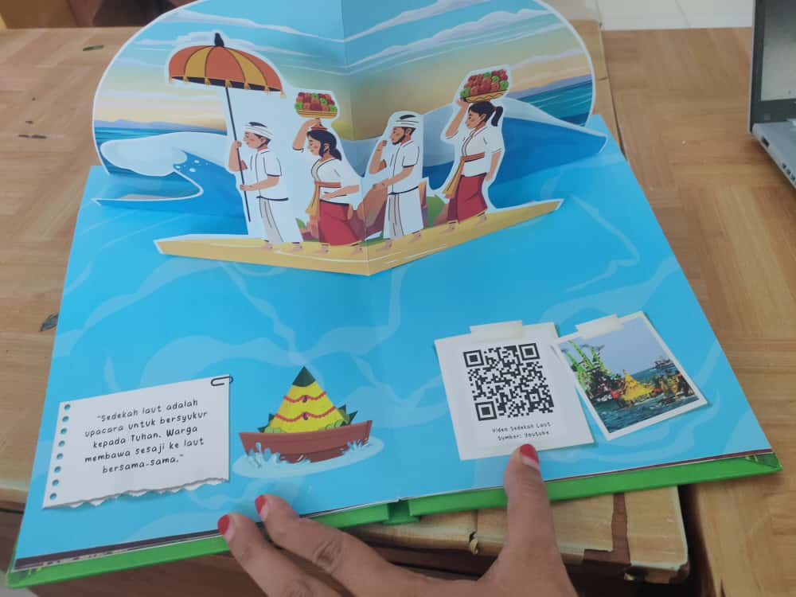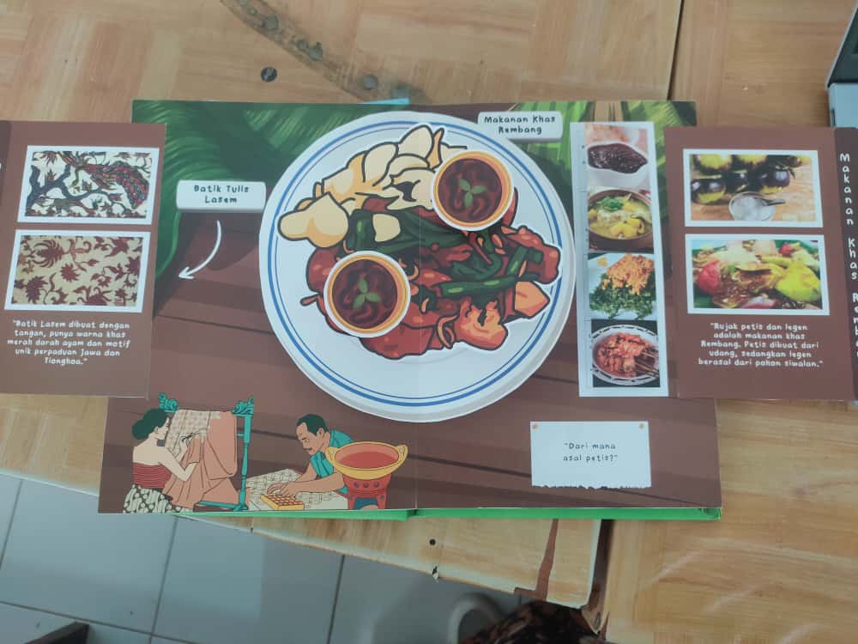
Source: Researcher Documentation, 2025
Figure 1. Initial Design of the Pop-Up Book Based on Rembang Local Wisdom

The media were designed using the principles of contextual learning with a scientific approach, enabling students to observe, question, reason, experiment, and communicate their findings. In addition, the media were developed by considering visual, cognitive, and character literacy aspects so that each page of the Pop-Up Book conveys moral and local cultural values. The initial design was subsequently validated by experts prior to the development phase.

Expert Validation Results
Validation was conducted by two validators: a material expert and a media expert. The evaluation employed a 5-point Likert scale covering content suitability, presentation, language, and attractiveness.

Table 2. Results of Material and Media Expert Validation
Assessment Aspect | Average Score | Category
Content feasibility | 4.78 | Very Feasible
Language appropriateness | 4.60 | Very Feasible
Visual attractiveness | 4.70 | Very Feasible
Relevance to local culture | 4.80 | Very Feasible
Total average (Material Expert) | 4.72 | Very Feasible
Total average (Media Expert) | 4.65 | Very Feasible
Source: Expert Validation Data (2025)

The material expert validation produced an average score of 4.72 (Very Feasible), indicating that the Pop-Up Book content aligns with the fourth-grade IPAS learning objectives and is relevant to Rembang’s cultural context. The validator suggested simplifying descriptive sentences to match students’ language development. Meanwhile, the media expert validation achieved an average score of 4.65 (Very Feasible). The most prominent aspect was the visual appeal and creativity of the Pop-Up design, which were rated highly attractive and innovative. Minor revisions were made to color balance and font size consistency for a more proportional appearance. Overall, the validation results confirmed that the Rembang local wisdom-based Pop-Up Book is feasible for classroom trials without major revisions.

Practicality Test Results
The practicality test was conducted with 30 fourth-grade students at SD Negeri Rakitan and SD Negeri Sluke. The class teachers also assessed practicality through questionnaires. The results revealed highly positive responses from both teachers and students.

Table 3. Results of Media Practicality Test by Teachers and Students
Respondent | Practicality Percentage (%) | Category
Teachers | 92.5 | Very Practical
Students | 91.8 | Very Practical
Source: Teacher and Student Practicality Questionnaires (2025)

The analysis showed that teachers gave an average practicality score of 92.5% (Very Practical), while students scored 91.8% (Very Practical). Teachers stated that the media were easy to use in classroom activities and helped explain the concept of cultural diversity more concretely. Students found the media engaging because they could touch, see, and interact with it, thereby enhancing their learning motivation. These findings indicate that the Rembang local wisdom-based Pop-Up Book possesses high practicality for both teachers and students, consistent with Lakens’ (2017) criteria of practicality ease of use, attractiveness, and comprehensibility.

Effectiveness Test Results
The media’s effectiveness was tested by comparing students’ pretest and posttest scores on critical thinking ability. The test consisted of 10 open-ended questions based on critical thinking indicators, including identifying, analyzing, evaluating, and drawing conclusions.

Table 4. Results of Students’ Critical Thinking Pretest and Posttest
No. | Nama Siswa | Pretest | Posttest | N-Gain | %N Gain
1 | Siswa 1 | 45 | 80 | 0.64 | 63.64
2 | Siswa 2 | 52 | 85 | 0.69 | 68.75
3 | Siswa 3 | 38 | 75 | 0.60 | 59.68
4 | Siswa 4 | 55 | 88 | 0.73 | 73.33
5 | Siswa 5 | 49 | 82 | 0.65 | 64.71
6 | Siswa 6 | 60 | 90 | 0.75 | 75.00
7 | Siswa 7 | 42 | 78 | 0.62 | 62.07
8 | Siswa 8 | 58 | 89 | 0.74 | 73.81
9 | Siswa 9 | 47 | 81 | 0.64 | 64.15
10 | Siswa 10 | 50 | 84 | 0.68 | 68.00
11 | Siswa 11 | 40 | 77 | 0.62 | 61.67
12 | Siswa 12 | 56 | 86 | 0.68 | 68.18
13 | Siswa 13 | 51 | 83 | 0.65 | 65.31
14 | Siswa 14 | 44 | 79 | 0.63 | 62.50
15 | Siswa 15 | 62 | 92 | 0.79 | 78.95
16 | Siswa 16 | 35 | 72 | 0.57 | 56.92
17 | Siswa 17 | 53 | 87 | 0.72 | 72.34
18 | Siswa 18 | 48 | 80 | 0.62 | 61.54
19 | Siswa 19 | 57 | 89 | 0.74 | 74.42
20 | Siswa 20 | 46 | 81 | 0.65 | 64.81
21 | Siswa 21 | 39 | 76 | 0.61 | 60.66
22 | Siswa 22 | 61 | 91 | 0.77 | 76.92
23 | Siswa 23 | 54 | 85 | 0.67 | 67.39
24 | Siswa 24 | 43 | 78 | 0.61 | 61.40
25 | Siswa 25 | 37 | 74 | 0.59 | 58.73
26 | Siswa 26 | 59 | 90 | 0.76 | 75.61
27 | Siswa 27 | 41 | 77 | 0.61 | 61.02
28 | Siswa 28 | 50 | 83 | 0.66 | 66.00
29 | Siswa 29 | 44 | 79 | 0.63 | 62.50
30 | Siswa 30 | 52 | 86 | 0.71 | 70.83
 | Rata-Rata | 48,9 | 82,6 | 0.67 | 66,69
Source: Data from the test results of fourth-grade students at SDN Rakitan and SDN Sluke (2025)

The analysis revealed that the students’ average pretest score was 48.9, which increased to 82.6 in the posttest. The N-Gain Score calculation produced an average value of 0.67, categorized as “moderate to high” according to Hake (2019). This demonstrates that the Pop-Up Book based on Rembang’s local wisdom effectively improved the critical thinking skills of fourth-grade students.
Beyond score improvement, observation and interview data indicated that students became more active in asking questions, engaging in discussions, and presenting arguments regarding cultural differences. They also showed greater enthusiasm in identifying examples of cultural diversity in their local surroundings. These findings align with Aldoobie (2015) and Branch (2020), who argue that visual and contextual learning media can enhance cognitive engagement and promote higher-order thinking skills.

Final Product Revision
Based on feedback from validators, teachers, and students, several minor revisions were made to the final product. These included adjusting background colors for better contrast, enlarging font size for readability, and simplifying language in several narrative sections. The finalized Pop-Up Book was printed in A4 size with 20 full-color pages divided into four thematic sections and included a teacher’s guide. The final product was rated as highly feasible and appealing for IPAS learning in fourth-grade elementary classes.

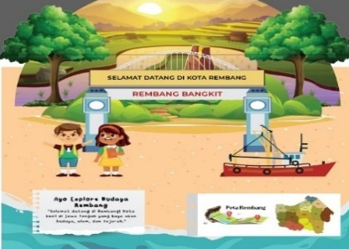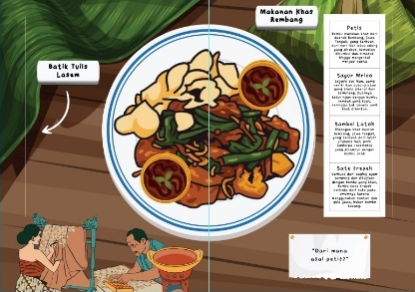
Source: Researcher Documentation, 2025

Figure 2. Final Product of the Pop-Up Book Based on Rembang Local Wisdom

In general, the results of this study indicate that the development of the Rembang local wisdom-based Pop-Up Book successfully produced a valid, practical, and effective learning medium for enhancing students’ critical thinking skills. This media serves not only as an instructional aid but also as a means of preserving regional cultural values through contextual and meaningful learning experiences

Discussion

Media Validity
The validation results show that the Pop-Up Book media based on Rembang Local Wisdom achieved a validity level of 95%, categorized as very valid. This indicates that the content, design, and presentation are aligned with the characteristics of elementary school students and the IPAS curriculum. The high level of validity demonstrates that the media meets the criteria for content feasibility, construction, and usability in learning.
This finding is consistent with the views of Branch (2020) and Molenda (2015), who state that effective instructional media must undergo expert validation to ensure alignment with learning objectives and learner characteristics. Furthermore, Rahayu and Sari (2021) found that Pop-Up Book media are considered very valid and engaging, as they display three-dimensional elements that are concrete and contextual, fitting the characteristics of elementary students.
This result is further supported by Fitriani, Hadiyanti, and Santoso (2020), who developed a culture-based Pop-Up Book for thematic learning and achieved 94% validity. The integration of local cultural elements was proven to strengthen content validity by providing real contexts that are familiar to students’ daily lives. Therefore, the findings of this study confirm that the Pop-Up Book based on Rembang Local Wisdom fulfills the required aspects of content, linguistic, and visual validity necessary for contextual learning.

Media Practicality
The practicality test results indicate that the teachers’ response to the media reached 90%, and students’ response was 97.3%, both categorized as very practical. This demonstrates that the Pop-Up Book is easy to use, attractive, and facilitates both teachers and students in understanding cultural diversity material. This finding reinforces the theory of Agil and Wati (2022), which states that effective learning media should simplify the teaching process while increasing student engagement. The interactive visual design of the Pop-Up Book enables students to actively participate through exploration and discussion, in line with the concept of active and joyful learning.
This result is also consistent with the findings of Sari and Nurhayati (2022), which showed that Pop-Up Books based on local wisdom increase learning motivation and make it easier for teachers to explain abstract concepts. Lestari, Nafis, and Nur (2021) also emphasized that integrating local culture into learning media fosters a sense of belonging and pride toward one’s region, which positively impacts students’ motivation and meaningful learning experiences. Therefore, the practicality of the Pop-Up Book based on Rembang Local Wisdom is proven to be high, as its design and content are aligned with students’ characteristics, easy for teachers to use, and supportive of collaborative and contextual learning.

Media Effectiveness on Critical Thinking Skills
The effectiveness test using the paired sample t-test showed a significance value of 0.000 < 0.05, indicating a significant difference between students’ pretest and posttest critical thinking scores. The N-Gain score of 0.68 falls into the moderate-to-high category, signifying a substantial improvement in critical thinking skills after the use of the media.
The Pop-Up Book based on Rembang Local Wisdom provides a meaningful learning context, encouraging students to observe, compare, and evaluate cultural values and to draw logical conclusions. This mechanism aligns with Ennis’s (2018) theory, which asserts that critical thinking can be developed through context-based learning and exploratory activities involving analysis and reflection.
This study also supports the findings of Wulandari, Prasetyo, and Widodo (2021), which revealed that using culture-based Pop-Up Books in thematic learning enhanced students’ critical thinking skills by 32%. Similarly, Putri (2020) found that visual media grounded in ethnoscience foster curiosity and promote higher-order thinking skills (HOTS). Hence, the effectiveness of the Rembang Local Wisdom-based Pop-Up Book is reflected not only in improved test scores but also in behavioral changes students became more active, reflective, and critical toward the cultural values around them.

Relationship with Theories and Previous Research
The relationship between this study and previous relevant studies can be seen in the following table.

Table 1. Comparison of Relevant Previous Research Findings
No | Researcher & Year | Research Focus | Previous Research Findings | Relation to This Study
1 | Fitriani, Hadiyanti, & Santoso (2020) | Culture-based Pop-Up Book | Media validity 94% (very valid) | Similar result with 95% validity, indicating consistency in the effectiveness of local-based media.
2 | Wulandari, Prasetyo, & Widodo (2021) | Thematic Pop-Up Book improving critical thinking | 32% improvement in critical thinking | Supports that Pop-Up Books effectively enhance critical thinking skills.
3 | Sari & Nurhayati (2022) | Local wisdom-based Pop-Up Book | Practical media that enhances learning motivation | Both show positive student responses to local-based media.
4 | Lestari, Nafis, & Nur (2021) | Regional culture-based media | Improves character values and cultural appreciation | Related to Pop-Up Book media that instills Rembang’s cultural values.

This research also reinforces the modern constructivist perspectives proposed by Fosnot (2016) and Vygotsky (2019), which state that knowledge is actively constructed through contextual experiences and social interaction. The Pop-Up Book based on local wisdom offers an authentic learning experience that enables students to construct meaning through engagement with their regional culture. Contextual learning grounded in local culture not only enhances cognitive abilities but also cultivates students’ social awareness and national character.
Overall, the findings of this study indicate that the Pop-Up Book based on Rembang Local Wisdom meets three essential criteria for ideal learning media: (1) Content and design validity (95%), (2) High practicality for teachers and students (90–97.3%), and (3) Effectiveness in improving critical thinking skills (N-Gain 0.68). These results confirm that integrating local cultural elements into learning media is an effective strategy to enhance the quality of IPAS learning in elementary schools while instilling contextual local wisdom values.
- CONCLUSION

This study produced a Pop-Up Book learning medium based on Rembang Local Wisdom that is valid, practical, and effective in improving the critical thinking skills of fourth-grade elementary students in IPAS learning on Cultural Diversity material. The results of expert validation on content and media indicate that the developed Pop-Up Book achieved a validity level of 95% (very valid). This demonstrates that the content, visual design, and presentation align with learners’ needs and the IPAS curriculum competencies. The materials integrating local cultural elements such as Batik Lasem, Tari Orek-Orek, and Sedekah Laut are considered relevant, authentic, and capable of enriching the local culture-based learning context. In terms of practicality, the trial results show positive responses from both teachers and students, with teacher practicality scores of 90% and student scores of 97.3%, both in the very practical category. Teachers found the media easy to use and helpful in delivering lessons, while students perceived the Pop-Up Book as engaging, motivating, and helpful for understanding cultural diversity concepts. Thus, the media proved to be practical for thematic and contextual learning environments.

Regarding effectiveness, the paired sample t-test results show a significance value of 0.000 < 0.05, indicating a significant improvement in students’ critical thinking skills after using the media. The average N-Gain score was 0.68, categorized as moderate-to-high, suggesting that the Pop-Up Book successfully encouraged students to analyze, evaluate, and conclude information more logically and reflectively. Theoretically, the findings reinforce the notion that critical thinking can be developed through context-based and analytical learning activities, supporting the modern constructivist theory that emphasizes the importance of authentic learning experiences and social interaction in knowledge construction. The use of Rembang local wisdom as a learning context also contributes to cultural preservation while strengthening regional identity within primary education.

The Pop-Up Book learning media based on Rembang Local Wisdom is: (1) Valid in terms of content, language, and design, meeting curriculum standards and student characteristics; (2) Practical for teachers and engaging for students, as it combines visual, narrative, and cultural elements; and (3) Effective in enhancing students’ critical thinking skills and promoting meaningful learning. This study demonstrates that integrating local wisdom into learning media not only enriches academic content but also fosters cultural awareness, regional pride, and higher-order thinking skills. Therefore, the Pop-Up Book based on Rembang Local Wisdom is a viable and innovative alternative for IPAS learning in elementary schools.

REFERENCES
Agil, D., & Wati, T. L. (2022). Video-based learning strengthens critical thinking in elementary science classes: Media video pembelajaran meningkatkan berpikir kritis siswa IPA SD. Indonesian Journal of Education Methods Development, 1(3), 123–136. https://doi.org/10.21009/IJEMD.1.3.889
Aldoobie, N. (2015). ADDIE model. American International Journal of Contemporary Research, 5(6), 68–72. https://doi.org/10.30845/aijcr.v5n6p12
Alifia, H. N., Salma, D., Arifin, M. H., & Istianti, T. (2021). Internalisasi keberagaman budaya dengan pendidikan karakter di sekolah dasar. Gentala Pendidikan Dasar, 6(2), 100–111. https://doi.org/10.22437/gentala.v6i2.15610
Anggraeni, D., & Setiawan, B. (2020). Pembelajaran berbasis budaya lokal untuk penguatan karakter siswa. Jurnal Pendidikan dan Kebudayaan, 10(2), 155–168. https://doi.org/10.24832/jpnk.v10i2.1598
Arya Chandra Wiguna, I. S., & Rustini, T. (2023). Upaya meningkatkan berpikir kritis siswa SD dalam pembelajaran IPS. Dirasah: Jurnal Studi Ilmu dan Manajemen Pendidikan Islam, 6(1), 62–70. https://doi.org/10.58401/dirasah.v6i1.775
Branch, R. M. (2020). Instructional design: The ADDIE approach. Springer. https://doi.org/10.1007/978-0-387-09506-6
Braun, V., & Clarke, V. (2019). Reflecting on reflexive thematic analysis. Qualitative Research in Sport, Exercise and Health, 11(4), 589–597. https://doi.org/10.1080/2159676X.2019.1628806
British Educational Research Association (BERA). (2018). Ethical guidelines for educational research (4th ed.). London: BERA. https://doi.org/10.1080/03054985.2018.1506040
Carter, N., Bryant-Lukosius, D., DiCenso, A., Blythe, J., & Neville, A. J. (2014). The use of triangulation in qualitative research. Oncology Nursing Forum, 41(5), 545–547. https://doi.org/10.1188/14.ONF.545-547
Creswell, J. W., & Plano Clark, V. L. (2018). Designing and conducting mixed methods research (3rd ed.). SAGE Publications. https://doi.org/10.4135/9781506335193
Dalimunthe, M. (2023b). [Judul artikel tidak dicantumkan dalam sumber asli]. [Nama Jurnal], Volume, [Halaman].
Dilla, M. (2023). Pengembangan keterampilan berpikir kritis siswa sekolah dasar melalui model pembelajaran inkuiri. Jurnal Pendidikan Guru Sekolah Dasar, 1(2), 138–154. https://doi.org/10.47134/pgsd.v1i2.138
Ennis, R. H. (2018). Critical thinking across the curriculum: A vision. Topoi, 37(1), 165–184. https://doi.org/10.1007/s11245-016-9401-4
Etikan, I., Musa, S. A., & Alkassim, R. S. (2016). Comparison of convenience and purposive sampling. American Journal of Theoretical and Applied Statistics, 5(1), 1–4. https://doi.org/10.11648/j.ajtas.20160501.11
Fatimah, F., & Rohani. (2021). Peningkatan keterampilan berpikir kritis dan hasil belajar siswa melalui pembelajaran menggunakan model discovery learning di SD Negeri Bile Penanggak. Teacher: Jurnal Inovasi Karya Ilmiah Guru, 2(3), 1–15. https://doi.org/10.51878/teacher.v2i3.1623
Firmansyah, A., & Lidiawati, L. (2019). Efektivitas media visual terhadap kemampuan berpikir kritis siswa SD. Jurnal Sekolah, 8(2), 88–96. https://doi.org/10.24114/js.v8i2.15730
Fitriani, N., Hadiyanti, R., & Santoso, A. (2020). Pengembangan pop-up book berbasis budaya lokal untuk pembelajaran tematik di sekolah dasar. Jurnal Pendidikan Dasar Nusantara, 6(2), 110–122. https://doi.org/10.33369/jpdn.v6i2.10234
Fosnot, C. T. (2016). Constructivism: Theory, perspectives, and practice (2nd ed.). Teachers College Press. https://doi.org/10.4324/9780203850980
Hake, R. R. (2019). Analyzing change/gain scores. American Educational Research Journal, 56(4), 1245–1265. https://doi.org/10.3102/0002831219830022
Hidayat, A., & Fadhilah, R. (2018). Peningkatan kemampuan berpikir kritis siswa sekolah dasar melalui model problem-based learning. Jurnal Pendidikan Dasar, 9(1), 59–70. https://doi.org/10.21009/JPD.009.01.07
Lakens, D. (2017). Equivalence tests: A practical primer for t-tests, correlations, and meta-analyses. Social Psychological and Personality Science, 8(4), 355–362. https://doi.org/10.1177/1948550617697177
Lestari, F. P., Nafis, K., & Nur, D. M. (2021). Pop-up book sebagai alat bantu visual dalam praktik pembelajaran sejarah di SMA Negeri 1 Mayong. Triwikrama: Jurnal Ilmu Sosial, 9(2), 45–58. https://doi.org/10.9963/rvgezt51
Lestari, S., & Kurniasih, R. (2020). Keefektifan media pop-up book dalam meningkatkan keterlibatan siswa. Jurnal Cakrawala Pendidikan, 39(1), 112–123. https://doi.org/10.21831/cp.v39i1.28910
Molenda, M. (2015). The ADDIE model: Dead or alive? Educational Technology, 55(5), 44–47. https://doi.org/10.1007/s11528-015-0892-4
Pramudiani, S., & Wulandari, T. (2021). Pengaruh media pembelajaran berbasis kearifan lokal terhadap motivasi dan hasil belajar. Jurnal Inovasi Pendidikan Dasar, 6(1), 45–53. https://doi.org/10.23917/jipd.v6i1.12454
Putri, A., & Suryani, E. (2022). Pengembangan pop-up book berbasis budaya daerah untuk pembelajaran tematik siswa SD. Jurnal Inovasi Pembelajaran SD, 2(2), 77–86. https://doi.org/10.26418/jipsd.v2i2.49711
Putri, F. N. (2020). Pengaruh media etnosains terhadap kemampuan berpikir tingkat tinggi siswa sekolah dasar. Jurnal Pendidikan IPA Indonesia, 9(4), 592–602. https://doi.org/10.15294/jpii.v9i4.26379
Rahayu, S., & Sari, M. (2021). Pengembangan media pop-up book pada pembelajaran tematik untuk siswa SD. Jurnal Cakrawala Pendidikan, 40(2), 345–357. https://doi.org/10.21831/cp.v40i2.39829
Ramadhan, F., & Utami, S. (2023). Efektivitas media pop-up book terhadap perkembangan kognitif dan afektif siswa. Jurnal Pendidikan Dasar Indonesia, 8(1), 41–52. https://doi.org/10.30998/jpdi.v8i1.14563
Saodi, S., Hajerah, H., & Amri, N. A. (2020). Pengembangan media pop-up book pada guru taman kanak-kanak di Kecamatan Tanralili Kabupaten Maros Provinsi Sulawesi Selatan. Raudhatul Athfal: Jurnal Pendidikan Islam Anak Usia Dini, 3(2), 89–102. https://doi.org/10.19109/ra.v3i2.4566
Sari, A. P., & Nurhayati, N. (2022). Pengembangan pop-up book berbasis kearifan lokal untuk meningkatkan motivasi belajar siswa SD. Jurnal Ilmiah Pendidikan Dasar, 9(1), 25–38. https://doi.org/10.26877/jipd.v9i1.11657
Sari, D. P., & Kurniawati, L. (2021). Pengembangan media pop-up book untuk meningkatkan hasil belajar siswa sekolah dasar. Jurnal Pendidikan Dasar, 12(2), 115–124. https://doi.org/10.21009/JPD.012.02.03
Siti Fatimah, Supangat, & Arini Rosa Sinensis. (2022). Pengembangan media belajar pop-up book berbasis literasi Qur’an pada materi tata surya kelas VI. Attadrib: Jurnal Pendidikan Guru Madrasah Ibtidaiyah, 5(2), 150–166. https://doi.org/10.54069/attadrib.v5i2.278
Susanti, R., & Rahmawati, A. (2019). Pengintegrasian kearifan lokal dalam pembelajaran tematik sekolah dasar. Jurnal Pendidikan Karakter, 9(3), 378–390. https://doi.org/10.21831/jpk.v9i3.27852
Tavakol, M., & Dennick, R. (2011). Making sense of Cronbach’s alpha. International Journal of Medical Education, 2, 53–55. https://doi.org/10.5116/ijme.4dfb.8dfd
Vygotsky, L. S. (2019). Mind in society: The development of higher psychological processes. Harvard University Press. https://doi.org/10.2307/j.ctvkjb2x7
Wahyuni, T., & Dewi, A. (2022). Kontekstualisasi pembelajaran IPAS dalam Kurikulum Merdeka. Jurnal Pendidikan Dasar Nusantara, 7(1), 22–34. https://doi.org/10.29407/jpdn.v7i1.17492

Wulandari, N., Prasetyo, E., & Widodo, S. (2021). Penggunaan media pop-up book untuk meningkatkan kemampuan berpikir kritis pada pembelajaran tematik. Jurnal Pendidikan Karakter, 12(1), 77–90. https://doi.org/10.21831/jpk.v12i1.40325

