Religious Education For Non-Muslim Students In Aceh: An Evaluation of Inclusivity And Implementation
Suharman¹, Tengku Hafinda², Nur Rohman³, Rahmad Syah Putra⁴, Khairuddin Hasan⁵, Maya Agustina⁶, Farah Sumaiyah⁷
^{1,2,3,5,6} STAIN Teungku Dirundeng Meulaboh, Aceh, Indonesia suharman@staindirundeng.ac.id, tengkuhafinda@staindirundeng.ac.id, nur.rohman@staindirundeng.ac.id, rahmad@bbg.ac.id, khairuddinhasan@staindirundeng.ac.id, mayaagustn@staindirundeng.ac.id, farahsumaiyah1@gmail.com
⁴ Bina Bangsa getsempena University Banda Aceh, Indonesia,

ARTICLE INFO |  | ABSTRACT
Keywords:  Learning Evaluation;  Religious Education;  Non-Muslim Students |  | This study investigates how religious education for non-Muslim students is implemented and evaluated in Muslim-majority schools in Aceh Province, with particular attention to inclusivity and its operational mechanisms. The issue stems from persistent ambiguity in teaching and evaluation patterns for minority groups, despite such rights being guaranteed by law. A qualitative phenomenological approach was employed to explore participants’ lived experiences. Data were collected through questionnaires, semi-structured interviews, and document analysis, involving school principals, religious teachers, non-Muslim students, and religious leaders from four regions: Aceh Singkil, West Aceh, Sabang, and Lhokseumawe. The findings reveal that the shortage of religious teachers of the same faith is addressed by involving religious leaders as instructors and assessors. Most learning takes place in houses of worship and is integrated into regular religious activities. Evaluation is conducted collaboratively between schools and religious leaders; however, the absence of standardized guidelines has led to variations in assessment criteria. This study contributes to a deeper understanding of alternative strategies for fulfilling the right to religious education for minority students and underscores the importance of school religious leader partnerships in designing inclusive curricula and assessment tools. It concludes that while the fulfillment of this right is underway in Aceh, implementation remains inconsistent across schools. The study recommends the development of a national guideline to serve as a reference for the implementation and evaluation of religious education for students of different faiths
Article history:
Received 2021-08-14
Revised 2021-11-12
Accepted 2022-01-17
 |  | This is an open access article under the CC BY-NC-SA license.
Corresponding Author: Suharman
State Islamic College Teungku Dirundeng Meulaboh, Aceh, Indonesia suharman@staindirundeng.ac.id
- INTRODUCTION

Education is a journey towards human maturity in achieving perfection as an individual. Human maturity covers all aspects of life, including physical, psychic, mental/moral, spiritual, and religious dimensions (Winditya, 2021). One of the missions of national education development is to improve the readiness of inputs and the quality of the educational process to optimize the formation of a moral personality (Andriani, 2021). The mandate emphasizes the role of education in developing the character and character of students in carrying out the educational process (Murtadlo &; Basri, 2022). Education has various forms, it can occur formally in the school environment, informally through educational and training institutions, and informally in the family environment. In the context of schools, religious education plays an important role as part of efforts to mature humans in the spiritual-religious dimension.

The existence of religious learning in schools is not only an effort to fulfill human religious nature but also a step to meet the objective needs of students for religious services in their lives. Religion and faith life are considered objective needs for every individual. (Khasanah, 2023). Law Number 20 of 2003 concerning SISDIKNAS, article 12 paragraph (1) letter a, stipulates that every student in every educational institution has the right to receive religious education by their religious beliefs, taught by educators who are in line with that religion. This applies not only in public schools but also in private schools. The government must ensure the provision or appointment of religious teaching staff by the religion of each student, both in public and private schools (UUD Sisdiknas, 2006). The implementation of public schools with religious elements is a community right, as stipulated in Law Number 20 of 2003, article 55, which states that the community has the right to provide community-based education in the form of formal and non-formal education by the character of religion, social environment, and culture for the common good.

The obligations of schools carried out by the community include the implementation of religious lessons by religious characteristics, as mandated by PP No. 55 of 2007 concerning Religious Education and Religious Education, article 3, which affirms that every education unit in all paths, levels, and types of education must provide religious education. The right to receive religious instruction is the right of parents and students, and as citizens, these rights must be guaranteed by the government (UUD Sisdiknas, 2007).

Arguably, the presence of religious subjects and educators from different religious backgrounds does not diminish the unique characteristics and religious autonomy of the school. Instead, having educators from different religions can promote interaction, dialogue, and the sharing of religious teachings and experiences within religious study groups. In other words, religious education becomes enriched through diversity (Hanafy, 2015). The principle of 'unity in diversity' is achievable, fostering inclusive behavior that promotes tolerance and mutual respect for differences (Saihu, 2019).

Religious lessons have been integrated into the nationwide school curricula in Indonesia as a compulsory subject accepted by all students (Seilatu, 2014). However, the current implementation of religious education in both public and private schools has indeed sparked debates and even caused problems (Sani, 2018). Moreover, the lack of clarity in religious education patterns for non-Muslim students attending state schools is a recurring issue, particularly in Aceh. According to Indonesian laws and regulations, every non-Muslim student whose religion is recognized has the right to receive appropriate religious education. Based on initial observations by researchers, it appears that religious education for non-Muslim students has not been adequately implemented. Despite the Ministry of Religious Affairs being tasked with ensuring religious education for all recognized religions in Indonesia, it has developed comprehensive guidelines for this purpose (Harmi, 2022). These guidelines are integrated into education policies and the religious moderation program in schools. Therefore, students with diverse religious beliefs are guaranteed to receive appropriate education that aligns with the ethical and moral teachings of their respective religions.(Rofik & Misbah, 2021).

Based on the data retrieved from Satu Data Kementerian Agama (www.satudata.kemenag.go.id), Aceh Province is the area with the highest percentage of Muslims. This fact will certainly impact the implementation of religious education for minority students. However, the findings obtained by the author are that several schools in Aceh Province have implemented learning schemes as mandated by the government. Among these schemes are: the involvement of religious leaders in the learning process, the use of houses of worship as a substitute for classrooms, and the learning evaluation process based on basic competencies and learning outcomes to be targeted. Thus, the right to obtain religious education, especially for adherents of minority religions, can be fulfilled. The shortage of qualified religious teachers and limited learning facilities are no longer obstacles to fulfilling the religious rights of all students.

However, if examined further, not all schools in Aceh province implement such a scheme. There are still schools that are confused in fulfilling religious rights for students who adhere to minority religions. This problem certainly has an impact on the acquisition of religious knowledge received by minority students. The lack of a clear assessment benchmark is also one of the triggers for the gap between students of other religions. This problem makes the implementation of religious education have its own challenges. (Rissanen dkk., 2020) explained that there are increasing challenges faced in implementing religious education for minority students. One of the main causes is an uninclusive curriculum that results in minority shiva being increasingly marginalized. Students from minority religions often experience social pressure that ultimately impacts the social and spiritual development of the student (Dupper dkk., 2015) Government policy and regulatory factors are also one of the factors that aggravate this situation. Religious education in schools often reflects bias and injustice against students who adhere to minority religions (Schleutker, 2019)

It is well known that according to Indonesia's laws and regulations, every non-Muslim student whose religion is recognized has the right to receive appropriate religious education. Every school is required to provide the same service to all adherents of different religions. The availability of teachers, learning facilities, and religious guidance are the main parts that need to be considered by the school, all of which have been affirmed in government policy.

We identify the study focused on the implementation of religious education in schools. Naeem & Yousaf, (2023). found that the International Islamic School of Darul Madinah and the Al-Hira Islamic School of India emphasize strong religious tolerance. To achieve this, these schools strategically design their curriculum through interfaith dialogue and provide facilities that enable students to coexist harmoniously, both within and outside the school environment. However, it is undeniable that misunderstandings rooted in religious beliefs often lead to disputes among religious communities. In response, these schools serve as mediators, bridging differences and offering proactive solutions to emerging issues. At the same time, schools will act as inclusive platforms that ensure open access to the fulfillment of religious rights.

Unfortunately, not all schools, especially in Indonesia, can fulfill this rights. Research conducted by Raihani (2016) indicates that minority religious students often face discriminatory treatment and encounter difficulties in accessing equal religious education. The shortage of qualified religious teachers and inadequate learning facilities are among the obstacles faced by minority religious groups. To overcome these various problems, Huda & Fattah, (2021) emphasize the importance of special strategies needed to overcome the problems that are often experienced by religious minority groups. The availability of appropriate facilities and educational personnel is an absolute part that must be fulfilled by every educational institution.

The above descriptions indirectly show that there is still a gap in scientific literature that should be able to provide a real picture of the solution to the problems that often occur in educational institutions, especially in the implementation of religious education for minority groups. Therefore, this study positions itself as the latest study that can explain how schools in Aceh Province provide religious education for minority groups. The focus of this research is the implementation of religious education evaluation for non-Muslim students in Aceh Province. The results of this research can later be a reference for both education providers and education implementers in fulfilling religious rights for all students, starting from policy formulation and implementation of religious education in schools.
- METHODS

We conducted the present study to gain a deeper understanding of the implementation of religious education evaluation for non-Muslim students in Muslim-majority schools in Aceh province. This entails examining various aspects such as teaching and learning activities, available learning facilities, the processes involved in evaluating religious learning, and the systematic assessment of religious education. This research uses a qualitative approach with a phenomenological type. This type of research is suitable for exploring a phenomenon that has not been extensively studied or documented (Flowerday & Scraw, 2000; Creswell, 2009). This research took place in Aceh Province, focusing on several specific locations: Aceh Singkil Regency, West Aceh Regency, Sabang City, and Lhokseumawe City. The selection of this location was determined using a multi-stage method on the grounds that these four cities are cities in Aceh Province with a large percentage of religious minorities. While participants for the interviews were carefully selected using criterion sampling, as outlined by Cohen et al. (2007). The criteria for participation included individuals from specific groups: principals and students from multi-religious schools, religious teachers with at least one year of experience in the evaluation process, non-Muslim high school students in grades XI and XII, as well as qualified religious leaders such as priests, monks, and nuns. The selection of these participants is based on the need for the necessary research data. School principals, religious teachers, and students who follow religious minorities are needed to know how to implement school policies in the implementation of religious education for students who follow religious minorities. Meanwhile, religious leaders are needed to see how the religious learning scheme they carry out in their respective houses of worship. To ensure the anonymity of participants, we change their names to pseudonyms. Additionally, we assign pseudonyms to the schools where the study is conducted. Participants in the current study are selected from four different regions in Aceh: Gumer High School, Abar High School, Island High School, and Acut High School. The quantitative data includes a total of 80 students, while the qualitative data involves four participants from each school: the principal, a non-Muslim student, a religious education teacher, and a religious leader. Through these interviews and data collected from schools, we gained valuable information about how religious education evaluations are conducted for non-Muslim students, covering aspects such as teaching approaches, school resources, evaluation procedures, and the overall assessment framework.

The data collection techniques used in this study are interviews and documentation. Semi-structured interviews were conducted to delve into the phenomenon of evaluating religious learning for non-Muslim students, focusing on the following guiding questions: 1) How is the teaching and learning process of religious education structured for non-Muslim students? 2) How are assessment and evaluation conducted for non-Muslim students? 3) What are the main obstacles faced by teachers and religious leaders during the learning and assessment processes?

The documentation techniques involved gathering supporting data for teaching, learning activities, and the assessment of religious learning. This documentation included curriculum documents, religious learning materials, and learning assessment documents such as exam questions and answer keys These data sources were utilized to understand how the evaluation of religious learning is conducted for non-Muslim students in Muslim-majority schools in Aceh Province. The data is then processed and analyzed using data triangulation techniques (Miles & Huberman, 1994).

The procedure for conducting this research generally consists of several stages. The first stage carried out in this study is to conduct a preliminary study. This stage is carried out to find out the initial data or phenomena of research that occur at the research location. The next stage is the stage of problem analysis and determination of the direction of research. At this stage, the initial data or phenomena obtained in the preliminary study are analyzed to obtain conclusions on the problems to be solved in the study. In addition, this stage is also carried out to determine the type of research used to solve the problem or explore the phenomenon. The next stage is data collection using the research instruments used, namely semi-structured interviews and documentation of evaluation data on religious learning in schools. The next stage is the data processing and analysis stage. The data obtained in this study were processed and analyzed to find the results of the study. The final stage in the study is the conclusion stage. Conclusions are drawn by referring to the results of processing and analysis of research conducted in this study.
- FINDINGS AND DISCUSSION
Distribution of non-Muslim students in Aceh
Based on the research data, responses from at least 80 participants provided the necessary information. The data collected from non-Muslim students in each school indicates a wide diversity of religious affiliations. The distribution of religious variations adopted by students in each school is illustrated in the following diagram and table.

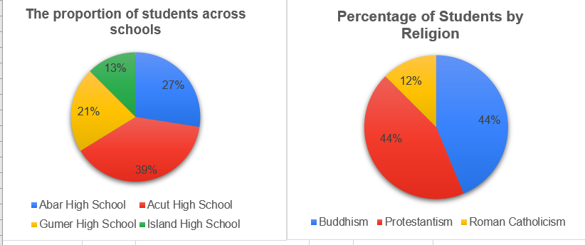
Figure 1: Distribution of religions across different schools

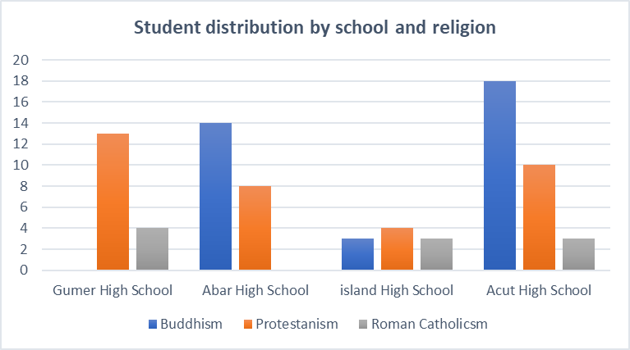
Figure 2: Student distribution by school and religion

The provided data show the distribution of religious affiliations among students in schools across four regions of Aceh (north, east, middle, and west). Specifically, it highlights the variations in student populations and their religious affiliations, with Acut High School having the highest number of non-Muslim adherents, and Island High School having the lowest. Here is a summary of the key points:
- Acut High School in northern Aceh has the highest proportion of non-Muslim students, at 38.75% (31 students). This is followed by Abar High School in western Aceh with 27.5% (22 students). Meanwhile, Gumer High School in Gunung Meriah comes next, with 21.25% (17 students). Lastly, Island High School in Sabang has the lowest proportion, at 12.5% (10 students).
- The dominant religions among the students are Buddhism and Protestantism, each comprising 43.8% of the student population, with 35 students each. Finally, Roman Catholicism accounts for 12.5% of the students, with 10 adherents.

The Religious Learning Process of Non-Muslim Students
The principle of the learning process is to take concrete steps to transform a situation from ignorance to knowledge, and from inability to capability (Rohman, 2021). This process is crucial and should be prioritized, especially for achieving learning goals. However, many educators in practice overlook its significance. Yet, this process is fundamental for reaching learning objectives. In fact, grades alone cannot fully reflect the depth of understanding students acquire.
If we examine further, it turns out that such problems also often occur in religious learning among non-Muslim students in Islamic schools. The data from the findings revealed that the teaching and learning process at Gumer High School for non-Muslim students has not been as effective as intended. This problem originates mainly from the shortage of teachers who come from the relevant religious backgrounds. Other contributing factors include the limited involvement of religious figures who could serve as substitutes for religious teachers, the absence of teaching modules, and inadequate support and guidance for teachers within the school. The issue mentioned above is highlighted by the statement made by IA, the religious teacher at Gumer High School:
"The learning process that we do, especially for non-Muslim students, is to involve religious leaders or pastors as substitutes for religious teachers in schools. But in the learning process, pastors do not teach in schools, but remain in their houses of worship and every worship they do becomes part of the learning process."

Furthermore, if the process of religious learning for non-Muslim students is seen from the student's side, another problem is found in the form of the lack of role of religious figures in the learning process. Although their worship activities became part of the religious learning process. However, these activities are only limited to ordinary routine worship in which there are no teaching and learning activities or religious guidance. As a result, students' knowledge related to religious learning is only about the worship they run. Even though there should be a lot of material that must be obtained by students such as in class XI Christianity there are materials that students must learn, namely: Christian education in the family, marriage with a Christian perspective, emulating the Lord Jesus in justice and peace, and others
However, based on a questionnaire filled out by 35 students, it showed that as many as 60% answered that religious leaders had never been involved in learning activities either at school or in their places of worship, 20% answered always, 17.1% answered occasionally, while 2.9% answered frequently. This data shows that learning activities carried out by religious leaders have not run as it is intended.

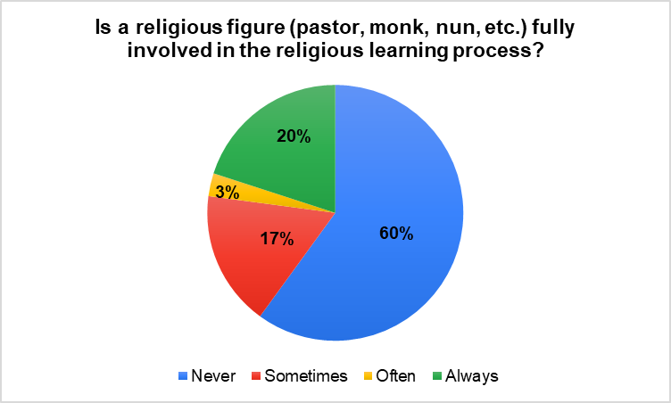
Figure 3. Questionnaire data on the role of religious leaders in religious learning

Furthermore, as a form of validation of the information obtained by researchers, it was found that the problem was triggered by several things such as religious leaders, difficulties in providing teaching, and the absence of study guides. This is as stated by Pastor HT below:
"The schools involve us pastors directly in the learning process. They've assigned us as substitutes for the regular religious teachers. So, alongside our church worship activities, we incorporate learning sessions for the students. It's like their worship time doubles as their religious education. But, surprisingly, our teachings aren't reflected in the school's religious textbooks. So, we mainly focus on what we cover during our weekly worship sessions" (HT, Pastor of GKPPD Church)

Based on data collected through research, the learning process for non-Muslim students in this school adopts a distinctive approach. Religious leaders serve as substitutes for regular religious teachers in schools. Interestingly, they do not teach within the school setting but rather in their places of worship. However, they explain that every worship activity conducted in their respective houses of worship becomes an integral part of the learning process for non-Muslim students at the school. This creates a close link between daily religious life and education in schools.
According to religious leaders, this strategy helps students gain a deeper understanding of the values of different religions and how to integrate these values into daily life. It also allows non-Muslim students to have an immersive experience in understanding and respecting other religions. However, they also acknowledge that the challenge faced is how to integrate this approach with public school curricula. They think that there is a need to better tailor the curriculum to religious activities conducted in houses of worship by religious leaders so that non-Muslim students can benefit from this approach without feeling separate from the existing school curriculum. This condition is further justified by a religious teachers as follows:
" For us at Island High School, all our teachers are Moslem. We don't have teachers from other religions. Since there are no non-Muslim teachers here, we've had to find alternative solutions for religious education. That is why we involve religious leaders in the learning process. (Interview EL, Religious Teacher of Island High School)

The same statement was echoed by a non-Muslim student at Island High School in the following comments:
"The learning process we have had so far is through the pastor at church because there are no teachers in school who share our religious beliefs. Our learning activities resemble weekly worship sessions, and sometimes these worship activities are part of our religious education" (Interview CT, non-Muslim student of Island High School).

Abar High School follows a similar approach to religious education for non-Muslim students as seen in other schools. They involve religious figures as substitutes for regular teachers, such as Bante and the Pastor, to ensure students' religious knowledge needs are met. The learning process occurs primarily in their respective places of worship, where weekly religious activities are valued and overseen by these figures. In addition to these activities, every Friday morning, students are given time to discuss and explore their religions. This coincides with a school routine where they gather in the school yard to collectively read Surah Yasin. One teacher said:

" In this school, non-Muslim students learn about religion through their own religious leaders because the school doesn't have teachers from their specific religions. They conduct their learning in their places of worship. Additionally, every Friday morning, we provide them with time to independently discuss their religion." (Interview of Islamic religious teacher,)

In line with the religious teacher's narrative, the Vice Principal of Curriculum at Abar High School, AD said that:

"So far, the religious learning process for non-Muslim students involves non-Muslim religious leaders as well. By the religion professed by the student. Incidentally, for non-Muslim students at Abar High School, there are only 2 religions. That is Buddhism and Protestantism. So that the religious figures we are involved in the religious learning process are the Bante and Pastor. As for technical learning, it is completely held by the priest and banter. However, the school provides basic points that must be met in the learning process, especially regarding the assessment of non-Muslim students."
As a form of confirmation of the interview data that has been explained by the two sources above, the author validates the information to the students concerned. The author's findings show that the process of religious learning is obtained by students through weekly worship activities and other worship. Religious formation and assistance are entirely carried out by each worship figure. But besides that, schools also have a role in instilling universal religious values such as cultivating student character.
Based on the interviews with the participants mentioned above, it is evident that at this school, the religious learning process for non-Muslim students occurs independently every Friday. This reflects the school's commitment to providing adequate space for religious diversity. Non-Muslim students can explore their understanding of their religious values by immersing themselves in the course material presented specifically on that day. In addition, for Protestant students, the learning approach becomes more personal with direct guidance from teachers of the same faith. Protestant teachers have a central role in guiding students about the teachings and values associated with their beliefs. This step not only ensures students' familiarity with their religious teachings but also reinforces the concept of togetherness in the context of religious diversity in schools.
In addition, the school also continues to involve religious leaders in the religious learning process. The involvement of religious figures brings a practical and applicable dimension to teaching, linking theory to everyday life. With this approach, the school provides a well-rounded religious learning experience, creating an environment where students can respect and understand religious differences more deeply.
In addition, the school also continues to involve religious leaders in the religious learning process. The involvement of religious leaders brings a practical and applicative dimension to teaching, connecting theory to everyday life (Syafei & Zam’an, 2024) With this approach, the school provides a well-rounded religious learning experience, creating an environment where students can respect and understand religious differences more deeply. (Zuhri dkk., t.t.) explained that religious leaders have a central role in the religious learning process in schools. Religious leaders function as teachers, counselors, and models that connect schools and communities. This ensures that religious education in schools will be in line with the religious values embraced by the community (Suryani & Muslim, 2024) For multicultural schools, the implementation of religious literacy often has great challenges. Therefore, religious leaders and school institutions must work together to be able to create a curriculum that can respect and appreciate diversity so that it can reduce the potential for interfaith conflict (Rissanen dkk., 2020)

Religious Learning Evaluation Process
An important process known as the evaluation of religious learning in schools aims to measure the extent to which students understand, internalize, and apply religious teachings, values, and concepts in their lives. This evaluation is very important to ensure that religious education in schools achieves the goals that have been set and provides the best benefit to students (Novarita et al., 2023).
Evaluation activities for religious learning in schools encompass various techniques, including written exams, project presentations, class discussions, student participation in religious ceremonies, and project-based assignments that apply religious principles in daily life (Febriana, 2021). However, if there is no religious teacher at the school, these activities will undoubtedly become different. Gumer High School, for instance, lacks a religious teacher for non-Muslim students. To overcome this problem, religious teachers in schools also involve religious leaders to provide assessments of religious lessons. The following is the explanation of IA, the religious teacher of Gumer High School:
"The evaluation process in religious learning involves the pastor. Initially, the school created assessment rubrics and gave them to pastors to assess students' activities during their learning in churches. However, over time, these rubrics didn't align with church teachings. So now, pastors design their own rubrics for assessing activities. Then, the school's religious teacher adjusts the grades given by the pastor to fit the school's rubric. The challenge is that schools lack guidelines for this process, and pastors have varying assessment criteria. This leads to differences in assessments among pastors."

Furthermore, as confirmed by the researchers, the priest acknowledged the existence of the problem, as indicated by the following quotes:
"When it comes to assessing students, the school includes us in the process where we evaluate their worship activities. We base our judgment on how disciplined they are during worship. We also design the assessment criteria ourselves. But honestly, we're not sure if it aligns with the educational concept because the school doesn't give us guidelines on what exactly to assess during the learning process" (HT, Pastor GKPPD)

Based on the data obtained, researchers also observed an interesting aspect of the assessment process for religious learning in this school. Assessments are not conducted by school teachers but by religious leaders, focusing on students' participation in religious activities within their community. This underscores that student assessment is closely tied to their engagement in religious practices within their religious community.

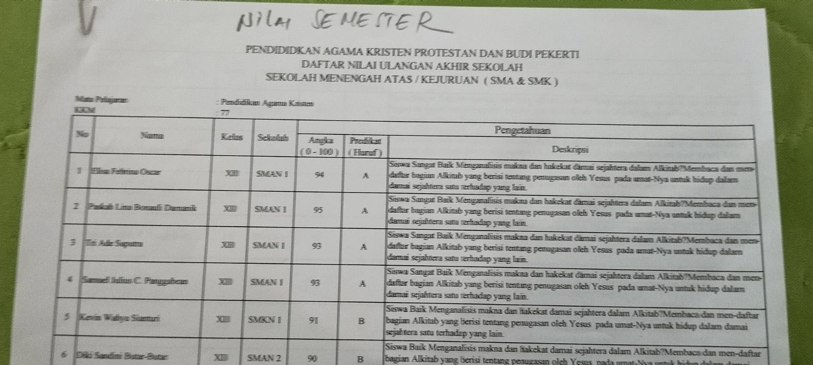

Figure 4: List of scores of non-Muslim students of Island High School

As mentioned earlier, Acut High School lacks a suitable religious teacher. Therefore, the school adopts an alternative approach to assess religious learning by involving religious leaders from various faiths, including Buddhists, Protestants, and Catholics. This step aims to foster an inclusive learning atmosphere and promote respect for religious diversity among students. Upon further examination, some efforts have been made to scrutinize the process of religious learning. These efforts include: First, to ensure the suitability of the material with the teachings of each religion, Acut High School involves Buddhist, Protestant, and Catholic religious leaders in compiling questions and answer keys.
Second, the exam questions and answer keys are prepared by their respective religious leaders. This decision is taken to ensure that the material tested is by the students' religious beliefs so that the exam truly reflects the understanding and application of religious teachings received during learning.
The exam process is carried out in a school environment, creating a conducive and comfortable atmosphere for students. This step also aims to reduce students' potential stress, so that they can show their true abilities without excessive emotional burden. Once the assessment is completed, students' questions and answers are returned to the religious leaders involved. This action is not only a form of transparency but also provides an opportunity for religious leaders to provide constructive feedback to students regarding their understanding of religious teachings. The above conclusion is indicated by the following narration of religious teachers from Acut High School:
"Because we don't have a qualified religious teacher, just like the learning process, we also involve religious leaders as partners to make exam questions. Questions will usually be sent or delivered to the school by the banter and pastor directly to the school. But usually, before the exam period takes place, we write first to each religious leader involved. The letter contained a notice that the exam was about to be held. The exam process is still being done at school, while the questions given are questions sent by the priest or banter."
Through this distinctive approach, Acut High School not only creates an inclusive learning atmosphere but also ensures that religious learning assessments truly reflect the values of diversity and respect for each religious belief. This collaborative approach between religious leaders can inspire other schools to adopt assessment methods that value and respond to religious diversity in the community. Therefore, the findings of this study indirectly deny that the limited number of religious teachers in schools can be an obstacle to the equitable implementation of religious education. The right curriculum is the key to the success of the implementation of religious education in schools (Hatim, 2018). The involvement of religious leaders in the preparation of the curriculum is a part that needs to be considered (Itulua-Abumere, 2013). The establishment of stronger partnerships between schools and religious communities can help strengthen the support and integration of religious values in the curriculum (Davies, 2019).

- CONCLUSION

The study highlighted initiatives in predominantly Muslim schools to support non-Muslim students in the teaching and evaluation processes of religious education. However, it is important to note that these findings pertain specifically to the implementation of religious education for non-Muslim students in four districts within Aceh, among a total of 23 districts in the region. Therefore, these findings should not be generalized to all schools across the entire districts of Aceh. Despite facing challenges due to the absence of qualified religious teachers, the implementation of religious education for non-Muslim students has been effectively managed. The involvement of religious leaders is a crucial part that has been done by the school in anticipating the absence of appropriate religious teachers. By involving religious leaders as substitutes for religious teachers in schools, the learning process is carried out in houses of worship in conjunction with weekly worship. Meanwhile, at the stage of evaluating religious learning for non-Muslim students, the school also involves religious leaders as partners in formulating questions and answer keys to be carried out. Some schools provide some outlines of the material to be assessed. The outline is in the form of basic competencies and learning achievement indicators. At this stage, intensive communication is the key to harmony between the school and religious leaders to fulfill students' rights to get appropriate religious education.

This finding indirectly reflects the reality that occurs in the field. Although it is seen from the fulfillment of religious rights that have been fulfilled, the implementation of religious education has not implemented or followed the proper rules. So the impact is the uneven implementation of religious education in every school. Unclear learning implementation standards, unstructured assessment benchmarks are part of the problems in schools. Therefore, it is hoped that the findings of this study can later be the basis for conducting further research related to how the ideal step for schools to organize religious education for minority students starts from the learning planning process, learning implementation to the learning evaluation process, all of which involve religious leaders as partners in the implementation process. The basic need in fulfilling religious education for minority students can be in the form of guidebooks that can be used by religious teachers in schools and religious leaders as guidelines in the learning process.

REFERENCES
A, I. (2023). Interview with IA, Religious Teacher at Gumer High School [Personal communication].
Andriani, R. D. (2021). Pola manajemen kepala sekolah dalam meningkatkan kinerja guru. Pionir: Jurnal Pendidikan, 10(3).
Cohen, L., Manion, L., Morrison, K., & Morrison, K. R. B. (2007). Research Methods in Education (6th ed.). Routledge.
Creswell, J. W., & Creswell, J. D. (2017). Research design: Qualitative, quantitative, and mixed methods approaches. Sage publications.
D, A. (2023). Interview with AD, Vice Principal of Curriculum at Abar High School [Personal communication].
Dupper, D. R., Forrest-Bank, S., & Lowry-Carusillo, A. (2015). Experiences of Religious Minorities in Public School Settings: Findings from Focus Groups Involving Muslim, Jewish, Catholic, and Unitarian Universalist Youths. Children & Schools, 37(1), 37–45. https://doi.org/10.1093/cs/cdu029
Fancourt, N., & Ipgrave, J. (2019). Schools and their local religious contexts: Building a framework of negotiations through qualitative meta-synthesis. Research Papers in Education, 35(3), 287–309. https://doi.org/10.1080/02671522.2019.1568530
Febriana, R. (2021). Evaluasi Pembelajaran. Bumi Aksara.
Flowerday, T., & Schraw, G. (2000). Teacher beliefs about instructional choice: A phenomenological study. Journal of Educational Psychology, 92(4), 634.
Hanafy, M. S. (2015). Pendidikan Multikultural dan Dinamika Ruang Kebangsaan. Jurnal Diskursus Islam, 3(1).
Harmi, H. (2022). Analisis kesiapan program moderasi beragama di lingkungan sekolah/madrasah. JPGI (Jurnal Penelitian Guru Indonesia), 7(1), 89–95.
Hatim, M. (2018). Kurikulum Pendidikan Agama Islam di Sekolah Umum. eL-HIKMAH: Jurnal Kajian Dan Penelitian Pendidikan Islam, 12(2), Article 2. https://doi.org/10.20414/elhikmah.v12i2.265
Huda, M. I., & Fattah, A. (2021). The Problem of Islamic Religious Education Learning Against Muslim Minority Students. 646–650. https://doi.org/10.2991/assehr.k.210421.094
Interview of Islamic religious teacher. (2023). [Personal communication].
Itulua-Abumere, F. (2013). The Significance of Religious Education in Local Primary Schools (Specific Reference to Christianity). IOSR Journal of Humanities and Social Science, 6(6), 69–94. https://doi.org/10.9790/0837-0666994
Khasanah, N. (2023). Implementasi Pembelajaran Agama Islam pada Peserta Didik Muslim Di SMP Kristen 2 Bandar Jaya. Undergraduate Journal of Educational Review, 1(1), 44–58.
L, E. (2023). Interview with EL, Religious Teacher of Island High School [Personal communication].
Miles, M. B., & Huberman, A. M. (1994). Qualitative data analysis: An expanded sourcebook. sage.
Murtadlo, M., & Basri, H. (2022). Indeks Karakter Peserta Didik Jenjang Pendidikan Menengah 2019. OSF Preprints. https://osf.io/preprints/nyx6q/
Naeem, A. F., & Yousaf, E. M. (2023). Case study: The concept of’religious tolerance’in the socio-religious construction of Islamic schools in India. Idarah (Jurnal Pendidikan Dan Kependidikan), 7(2), 149–164.
Novarita, Rosmilani, Agnes, Irmania Jome’, & Eta’ Tikadang. (2023). Analisis pelaksanaan teori progresivisme John Dewey dalam pembelajaran pendidikan agama Kristen. Jurnal Pendidikan dan Keguruan, 1(6), 529–540.
Raihani, R. (2015). Minority Right to Attend Religious Education in Indonesia. Al-Jami’ah: Journal of Islamic Studies, 53(1), 1–26. https://doi.org/10.14421/ajis.2015.531.1-26
Republik Indonesia, P. (2003). Undang-Undang Republik Indonesia Nomor 20 Tahun 2003 tentang Sistem Pendidikan Nasional (p. Pasal 12 ayat (1) huruf a). Kementerian Pendidikan Nasional.
Republik Indonesia, P. (2007). Peraturan Pemerintah Republik Indonesia Nomor 55 Tahun 2007 tentang Pendidikan Agama dan Pendidikan Keagamaan (p. Pasal 3). Kementerian Sekretariat Negara.
Rissanen, I., Ubani, M., & Sakaranaho, T. (2020). Challenges of Religious Literacy in Education: Islam and the Governance of Religious Diversity in Multi-faith Schools. In T. Sakaranaho, T. Aarrevaara, & J. Konttori (Eds.), The Challenges of Religious Literacy (pp. 39–53). Springer International Publishing. https://doi.org/10.1007/978-3-030-47576-5_4
Rofik, M. N., & Misbah, M. (2021). Implementasi Program Moderasi Beragama yang Dicanangkan oleh Kementerian Agama Kabupaten Banyumas di Lingkungan Sekolah. Lectura: Jurnal Pendidikan, 12(2), 230–245.
Rohman, N. (2021). Analisis Teori Behaviorisme (Thorndike) Pada Pelajaran Matematika Dan Bahasa Indonesia Sdn Upt Xvii Mukti Jaya Aceh Singkil. Abdau: Jurnal Pendidikan Madrasah Ibtidaiyah, 4(2), 223–236.
Saihu, M. (2019). Merawat Pluralisme Merawat Indonesia (Potret Pendidikan Pluralisme Agama Di Jembrana-Bali). Deepublish.
Sani, N. L. (2018). Penanaman nilai-nilai Islam bagi siswa muslim di SMP Katolik Frateran Celaket 21 Malang [PhD Thesis, Universitas Islam Negeri Maulana Malik Ibrahim]. http://etheses.uin-malang.ac.id/11743/
Schleutker, E. (2019). Discrimination Against Religious Minorities. Journal of Church and State, 61(2), 282–307. https://doi.org/10.1093/jcs/csy031
Seilatu, F. (2014). Relevansi Pendidikan Religiositas sebagai Alternatif Pendidikan Agama Kristen di Sekolah Kristen dalam Konteks Masyarakat Plural [PhD Thesis, Program Studi Teologi FTEO-UKSW]. https://repository.uksw.edu/handle/123456789/8880
Suryani, A., & Muslim, A. B. (2024). Religious Tolerance, Intellectual Humility, and Democratic Education. In A. Suryani & A. B. Muslim (Eds.), Embracing Diversity: Preparing Future Teachers to Foster Religious Tolerance (pp. 13–34). Springer Nature. https://doi.org/10.1007/978-981-97-1616-6_2
Syafei, M., & Zam’an, P. (2024). Prinsip-prinsip Penerapan Pembelajaran Berbasis Proyek pada Perkuliahan Pendidikan Agama Islam di Perguruan Tinggi. Inovasi Pendidikan Dalam Multi Perspektif, 1. https://www.researchgate.net/profile/Waway-Qodratulloh/publication/377975170_Inovasi_Pendidikan_dalam_Multi_Perspektif/links/65c0fafd79007454976578c8/Inovasi-Pendidikan-dalam-Multi-Perspektif.pdf#page=8
T, C. (2023). Interview with CT, non-Muslim student of Island High School [Personal communication].
T, H. (2023). Interview with HT, Pastor of GKPPD Church [Personal communication].
Winditya, H. (2021). Pengembangan Iman Anak Dalam Komunitas Melalui Pendidikan Agama Yang Berkualitas. JAPAM (Jurnal Pendidikan Agama), 1(2), 94–102.
Zuhri, M. M., Rokhman, F., Nuryatin, A., & Raharjo, T. J. (n.d.). Community Development: The Role of Religious Leaders in Community Empowerment. Community Development.

