Revitalizing Madihin in the Digital Era: Responding to the Challenges of Globalization on Cultural Education

Muhammad Budi Zakia Sani ¹, Wadiyo Wadiyo² , Syakir Syakir³ , Suminto A Sayuti⁴
,
- Semarang State University; mbudizakiasani@students.unnes.ac.id mbudizakiasani@ulm.ac.id
- Semarang State University; wadiyo@mail.unnes.ac.id
- Semarang State University; kirmuharrar@mail.unnes.ac.id
- Yogyakarta State University;suminto_sayuti@uny.ac.id
ARTICLE INFO |  | ABSTRACT
Keywords:  Madihin;  Cultural Revitalization;  Digital Age;  Globalization;  Cultural Education; |  | Madihin, a traditional form of storytelling typical of the Banjar people of South Kalimantan, plays a crucial role in transmitting cultural, moral, and religious values. However, the advancement of globalization and the rapid flow of digitalization pose serious challenges to its sustainability, particularly related to the declining interest of the younger generation and the potential loss of authenticity. This study aims to analyze how Madihin can be revitalized in the digital era so that it can function as a cultural education medium that is both adaptive and relevant to the needs of the times.  The research method employed a qualitative approach, combining literature studies, observations, and in-depth interviews with teachers, artists, and the Madihin community. The results show that Madihin has successfully transformed itself through digital media such as YouTube, TikTok, and Instagram. This adaptation has opened wider access for the younger generation, strengthened Madihin's role as a means of character education, and integrated local wisdom into digital literacy practices. Other findings demonstrate that while digitalization brings new opportunities, challenges such as cultural commodification and the risk of diminishing spiritual values ​​still need to be addressed.  This research confirms that the revitalization of Madihin through the digital realm not only preserves the existence of local culture but also strengthens the identity of the Banjar community amidst globalization. The practical implication of this research is the importance of collaboration between educational institutions, arts communities, and local governments to make Madihin a medium for local culture-based learning, a means of promoting cultural tourism, and a tool for character development for the younger generation.
Article history:
Received
Revised
Accepted
Article history:  Received  Revised  Accepted |  | This is an open access article under the CC BY-NC-SA license.
Corresponding Author:
Muhammad Budi Zakia Sani
Semarang State University; mbudizakiasani@students.unnes.ac.id
- INTRODUCTION
Globalization and the penetration of digital technology have transformed the face of social, economic, and cultural interactions in many local communities. In the realm of education, this process has driven a global exchange of values, curriculum standards, and learning media, posing challenges to the preservation of local cultural heritage without adaptive strategies that combine tradition with modern technology (McGinn, 1997).
Madihin, a traditional Banjar oral art form that combines poetry, humor, and moral messages, is a form of local wisdom that embodies social values, ethics, and the collective identity of the people of South Kalimantan. Recent ethnographic studies and textual analysis confirm that Madihin texts embody shared values, social norms, and serve as instruments for local community da'wah (Islamic outreach). This makes Madihin relevant as cultural education material with the potential to enrich the local curriculum (Rico, Riduan, & Prasetyo, 2024) and (Sani, Muhammad Budi Zakia, Wadiyo, Sayuti, & Syakir, 2023).
However, several field studies have shown a shift in the content orientation and presentation practices of Madihin, both due to changes in its social function and the influence of popular tastes—which has the potential to weaken Madihin's position within formal and informal learning structures. This shift requires academic attention, as without appropriate intervention, the transmission of values ​​through Madihin risks being interrupted in the younger generation (Jannah, 2022) (Sani, M.B. Zakia, 2022).
Another aspect of the digital era is the emergence of new opportunities: digital platforms (video sharing, social media, and learning apps) create space for documenting, disseminating, and even revitalizing traditional arts practices. Studies on the digitization of cultural heritage emphasize that technology can be a catalyst for expanding the reach of local cultures, increasing youth engagement, and creating interactive learning materials sourced from within the community itself. However, the digitization process must be carried out contextually and ethically to avoid commodification that undermines cultural meaning (Ajani et al., 2024).
From a cultural education perspective, integrating Madihin into teaching practices requires an instructional model that incorporates local values, communication skills, and digital literacy. A culture-based learning approach that utilizes digital media, such as Madihin audiovisual content complemented by pedagogical guidance, can strengthen students' identities while simultaneously developing 21st-century competencies. Contemporary research shows that such strategies are effective in increasing students' interest and participation in cultural preservation (Acke, Corradi, & Verlinden, 2024) and (Sani & Budi, 2021).
However, adapting Madihin to the digital realm is not without risks: critical examination of the authenticity, cultural ownership, and pedagogical quality of digital content is necessary. Several studies suggest a framework that combines community-led digitization, documentation standards, and collaboration between educational institutions to ensure that materials incorporated into curricula or digital platforms represent authentic Madihin values ​​and provide tangible educational benefits (Buragohain, 2024) (Putra & Hidayat, 2023).
Given this knowledge gap, this study focuses on how the Madihin revitalization process can be engineered within the context of cultural education in the digital era, identifying effective digital practices, implementation barriers, and pedagogical implications. The proposed approach will combine field studies of Madihin practitioners, analysis of circulating Madihin digital content, and evaluation of potential integration into local/school/madrasah curricula. This step is expected to generate practical recommendations for educators and cultural policymakers (Harpriyanti et al., 2022) (McQuaid & Pirmasari, 2023).
Thus, this study aims to: (1) describe the development and forms of Madihin revitalization on digital platforms; (2) analyze the role of Madihin in strengthening cultural education and local identity among the younger generation; and (3) formulate an integrative pedagogical model that combines Madihin and digital media for cultural teaching. The findings are expected to contribute to the literature on cultural education and provide implementation guidance for schools, communities, and cultural policy makers who wish to address the challenges of globalization through technology-based revitalization.
- METHODS
This research adopts a descriptive qualitative approach using digital ethnography methods to explore the practices and changes of Madihin art in the digital era. Digital ethnography allows researchers to examine representations of traditional culture in digital spaces, including interactions between artists and audiences through online platforms. This approach is essential for understanding how Madihin adapts and survives amidst globalization and cultural digitalization (Sari, 2022), (Putra & Hidayat, 2023), and (Raharjo, Soesanto, Rohidi, & Utomo, 2021).
This research was conducted in South Kalimantan, particularly in Banjarmasin City and its surrounding areas, which is the center of Madihin art development. Participants included Madihin puppeteers, arts communities, educators, and students participating in Madihin activities. Participants were selected purposively to gain in-depth insights into Madihin preservation and change in the digital era (Fitriani, 2023). Data were collected through participant observation, in-depth interviews, and digital content analysis. Observations were conducted of Madihin performances both live and through digital platforms. In-depth interviews were conducted with artists, educators, and audiences to understand their perceptions and experiences of Madihin.
Digital content analysis included an evaluation of Madihin's videos, audio, and promotional materials uploaded to social media and websites (Taufik & Rahmawati, 2021). The data were analyzed using thematic analysis to identify themes and patterns in Madihin's artistic practices. Furthermore, multimodal analysis was applied to understand the interactions between visual, audio, and narrative elements in Madihin's digital content. The analysis was conducted iteratively, comparing field and digital data to gain a comprehensive understanding of Madihin's revitalization in the digital era. The validity of the research was maintained through triangulation of sources and methods, comparing data from observations, interviews, and digital documents. This research adhered to ethical principles by seeking participant consent, maintaining anonymity, and ensuring that the analysis of Madihin content obtained approval from cultural rights holders. This approach aligns with ethical principles for cultural and digital research.
- FINDINGS AND DISCUSSION
3.1 Revitalization of Madihin in the Field of Education.
The revitalization of Madihin in education not only presents art as part of extracurricular activities, but also as a pedagogical method that emphasizes the closeness of cultural contexts to students. Teachers in schools and Islamic schools utilize Madihin as a medium to introduce moral, social, and religious values ​​in a fun and easy-to-understand manner. This aligns with a local wisdom-based educational approach that emphasizes the integration of academic knowledge and students' cultural experiences. By using Madihin, educators not only teach subject matter but also strengthen children's sense of identity and connection to their environment (Nurfajrin, 2023).
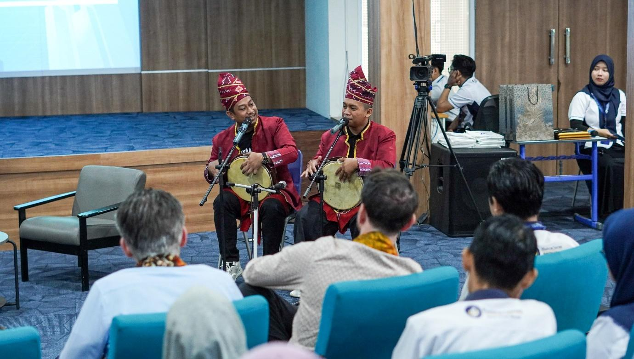
Figure 1.Two madihin players are performing in front of a foreign audience from outside Indonesia.
The integration of Madihin into the education curriculum demonstrates innovation in teaching methods that have tended to be text- and textbook-oriented. In practice, Madihin presents musical nuances, improvisation, and humor, allowing students to learn in a more participatory atmosphere (Atqa, Simatupang, & Koapaha, 2019). This encourages the creation of an active learning process that directly involves students in interpreting cultural values ​​and strengthening character. This model supports national education policies that encourage the internalization of Pancasila values, strengthening literacy, and developing Pancasila student profiles through creative and locally based methods.
From a psychopedagogical perspective, the use of Madihin as an educational medium has a positive impact on increasing learning motivation. Children who were initially passive in participating in learning tend to become more enthusiastic when the material is delivered through Madihin (Nurjatisari, Sukmayadi, & Nugraheni, 2023). The humorous elements and rhythm of the poetry provide a relaxing effect while improving students' memory. This aligns with the theory of embodied cognition, which states that learning experiences involving emotional and sensory aspects are more easily accepted by the brain than learning experiences that are solely cognitive. Thus, Madihin is a learning medium that combines cognitive, affective, and psychomotor aspects.
Furthermore, the revitalization of Madihin in education also has strategic value in building cultural awareness among the younger generation (Syawal, 2022). Students understand Madihin not only as an artistic product but also as a reflection of Banjar history, values, and identity. Thus, students are encouraged to appreciate and preserve their ancestral traditions amidst the homogenizing currents of globalization. This aligns with the perspective of multicultural education, which emphasizes the importance of introducing local identities as a basis for strengthening pluralism. Madihin-based education ultimately contributes to the formation of individuals who are proud of their own culture while also appreciating the diversity of other cultures.
However, it should be noted that the implementation of Madihin in education also faces several challenges, such as the limited number of educators competent in reciting Madihin, as well as the limited availability of supporting teaching materials. Therefore, the revitalization of Madihin in schools and madrasahs requires clear policy support from both local and central governments. Providing teacher training, developing Madihin-based learning modules, and integrating it into the national curriculum are strategic steps that need to be taken. If these can be implemented, Madihin will not be merely a supplement but can truly play a significant role as a medium for culture-based character education.
3.2 Adaptation of Madihin in Digital Platforms
The transformation of Madihin into the digital space marks a major shift in the cultural consumption patterns of the Banjar people. Previously, Madihin could only be enjoyed at traditional events, weddings, or celebrations, but now Madihin is available digitally through YouTube, Instagram, and TikTok. The presence of digital media has opened up new opportunities for Madihin artists to expand their audience reach, both geographically and demographically. This phenomenon demonstrates that digitalization is not merely a distribution medium but also a space for negotiating meaning, where Madihin intersects with global cultural dynamics. In this context, Madihin functions not only as a local heritage but also as a cultural product that can adapt to developments in communication technology (Ardyanto & Rachman, 2022).
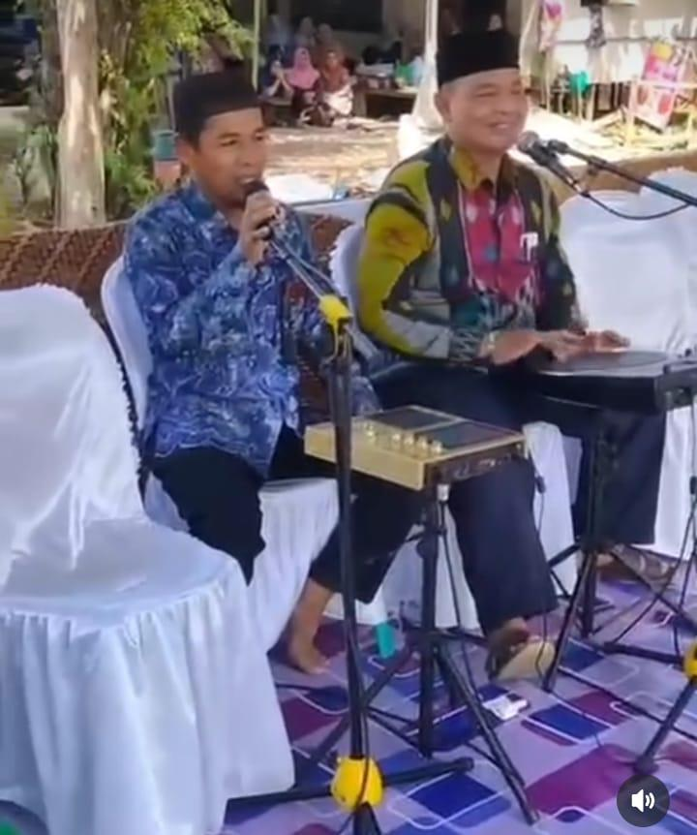
Figure 2.Two madihin players use Launch Pad and electric drums for madihin performances by adapting digital technology in music.
The adaptation of Madihin on digital platforms presents a significant opportunity for cultural preservation. Through short video content on TikTok or long videos on YouTube, Madihin becomes more accessible to the younger generation, who largely live in a digital ecosystem. Digital media allows this traditional art to be documented and replayed at any time, thus minimizing the risk of extinction due to the decline in conventional performances. Furthermore, digital platforms provide a space for two-way interaction through comments, likes, and content sharing, which strengthens public participation in the preservation process. This demonstrates cultural democratization, where access to culture is no longer limited to physical spaces but is widely open to the global public (Acke et al., 2024) (Liebman & Stone, 2020).
Beyond serving as a medium for preservation, Madihin digitalization also serves as a medium for creative innovation. Many young Madihin artists combine traditional elements with modern music, visual effects, and even cross-art collaborations to capture the attention of digital audiences. This demonstrates that digitalization fosters the creation of hybrid forms, where tradition is viewed not as static, but as a dynamic entity that is constantly transforming. This process aligns with the concept of glocalization, namely the ability of local culture to maintain its identity while adapting to global influences. Thus, digitalization does not merely shift tradition, but rather paves the way for its revitalization in a format more contextual to the needs of today's generation.
However, adapting Madihin to digital media also presents certain dilemmas. One major challenge is the difference between live performance and digital, which tends to be fragmented and ephemeral. Madihin is traditionally known for its lengthy improvisations that require concentration, while digital media favors fast, instant content. As a result, there is a risk that Madihin's essence, a long, meaningful narrative, will be diminished in favor of conforming to the algorithmic logic of digital platforms. Another challenge is the new aesthetic standards established by digital media, such as demands for compelling visuals and technical editing, which may shift the focus from cultural value to purely entertainment.
Nevertheless, Madihin's adaptation to digital platforms remains strategic in maintaining the art's sustainability amidst globalization. With its presence on social media, Madihin transcends geographical boundaries and introduces Banjar culture to national and even international audiences. This makes Madihin not only a local art form but also part of Indonesia's cultural diplomacy. If managed effectively through appropriate digital cultural policies, Madihin can serve as a successful example of how traditional arts can survive and thrive amidst rapid technological change. This adaptation emphasizes that tradition is not a rigid entity, but rather a living cultural organism that can transform according to the needs of the times.
3.3 Acceptance of the Young Generation
The younger generation, especially Generation Z, who were born and raised in the digital era, have different cultural appreciation patterns than previous generations. They are accustomed to short content, engaging visuals, and interactive communication. In this context, Madihin in digital format actually holds significant significance because its elements of improvisation, humor, and rhythm align with the characteristics of younger generations' entertainment consumption. This positive response indicates that Generation Z is not completely ignorant of local culture, but rather willing to accept and appreciate traditional arts when packaged according to their familiar communication style. This refutes the assumption that digitalization only distances the younger generation from their cultural roots (Fauzan, 2022) (Supiarza & Sarbeni, 2021).
The younger generation's acceptance of Madihin in the digital space also demonstrates the highly adaptable nature of tradition when combined with technology. Packaged with relevant narratives, a relaxed style of language, and engaging visuals, Madihin can serve as an effective communication medium for the younger generation. This demonstrates that tradition isn't always mired in conservatism, but can transform into a tool that brings the younger generation closer to ancestral cultural values. In fact, in some cases, school and university students have begun using Madihin as a creative presentation medium in academic activities, demonstrating the process of cultural internalization through new forms of youth participation.
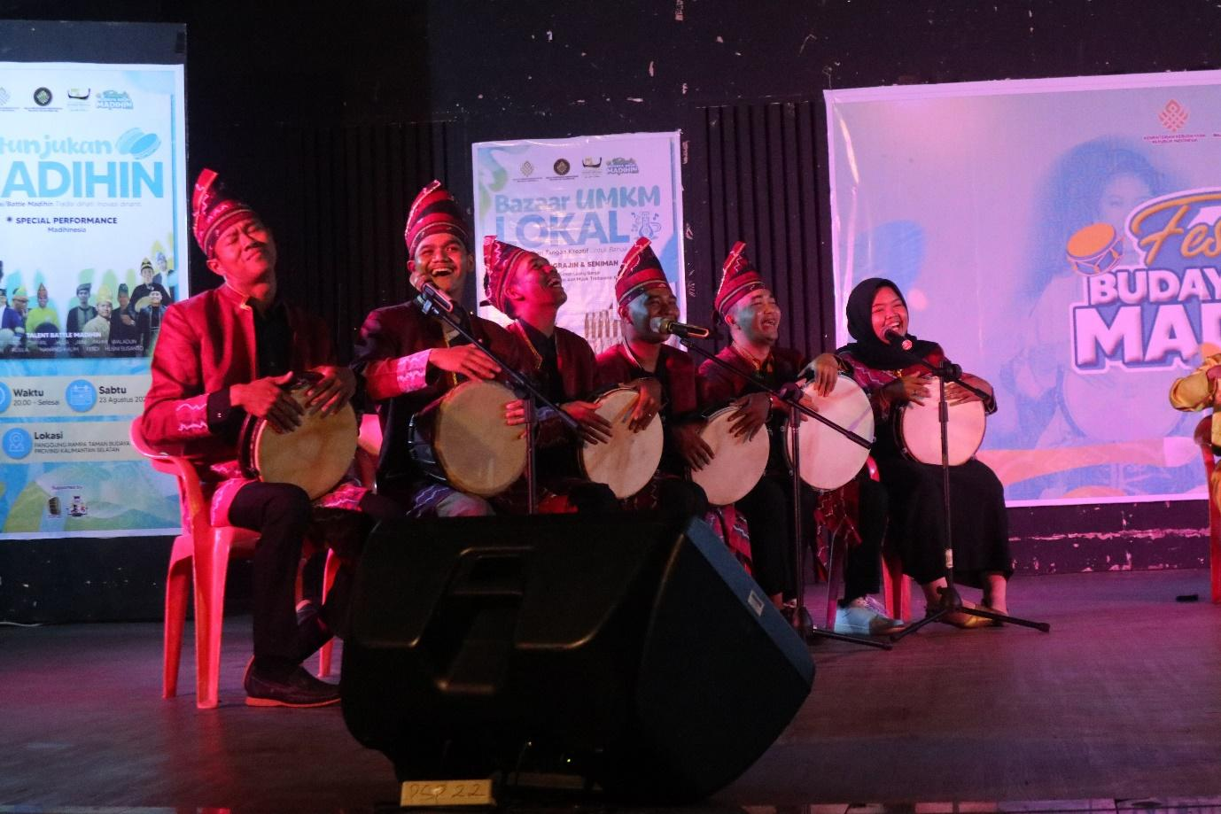
Figure 3.A group of young madihin players are competing with each other in the Madihin Battle at the 2025 Aruh Madihin Cultural Festival Event at the Balirungsari Building, South Kalimantan Provincial Cultural Park.
Furthermore, the younger generation's positive reception of Madihin in the digital realm can also be interpreted as an identity strategy. Amidst the strong penetration of global culture, Generation Z seeks a space for expression that reflects local uniqueness while remaining relevant to the digital world. Madihin in digital format addresses this need, as it combines local Banjarese identity with a global communication medium. This phenomenon demonstrates that the younger generation is not merely a consumer of global culture, but also an agent who actively selects, cultivates, and shapes their own representation of identity through traditional arts. Thus, the digitalization of Madihin not only preserves tradition but also strengthens the cultural identity of the younger generation amidst the currents of globalization.
However, acceptance by the younger generation is also influenced by creativity in Madihin presentation. Madihin content that is packaged monotonously and doesn't take into account young people's digital preferences tends to be less popular. Therefore, Madihin artists who are able to innovate—for example, combining traditional poetry with contemporary music, animated illustrations, or meme culture—tend to be more successful in attracting a younger audience. This shows that the younger generation appreciates traditional values ​​but also demands presentations that are fresh, dynamic, and in line with their aesthetic patterns. In other words, the success of Madihin digitalization in winning the hearts of the younger generation lies in the ability to adapt while maintaining cultural substance.
Ultimately, the acceptance of Madihin by the younger generation is a crucial indicator of the future sustainability of this traditional art form. Without their involvement, Madihin revitalization will lose its regenerative power. Therefore, support from education, the community, and the government in providing spaces for expression and facilitating the creativity of the younger generation is crucial. Madihin that is internalized and appreciated by the younger generation will not only survive as an art form but will also develop into an instrument of education, cultural identity, and creative expression suited to the needs of the times. Therefore, acceptance by the younger generation is a key factor in the success of Madihin revitalization in the digital age.
3.4 Challenges of Authenticity and Commodification
The digitalization of Madihin brings significant opportunities for cultural preservation, but also presents challenges related to authenticity (Komala, 2021). As an oral tradition, Madihin is characterized by improvisation, a strong use of Banjarese language, and local narratives that reflect community values. However, when produced digitally, many of these elements are simplified to accommodate the platform's needs. Content that must be concise to fit TikTok or Instagram algorithms often prevents the philosophical meaning and moral values ​​inherent in Madihin from being fully conveyed. This challenge raises a fundamental question: can Madihin produced digitally still be considered an authentic representation, or is it simply a form of entertainment inspired by the original tradition.
Beyond authenticity, the issue of commodification has also emerged as a result of digitalization. Many Madihin artists have begun producing content for economic gain, such as YouTube monetization or product promotion collaborations. While this is professionally legitimate, there are concerns that the economic orientation could diminish the cultural values ​​at the core of Madihin. Poetry, which originally served to educate and convey local wisdom, could become merely a medium for advertising or commercial content. This situation illustrates the friction between Madihin's socio-cultural function and the logic of digital capitalism, where cultural values ​​are potentially replaced by market values ​​(Purnomo & Aulia, 2021).
However, commodification doesn't always have to be viewed negatively. From another perspective, commodification can actually be a survival strategy to keep Madihin relevant in the digital age. By leveraging the economic opportunities offered by digital platforms, Madihin artists can earn income that supports the sustainability of their artistic practices. This also provides an incentive for the younger generation to become involved in preserving Madihin. The challenge lies in balancing economic interests with preserving authentic values. If this balance can be maintained, commodification can be understood as an adaptive strategy that helps traditions survive amidst global cultural competition.
The discourse on authenticity and commodification is also closely related to the dynamics of cultural power. In the digital space, who controls the Madihin narrative will largely determine how this tradition is represented. If Madihin production is primarily carried out by parties outside the Banjar community or simply follows algorithmic logic, there is a risk of distortion of meaning and marginalization of authentic local voices. On the other hand, if the Banjar community retains a central role in managing and producing Madihin content, digitalization can strengthen local cultural autonomy. This means that authenticity lies not only in the art form itself, but also in who has the right to define and manage its representation (Pramana & Irfansyah, 2019).
Therefore, the challenges of authenticity and commodification in the digitalization of Madihin must be viewed as part of the dialectic of tradition and modernity. Madihin appearing in the digital space does not mean losing its identity, but rather negotiating with the demands of the times. A crucial task going forward is to create a preservation model that can maintain Madihin's cultural value while still opening up space for innovation and economic sustainability. This effort requires a collaborative effort between artists, academics, communities, and the government, so that digitalization does not sacrifice authenticity but instead becomes a means to expand the meaning and function of Madihin in the global era. Thus, this challenge is not merely a threat, but also an opportunity to strengthen Madihin's position as an adaptive and sustainable traditional art.
3.5 Strengthening Local Cultural Identity
The revitalization of Madihin through digital media serves not only as a preservation strategy but also as a means of strengthening the local cultural identity of the Banjar people. In each Madihin performance, the use of the Banjar language, narratives close to the community's lives, and moral messages rooted in local wisdom present a unique representation of identity. When Madihin is present in the digital space, this identity is not only consumed by the Banjar people but also widely recognized by the national and international public. This phenomenon shows that the digitalization of traditional arts can expand the reach of cultural identity, so that local identities are not drowned in the currents of global homogenization, but instead appear more firmly in the global public space (Sutisna & Sutisna, 2024) (Rafiek, 2019) (Salam, 2019).
In the context of globalization, concerns have arisen that local cultures will be increasingly marginalized due to the dominance of global popular culture. However, Madihin in digital format proves that local culture has the capacity to be both a rival and an alternative to global culture. The Banjar identity embodied in Madihin, such as polite language, religiosity, and the Banjar people's distinctive humor, emerges as a cultural marker that distinguishes them from other communities. Thus, the digitalization of Madihin serves as a "glocalization" strategy, namely an effort to adapt local culture to a global format without losing its local roots. This not only maintains but also strengthens local cultural identity through negotiation with modern technology.
Strengthening local cultural identity through Madihin can also be seen from an educational perspective. In schools and Islamic schools, Madihin is used as a learning medium that introduces students to the Banjar language and cultural values. This process not only preserves tradition but also strengthens a sense of belonging and pride in local identity among the younger generation. Thus, Madihin serves a dual role: as a medium of entertainment and as a vehicle for cultural identity formation. When Madihin is combined with digital media, this educational process becomes more relevant and accessible to the digital native generation, enabling more effective cultural identity strengthening.
Furthermore, Madihin in the digital realm also creates new spaces for Banjar people to negotiate their identities amidst increasingly complex social dynamics. Madihin's presence on global platforms such asYouTube or TikTokThis allows Banjarese identity to emerge in cross-cultural conversations, both with other local communities in Indonesia and with international audiences. This identity is not only preserved but also projected as part of the world's cultural heritage. In other words, digitalization allows Madihin to transform from a local art form into a representation of cultural diplomacy that strengthens the Banjarese community's position in the global arena (Wang, 2022) (Giovannini, 2021).
However, strengthening local cultural identity through Madihin cannot be separated from the collective role of the community, artists, and cultural institutions. Identity is not static, but rather a social construct that is constantly being negotiated. Therefore, it is crucial to ensure that the digitalization of Madihin not only presents an entertainment aspect but also reinforces the local values ​​that underlie Banjarese identity. If managed well, Madihin can become a symbol of resistance to global cultural domination and a means of strengthening social cohesion at the local level. Therefore, the digitalization of Madihin is not only a strategy for preserving traditional arts, but also a conscious effort to strengthen local cultural identity as a valuable asset in building a deeply rooted, empowered, and competitive society.
3.6 Madihin as a Digital Literacy Media
Madihin's transformation into the digital realm opens up new possibilities for this traditional art form to function as a medium for digital literacy. Digital literacy is not just about technical skills in using devices or platforms, but also about the ability to understand, critique, and utilize digital information wisely. In this context, Madihin, present on platforms like YouTube, Instagram, and TikTok, provides a concrete example of how local wisdom can be repackaged to convey digital literacy messages. Madihin's improvisational and critical poetry is often used to comment on contemporary issues, including social media use, digital ethics, and the dangers of disinformation. This makes Madihin relevant as a contextual digital literacy learning tool close to the daily lives of the Banjar people.
Madihin, as a digital literacy medium, also possesses strengths due to its entertaining and educational nature (edutainment). In modern education, methods that combine entertainment with learning have proven more effective in capturing the attention of students, especially Generation Z and Alpha, who are accustomed to visual and interactive content. With its improvisational style, humor, and distinctive rhythm, Madihin is able to convey serious messages about healthy internet use without feeling patronizing. This positions Madihin as a creative digital literacy instrument, which not only teaches digital skills but also instills ethical values ​​and local wisdom in the virtual space.
Furthermore, digital Madihin can also be used to train people's critical thinking skills regarding the flow of information. In their performances, pamadihinan often utilize satire or sarcasm to reveal social phenomena occurring in society. When this is transferred to the digital space, Madihin can become a reflective medium that encourages people to consider information they find online more openly. Thus, Madihin functions as a "cultural filter" that helps people navigate the flood of digital information while keeping critical thinking rooted in local values.
In addition to fostering critical thinking, Madihin also supports the development of digital creativity. Younger generations who are drawn to Madihin in digital format are often inspired to create similar content utilizing digital technology. This process trains their skills in content production, platform mastery, and effective digital communication. Thus, Madihin is seen not only as a cultural heritage but also as a participatory space that fosters creative digital literacy. This phenomenon demonstrates that traditional arts can bridge cultural heritage with 21st-century skills.
Ultimately, Madihin, as a digital literacy medium, proves that local wisdom can be integrated with modern educational needs. Rather than being considered outdated, Madihin emerges as an innovative instrument that helps people understand and master the digital world. The values ​​embodied in Madihin—such as honesty, togetherness, and wisdom—can serve as guidelines for the ethical use of technology. Thus, Madihin not only plays a role in preserving Banjar cultural identity but also serves as a strategic medium for creating a digital society with character, intelligence, and roots in local traditions.
3.7 Community and Government Collaboration
The revitalization of Madihin in the digital era is inseparable from the collaboration between the arts community, educational institutions, and local governments (Agustinus Gulo, 2023). This collaboration is a crucial factor in determining the success of cultural preservation efforts, especially when facing the challenges of globalization and technological development. The artist community plays a key role in maintaining the authenticity and developing new forms of Madihin, while the government provides policy support, infrastructure, and funding. Meanwhile, educational institutions serve as spaces for actualization to transmit Madihin values ​​to the younger generation. The synergy between these three elements forms a sustainable cultural ecosystem, where Madihin not only survives but also thrives relevantly in the digital space.
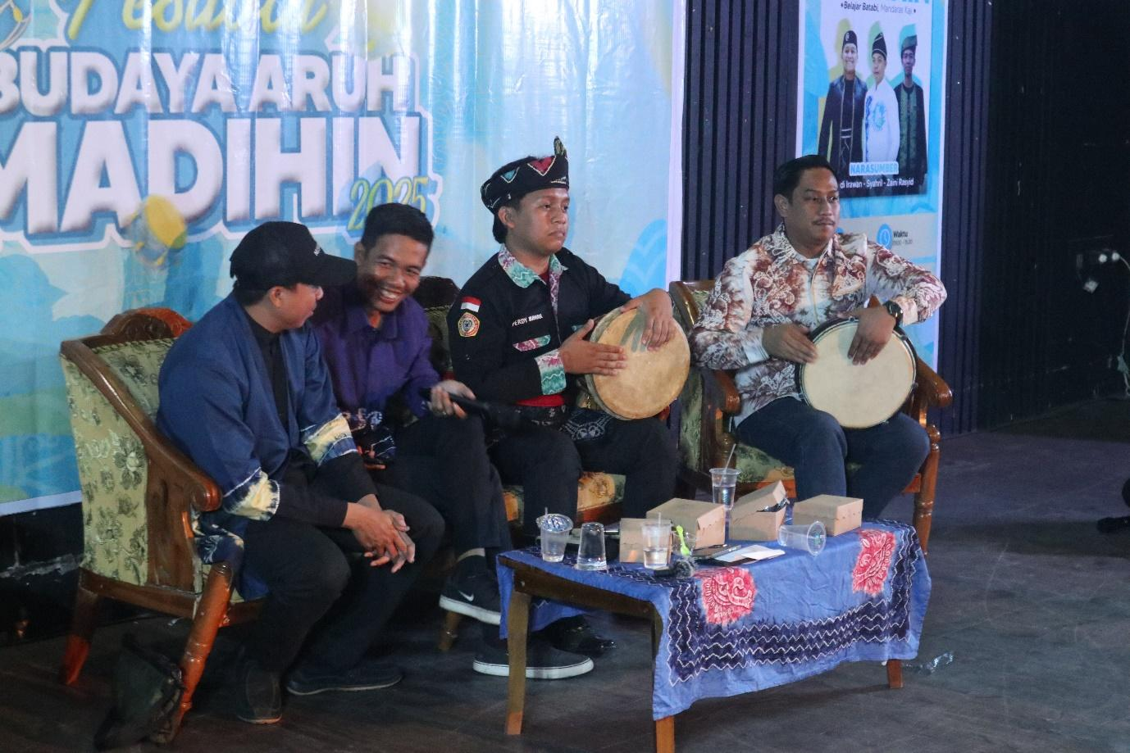
Figure 4.Madihin players are giving workshops to the younger generation as a form of preserving Madihin performing arts.
The South Kalimantan regional government, for example, has initiated numerous cultural programs focused on preserving traditional arts, including Madihin, through technology-based approaches (Hartati, 2021). Online festivals, Madihin competitions on social media, and digital training for local artists are strategies that align the government's interest in preserving cultural identity with the community's aspirations to expand its audience. This kind of support not only provides space for Madihin to develop but also strengthens the artist community's position in the digital ecosystem. Furthermore, the presence of public policies that support cultural preservation demonstrates the government's understanding of the importance of local cultural heritage as part of inclusive social development.
Collaboration is also evident in the arts community's active role in innovation. Madihin artists often utilize simple technology to document and disseminate their work through digital platforms. Through collective initiatives, they create learning spaces for younger generations to understand and engage with Madihin art. These efforts demonstrate that cultural revitalization depends not only on top-down policies but also on grassroots community participation. In other words, Madihin preservation in the digital age is the result of a combination of complementary structural policies and cultural initiatives.
Collaboration between the government and the community is also crucial in maintaining the balance between authenticity and innovation. The government can act as a facilitator, ensuring that the digitalization process does not eliminate the original values ​​of Madihin, while the artist community is responsible for keeping the content relevant to current developments. This kind of collaboration allows Madihin to emerge as a dynamic traditional art form: maintaining its Banjar cultural roots while simultaneously speaking a digital language understood by the younger generation. This demonstrates that cultural preservation in the era of globalization is not a rigid attempt to maintain tradition, but rather a process of adaptation involving a dialogue between the past and the present.
Ultimately, the collaboration between the community and government in revitalizing Madihin demonstrates a model of cultural sustainability that other regions in Indonesia can emulate. The strength of this collaboration lies in the clear distribution of roles: the community maintains authenticity, the government provides structural support, and educational institutions ensure cultural transmission to future generations. With this model, Madihin has not only survived as a cultural heritage but also developed as a strong local identity in the digital age. Furthermore, this collaboration demonstrates that preserving traditional culture cannot be left to a single party but must be managed collectively to truly meet the challenges of modernization and globalization.
3.8 Theoretical Discussion and Practical Implications
Theoretically, the revitalization of Madihin in the digital era can be understood through the theory of glocalization, namely the process by which local culture adapts to global dynamics without losing its original identity. Madihin, as a typical Banjar oral art, has successfully entered the digital space and interacted with global audiences through platforms such as YouTube and TikTok. This adaptation demonstrates that traditional culture is not static, but rather fluid and able to adapt to the context of the times. Through the glocalization framework, Madihin is understood as a cultural practice that negotiates two poles: the preservation of local values ​​and openness to global innovation. Thus, the revitalization of Madihin is not merely a form of passive preservation, but also an active representation of the dynamics of cultural identity in the digital era.
From the perspective of cultural memory theory, the digitization of Madihin can also be seen as an effort to document and expand the reach of the Banjar community's collective memory (Saputra, 2022). Oral traditions are inherently vulnerable to loss due to their reliance on direct intergenerational transmission. However, when Madihin is packaged in digital format, it becomes a more durable archive, retrievable and discussed across generations and regions. This emphasizes that digitization is not merely a technical tool but also a strategy for strengthening collective cultural memory. In this context, Madihin emerges as a medium that not only provides entertainment but also strengthens the continuity of Banjar identity in an increasingly digitalized society.
Practically, the research findings indicate that Madihin can be used as an innovative medium in education, particularly character education and digital literacy. Teachers and educators can utilize Madihin to convey moral values, social criticism, and contextual knowledge in a more engaging and relevant way for students. This implication aligns with the needs of 21st-century education, which emphasizes creativity, collaboration, and critical thinking. Through digital Madihin, students not only learn about local culture but are also trained to understand the positive use of technology. This suggests that Madihin can be an effective culture-based learning model for improving the quality of education in Indonesia.
Beyond education, the revitalization of Madihin also has practical implications for the development of cultural tourism. Digitally packaged Madihin performances can be an effective way to promote tourism in South Kalimantan, introducing local identity to both national and international audiences. Local governments can incorporate Madihin into their cultural branding strategies, ensuring that this tradition not only lives on within local communities but is also widely recognized as a national treasure. In this way, Madihin can play a dual role: preserving cultural identity while contributing to economic development through the culture-based tourism sector.
This theoretical and practical discussion ultimately confirms that the revitalization of Madihin in the digital era is a multidimensional phenomenon involving education, culture, technology, and economics. Theoretically, Madihin demonstrates how traditional arts can adapt to globalization without losing their authenticity. Practically, Madihin demonstrates that traditional arts can be used as strategic instruments for education, tourism, and strengthening local identity. These findings provide an important contribution to the literature on cultural digitalization, while also opening up opportunities for further research to further examine how other traditional arts can follow Madihin's lead in navigating the digital era, which is full of challenges and opportunities.
- CONCLUSION
This research demonstrates that the revitalization of Madihin in the digital era is both a complex and strategic phenomenon in preserving local culture amidst globalization. Initially viewed solely as oral entertainment, Madihin has now transformed into an educational instrument, a digital literacy medium, and a means of strengthening Banjar cultural identity. The findings demonstrate that Madihin is able to meet the needs of the times by adapting through digital platforms such as YouTube, TikTok, and Instagram, thereby reaching a wider audience, including the younger generation.
This adaptation process demonstrates that digitalization does not necessarily erode traditional values, but rather opens up new opportunities to strengthen cultural memory and expand the social function of traditional arts. The positive response from the younger generation demonstrates that creativity and innovation in Madihin packaging can create new appeal without losing the essence of the moral, religious, and local wisdom contained within. This indicates that revitalizing traditional arts can be an effective strategy to address the challenges of cultural relevance in the modern era.
However, this research also highlights challenges that need to be addressed, particularly regarding authenticity and the risk of cultural commodification. Excessive commercialization of Madihin can potentially lose its spiritual and philosophical significance, necessitating a balance between digital innovation and the preservation of its authentic values. In this context, collaboration between artist communities, educational institutions, and local governments is key to Madihin's sustainability as a living and adaptive cultural heritage.
The practical implications of this research are the need for local culture-based learning strategies through digital Madihin, which can strengthen students' character education and digital literacy. Furthermore, Madihin can be used as a promotional medium for cultural tourism, supporting the development of regional creative economies. Meanwhile, theoretically, this research enriches the discourse on glocalization and cultural memory, by emphasizing that traditional arts can survive and thrive in a digital ecosystem.
This research suggests that further studies should delve deeper into Madihin's long-term sustainability strategies, particularly within the context of public policy, the creative economy, and curriculum integration. Furthermore, comparative research with other oral traditions in Indonesia is crucial to understand local cultural adaptation patterns to the challenges of digitalization. Thus, Madihin revitalization can serve as an inspiring model for preserving other traditional arts in the face of changing times.
REFERENCES
Acke, L., Corradi, D., & Verlinden, J. (2024). Comprehensive educational framework on the application of 3D technologies for the restoration of cultural heritage objects. Journal of Cultural Heritage, 66, 613–627. https://doi.org/10.1016/j.culher.2024.01.013
Agustinus Gulo. (2023). Cultural Revitalization in the Digital Era and Exploration of the Impact of Social Media on Socio-Cultural Dynamics in Society.Journal of Education and Culture (JURDIKBUD), 3(3), 172–184. https://doi.org/10.55606/jurdikbud.v3i3.2655
Ajani , Y. A. , Oladokun , B. D. , Olarongbe , S. A. , Amaechi , M. N. , Rabiu , N. , & Bashorun , M. T. (2024). Revitalizing Indigenous Knowledge Systems via Digital Media Technologies for Sustainability of Indigenous Languages. Preservation, Digital Technology and Culture, 53(1), 35–44. https://doi.org/10.1515/pdtc-2023-0051
Ardyanto, D., & Rachman, A. (2022). Virtual Keroncong Music Performances As An Effort To Maintain Their Existence During The Covid-19 Pandemic. Journal of Music Arts, 11(1), 78–85. https://doi.org/10.15294/jsm.v11i1.58066
Atqa, U. A., Simatupang, G. R. L. L., & Koapaha, R. B. (2019). Musical Experience in Howard Gardner's Theory of Multiple Intelligences.Journal of Art Studies, 5(1), 1. https://doi.org/10.22146/jksks.52258
Buragohain, D. (2024). Digitalizing cultural heritage through metaverse applications. Heritage Science Reviews. Retrieved from https://www.nature.com/articles/s40494-024-01403-1
Fauzan, A. (2022). Variations in Form and Function of Madihin.Journal of Language, Literature and Its Learning, 12(2), 290. https://doi.org/10.20527/jbsp.v12i2.11774
Giovannini, E. C. (2021). Digital practices to enhance intangible cultural heritage. International Archives of the Photogrammetry, Remote Sensing and Spatial Information Sciences - ISPRS Archives, Vol. 46, pp. 273–278. https://doi.org/10.5194/isprs-Archives-XLVI-M-1-2021-273-2021
Harpriyanti, H., Yuwana, S., Ahmadi, A., Pairin, U., Darni, D., & Suhartono, S. (2022).Ethnic Value in South Kalimantan Madihin Text: Ethnopoetical Review. https://doi.org/10.4108/eai.28-10-2020.2315319
Hartati, R. (2021). ARTS AND TECHNOLOGY AS MEDIA FOR DAKHAH COMMUNICATION (A STUDY OF THE INSTAGRAM ACCOUNT @Gazali_rumi).InẚṣDirection of the Journal of Contemporary Islamic Studies, 3(1), 17. https://doi.org/10.18592/msr.v3i1.4954
Jannah, E. N. (2022). Madihin Banjar : Study of Orientation Shift.
Komala, A. N. E. (2021). Commodification of Mak Yong Mask Performance as a Cultural Tourism Attraction on Mantang Island.JPendTar, 2(1), 103–117. https://doi.org/10.21009/jpt.218
Liebman, E., & Stone, P. (2020). Artificial Musical Intelligence: A Survey. 1–99. Retrieved from http://arxiv.org/abs/2006.10553
McGinn, N. F. (1997). The impact of globalization on national education systems. Prospects, 27(1), 41–54. https://doi.org/10.1007/bf02755354
McQuaid, K., & Pirmasari, D. A. (2023). There's Only One Word: Fight! On decolonizing and building a mutual collaborative research practice on gender and climate change.Gender and Development, 31(2–3), 575–595. https://doi.org/10.1080/13552074.2023.2252247
Nurfajrin, D. (2023). The Oral Tradition of Ngabeluk in Sundanese Society: Hegemony and Representation of Identity.Arif Journal of Literature and Local Wisdom, 3(1), 24–42. https://doi.org/10.21009/arif.031.02
Nurjatisari, T., Sukmayadi, Y., & Nugraheni, T. (2023). Strengthening the Pancasila Student Profile Through Arts Performance Packaging in the Independent Curriculum in Elementary Schools.Obsession Journal Early Childhood Education Journal, 7(4), 4013–4024. https://doi.org/10.31004/obsesi.v7i4.4836
PRAMANA, G. I., & IRFANSYAH, A. (2019). Street Art as Political Communication: Art, Protest, and Political Memory.Scientific Journal of Sociopolitical Widya, 1(2), 98. https://doi.org/10.24843/jiwsp.2019.v01.i02.p04
Purnomo, T. W., & Aulia, S. M. (2021). Analysis of the Mudiak Arau Song in the Talempong Pacik Ikua Parik Kanagarian Limbanang Performance.Bitter Music Journal, 10(1), 46. https://doi.org/10.24114/grenek.v10i1.24891
Putra, A. R., & Hidayat, F. (2023). Integration of Madihin in digital-based cultural learning.Journal of Cultural Education, 5(1), 15–30. https://doi.org/10.5678/jpb.2023.15
Rafiek, M. (2019). Madihin of John Tralala and Hendra: A Study of Presentation, Structure, Form, Value, and Function. Celt: A Journal of Culture, English Language Teaching & Literature, 19(2), 257. https://doi.org/10.24167/celt.v19i2.1844
Raharjo, E., Soesanto, Rohidi, T. R., & Utomo, U. (2021). Preserving gambang semarang music through the process of enculturation in the society.Harmonia: Journal of Arts Research and Education, 21(1), 60–67. https://doi.org/10.15294/harmonia.v21i1.27722
Rico, M., Riduan, M., & Prasetyo, R. (2024). Interpreting the History of Madihin Culture as Banjar Oral Literature and the Meaning Contained in Its Performances. Downgraded, 2(2), 73–84. https://doi.org/10.58355/dirosat.v2i2.72
Salam, A. (2019). Efforts to Preserve Madihin Arts Through Poetry Learning.UNDAS: Journal of Language and Literature Research Results, 15(1), 33. https://doi.org/10.26499/und.v15i1.1443
Sani, M.B.Zakia, S. (2022). Development of Madihin Performance Skills in the Madihinese Community of South Kalimantan Muhammad.Ilung : Journal of Superior Wetland Innovation Service, 1(3), 89–97.
Sani, Muhammad Budi Zakia, Wadiyo, W., Sayuti, S. A., & Syakir, S. (2023).The Ideology of Madihin Arts in Banjarmasin : Henry Giroux ’ s Conservative Ideological Perspective. 524–527.
Sani, Z., & Budi, M. (2021). Madihin Banjar. Lambung Mangkurat University. Retrieved from https://repo-dosen.ulm.ac.id/handle/123456789/19542
Saputra, D. N. (2022). Digitalization of Music Performances with the Theme “Melodie Del Mondo Fantastico.”Virtuoso Journal of Music Research and Creation, 4(2), 120–126. https://doi.org/10.26740/vt.v4n2.p120-126
Supiarza, H., & Sarbeni, I. (2021). Teaching and learning music in digital era: Creating keroncong music for gen z students through interpreting poetry. Harmonia: Journal of Arts Research and Education, 21(1), 123–139. https://doi.org/10.15294/harmonia.v21i1.28585
Sutisna, N., & Sutisna, N. (2024). Traditional Art In The Digital Era And Sawo Kecik Studio's Efforts In Preserving Cirebon Mask Dance With A Semiotic Approach. Multicultural, 3(4). https://doi.org/10.7454/multikultura.v3i4.1075
Syawal, S. (2022). Educational Tracks in Cultural Perspectives (Educational Studies and Toraja Ma' nene Culture). Tambusai Education Journal, 6(3), 14087–14094. https://doi.org/10.31004/jptam.v6i3.3150
Wang, S. (2022). Mining whole-lung information by artificial intelligence for predicting EGFR genotype and targeted therapy response in lung cancer: a multicohort study. The Lancet Digital Health, 4(5). https://doi.org/10.1016/S2589-7500(22)00024-3

