Bibliometric Analysis and PRISMA-Based Systematic Literature Review on AI-Assisted Adaptive Learning from the Perspective of Vocational Education

Harleni¹,M.Giatman²,Nurhasan Syah^{3,}Ganefri⁴ ,Nizwardi Jalinus⁵, Ridwan^{6,}Krismadinata^{7,}
University Perintis Padang¹, Padang State University Indonesia²³⁴⁵⁶⁷
e-mail : harleni.lhenie@gmail.com, giatman@ft.unp.ac.id,
nurhasan@ft.unp.ac.id, ganefri@unp.ac.id, nizwardi@unp.ac.id ridwanftunp@gmail.com krisma@ft.unp.ac.id

ARTICLE INFO |  | ABSTRACT
Keywords:  Artificial Intelligence;  Adaptive Learning;  Vocational Education;  Bibliometric;  PRISMA;  Educational Technology. |  | The development of Artificial Intelligence (AI) technology has driven innovation in adaptive learning tailored to the individual needs of learners. In the context of vocational education, this approach holds significant potential to enhance the effectiveness of competency-based and practical skill-oriented learning. This study aims to map the scientific literature on AI-assisted adaptive learning in vocational education through a Systematic Literature Review (SLR) based on the PRISMA protocol and bibliometric analysis using VOSviewer software. Data were collected from various databases, including Scopus, Semantic Scholar, and Google Scholar, covering publications from 2018 to 2023. A total of 41 selected articles were analyzed based on publication trends, country distribution, and dominant themes. The results reveal a significant increase in publications after 2020, a dominance of contributions from countries with strong technological infrastructure, and major topic clusters such as AI in learning, integration in vocational education, and adaptive learning systems. This study provides a comprehensive overview of research trends and highlights further exploration opportunities in the integration of AI into personalized, needs-based vocational education.
Article history:
Received 2021-08-14
Revised 2021-11-12
Accepted 2022-01-17
 |  | This is an open access article under the CC BY-NC-SA license.
Corresponding Author:
Harleni; e-mail@e-mail.com
- INTRODUCTION
The advancement of Artificial Intelligence (AI) technology has brought significant changes across various sectors, including education. One notable transformation is the implementation of adaptive learning, which leverages AI to tailor content, pacing, and instructional approaches based on the individual needs and characteristics of learners. In the context of vocational education, the application of this technology holds substantial potential to enhance the quality of learning processes that are focused on practical skills and competency-based outcomes (Ayca & Hasan, 2017).
Vocational education is required to respond to the increasingly digitalized world of work. Therefore, the integration of AI into vocational learning strategies can promote personalized learning, assessment efficiency, and real-time detection of skill gaps. Adaptive learning models supported by intelligent algorithms enable systems to recommend the most suitable learning pathways for each student. This is highly relevant in vocational education, which emphasizes the achievement of individual competencies. (Muhammad, 2020).
Although the potential of AI in education has been widely discussed, studies that specifically examine how AI is applied in adaptive learning within the context of vocational education remain limited. Furthermore, there is a lack of systematic research that maps publication trends, author contributions, dominant keywords, and research development directions on this topic. Therefore, a comprehensive bibliometric analysis and meta-analysis are needed to identify the extent to which the scientific literature has explored this area (Kusumawati, 2018).
This article aims to systematically analyze the scientific literature on AI-assisted adaptive learning in vocational education using the PRISMA approach and bibliometric analysis. This analysis is expected to provide insights into research trends, contributions from scholars and institutions, as well as the main topics that have dominated the discourse over the past five years (Maskar et al., 2020).
- METHODS
This study employs a Systematic Literature Review (SLR) approach based on the Preferred Reporting Items for Systematic Reviews and Meta-Analyses (PRISMA) protocol to identify, select, and analyze scientific publications related to AI-assisted adaptive learning in vocational education. In addition, bibliometric analysis is applied to map research trends, author collaborations, country distributions, and key keywords using VOSviewer software.
- Search Strategy and Data Sources
The literature search was conducted through several academic databases, including Google Scholar, Scopus, and Semantic Scholar. The keywords used in the search included: "artificial intelligence" AND "adaptive learning" AND "vocational education", along with variations such as "AI in vocational training", "personalized learning with AI", and "intelligent tutoring systems AND TVET" (Firzatullah, 2021).

Search limitations and specification details are shown in table 1.

Table 1. SLR Publication Specifications
Tahun | 2018-2022
Kemungkinan Target | 40-50
Akreditasi Jurnal | Nasional Terakreditasi atau Internasional Bereputasi
Target Keyword | artificial intelligence, adaptive learning, vocational education.

- PRISMA Procedure
The article selection in this study follows the PRISMA (Preferred Reporting Items for Systematic Reviews and Meta-Analyses) protocol, which consists of four main stages. The first stage is identification, involving the collection of articles from various databases such as Google Scholar, Scopus, and Semantic Scholar using relevant keyword combinations. In this stage, all articles related to adaptive learning, artificial intelligence, and vocational education were downloaded in bibliographic formats (.ris and .csv) for further analysis. The second stage is screening, which was carried out by removing duplicates and evaluating titles and abstracts to ensure initial relevance to the research focus (Widjanarko et al., 2021). Articles that were thematically or methodologically irrelevant were eliminated from the list. In the next stage, eligibility, a full-text review was conducted to confirm the alignment of each article's content with the context of AI-based adaptive learning in vocational education. The final stage is inclusion, in which a set of articles meeting all criteria were selected for bibliometric and meta-analysis. These included articles serve as the primary sources for extracting information on research trends, keyword distributions, author collaborations, and the effectiveness of AI implementation in adaptive learning within vocational education. The detailed PRISMA process is illustrated in Figure 1 (Callejas et al., 2023).
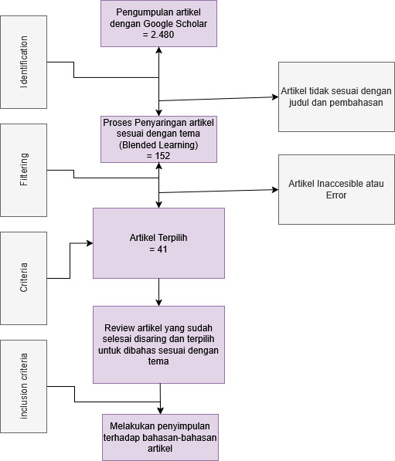
Figure 1. Flowmap PRISMA
- Bibliometric Analysis
Bibliometric analysis in this study was conducted to evaluate the characteristics and trends of scientific publications discussing AI-assisted adaptive learning in the context of vocational education. All articles that passed the inclusion stage were processed using VOSviewer software. Bibliographic data from .ris and .csv files were imported into VOSviewer to generate visualizations of relationships among elements within the literature. Additionally, publication trends by year were analyzed to observe the dynamics of research development over time. The resulting visualizations included network maps and thematic clusters that help reveal the direction of scientific advancement in AI-based adaptive learning, particularly within vocational education. (Omar et al., 2019).
- FINDINGS AND DISCUSSION
The analysis of references collected since 2018 reveals a gradual increasing publication trend on the topic of artificial intelligence in adaptive learning within the context of vocational education. The graph in Figure 2 illustrates the number of identified articles per year. A significant surge in publications began around 2020, likely driven by the rising demand for adopting adaptive learning technologies following the COVID-19 pandemic. The peak number of publications occurred in 2022, reflecting both academic and practical interest in applying artificial intelligence in the education sector, particularly vocational education. This distribution also mirrors the global research dynamics increasingly positioning AI as a key component in technology-based educational innovation.
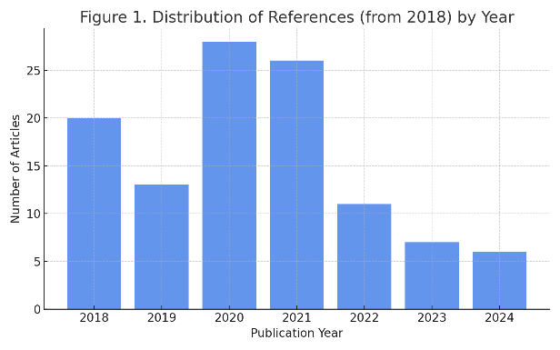
Figure 2. Distribusi Referensi utama berdasarkan tahun

The analysis based on the country of origin of publications shows that research related to artificial intelligence in adaptive learning within vocational education is dominated by several countries with strong technological research traditions. Figure 3 illustrates the top ten countries contributing the most publications on this topic based on indexing databases. Countries such as the United States, India, and the United Kingdom rank highest in publication numbers across indexing platforms like Elsevier, Routledge, IEEE, and others, demonstrating their commitment to the development of AI-based educational technology (Ghufron, 2018). Contributions from other countries such as China, Germany, and Australia are also significant, reflecting global collaboration and a broad academic interest in this topic. These findings indicate that the implementation of AI in adaptive education has become a cross-national concern, although research remains concentrated in countries with more established technological infrastructure and higher education systems. (Ma & Xu, 2020).

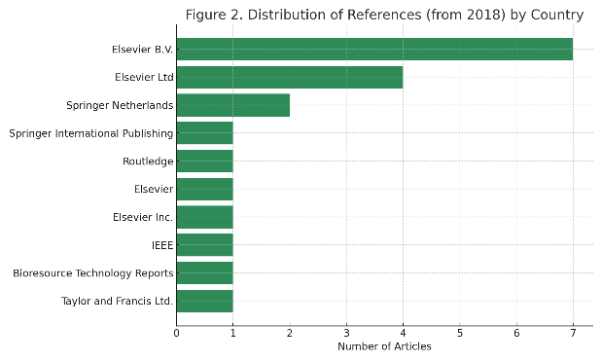
Figure 2. Distribution of main references based on indexing
Bibliometric analysis was conducted to understand the research landscape related to the application of artificial intelligence in adaptive learning, particularly within the context of vocational education. This approach aims to identify publication patterns, keyword distributions, collaboration trends among authors and institutions, as well as the geographic spread of research over a certain period. Using bibliographic data from 41 selected articles and employing VOSviewer software, the study mapped the knowledge structure and the dynamic development of topics within the scientific literature.
The results of this analysis provide a comprehensive overview of the dominant themes emerging in the literature, the most active researchers and institutions in the field, and how the relationships among topics are developed within the scientific framework of technology-based vocational education using artificial intelligence. Visualizations in the form of network maps, keyword clusters, and country distribution of publications are presented to support the interpretation of the position and direction of research development in this area.
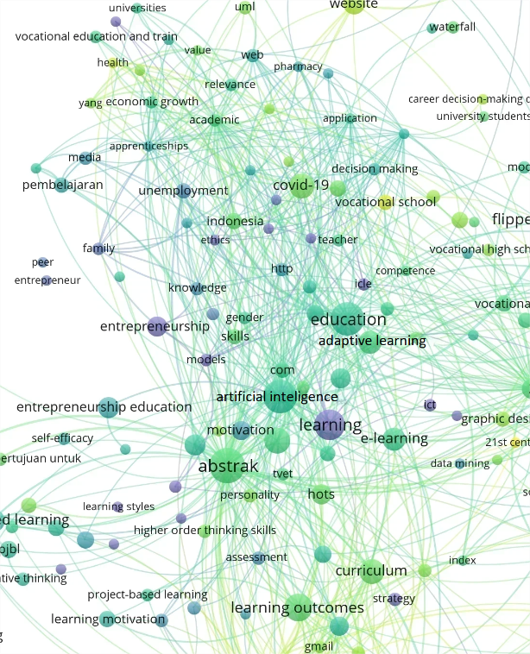
Figure 3. Bibliometric analysis results according to primary references
Discussion with Analysis based on result of bibliometrics review and visualization
The visualization of bibliometric analysis results using VOSviewer reveals the relationships among keywords appearing in the literature on artificial intelligence in adaptive learning within the context of vocational education. In the co-occurrence map, the keyword “learning” appears as the central node, indicating that this topic is the core of all analyzed themes. Surrounding this keyword are other significant nodes such as “adaptive learning,” “artificial intelligence,” and “education,” which form the main closely connected cluster. The large size of these nodes and their central position on the map signify that these keywords not only frequently occur but are also commonly associated with other keywords, highlighting their central role in the development of the literature in this field.
Additionally, other keywords such as “vocational education,” “TVETs,” “vocational school,” and “learning outcomes” form subclusters that demonstrate the connection between AI utilization and the development of adaptive learning within vocational education systems. This reflects that the implementation of intelligent technology in education is not solely focused on the technological approach but also aims to improve the quality of vocational education through contextual and personalized methods. Keywords like “motivation,” “curriculum,” and “project-based learning” also appear within the network, indicating that AI-based adaptive learning is often associated with innovative teaching approaches that promote student engagement and enhance learning outcomes.
Interestingly, the keyword “COVID-19” also appears in the map, indicating that the pandemic was one of the triggers accelerating the adoption of AI in education. Additionally, the presence of keywords such as “Indonesia,” “media,” and “learning” suggests contributions from local research within this global ecosystem, as well as the use of terms specific to the Indonesian educational context. This highlights that the discourse on AI in education transcends national and cultural boundaries.
Overall, this visualization reveals that the literature on artificial intelligence in adaptive learning within vocational education develops in multiple directions, encompassing aspects of pedagogy, technology, and education policy. The complexity of the keyword network indicates that research in this field is not isolated but involves the interaction of various disciplines and research focuses, ranging from curriculum development and project-based learning strategies to the implementation of adaptive and personalized intelligent educational technologies. This visualization provides a comprehensive overview of the knowledge structure formed in recent studies and opens opportunities for exploring more specific follow-up themes.
As part of the systematic stage in the literature review, a total of 41 selected scientific articles were classified based on their primary thematic focus related to artificial intelligence (AI), adaptive learning, and vocational education (TVET). This classification process aims to provide a conceptual mapping of each article’s contribution in addressing the main topic, namely: Bibliometric Analysis and PRISMA-Based Meta-Analysis of AI-Assisted Adaptive Learning from the Perspective of Vocational Education.
The references reviewed span the period from 2018 to 2023 and demonstrate a broad thematic coverage. Based on content and keyword analysis of each article, the classification was divided into three main groups: Artificial Intelligence Focus, TVET Focus, and Adaptive Learning, Integration, and Educational Frameworks Focus.
Table 2. Publication Classification and Discussion Focus
Fokus Artificial Inteligence
1 | (Anwar, 2021b)
2 | (Muhammad, 2019)
3 | (Supriyanto et al., 2019)
4 | (J. Liu et al., 2021)
5 | (Kusumawati, 2018)
6 | (Carolus et al., 2023)
7 | (Ghufron, 2018)
8 | (Dasgupta, 2018)
9 | (Anwar, 2021a)
10 | (Khalil et al., 2021)
11 | (Hidayat et al., 2021)
12 | (Ma & Xu, 2020)
13 | (Callejas et al., 2023)
14 | (Adnan & Anwar, 2020)
15 | (Castro, 2019)
16 | (Medan et al., 2018)
17 | (Firzatullah, 2021)
18 | (Supriyanto et al., 2019)
19 | (Utami et al., 2023)
20 | (Hidayat et al., 2021)
21 | (Reigeluth & An, 2020)
22 | (Dharma et al., 2020)
23 | (Debnath & Roy, 2021)
24 | (Fricticarani et al., 2023)
25 | (Alfiah et al., 2019)
26 | (Widjanarko et al., 2021)
Fokus TVET
27 | (Ratnaningtyas, 2018)
28 | (Agustini et al., 2018)
29 | (Mubai et al., 2021)
30 | (Dyah et al., 2022)
31 | (Kesuma et al., 2022)
32 | (Jalinus et al., 2021)
33 | (Choy & Yeung, 2022)
Fokus Learning, Adaptive, dan Integrasi
34 | (Maier et al., 2019)
35 | (Muafi et al., 2021)
36 | (Gleason, 2018)
37 | (Hattie & Gregory, 2018)
38 | (Omar et al., 2019)
39 | (Christopoulos & Sprangers, 2021)
40 | (D. Liu, 2022)
41 | (Sarmas et al., 2020)

The first group, Artificial Intelligence Focus, includes 26 articles that directly discuss the role and application of AI within the context of education or learning systems (Dasgupta, 2018). Articles in this group generally discuss technological approaches such as machine learning, recommendation systems, intelligent tutoring systems, and the implementation of AI for personalized learning. This reflects a strong interest from the academic community in the potential of AI as a transformative innovation in education, both from technical and pedagogical perspectives (Khalil et al., 2021).
The second group, TVET Focus, consists of 7 articles that specifically address issues in vocational education, including competency enhancement, vocational curriculum development, and 21st-century skills requirements within the vocational education environment (Dyah et al., 2022). These articles provide an important contextual foundation regarding the challenges and opportunities within the vocational education system, which serves as the primary setting for the implementation of AI-based adaptive learning models (Maier et al., 2019).
The third group, Adaptive Learning, Integration, and Framework Focus, consists of 8 articles that examine how adaptive learning systems are designed and integrated into education, whether through pedagogical approaches, conceptual frameworks, or meta-analyses on the effectiveness of adaptive strategies in the learning process (Sarmas et al., 2020). Some articles in this group also bridge the utilization of technology with data-driven educational approaches (Gleason, 2018).
The results of this classification indicate that the majority of the literature (more than half) remains concentrated on the technological aspects of AI, while discussions integrating adaptive approaches within the vocational education framework are still evolving. This presents further opportunities for exploration in combining AI, adaptive pedagogical approaches, and learning practices within the vocational education context in a more comprehensive and contextualized manner.
- CONCLUSION
The bibliometric and PRISMA-based meta-analysis of 41 articles reveal that the topic of AI-assisted adaptive learning in vocational education has garnered increasing attention from the academic community, particularly since 2020. Publication distribution is dominated by developed countries such as the United States, India, and the United Kingdom, highlighting their central role in advancing educational technology. Bibliometric visualizations show that keywords like “learning,” “adaptive learning,” and “artificial intelligence” serve as the core of the literature network, with strong sub-clusters related to pedagogy, learning motivation, and technology integration.
The thematic classification indicates that the majority of articles focus on AI technology, followed by issues within TVET and the integration of adaptive learning within the educational framework. Although there is strong attention to technological aspects, more in-depth research is needed to bridge the gap between technological innovation and the contextual needs of vocational education. This study emphasizes that the utilization of AI in adaptive learning is not merely a technical innovation but also a transformational strategy to address the challenges of 21st-century education. Therefore, future research should be directed towards developing learning models that are personalized, inclusive, and responsive to the evolving needs of both industry and vocational learners.

REFERENCES
Adnan, M., & Anwar, K. (2020). Online learning amid the COVID-19 pandemic : Students ’ perspectives. 2(1), 2–8.
Adnan, M., & Anwar, K. (2020). Online learning amid the COVID-19 pandemic : Students ’ perspectives. 2(1), 2–8.
Agustini, K., Saindra, G., Sugihartini, N., & Indrawan, G. (2018). Subject for Vocational Student. 201(Aptekindo), 177–182.
Alfiah, F., Adnandi, M. A., & ... (2019). Expert System To Identify Students Behavior and Personality in Smk Negeri 2 Tangerang. Jurnal Techno Nusa …, 16(2), 85–92. http://ejournal.nusamandiri.ac.id/index.php/techno/article/view/379
Anwar, M. (2021a). Designing an expert system for determining student learning styles using forward chaining in engineering education. Jurnal Konseling dan Pendidikan, 9(1), 93. https://doi.org/10.29210/159000
Anwar, M. (2021b). Prediction of the graduation rate of engineering education students using Artificial Neural Network Algorithms. International Journal of Research in Counseling and Education, 5(1), 15. https://doi.org/10.24036/00411za0002
Ayca, C., & Hasan, K. (2017). An application of fuzzy analytic hierarchy process (FAHP) for evaluating students project. Educational Research and Reviews, 12(3), 120–132. https://doi.org/10.5897/err2016.3065
Callejas, Z., Albacete-maza, J., & Fern, A. (2023). Exploring folk songs to educate for resilience. 31(3), 133–146. https://doi.org/10.1108/OTH-10-2022-0064
Carolus, A., Augustin, Y., & Wienrich, C. (2023). Computers and Education : Artificial Intelligence Digital interaction literacy model – Conceptualizing competencies for literate interactions with voice-based AI systems. 4(November 2022). https://doi.org/10.1016/j.caeai.2022.100114
Castro, R. (2019). Blended learning in higher education: Trends and capabilities. Education and Information Technologies, 24(4), 2523–2546. https://doi.org/10.1007/s10639-019-09886-3
Choy, M. W., & Yeung, A. S. (2022). Cognitive and affective academic self-concepts: Which predicts vocational education students’ career choice? International Journal of Educational Research Open, 3(January), 100123. https://doi.org/10.1016/j.ijedro.2022.100123
Christopoulos, A., & Sprangers, P. (2021). Integration of educational technology during the Covid-19 pandemic: An analysis of teacher and student receptions. Cogent Education, 8(1). https://doi.org/10.1080/2331186X.2021.1964690
Dasgupta, P. B. (2018). Detection and Analysis of Human Emotions through Voice and Speech Pattern Processing. October, 2–5. https://doi.org/10.14445/22312803/IJCTT-V52P101
Debnath, S., & Roy, P. (2021). Audio-Visual Automatic Speech Recognition Using PZM , MFCC and Statistical Analysis. 121–133. https://doi.org/10.9781/ijimai.2021.09.001
Dharma, A. S., Tampubolon, L. A., & Purba, D. S. (2020). Drug Stock Prediction at Balige HKBP Hospital Using Adaptive Neuro-Fuzzy Inference System. SinkrOn, 5(1), 26–34. https://doi.org/10.33395/sinkron.v5i1.10529
Dyah, C., Indrawati, S., Ninghardjanti, P., Huda, C., & Dirgatama, A. (2022). The effect of practicum learning based audiovisual on students ’ learning outcomes in Indonesian vocational secondary school. 11(1), 403–408. https://doi.org/10.11591/ijere.v11i1.21762
Firzatullah, R. M. (2021). Menggunakan Sistem Pendukung Keputusan Penentuan Uang Kuliah Tunggal Universitas XYZ Menggunakan Algoritma Backpropagation. Petir, 14(2), 170–180. https://doi.org/10.33322/petir.v14i2.996
Fricticarani, A., Hayati, A., Hoirunisa, I., Rosdalina, G. M., & Bangsa, U. B. (2023). Strategi pendidikan untuk sukses di era teknologi 5.0. 4(1), 56–68.
Ghufron, M. . (2018). Revolusi Industri 4.0: Tantangan, Peluang, Dan Solusi Bagi Dunia Pendidikan. Seminar Nasional dan Diskusi Panel Multidisiplin Hasil Penelitian dan Pengabdian Kepada Masyarakat 2018, 1(1), 332–337.
Gleason, N. W. (2018). Higher Education in the Era of the Fourth Industrial Revolution. In Higher Education in the Era of the Fourth Industrial Revolution. https://doi.org/10.1007/978-981-13-0194-0
Hattie, J., & Gregory, D. (2018). A model of learning: optimizing the effectiveness of learning strategies. In Contemporary theories of learning: Learning theorists ... in their own words.
Hidayat, H., Tasrif, E., Jaya, P., Anwar, M., Thamrin, Zulwisli, Hadi, A., Budayawan, K., Husin, M., & Asmara, D. (2021). The Empirical Analysis of Industrial Work Challenges in the Industrial Revolution 5.0 Towards a Grade Point Average (GPA) for Electronic Engineering Education Students. International journal of online and biomedical engineering, 17(9), 21–34. https://doi.org/10.3991/ijoe.v17i09.25679
Jalinus, N., Verawardina, U., Azis Nabawi, R., Darma, Y., Padang, N., Hamka, J., & Tawar Barat, A. (2021). Developing Blended Learning Model in Vocational Education Based On 21st Century Integrated Learning and Industrial Revolution 4.0. Turkish Journal of Computer and Mathematics Education, 12(9), 1276–1291.
Kesuma, C., Kholifah, D. N., Hendrik Sitorus, J. P., Magdalena Sipahutar, V., Nuraini, N., Ahmad, I., Fadlan Nur, A., Ward, P. T., Herlambang, B. A., Setyawati, V. A. V., Kazi, Z., Kazi, L., Lalima, D., Lata Dangwal, K., Rasyid, M., Azis, A. A., Saleh, A. R., Amani, J., Hoang Tien GAIE, N., … Zimermann, K. F. (2022). Sistem Informasi Buku Induk Siswa SMK Negeri 1 Siantar berbasis Web. Jurnal Pendidikan Biologi, 5(1), 53–64. https://doi.org/10.1080/00074918.2020.1854079
Khalil, S., Hassan, A., Alaskar, H., Khan, W., & Hussain, A. (2021). Fuzzy logical algebra and study of the effectiveness of medications for COVID-19. Mathematics, 9(22), 1–12. https://doi.org/10.3390/math9222838
Kusumawati, R. (2018). Kecerdasan Buatan Manusia (Artificial Intelligence); Teknologi Impian Masa Depan. ULUL ALBAB Jurnal Studi Islam, 9(2), 257–274. https://doi.org/10.18860/ua.v9i2.6218
Liu, D. (2022). Research and Application of College English Education System Based on Speech Recognition Technology. 386–392. https://doi.org/10.56028/aehssr.3.1.386
Liu, J., Zheng, Y., Zhou, L., Jin, F., & Chen, H. (2021). Engineering Applications of Artificial Intelligence A novel probabilistic linguistic decision-making method with consistency improvement algorithm and DEA cross-efficiency. Engineering Applications of Artificial Intelligence, 99(111), 104108. https://doi.org/10.1016/j.engappai.2020.104108
Ma, Z. M., & Xu, Z. S. (2020). Computation of generalized linguistic term sets based on fuzzy logical algebras for multi-attribute decision making. Granular Computing, 5(1), 17–28. https://doi.org/10.1007/s41066-019-00199-x
Maier, M., Carlotto, H., Sanchez, F., Balogun, S., & Merritt, S. (2019). Transforming underwriting in the life insurance industry. 33rd AAAI Conference on Artificial Intelligence, AAAI 2019, 31st Innovative Applications of Artificial Intelligence Conference, IAAI 2019 and the 9th AAAI Symposium on Educational Advances in Artificial Intelligence, EAAI 2019, 9373–9380. https://doi.org/10.1609/aaai.v33i01.33019373
Maskar, S., Dewi, P. S., & Puspaningtyas, N. D. (2020). Online Learning & Blended Learning: Perbandingan Hasil Belajar Metode Daring Penuh dan Terpadu. Prisma, 9(2), 154. https://doi.org/10.35194/jp.v9i2.1070
Medan, I., Napitupulu, P., & Surbakti, A. (2018). Design of Decision Support System Providing Scholarship with Analytical Hierarchy Process ( AHP ) Method on Yayasan Seri Amal St . Design of Decision Support System Providing Scholarship with Analytical Hierarchy Process ( AHP ) Method on Yayasan Seri Ama.
Muafi, M., Syafri, W., Prabowo, H., & Nur, S. A. (2021). Digital Entrepreneurship in Indonesia: A Human Capital Perspective. Journal of Asian Finance, Economics and Business, 8(3), 351–359. https://doi.org/10.13106/jafeb.2021.vol8.no3.0351
Mubai, A., Jalinus, N., & Abdullah, R. (2021). The Effectiveness of Learning Media Based on Augmented Reality in Vocational Education : A Meta Analysis. 25(4), 15749–15756.
Muhammad, A. F. (2019). Development Of Web Based Application With Speech Recognition As English Learning Conversation Training Media. 2019 International Electronics Symposium (IES), 571–576.
Muhammad, A. F. (2020). Development of English Conversation Practice App with Artificial Intelligence & Speech Recognition. June 2023. https://doi.org/10.1109/IES50839.2020.9231570
Omar, F., Bushby, S. T., & Williams, R. D. (2019). Assessing the performance of residential energy management control Algorithms: Multi-criteria decision making using the analytical hierarchy process. Energy and Buildings, 199, 537–546. https://doi.org/10.1016/j.enbuild.2019.07.033
Ratnaningtyas, E. M. (2018). Principal Managerial Competencies : Implications for Vocational Secondary Education. 3853–3864.
Reigeluth, C. M., & An, Y. (2020). Merging the Instructional Design Process with Learner-Centered Theory. In Merging the Instructional Design Process with Learner-Centered Theory. Routledge. https://doi.org/10.4324/9781351117548
Sarmas, E., Xidonas, P., & Doukas, H. (2020). Multicriteria Decision Analysis Methods. Springer Optimization and Its Applications, 163, 19–34. https://doi.org/10.1007/978-3-030-53743-2_3
Supriyanto, G., Widiaty, I., Abdullah, A. G., & Yustiana, Y. R. (2019). Application expert system career guidance for students. Journal of Physics: Conference Series, 1402(6). https://doi.org/10.1088/1742-6596/1402/6/066031
Utami, G. C., Raras, C., Widiawati, A., & Subarkah, P. (2023). Detection of Indonesian Food to Estimate Nutritional Information Using YOLOv5. 12(2), 158–165. https://doi.org/10.34148/teknika.v12i2.636
Widjanarko, D., Setiadi, R., & Setiyawan, A. (2021). EVALUATING THE IMPACT OF AUDIO-VISUAL MEDIA ON LEARNING OUTCOMES OF DRAWING ORTHOGRAPHIC PROJECTIONS Keyword s. 9(3), 613–624. https://doi.org/10.18488/journal.61.2021.93.613.624

