THE IMPLEMENTATION OF THE DIRECT INSTRUCTION
MODEL INTEGRATED WITH LOCAL CULTURE TO IMPROVE LEARNING ACTIVITIES AND OUTCOMES IN ISLAMIC RELIGIOUS EDUCATION FOR FIFTH GRADE STUDENTS AT INPRES TOLOLARA PUBLIC ELEMENTARY SCHOOL

¹Klis Dianti. Postgraduate student of PAI, University of Muhammadiyah Bima. Indonesia 1; klisdiantiikraman1999@gmail.com
²Luthfiyah. Lecturer of Islamic Education Postgraduate Program, University of Muhammadiyah Bima. Indonesia 1; luthfiyah.inarizqi@gmail.com
³ Syarifuddin. Lecturer of Islamic Education Postgraduate Program, University of Muhammadiyah Bima. Indonesia 1; syarifpps@gmail.com

ARTICLE INFO |  | ABSTRACT
Keywords:  keyword 1; Direct Instruction  keyword 2; Islamic Religious Education  keyword 3 ; Local Culture |  | This study aims to analyze the application of Direct Instruction model combined with local culture “Maja Labo Dahu” in improving the activities and learning outcomes of fifth grade students at INPRES Tololara State Elementary School in Islamic Religious Education lessons. Using a classroom action research (PTK) approach in two cycles, where each cycle includes planning, implementation, observation, and reflection. Data were collected through observation of student learning activities and evaluation of learning outcomes. The findings showed that there was an increase in student learning activities and outcomes, from 61.67% in cycle I to 85% in cycle II, with classical completeness increasing from 60% to 86.67%. This improvement was driven by firmer guidelines, cultural integration that made the content more appropriate, and facilitated demonstration and practice techniques. Reflection from cycle I provided an opportunity to refine the strategy in cycle II, which resulted in increased student motivation, interaction, and comprehension. In conclusion, the application of the Direct Instruction model combined with the local culture of “Maja Labo Dahu” proved successful in improving students' learning activities and outcomes. In addition to having a good impact on academic understanding, this method also contributes to the formation of student character based on cultural values and Islamic teachings, such as integrity, respect, integrity, and respect.
Article history:
Received 2021-08-14
Revised 2021-11-12
Accepted 2022-01-17
 |  | This is an open access article under the CC BY-NC-SA license.
Corresponding Author:
Klis Dianti
Affiliation 1; klisdiantiikraman1999@gmail.com
- INTRODUCTION

Education in definition is seen as an effort to educate the life of the nation, developing Indonesian humans who have faith and devotion (Nur et al. 2022). Education in definition is seen as an effort to educate the life of the nation, developing Indonesian humans who have faith and devotion (Murniarti and Anastasia 2016).

Education is a process to humanize humans so that they are able to actualize themselves in life (Sastrawan 2019). Ideally, education does not only encourage students to develop talents that are adjusted to the knowledge gained at school, but education has the aim of increasing human capabilities, namely humans who are faithful and devoted to God Almighty (Sastrawan 2019).

Interestingly, there are many gaps and disparities in Indonesian education, which actually build a distance between the desired capabilities and the achieved results (Halim 2022). Education is the most important component in shaping the character and quality of human resources (Sa’diyah 2018). To facilitate the teaching-learning process, teaching planning is needed (Juwariah 2022).

Today's education and learning must be able to respond well to any changes that occur. Education and learning now not only serve to convey the knowledge needed for manual and routine tasks, but must also be able to teach students to have the abilities and skills needed to live life and face fierce competition in the 21st century (Ridwan 2014).

Learning is a substitute for the term “instruction” in English. While in Greek it is called “instructus” or “intruere” which means expressing thoughts (Asrul 2022). Learning is a process in which an individual's environment is deliberately arranged so that he can participate in certain behaviors under certain conditions or respond to specific situations (Masdul 2018). Therefore, learning can be considered as a system that includes various aspects, such as goals, materials, learners, teachers, methods, situations, and evaluations, where each aspect is interconnected with each other (Yulia Syafrin, Muhiddinur Kamal, Arifmiboy 2023).

In the learning process, student involvement is a crucial fundamental element to achieve success in learning activities (Abrori et al. 2023). Activeness is an activity that involves physical and mental aspects, namely acting and thinking as an inseparable unit. An effective learning process needs to involve various types of activities, both physical and mental (Abrori et al. 2023). Learning outcomes are the skills that students acquire after undergoing the learning process (Firmansyah 2015). Then learning outcomes are a change in attitude that occurs after undergoing the teaching and learning process in accordance with educational objectives (Siti Komariyah 2018). According to Slameto, the factors within students that can affect learning outcomes are (internal factors) which include physical and psychological factors (Leni and Sholehun 2021).

Islamic Religious Education is a subject that teaches religious values to form students to be faithful and pious to Allah SWT, especially at the elementary school level (Aladdiin 2019). he values of Islamic Religious Education become the basis for humans to achieve the purpose of life, namely devotion to the Creator (Ummi Kulsum 2022). Islamic learning prepares students to understand and recognize the teachings of Islam through learning activities (Darise 2021).

lamic Religious Education is seen as a lesson that is mostly memorized without having to understand and apply it in everyday life. This belief has led to low student interest and motivation in participating in Islamic Religious Education learning in the classroom. The lack of student learning motivation directly impacts on improving student academic achievement(Solehuddin 2019).

The Direct Instruction model is an alternative to the above problems. Direct Instruction is a teaching method carried out by the teacher directly to teach basic skills, which are shown directly to students with planned steps (Sitompul and Hayati 2019). The advantages of the Direct Instruction model are that it is specifically designed to improve factual knowledge that is taught sequentially, aiming to help learners master the procedural knowledge needed to carry out various complex skills (Setyawan and Riadin 2020).

Direct Instruction is a learning model that includes an explanation from the teacher of a new concept or skill, and involves the teacher interacting with students individually or in small groups (Sidik NH. and Winata 2016). In which one of the group representatives tries to convey the answer to the question at hand, then the other groups are asked to give their reactions (Iswara and Sundayana 2021).

The teacher acts as a source of information related to learning materials, learning management, and student discipline in the learning process (Mabrur, Setiawan, and Mubarok 2021). The characteristics of direct learning include the existence of learning objectives, the existence of syntax or overall patterns and flow of learning activities, as well as management systems and learning environments that support the learning process (Agung 2020). Direct teaching focuses on the interaction between teachers and students, which consists of 5 steps in its implementation: This model is presented in five stages, including: (Amintoko 2017). 1) Orientation stage 2) Presentation stage, 3) Guided practice stage, 4) The stage of evaluating understanding and providing feedback, 5) The stage of independent practice : (Amintoko 2017). 1) 1) Orientation stage 2) Presentation stage, 3) Guided practice stage, 4) The stage of evaluating understanding and providing feedback, 5) The stage of independent practice (Pritandhari and Pendidikan 2017).

Utilization of the Direct Instruction model is expected to improve student learning activities and achievement. To be more efficient in the local context, this model should be adapted to the local culture familiar to students, Maja Labo Dahu, or appropriate cultural symbols.

The importance of integrating the Direct Instruction model with local culture. Because culture plays a positive role in learning, one of which can be a source of learning and improve and develop learning outcomes (Muhammad Syazali 2022). Based on Permendagri Number 39 of 2007 article 1, local culture is defined as "a set of values held by certain communities or groups of people in an area, which are believed to be able to fulfill the expectations of its members and in which there are values and attitudes of community norms that are believed to fulfill the lives of its members (Setiyawan 2012).

Bima culture as the most visible protector of life is the “Maja labo Dahu” culture. A culture that functions as a foundation for individual behavior in life, which can provide guidance to determine which actions are right or wrong. Thus, “Maja Labo Dahu” acts as a cultural value system for the people of Bima and the Mbojo tribe in general (Najamudin and Andang 2022).

Hence, “Maja labo Dahu” means, “Shame and Fear.” Philosophically, “Maja labo Dahu” has several meanings: First, Maja; interpreted as an individual's moral attitude to feel “ashamed” of inappropriate actions, which reflects the local wisdom of a community. The teaching of “Maja” teaches moral and ethical values to humans that wrongdoing is very shameful (Najamudin and Andang 2022). Therefore, “Maja labo Dahu” functioned as the cultural value system of the Bima people during the reign of Sultan Muhammad Salahuddin 1917-1951 and the Mbojo people in general (Ilmiawan Mubin 2018).

The philosophy of Maja labo Dahu is not just an idea but also a way of life as well as a motivation for the people of Bima, which is sourced from Islamic values that are considered as a manners based on Islamic education that is able to regulate attitudes and behavior in every activity of the Bima community's life (Salam 2022).

The culture of “Maja Labu Dahu” has ethical values that are in line with Islamic Religious Education (PAI). And its relationship with learning as described in the Islamic Religious Education (PAI) material for grade V elementary school, in lesson 3 which discusses “My aspiration to be a pious child”, a) An honest person is loved by Allah SWT, b) Respect and obey parents and teachers, c) The beauty of mutual respect, which is in line with the philosophy of “Maja Labo Dahu” as a symbol of adherence to religious values.

By integrating “Maja Labo Dahu” in the learning process, students not only understand the concept of religion in theory, but also apply it in everyday life. They will be more sensitive in maintaining morals, doing good in the school environment and outside school, and being responsible in carrying out their duties as a Muslim. The incorporation of culture in the learning process makes the material more relevant to students' lives. By connecting Islamic Religious Education materials with local values such as “Maja Labo Dahu”, students will find it easier to understand and internalize Islamic teachings because it is related to the culture they have known since childhood.

At INPRES Tololara State Elementary School, it is seen that the involvement of grade V students in Islamic Religious Education lessons is still minimal. This can be seen from the low participation of students in the learning process, the low enthusiasm to ask questions or discuss, and their limited initiative in completing the tasks given. In addition, students' learning achievement is also still not achieving maximum results. Based on the results of previous assessments, the average student score tends to be below the specified standard. One of the main factors of this problem is the conventional way of learning, where the teacher acts more as a source of information, while students tend to be passive.

To overcome this problem, it is necessary to apply creative and contextualized learning models. One example is the Direct Instruction model integrated with local culture. This model provides an organized learning method that facilitates students to understand the material deeply while connecting it to relevant cultural values in their lives. Thus, this study aims to analyze how to apply the Direct Instruction model that integrates local culture to improve the activities and learning outcomes of grade V students at INPRES Tololara State Elementary School in Islamic Religious Education lessons.
- METHODS

This type of research is Classroom Action Research (PTK). This study applies the Kemmis and McTaggart model which includes planning, action, observation, and reflection (Prihantoro and Hidayat 2019). The purpose of the implementation was to improve the quality of students' learning activities and outcomes (Ajeng Arini, Gianistika, and Rahmat 2019).

Data collection techniques are: Observation can be carried out by the teacher himself or by other teachers. Observations are focused on student activities and learning processes, while preparations are made to document the learning process (Firdaus et al. 2023). Interviews or questions are crucial to understand the perceptions, thoughts, opinions, and feelings of individuals regarding a symptom, event, fact, or reality (Raco 2010). The test method, here researchers utilize written tests as a way of collecting data on pre-cycle, cycle I, and cycle II. A written test is a test carried out by students answering a number of questions in writing (Arikunto 2011). There are two tests carried out, namely: Pre-test, which is used when the delivery of material begins with the aim of evaluating the extent to which students have mastered the material or material to be taught (Magdalena et al. 2021). Post-test, also known as post test, is carried out at the end of learning a material (Novitasari 2016). Documentation in the form of written manuscripts about various activities or events that occurred in the past. All documents related to the research concerned need to be recorded as a source of information (Gulo 2002).

Research instruments are devices used by researchers to collect data. Research instruments are one of the important things, namely the tools used to measure the phenomena studied during data collection (Muslihin, Loita, and Nurjanah 2022). Classroom Action Research data analysis techniques can be carried out using descriptive quantitative, qualitative, or a combination of descriptive quantitative and qualitative methods (Mulyatiningsih 2021)
- FINDINGS AND DISCUSSION
Pre-Cycle According to the data analysis conducted, it was revealed that students' learning activities and achievements were still at a low level. The factors that influence the low learning activities and outcomes include the lack of student participation in the learning process, the application of methods that are not diverse, and the lack of student understanding of the material being taught. Therefore, it is necessary to implement a more efficient learning model, in this case Direct Instruction integrated with local culture “Maja Labo Dahu”, to improve student activities and learning outcomes in Islamic Religious Education subjects in class V of INPRES Tololara State Elementary School.
- Findings I
- Observation results of student learning activities cycle I
Students' learning activities regarding the teaching material in cycle I were observed by utilizing the observation sheet prepared by the researcher. Data on student learning activities during the application of the Direct Instruction model integrated with local culture in cycle I.
Based on the results of the two meetings in cycle I, it can be seen that student learning activities at the first meeting were still relatively low, as seen from the results of observations or observation sheets which were in the sufficient category with an average of 61.67%. Meanwhile, at the second meeting there was an increase which was in the high category with an average value of 63.33%.
- Student learning outcomes cycle I
Evaluation of student learning outcomes is carried out based on tests or evaluation of learning outcomes that have been given with material about honesty in the sight of Allah and respect and obedience to parents, which consists of 10 questions, 10 multiple choice questions and 5 essay questions delivered at meeting 3.

Calculating the average with the final score divided by the total number of students $\frac{1045.2}{15}= 69.7$
With the number of completions witnessed
KK = $\frac{F}{N} x 100\%$
KK : Classical Completeness
F : Number of students who scored ≥ 75
N : Number of Students
KK = $\frac{9}{15} x 100\%$ = 60,0%

Based on the analysis, the number of students who scored above the KKM (75) was 9 students, so it can be concluded that the nine students have been completed individually. Based on the initial measurement results, it is known that on average students still do not understand or master the subject matter taught by the teacher. After understanding the learning process in one cycle consisting of 2 meetings, with an average of 69.7, the highest score was 87.6, and the lowest score was 46.5 (9 students succeeded and 6 did not succeed). Classical completeness in cycle I reached 60.0%. This value appears to be still below 80% or below the specified research success criteria.
Findings from the research on student learning activities showed that the average score achieved was 66.7, with a maximum score of 86.6 and a minimum score of 46.5. Of all students, 9 students passed, while 6 students did not complete, with the percentage of classical passing reaching 60.0%. In addition, there were still students who were not fully concentrated and serious in listening to the teacher when explaining the subject matter.
- Findings II
- Observation results of student learning activities cycle II
Student learning activities during learning in cycle II were observed using an observation form that had been prepared by the researcher. Information about student activities after the application of the Direct Instruction model integrated with local culture, in cycle II.
Based on the observation results, student activity in the first meeting of cycle II increased to 75.33%, which is in the high category. Meanwhile, in the second meeting, the average student participation reached 85%, which is also included in the high category. In general, students' involvement in the learning process showed very good progress. Learners were more proactive, involved, and showed great enthusiasm in undergoing the learning process.
- Student learning outcomes of the cycle II
Assessment of student learning outcomes is based on the evaluation or test given at the third meeting, with the material “Respect and Obedience to Teachers and the Beauty of Mutual Appreciation”. This test consists of 10 questions, which include 5 multiple choice questions and 5 essay questions.
The average student learning outcomes are calculated by dividing the total final score by the total number of students, namely : $\frac{1211,64}{15}= 80.78$
KK = $\frac{F}{N} x 100\%$
KK : Classical Completeness
F : Number of students who scored ≥ 75
N : Number of Students
KK = $\frac{13}{15} x 100\%=86,67\%$
Based on the table above, 15 students took the learning outcomes test. Based on the results of the cycle II evaluation, there were 13 students who achieved a score of ≥ 75 (complete), while 2 students had not yet reached completeness. Overall, the student completeness rate reached 86.67%, which shows very satisfying results.
In accordance with the agreement reached between the researcher and the Religion Teacher of the Islamic School, the results of the V grade students' assessments at the INPRES Tololara Elementary School indicate that the assessments are indeed meaningful. It is evident that the percentage of students who have demonstrated mastery of the learning objectives has increased to 86.67% in cycle II, thereby meeting the established standard.
The assessment results in cycle II showed that the application of Direct Instruction learning model integrated with local culture significantly improved students' activities and learning outcomes. Cycle II was declared a success, because it had met the specified success indicators, with an average score of 80.78 and classical completeness reaching 86.67%. Of the 15 students who took part in the evaluation, 13 students passed, while 2 students did not reach the passing criteria.
- Finding III
This research shows that the application of the Direct Instruction model that integrates the local culture of "Maja Labo Dahu" not only improves students' learning activities and results in PAI lessons, but also shapes students' characters based on the values of Islamic teachings and Bima's local culture, such as honesty, respect, obedience, and mutual respect.
By learning about "Honest People are Loved by Allah," "Respect and Obedience to Parents and Teachers," and "The Beauty of Mutual Respect," the integration of the value of "Maja Labo Dahu" becomes an effective method to instill deep moral awareness in students. The concept of "Maja" (feeling ashamed to make mistakes or act fraudulently) motivates students to place honesty as a priority in all aspects of life, be it in learning or associating with peers. On the other hand, the notion of "labo Dahu" (fear of the consequences of negative actions) strengthens students' loyalty to parents and teachers, and instills discipline in carrying out their duties and responsibilities as students.
In addition, the study also revealed that integrating local cultural values in the learning process can increase learners' empathy and social awareness, making it easier for them to understand the importance of mutual respect in social interactions. This can be seen in their more balanced interactions, increased spirit of helping each other, and a stronger sense of togetherness in learning activities.
ANALYSIS
- Finding I
- Analysis of Student Learning Activities cycle I
Based on the observations made during Cycle I, there was an increase in student learning activities from the first meeting to the second meeting. In the first meeting, the average student participation was in the "Fair" category with a value of 61.67%, while in the second meeting it increased to the "High" category with a value of 63.33%. This shows an increase in students' reaction to the Direct Instruction learning model that integrates local cultural values "Maja Labo Dahu".
Figure 1
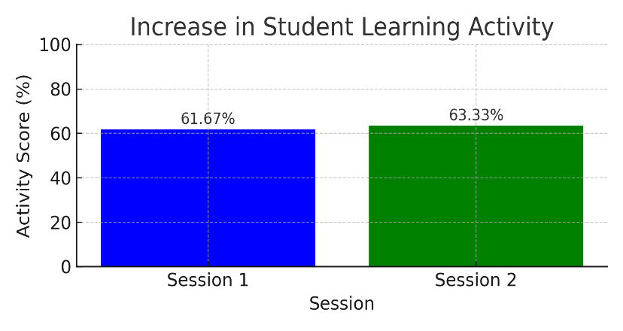

IThe implementation of the Direct Instruction model in the teaching and learning process can improve students' understanding of the material provided. Through face-to-face discussions, question and answer sessions, and interaction between teachers and students (Albakir 2024).
However, this increase is still considered minor and has not met the ideal target. Some indicators such as students' readiness to participate in learning and students' enthusiasm while learning are still relatively low, especially in the first meeting. This shows that the learning methods used need to be adjusted to be more interesting and able to increase student involvement more significantly.
- Analysis of Student Learning Outcomes cycle I
The results of the evaluation carried out at the third meeting showed that the students' classical pass rate was still below the research success standard. Out of a total of 15 students, only 9 obtained scores exceeding the Minimum Completion Criteria (KKM) set at 75, with an average score of 69.7. The percentage of classical complet
This increase has not yet reached the specified success indicator so that it is continued to cycle II. There were several obstacles in the implementation of cycle I actions, resulting in learning outcomes that did not meet the desired expectations (Made Sulastriningsih et al. 2021).
Figure 2
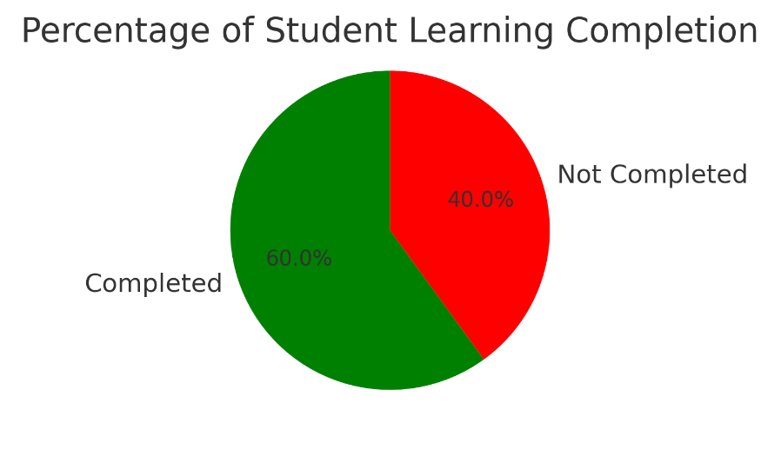

The distribution of scores shows a significant difference between students who achieved high scores (87.6) and students who achieved low scores (46.5). This indicates that there are still differences in understanding within the class, which may be caused by several factors, such as variations in student learning speed, lack of active participation in the learning process, and lack of understanding of the material presented.
Therefore, problems in learning were identified. From the evaluation conducted after the implementation of the actions in Cycle I, there were several main problems that needed attention: 1) Student participation in learning is still not optimal, 2) Student learning outcomes have not yet reached the criteria for completeness, 3) The lack of attention and seriousness of students in receiving directions from the teacher.
To overcome the obstacles encountered, more thorough preparation will be carried out and fix the existing problems so that the results in cycle II will improve and meet the predetermined criteria (Made Sulastriningsih et al. 2021). Reflection is also carried out to identify weaknesses that arise in cycle I so that they can be improved in Cycle II (Santra 2021).
There were improvement efforts made in Cycle II. Based on the results of the reflection, some improvement strategies that will be applied in Cycle II include: 1) Increase student participation in learning, 2) Clarifying instructions in learning. 3) Maximize assessment and feedback, 4) Provide additional support for students who have not finished.
- Finding II
In cycle II, this research indicated a significant increase in students' activities and learning outcomes after the application of the Direct Instruction model integrated with local culture. The learning process, which was carried out in three sessions, was more organized based on the reflection results from cycle I.
Learning outcomes are an object of evaluation that basically assesses students' mastery of learning objectives. This is the result of the formulation of instructional objectives that reflect the learning outcomes that must be mastered by students, namely the abilities of students after completing or following their learning experience (Andriyani 2020). The following is a discussion of the results obtained in cycle II.
- Student Learning Aktivity
From the observations made during the learning process, student learning activities showed a significant increase. Based on the information obtained, student involvement in the first session reached 75.33% and rose to 85% in the second session.

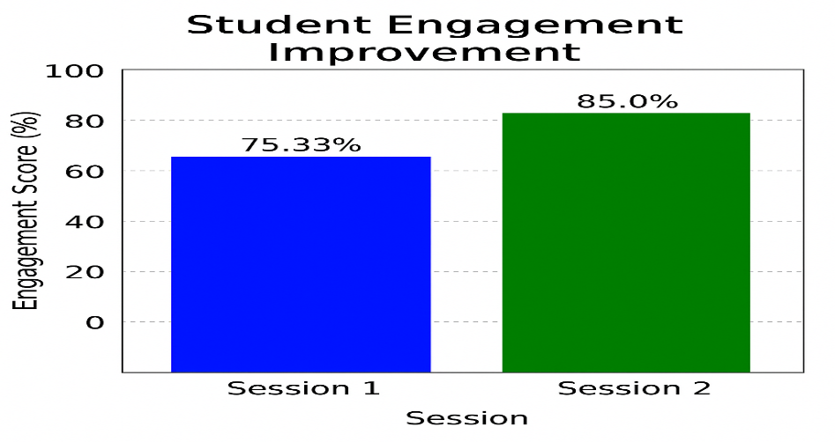
Figure 3

The learning method through Direct Instruction can increase students' enthusiasm for learning. The average learning motivation of students in classes taught with the direct instruction model increased compared to before (Dalimunthe 2017). This increase shows that students become more active in participating in learning. This can be attributed to various factors, including: 1) More detailed instruction delivery: The Direct Instruction model allows teachers to provide more systematic instructions, so students better understand what needs to be done at each stage of learning. 2) Integration of local culture: Utilizing the cultural values of "Maja Labo Dahu" makes the material more appropriate and understandable to students, thus increasing their interest in learning. 3) Demonstration and directed practice: Students not only get the material passively, but also have the opportunity to practice and apply concepts in a real context, which increases their engagement in learning.
- Improved Student Learning Outcomes
The results of the evaluation carried out at the third meeting showed significant progress in student learning outcomes. Of the 15 students who took the exam, 13 students achieved a score of ≥ 75, so the classical completeness reached 86.67%. The average score achieved by students was 80.78, which indicates progress from the last cycle.
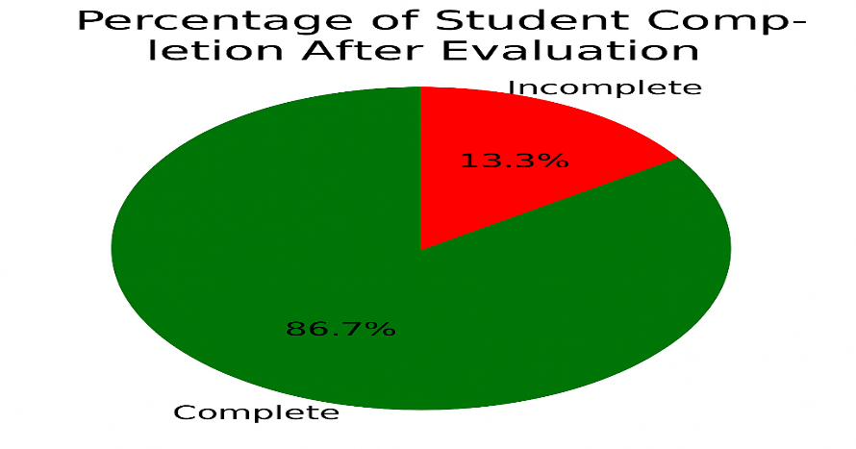
Figure 4

Factors that play a role in improving student learning outcomes include: 1) A more efficient learning approach: Through reflection from cycle I, the approach in cycle II was more focused, paying more attention to students who faced difficulties. 2) Reinforcement of understanding through activities and dialog: Learning that focuses on practice and reflection allows students to understand concepts more deeply than just passively receiving theory. 3) Implementation of formative evaluation: Through gradual evaluation with directed practice and individual exercises, students are better prepared for the final exam in this cycle.
The implementation of direct learning models can increase learning activities, where students are greatly helped through explanations and demonstrations, so that material that is difficult to understand only by explanation can be received by students more easily, and the class becomes conducive and active thanks to good teacher mastery. This increase in learning activities is certainly due to the improvement of the learning process by teachers in cycle II (Yanti 2019).
Reflection conducted after cycle II showed that the application of Direct Instruction model integrated with local culture had a positive impact on students' activities and learning outcomes. Some of the main things that can be concluded from this reflection are: 1) The effectiveness of the learning method. 2) The significance of students' motivation and participation in the learning process. 3) The importance of culture in the learning process
Indicators of successful implementation of the Direct Instruction learning model include: 1) During the learning process, students seem more enthusiastic, happy, and do not feel bored, so they are able to complete the tasks given by the teacher on time; 2) Students have a high desire to know, namely actively asking questions and being able to answer teacher questions verbally. This shows that students no longer feel afraid to learn to express opinions and ask questions; 3) is an improvement in student learning outcomes. This can be seen from the increase in each cycle (Urath 2023).
- Temuan III
The research findings indicate that the use of the Direct Instruction model in collaboration with the local culture of "Maja Labo Dahu" has a significant impact on improving students' activities and learning outcomes in Islamic Religious Education (PAI) lessons. In addition, the use of this method also plays a role in the formation of student character based on the values of Islamic teachings and Bima local culture. The characters formed include honesty, respect, obedience, and mutual respect.
, it is not surprising that learning models can be integrated with culture. However, not all understanding can be gained quickly through the discovery method. , in science learning, teachers need other teaching models to help learners in mastering the various knowledge. Direct Instruction and contextual learning models can be alternatives because they have been empirically proven (Muhammad Syazali 2022).
Through the teaching of "Honest People are Loved by God," "Respect and Obedience to Parents and Teachers," and "The Beauty of Mutual Respect," the integration of the value of "Maja Labo Dahu" proved successful in fostering a deeper moral awareness in students. The concept of "Maja" (shame to do wrong or act incorrectly) supports students in building an honest attitude in their daily lives, both in undergoing the learning process and in their social relationships.
Students' learning activities will improve if they are motivated to learn, one of the things that can encourage student motivation is when they more easily understand the subject matter. Therefore, teaching materials in schools should be relevant to the students environment, in other words, learning should be directly related to the lives of students who have seen, heard, and observed their surroundings (Gaol and Simarmata 2019).
In concept development, learning tools are expected to be able to improve student learning outcomes if they emphasize cultural themes that are integrated with local culture during the process. The hope is that through the learning process that has been passed, it can have a impact, both in students' behavior, knowledge, and thinking skills (Armadi and Astuti 2018) .
Culturally grounded learning is a strategy for creating learning environments and designing learning experiences that incorporate culture as an element of the learning process (Armadi and Astuti 2018). Culturally grounded learning is a strategy for creating learning environments and designing learning experiences that incorporate culture as an element of the learning process (Armadi and Astuti 2018) .
Furthermore, the results of this study show that integrating local wisdom in education does not only act as a strategy to improve academic results, but also as an effort to preserve culture and form a superior character that is in line with the identity of the Bima community. Through this approach, schools are not only a means to convey knowledge, but also function in shaping a generation that has good morals, appreciates local cultural values, and has high moral awareness in everyday life.
- CONCLUSION
Before the implementation of the Direct Instruction model integrated with the local culture of Maja Labo Dahu, student learning activities were still relatively low. This can be seen from the lack of student involvement in learning and the lack of interaction between students and teachers. Initial observations showed that the level of student activeness only reached 61.67% at the first meeting and increased slightly to 63.33% at the second meeting in the first cycle. Although there is an increase, this result is still not significant and requires a more effective learning strategy to increase student engagement.
After the implementation of the learning model in cycles I and II, student learning activities showed quite good progress. In cycle I, student activity increased to 75.33% in the first session and to 85% in the second session. This increase indicates that a more systematic learning method and the incorporation of local culture can enlarge students' motivation and participation in the learning process. In addition, the improvement of learning strategies in cycle II further strengthened the effectiveness of the methods used.
The development of student learning outcomes also showed an increase from cycle I to cycle II. Before the implementation of the Direct Instruction model, the average student pretest score was only 55, while the determined KKM was 75. After cycle I, the average student score rose to 69.7 with classical completeness reaching 60%. However, this result still did not reach the desired standard. In cycle II, after improving the learning strategy, the average student score increased significantly to 80.78 with classical completeness reaching 86.67%. This indicates that a more efficient learning approach, reinforcement of ideas through practice and discussion, and appropriate formative evaluation played a role in improving student learning outcomes.
Acknowledgments
Thank you.
Conflicts of Interest:

There is no conflict of interest.

REFERENCES
Abrori, Achmad Noval, Conny Dian Sumadi, Jl Raya Telang, Kecamatan Kamal, Kabupaten Bangkalan, Provinsi Jawa, and Timur Kode. 2023. “Pengaruh Model Pembelajaran Kooperatif Tipe STAD Terhadap Keaktifan Belajar Siswa Kelas 2 SDN Morkoneng 1.” Jurnal Inovasi Ilmu Pendidikan 1 (4): 296–315. https://doi.org/10.55606/lencana.v1i4.2385.
Agung, Riadin Dedy Setyawan dan. 2020. “IMPLEMENTASI MODEL PEMBELAJARAN DIRECT INSTRUCTION(DI) BERBANTUAN MEDIA AUDIOVISUALUNTUKMENINGKATKAN HASIL BELAJAR IPA PADA PESERTA DIDIK KELAS V SDN-1 LANGKAI PALANGKA RAYA.” Pedagogik Jurnal Pendidikan, 15 (1): 1–9.
Ajeng Arini, Dede, Chika Gianistika, and Rahmat Rahmat. 2019. “Penerapan Pendekatan Inkuiri Untuk Meningkatkan Hasil Belajar Siswa Dalam Pembelajaran IPA Di Sekolah Dasar (Penelitian Tindakan Kelas Pada Siswa Kelas V SDN Rengasdengklok Selatan II).” Jurnal Tahsinia 1 (1): 25–37. https://doi.org/10.57171/jt.v1i1.33.
Aladdiin, Hisyam Muhammad Fiqyh. 2019. “Materi Pendidikan Agama Islam Di Sekolah Dalam Membentuk Karakter Kebangsaan.” Jurnal Penelitian Medan Agama 10.
Albakir, Masni. 2024. “IMPLEMENTASI MODEL PEMBELAJARAN DIRECT INSTRUCTION DALAM MENINGKATKAN HASIL BELAJAR SISWA PADA MATERI HADITS SILATURAHMI DI KELAS IV SDN 05 TALUDITI.” Al-Mihnah 2 (3): 804–14.
Amintoko, Gunanto. 2017. “MODEL PEMBELAJARAN DIRECT INSTRUCTION DALAM MENINGKATKAN PEMAHAMAN KONSEP DAN HASIL BELAJAR.” Supremum Journal of Mathematics Education (SJME) 1 (1): 7–12.
Andriyani, Dia. 2020. “PENINGKATAN HASIL BELAJAR SISWA PADA MATERI STRUKTUR DAN FUNGSI BAGIAN TUMBUHAN DENGAN MENGGUNAKAN MODEL PEMBELAJARAN DIRECT INSTRUCTION DI KELAS IV SD NEGERI 2 BANDA SAKTI.” JESBIO IX (1): 21–26.
Arikunto, Suharsimi. 2011. “Prosedur PenelitianTindakan Kelas.” Angewandte Chemie International Edition, 6(11), 951–952., 5–24.
Armadi, Ali, and Yeni Putri Astuti. 2018. “Pembelajaran Terpadu Tipe Webbed Berbasis Budaya Lokal Untuk Meningkatkan Hasil Belajar Siswa Kelas IV Sekolah Dasar.” Premiere Educandum : Jurnal Pendidikan Dasar Dan Pembelajaran 8 (2): 185. https://doi.org/10.25273/pe.v8i2.3282.
Asrul, Abdul Hasan Saragih dan Mukhtar. 2022. Evaluasi Pembelajaran : Diterbitkan Oleh: PERDANA PUBLISHING. Perdana Publishing. http://repo.iain-tulungagung.ac.id/5510/5/BAB 2.pdf.
Dalimunthe, Nurhamidah. 2017. “PENERAPAN MODEL PENGAJARAN LANGSUNG (DIRECT INSTRUCTION) UNTUK MENINGKATKAN MOTIVASI BELAJAR SISWA PADA MATA PELAJARAN IPA DI KELAS V SD NEGERI 291 SIMPANG GAMBIR.” Jurnal Guru Kita (JGK). 2 (1): 83–90.
Darise, Gina Nurvina. 2021. “Pendidikan Agama Islam Dalam Konteks Merdeka Belajar.” Journal of Islamic Education : The Teacher of Civilization 2 (2): 1–18. https://doi.org/10.30984/jpai.v2i2.1762.
Firdaus, Iqlima, Rahmadisha Hidayati, Rida Siti Hamidah, Rina Rianti, Ritha Cahyuni, and Khusnul Khotimah. 2023. “Model-Model Pengumpulan Data Dalam Penelitian Tindakan Kelas.” Jurnal Kreativitas Mahasiswa Vol.1 No.2 (2): 107.
FIRMANSYAH, DANI. 2015. “PENGARUH STRATEGI PEMBELAJARAN DAN MINAT BELAJAR TERHADAP HASIL BELAJAR MATEMATIKA.” JURNAL PENDIDIKAN UNSIKA 3 (1): 86. https://doi.org/10.24114/jtp.v11i1.11199.
Gaol, Rumiris Lumban, and Ester Julinda Simarmata. 2019. “Efektivitas Bahan Ajar Tematik Sekolah Dasar Berbasis Budaya Lokal Melalui Penerapan Model Pembelajaran Contextual Teaching and Learning (Ctl) Terhadap Aktivitas Belajar Siswa.” Jurnal Guru Kita PGSD 3 (4): 342. https://doi.org/10.24114/jgk.v3i4.15079.
Gulo, W. 2002. “Metodologi Penelitian.” Gramedia Widiasarana Indonesia, 262 H. http://scioteca.caf.com/bitstream/handle/123456789/1091/RED2017-Eng-8ene.pdf?sequence=12&isAllowed=y%0Ahttp://dx.doi.org/10.1016/j.regsciurbeco.2008.06.005%0Ahttps://www.researchgate.net/publication/305320484_SISTEM_PEMBETUNGAN_TERPUSAT_STRATEGI_MELESTARI.
Halim, Amar. 2022. “Signifikansi Dan Implementasi Berpikir Kritis Dalam Proyeksi Dunia Pendidikan Abad 21 Pada Tingkat Sekolah Dasar.” Jurnal Indonesia Sosial Teknologi 3 (3): 404–18. https://doi.org/10.36418/jist.v3i3.385.
Ilmiawan Mubin, Hikmah Hikmah. 2018. “Makna Filosofi Maja Labo Dahu Dan Pengaruhnya Terhadap Karakter Masyarakat Bima Pada Masa Pemerintahan Sultan Muhammad Salahudin 1917-1951.” Historis 3 (2): 8. http://journal.ummat.ac.id/index.php/historis/article/view/1385.
Iswara, Eris, and Rostina Sundayana. 2021. “Penerapan Model Pembelajaran Problem Posing Dan Direct Instruction Dalam Meningkatkan Kemampuan Pemecahan Masalah Matematis Siswa.” Plusminus: Jurnal Pendidikan Matematika 1 (2): 223–34. https://doi.org/10.31980/plusminus.v1i2.897.
Juwariah, Enung. 2022. “Supervisi Akademik Dalam Upaya Peningkatan Kompetensi Pedagogik Guru Non Kependidikan Dalam Penyusunan Perencanaan Pembelajaran.” Wilangan: Jurnal Inovasi Dan Riset Pendidikan Matematika 3 (1): 41. https://doi.org/10.56704/jirpm.v3i1.14426.
Leni, Marlina, and Sholehun. 2021. “Analisis Faktor-Faktor Yang Mempengaruhi Hasil Belajar Bahasa Indonesia Pada Siswa Kelas IV SD Muhammadiyah Majaran Kabupaten Sorong.” Jurnal Keilmuan, Bahasa, Sastra, Dan Pengajarannya 2 (1): 66–74. https://unimuda.e-journal.id/jurnalbahasaindonesia/article/download/952/582.
Mabrur, Mabrur, Anang Setiawan, and Mochamad Zakky Mubarok. 2021. “Pengaruh Model Pembelajaran Direct Instruction Terhadap Hasil Belajar Teknik Dasar Guling Depan Senam Lantai.” Physical Activity Journal 2 (2): 193. https://doi.org/10.20884/1.paju.2021.2.2.4014.
Made Sulastriningsih, Ni, Sulfan Efendi, Kecamatan Tegallalang, Kabupaten Gianyar, SDN Tamanan, Kec Tamanan, and Kab Bondowoso. 2021. “Penerapan Model Direct Instruction Berbantuan Media Power Point Untuk Meningkatkan Hasil Belajar Siswa Kelas I SD Negeri 4 Sebatu Tahun Ajaran 2020/2021.” Jurnal Pendidikan Dasar 1 (2): 121–28. https://jurnal.educ3.org/index.php.
Magdalena, Ina, Miftah Nurul Annisa, Gestiana Ragin, and Adinda Rahmah Ishaq. 2021. “Analisis Penggunaan Teknik Pre-Test Dan Post-Test Pada Mata Pelajaran Matematika Dalam Keberhasilan Evaluasi Pembelajaran Di Sdn Bojong 04.” Jurnal Pendidikan Dan Ilmu Sosial 3 (2): 150–65.
Masdul, Muh Rizal. 2018. “Komunikasi Pembelajaran Learning Communication.” Iqra: Jurnal Ilmu Kependidikan Dan Keislaman 13 (2): 1–9. https://www.jurnal.unismuhpalu.ac.id/index.php/IQRA/article/view/259.
Muhammad Syazali, Umar. 2022. “Peran Kebudayaan Dalam Pembelajaran IPA Di Indonesia: Studi Literatur Etnosains.” Jurnal Educatio FKIP UNMA 8 (1): 344–54. https://doi.org/10.31949/educatio.v8i1.2099.
Mulyatiningsih, Dr. Endang. 2021. “Metode Penelitian Tindakan Kelas,” 42.
Murniarti, Erni, and Nouf Zahrah Anastasia. 2016. “Pendidikan Inklusif Di Tingkat Sekolah Dasar.” Jurnal Dinamika Pendidikan 9 (1): 9. https://doi.org/10.33541/jdp.v9i1.134.
Muslihin, Heri Yusuf, Aini Loita, and Dea Siti Nurjanah. 2022. “Instrumen Penelitian Tindakan Kelas Untuk Peningkatan Motorik Halus Anak.” Jurnal Paud Agapedia 6 (1): 99–106. https://doi.org/10.17509/jpa.v6i1.51341.
Najamudin, N, and A Andang. 2022. “Urgensi Budaya Bima Maja Labo Dahu Dalam Mendorong Revolusi Mental.” Pedagogos: Jurnal Pendidikan 4 (1): 48–54. http://jurnal.stkipbima.ac.id/index.php/gg/article/view/666%0Ahttp://jurnal.stkipbima.ac.id/index.php/gg/article/download/666/433.
Novitasari, Dian. 2016. “Pengaruh Penggunaan Multimedia Interaktif Terhadap Kemampuan Pemahaman Konsep Matematis Siswa.” FIBONACCI: Jurnal Pendidikan Matematika Dan Matematika 2 (2): 8. https://doi.org/10.24853/fbc.2.2.8-18.
Nur, Muhammad, Cut Zahri Harun, Sakdiah Ibrahim, Universitas Syiah Kuala Banda Aceh, and Prodi Magister Administrasi Pendidikan Universitas Syiah Kuala Riski Dwi Utami UIN Antasari Banjarmasin. 2022. “Management of Education: Jurnal Manajemen Pendidikan Islam MANAJEMEN SEKOLAH DALAM MENINGKATKAN MUTU PENDIDIKAN PADA TINGKAT SD School Management in Improving the Quality of Education at the Elementary Level.” Management of Education: Jurnal Manajemen Pendidikan Islam 8 (1): 23–30.
Prihantoro, Agung, and Fattah Hidayat. 2019. “Ulumuddin: Jurnal Ilmu-Ilmu Keislaman MELAKUKAN PENELITIAN TINDAKAN KELAS.” Ulumuddin: Jurnal Ilmu-Ilmu Keislaman 9 (1): 49–60.
Pritandhari, Meyta, and Pendidikan. 2017. “IMPLEMENTASI MODEL PEMBELAJARAN DIRECT INSTRUCTION UNTUK MENINGKATKAN KEMAMPUAN BERPIKIR KREATIF MAHASISWA.” JURNAL PROMOSI Jurnal Pendidikan Ekonomi UM Metro 5 (1): 47–56.
Raco, J.R. 2010. “METODE PENELlTlAN KUALlTATlF: JENIS, KARAKTERISTIK, DAN KEUNGGULANNYA.” PT Grasindo, 146.
Ridwan, Asep Eri. 2014. “Pendidikan IPS Dalam Membentuk SDM Beradab.” Jurnal Pendidikan Ilmu Sosial 23 (1): 27–35. https://doi.org/10.17509/jpis.v23i1.2060.
Sa’diyah, Halimatus. 2018. “Manajemen Mutu Pendidikan Dalam Meningkatkan Sumber Daya Manusia.” Bidayatuna: Jurnal Pendidikan Guru Mandrasah Ibtidaiyah 1 (2): 101. https://doi.org/10.36835/bidayatuna.v1i2.329.
Salam, Abd. 2022. “Karakter Maja Labo Dahu Dalam Perspektif Pendidikan Islam Di Bima.” Fitrah: Jurnal Studi Pendidikan 13 (2): 98–106. https://doi.org/10.47625/fitrah.v13i2.391.
Santra, Wayan. 2021. “Implementasi Model Direct Instruction Untuk Meningkatkan Hasil Belajar Teknik Dasar Sprint.” Indonesian Journal of Educational Development 2 (2): 382–90. https://doi.org/10.5281/zenodo.5257265.
Sastrawan, Ketut Bali. 2019. “Peningkatan Mutu Pendidikan Melalui Perencanaan Mutu Strategis.” Jurnal Penjaminan Mutu 5 (2): 203. https://doi.org/10.25078/jpm.v5i2.763.
Setiyawan, Agung. 2012. “Budaya Lokal Dalam Perspektif Agama: Legitimasi Hukum Adat (‘Urf) Dalam Islam.” Esensia XIII (2): 1–20.
Setyawan, Dedy, and Agung Riadin. 2020. “Implementasi Model Pembelajaran Direct Instruction (DI) Berbantuan Media Audiovisual Untuk Meningkatkan Hasil Belajar IPA Pada Peserta Didik Kelas V SDN-1 Langkai Palangka Raya.” Pedagogik: Jurnal Pendidikan 15 (1): 1–9. https://doi.org/10.33084/pedagogik.v15i1.1277.
Sidik NH., Moch Ilham, and Hendri Winata. 2016. “Meningkatkan Hasil Belajar Siswa Melalui Penerapan Model Pembelajaran Direct Instruction.” Jurnal Pendidikan Manajemen Perkantoran 1 (1): 49. https://doi.org/10.17509/jpm.v1i1.3262.
Siti Komariyah, Ahdinia Fatmala Nur Laili. 2018. “Pengaruh Kemampuan Berpikir Kritis Terhadap Hasil Belajar Matematika.” Jurnal Penelitian Pendidikan Dan Pengajaran Matematika 4 (2): 38–41. https://doi.org/10.33751/jppguseda.v3i1.2013.
Sitompul, Dian Novianti, and Isra Hayati. 2019. “Pengaruh Model Pembelajaran Direct Instruction Berbasis Games Terhadap Minat Belajar Mahasiswa Pada Mata Kuliah Akuntansi Pasiva Program Studi Pendidikan Akuntansi FKIP UMSU T.A 2017/2018.” Liabilities (Jurnal Pendidikan Akuntansi) 2 (3): 243–53. https://doi.org/10.30596/liabilities.v2i3.4023.
Solehuddin. 2019. “Penerapan Model Pembelajaran Market Place Activity (MPA) Dalam Upaya Peningkatan Prestasi Belajar PAI Dan Budi Pekerti Pada Materi Haji Dan Umroh Siswa Kelas IX A SMP Negeri 1 Tonjong.” Jurnal Dialektika 3 (1): 53–56.
Ummi Kulsum, Abdul Muhid. 2022. “Pendidikan Karakter Melalui Pendidikan Agama Islam Di Era Revolusi Digital.” Jurnal Intelektual: Jurnal Pendidikan Dan Studi Keislaman 12 (2): 157–70. https://doi.org/10.33367/ji.v12i2.2287.
Urath, Khadijah. 2023. “PENERAPAN MODEL PEMBELAJARAN DIRECT INSTRUCTION DALAM MENINGKATKAN LITERASI MENULIS AL-QURAN MATERI MARI BELAJAR QS. AL- FALAQ MATA PELAJARAN PENDIDIKAN AGAMA ISLAM DAN BUDI BEKERTI.” Al-Muhtarif: Jurnal Pendidikan Agama Islam 1 (2): 120–32.
Yanti, Wira. 2019. “Penggunaan Model Pembelajaran Langsung (Direct Instruction) Untuk Meningkatkan Hasil Belajar Biologi Siswa Kelas X Ipa 1 Sma Negeri 15 Kota Takengon Tahun Pelajaran 2018-2019.” BIOTIK: Jurnal Ilmiah Biologi Teknologi Dan Kependidikan 7 (2): 115. https://doi.org/10.22373/biotik.v7i2.5652.
Yulia Syafrin, Muhiddinur Kamal, Arifmiboy, Arman HusniVV. 2023. “Pelaksanaan Pembelajaran Pendidikan Agama Islam.” Educativo: Jurnal Pendidikan 2 (1): 72–77. https://doi.org/10.56248/educativo.v2i1.111.

