Development of Interactive E-LKPD Based on Live-Worksheets for Reading and Viewing Skills
Rizka Dwi Rahmayani¹, Atmazaki²
¹ Universitas Negeri Padang; rizkadwirahmayani663@gmail.com
² Universitas Negeri Padang; atmazaki@fbs.unp.ac.id

ARTICLE INFO |  | ABSTRACT
Keywords:  interactive E-LKPD;  live-Worksheets;  reading skills;  viewing skills;  student engagement |  | This study aims to develop an interactive Electronic Student Worksheet (E-LKPD) using the Live-Worksheets platform to enhance reading and viewing skills in Indonesian language subjects. The research involves validating the E-LKPD through expert reviews in terms of content, media, and language, as well as assessing its effectiveness based on students' learning outcomes and engagement. The Research and Development (R&D) approach with the 4-D model was employed, utilizing instruments such as validation sheets, practicality questionnaires, test instruments, and student activity observations. The results show that the E-LKPD meets students' needs for interactive and creative learning media while promoting critical thinking skills and digital literacy. Expert validation yielded high scores for content, media, and language, with 90%, 86%, and 86%, respectively. Practicality ratings from teachers and students were 89% for small groups and 91% for large groups, with 91% positive responses. Students' learning outcomes averaged a score of 92, reflecting high comprehension, while their engagement averaged 98%. These findings demonstrate that the E-LKPD developed using the Live-Worksheets platform is effective in enhancing students' learning outcomes and engagement, making it a valuable tool in modern educational settings.
Article history:
Received 2021-08-14
Revised 2021-11-12
Accepted 2022-01-17
 |  | This is an open access article under the CC BY-NC-SA license.
Corresponding Author:
Rizka Dwi Rahmayani
Universitas Negeri Padang, Indonesia; rizkadwirahmayani663@gmail.com
- INTRODUCTION
Student Worksheets (LKPD) are an effective learning tool to enhance interaction between students and teachers and to help students achieve academic success (Istiqomah & Suparman, 2020). The LKPD supports independent learning and facilitates material comprehension (Marshel & Ratnawulan, 2020).
Conventional Student Worksheets (LKPD) have long been utilized in education but often encounter challenges such as less engaging designs and monotonous materials, which hinder effective learning. Conventional LKPDs also fail to fully address the diverse learning needs of students (Prastowo, 2013). These challenges are further exacerbated by the demands of HOTS-based (Higher Order Thinking Skills) learning, which requires more innovative and interactive learning media (Yuanita et al., 2021). With advancements in technology, solutions to these challenges have emerged in the form of Electronic Student Worksheets (E-LKPD), enabling more interactive and flexible learning experiences.
The advancement of information and communication technology offers a solution to the limitations of conventional student worksheets (LKPD) through the development of Electronic Student Worksheets (E-LKPD). E-LKPD supports 21st-century learning that is interactive and flexible (Alexon & Handayani, 2024). Furthermore, E-LKPD aligns with the principles of the Independent Curriculum (R. N. Sari et al., 2024) which emphasizes the importance of innovative learning tailored to students' needs. This technology enhances the efficiency, engagement, and accessibility of learning anywhere. However, E-LKPD is still limited in some schools, making innovation in technology-based learning media essential to boost student motivation and reduce the environmental impact of paper-based teaching materials (Nenggala et al., 2024).
In the context of the Kurikulum Merdeka, reading and viewing skills are highly significant, particularly in the Indonesian language subject. These skills encompass not only the comprehension of information but also the ability to analyze messages across various media. Therefore, the E-LKPD emerges as an innovative tool that leverages digital technology. By integrating images, multimodal texts, and other digital media, E-LKPD offers a more engaging and effective learning experience compared to conventional worksheets (Linder & Falk-Ross, 2024). This E-LKPD facilitates interaction between teachers and students, enhances students' interest in interactive learning, and supports teachers in monitoring students' participation (Kristanto et al., 2025).
One platform that supports the development of E-LKPD is Live-Worksheets. According to Yuniastuti et al., (2021), Live-Worksheets is a platform that allows users to replace traditional worksheets with an interactive online version, providing an engaging learning experience for students. Khikmiyah (2021) adds that the use of E-LKPD through this platform enables the integration of textual content, photos, animations, and videos, aiming to create a more effective understanding and improve the quality of learning, especially for students experiencing a decline in interest. The use of Live-Worksheets also benefits teachers, as they can save time, monitor student participation, and identify existing gaps in understanding (Ha Le & Prabjandee, 2023).
The Live-Worksheets-assisted E-LKPD enables the use of more creative and intuitive innovative media, integrating various media and interactive activities, creating a more holistic learning experience, enhancing concentration, and accelerating the improvement of students' learning experiences (Nurjanah & Mukarromah, 2021).
This research focuses on the elements of reading and viewing. These skills are an essential part of the Merdeka Curriculum, particularly in the Indonesian Language subject. E-LKPD enables effective learning by reducing barriers of space and time while increasing student interest and motivation (Nurjanah & Mukarromah, 2021), creating an enjoyable and independent learning environment (Sya’idah et al., 2020), and helping to build students' knowledge. E-LKPD can be an engaging tool for students who have lost interest in learning.
Development of E-LKPD assisted by Live-Worksheets for the reading and viewing elements in Phase F of the Indonesian Language subject, Sub-Chapter II: Finding Current and Accurate Information. The use of innovative media in this E-LKPD can enhance interactivity and student engagement, as well as support student-centered learning, in line with the principles of the Merdeka Curriculum (Uddin & McNeill, 2025).
The study by Khoerunnisa et al., (2023) shows that the Live-Worksheets-based E-LKPD is effective in enhancing the quality of learning, with high achievement levels from subject matter experts and student responses.
This research aims to develop a valid, practical, and effective E-LKPD assisted by Live-Worksheets to improve students' reading and viewing skills. This media is expected to address the weaknesses of traditional LKPDs and support interactive learning that meets the needs of the digital era.
- METHODS
This type of research is a development study that uses the Research and Development (R&D) method with a three-stage approach from the 4-D development model. According to Sugiyono, (2013), the R&D method is applied to develop new products while also disseminating their effectiveness. This research model is deliberately and systematically designed to identify, formulate, improve, develop, produce, and test the validity, effectiveness, and practicality of a product, model, method, or specific procedure to make it more superior (Okra & Novera, 2019).
The research was conducted at SMA Negeri 2 Padang from June to August. The product produced is an E-LKPD based on the Live-Worksheets platform, focusing on the reading and viewing elements of students with the material "Finding Accurate and Current Information in News Texts" for Phase F of the 2024/2025 Academic Year.
- Development Procedure
The development of this E-LKPD follows the 4-D model proposed by Thagarajan et al. (1974), which consists of four stages: define, design, development, and disseminate. The development procedure is illustrated in Figure 1 as follows:
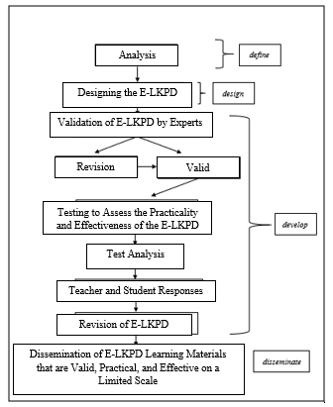
Figure 1. 4-D Model Development Procedure (Source: Adapted from Thiagarajan, 1974)
- Definition
The definition stage serves to identify and explain the needs, as well as gather relevant information related to the aspects that will be developed in the product to be created (Haviz, 2016). In this study, the definition stage has been carried out through several phases, including front end analysis, learner analysis, task analysis, concept analysis, and the formulation of learning objectives.
- Design
The initial design consists of several components, including the cover page, preface, learning achievements and objectives, learning material, Activity 1: Finding Current News, Activity 2: Identifying Media That Provide Current News, Activity 3: Let's Find the Words, Activity 4: Viewing Audio-Visual Content, Activity 5: Reading News Texts, Activity 6: Evaluation, reflection, and finally, the conclusion. This E-LKPD design refers to Daryanto et al., (2014)
- Development
In this study, the development stage includes the E-LKPD Validation phase, small-scale testing, practicality testing of the E-LKPD by teachers and students, and the effectiveness testing of the E-LKPD.
    - E-LKPD Validity Test
The design of the E-LKPD will be evaluated by each expert to identify its strengths and weaknesses. The E-LKPD will be validated by experts in media and language. The validators who are willing to conduct the validation of the E-LKPD are listed in Table 1.
Table 1. Validator of E-LKPD Assisted by the Live-Worksheets Platform in the Reading and Viewing Elements Phase F
Field | Validator | Affiliation
Material | Dr. Nursaid, M,Pd. | Universitas Negeri Padang
Material | Vivi Indriyani, M.Pd. | Universitas Negeri Padang
Media | Prof. Darmansyah, M.Pd. | Universitas Negeri Padang
Language | Herlin Triana, M.Hum. | Universitas Negeri Padang
The validator provides an assessment of this E-LKPD by evaluating the statements provided on the validation sheet, referring to the following rating scale.
Table 2. Assessment Criteria for E-LKPD Statement
Symbol | Statement | Value
SS | Strongly Agree | 4
S | Agree | 3
TS | Disagree | 2
STS | Strongly Disagree | 1
- Practicality Test
The practicality test was conducted after the product was revised based on the suggestions from the validators. The purpose of this test is to assess the responses from both teachers and students. In this study, the practicality trial was carried out in two stages: a small-scale trial and a large-scale trial. In the first stage, the practicality questionnaire was distributed to one teacher, Mrs. Rani Mahendra, S.Pd., and six students from a small class. Based on the positive results, the trial continued with a large-scale trial involving 31 students from class XI F.11 at SMA Negeri 2 Padang.
- Effectiveness Test
Effectiveness testing is an evaluation process aimed at assessing the extent to which a developed product is effective (Sari & Susanti, 2016). The effectiveness of this E-LKPD development is measured through student learning activities and achievement of learning outcomes.
- Data Analysis
The research data were analyzed using both qualitative and quantitative approaches. Data from the defining and design stages were analyzed qualitatively and presented descriptively. Meanwhile, data from the development stage, including validity, practicality, and effectiveness, were analyzed using quantitative methods.
- Analysis of Validity Data
The validation data of the E-LKPD is analyzed to assess the feasibility and relevance of the developed product. The validity scores obtained from the validation sheets filled out by the experts in content, media, and language are tabulated. After that, the validity value is calculated using the following percentage formula.
$$Validity Score= \frac{Total Score}{Maximum Score}x 100\%$$
The validity value is then interpreted based on the validity criteria table 3, which is modified from (Riduwan, 2014) , as follows.
Table 3. Criteria for Validity of E-LKPD
Persentage | Validity Criteria | Description
0-20 | Not Valid | Total Revision
21-40 | Less Valid | Partial Revision
41-60 | Sufficiently Valid | Somewhat Revised
61-80 | Valid | No Revision Needed
81-100 | Very Valid | No Revision Needed
- Practivally Data Analysis
The practicality data was obtained through the analysis of practicality questionnaires filled out by Indonesian language teachers and students. Data regarding the practicality of using the E-LKPD was analyzed in percentage form. The results of the practicality analysis were then interpreted based on the modified practicality criteria table 4 from (Purwanto, 2012) as follows.
Table 4. Practicality Criteria for E-LKPD
Persentage | Practicality Criteria
86-100% | Very Practical
76-85% | Practical
60-75% | Quite Practical
≤54% | Very Imractical
- Effectiveness Data Analysis
The analysis of the effectiveness of E-LKPD consists of an analysis of student activities and an analysis of student learning outcomes.
- Analysis of Student Activities
The data from the observation of the learning implementation is is presented in Table 5. to find the percentage of implementation. The percentage value of the implementation is then interpreted based on the modified assessment scale from (Sudjana, 2005) as follows.
Table 5. Qualifications of Learning Implementation
Persentage | Category
k ≥ 90% | Very well implemented
80 ≤ k ≤ 90 | Well implemented
70 ≤ k ≤ 80 | Fairly implemented
60 ≤ k ≤ 70 | Poorly implemented
k < 60 | Very poorly implemented
- Analysis of Student Learning Outcomes
The E-LKPD is considered successful if more than 80% of students achieve the learning completeness (Hobri, 2010). Learning completeness depends on the Minimum Completeness Criteria (KKM) set by the school, which is 80
- FINDINGS AND DISCUSSION
The results of the development of the E-LKPD Assisted by the Live-Worksheets Platform for Students' Reading and Viewing Skills based on the 4-D Model are as follows.
- Define Stage
In the defining stage of developing an interactive E-LKPD using the Live-Worksheets platform, three main analyses were conducted, resulting in crucial data. First, the front-end analysis identified students' need for an interactive learning media that enhances reading and viewing skills, as well as critical thinking abilities in assessing information accuracy. Second, the task analysis determined the types of tasks based on problem-solving and information analysis, such as evaluating news texts and assessing information sources, to support the learning objectives. Third, the concept analysis identified key concepts that students need to master, including information accuracy, analytical skills, and the ability to connect text content with personal experiences. The outcomes of these three analyses will be used to design the E-LKPD to meet the needs and learning objectives of the students.
- Design Stage
The development stages of the E-LKPD (Electronic Student Worksheets) assisted by the Live-Worksheets platform for the reading and viewing elements of the topic "Finding Accurate and Up-to-Date Information in News Texts" involve several key steps. The main concept of this development includes understanding information, cross-checking sources, analyzing current information, digital literacy, and critical viewing to help students identify and evaluate information from various sources.
In the design stage, the construction of test standards is based on reading and viewing assessment indicators, which measure students' abilities to identify key information, analyze the accuracy of information, and evaluate news sources. Additionally, appropriate media selection is made, using news texts and the Live-Worksheets platform to enhance students' skills.
The initial design of the E-LKPD includes key components such as the cover page, which reflects the topic and learning objectives. Figure 2. Cover Page will serve as an introduction to help students understand the material to be learned.
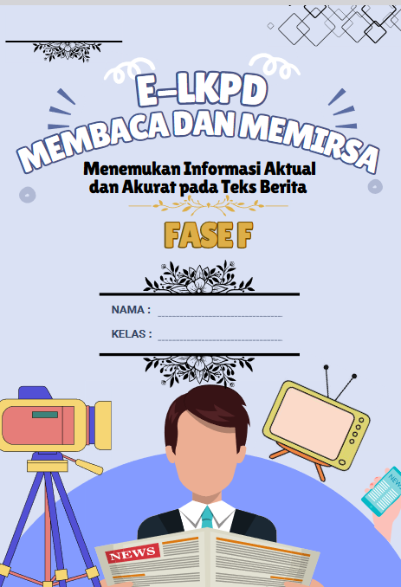
Figure 2. Cover Page
Important learning activities include reading and viewing activities. In the reading activity, students will engage in finding accurate and up-to-date information in news texts. Figure 3 Reading News Texts will show how students interact with news material. Meanwhile, the viewing activity encourages students to analyze visual elements related to the news. Figure 4. Viewing Audio-Visuals will demonstrate how students engage with visual media.
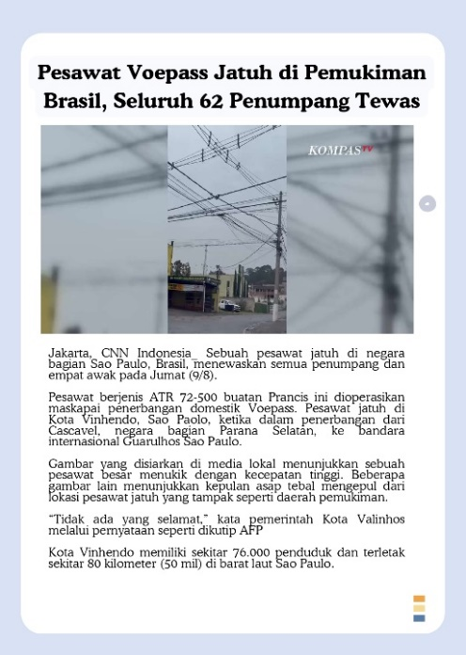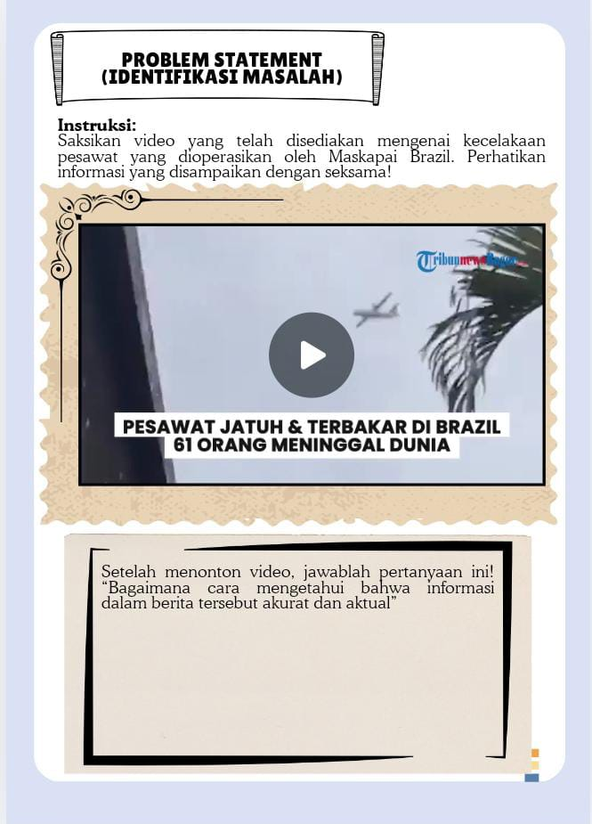
Figure 3 Reading News Texts Figure 4 Viewing Audio-Visuals
After completing each activity, students will engage in an evaluation to assess their understanding of the material. Figure 5. Evaluation will illustrate how students review their learning outcomes, reflect on their performance, and receive feedback for improvement.
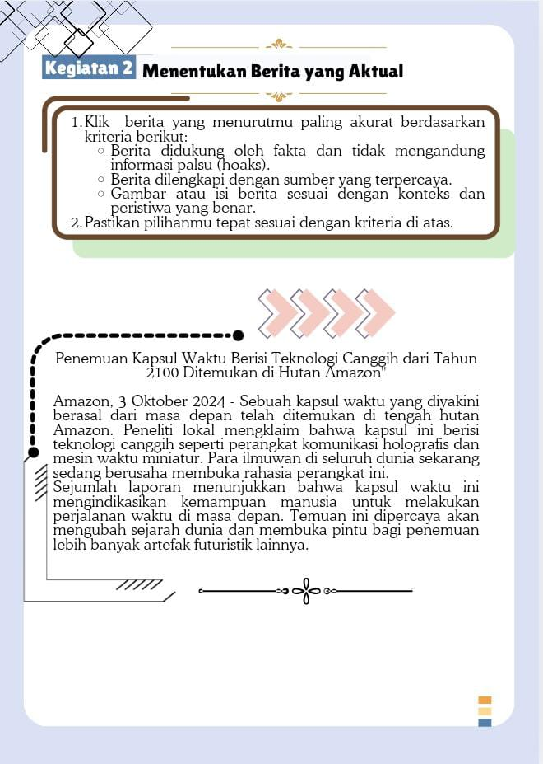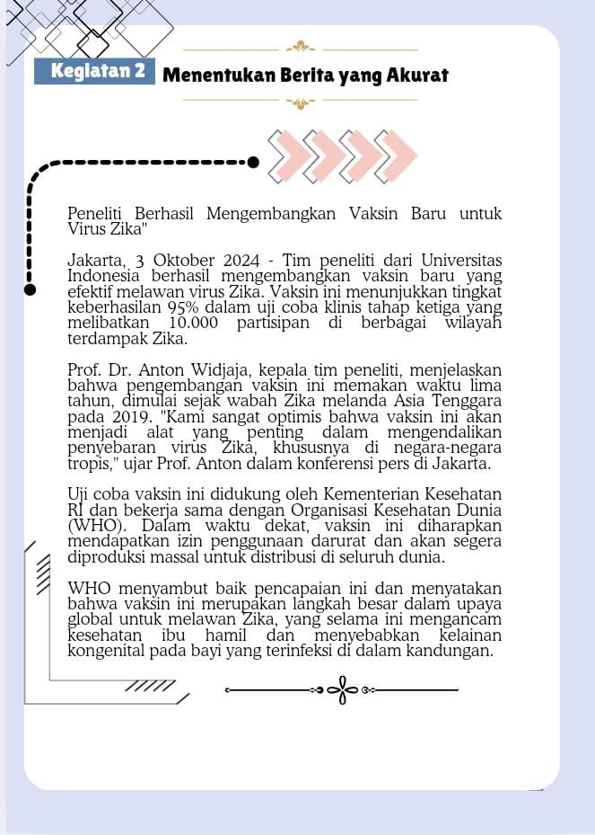
Figure 5. Evaluation
In addition, an interactive word-search game is included to reinforce learning about finding accurate information. Figure 6. Let's Find the Words will show how students search for key terms related to the news to improve their understanding of important concepts.
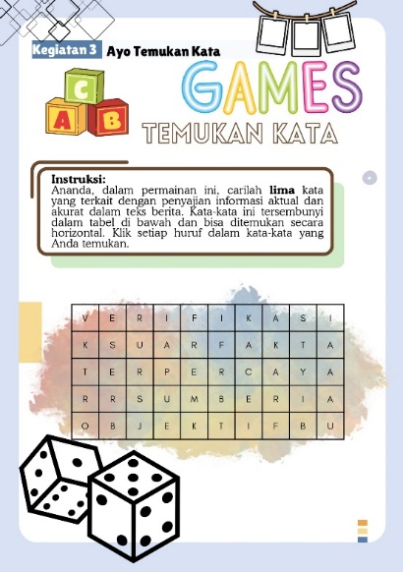
Figure 6. Let's Find the Words

Additionally, the worksheet also includes a reflection section to help students critically evaluate what they have learned. Figure 7. Reflection provides space for students to reflect on their learning process. Finally, Figure 8. Conclusion wraps up the lesson, summarizing the key takeaways and reinforcing the learning objectives.
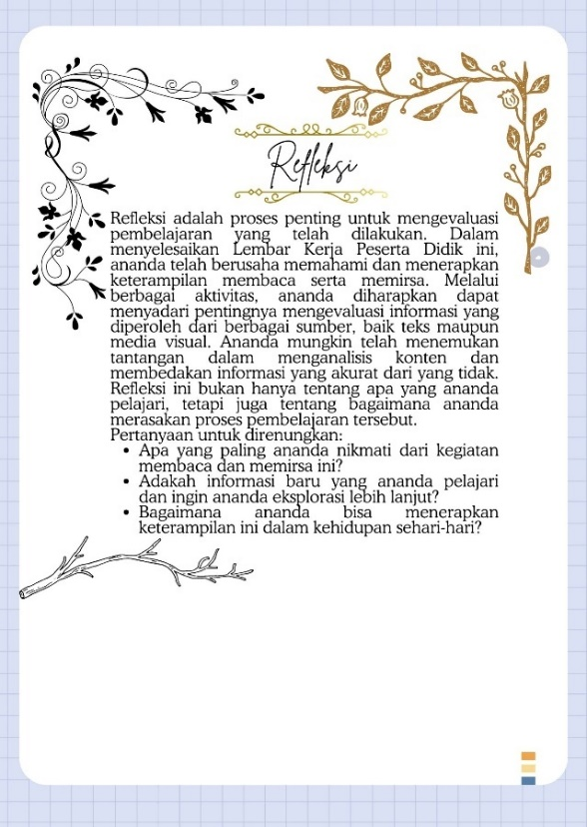
Figure 7. Reflection Figure 8. Conclusion
- Development Stage
At this stage, the developed product goes through several stages as follows.
- Validation
The following table 6 presents the assessment results from the content expert, media expert, and language expert.
Table 6. Validation Results from the Experts
Validator | Percentage | Qualification
Content Expert | 90% | Highly Valid
Media Expert | 86% | Highly Valid
Language Expert | 86% | Highly Valid
Based on Table 6. abave, which include validation from material, media, and language experts, the E-LKPD received an overall average validity score of 87.3% (categorized as "Very Valid"). Below are the details of the individual validation results for material, media, and language.
- Material Expert Validation
The validation results from material experts indicate a validity level of 90%, categorized as "Very Valid," signifying that the E-LKPD effectively supports the reading and viewing elements and aligns well with the learning objectives, with content relevant to daily life. However, aspects such as content relevance and fostering critical thinking scored 75% ("Fairly Valid"). Recommendations for improvement include enhancing visual appeal through better color composition and lighting, refining language use (e.g., replacing “adapun” and italicizing foreign terms like "headline"), synchronizing learning steps with the applied model, adding references for content accuracy, and presenting news elements in greater detail to aid understanding. These refinements suggest the E-LKPD is of high quality but requires minor adjustments to further enhance its impact on critical thinking.
- Media Expert Validation
The results of the media expert validation revealed a validity level of 86%, categorizing it as "Very Valid." The layout and navigation of the E-LKPD were rated excellent, facilitating the ease of understanding the material. Supporting media, including images, videos, and audio, were considered relevant and varied, enhancing the interactive learning experience aligned with students' cognitive levels. However, the validator suggested selecting more relevant images to enhance the content's appeal, and adjusting the margins and spacing of the text to meet academic writing standards for improved readability. With a well-structured layout and sufficient interactive elements, the E-LKPD is ready for use, with only minor visual improvements needed to further enhance the learning experience.
- Language Expert Validation
The validation by the language expert shows a validity level of 86%, placing it in the "Highly Valid" category. The language used adheres to Indonesian grammar rules, is clear, and free from ambiguity. Furthermore, the presentation of the language has been adjusted to match the age and ability levels of the students. The validator suggested adding elements of language that actively engage students to encourage participation in the learning process, as well as adjusting the formulation of questions to ensure their relevance to the learning objectives. While the language is one of the strengths of the E-LKPD, these adjustments in interactivity and question standards could further support active student involvement.
- Praktikality
The trial was conducted in two stages: a small-scale and a large-scale phase. In the first stage, the practicality questionnaire was distributed to one teacher and six students from a small class. Based on the positive results, the trial continued with a large-scale phase involving 31 students from class XI F.11 at SMA Negeri 2 Padang.
- Responses from the Teacher and Students in the Small Group
The analysis of the practicality data was based on four main aspects: Ease of Use, Time Efficiency, Student Engagement, and Interpretation and Assessment. Overall, the results of the trial showed that the E-LKPD was well received by all respondent groups, with very positive evaluations as follows.

Figure 15. Student Learning Outcomes
Based on Figure 15 above, The E-LKPD platform received high ratings for ease of use, with 98% of teachers and 90% of small group students finding it intuitive. Time efficiency was also well-rated, with 85% of teachers and 88% of students noting its effectiveness, though some suggested a more balanced time distribution. In terms of engagement, 100% of teachers and 89% of students found the multimedia features engaging, with suggestions for adding discussion forums. Feedback on interpretation and assessment was positive (95% for teachers, 90% for students), though some requested more detailed, rubric-based feedback.
- Large-Scale Trial
After a successful small-scale trial, a large-scale trial was conducted with 31 students from class XI F.11 at SMA Negeri 2 Padang, resulting in an average practicality score of 91%. This demonstrates the high practicality of the E-LKPD and its positive impact on enhancing the effectiveness of learning, particularly in reading and observing elements. However, areas for improvement were identified, including increasing student engagement in collaborative activities and the development of critical thinking skills. Although engagement was good, further strengthening of group discussions, collaborative projects, and debates is recommended. Additionally, some students suggested more balanced time allocation for activities to avoid rushing or over-spending time on certain tasks, with flexible time management as a potential solution.
- Effectiveness of E-LKPD Assisted by the Live-Worksheets Platform in Reading and Viewing Elements
The effectiveness of the E-LKPD in Reading and Viewing is assessed through student learning outcomes and the observation of student activity during the learning process. The development of the E-LKPD using the Live-Worksheets platform has proven to be effective and interactive, as shown by improvements in student learning outcomes and active participation. The following is the analysis:

Figure 16. Student Learning Outcomes
Based on figure 16 above, the use of the E-LKPD supported by the Live-Worksheets platform led to an average student learning outcome score of 92, with most students scoring between 90 and 95. This improvement in learning outcomes reflects the effectiveness of the platform in enhancing student achievement.
Observations of student activities revealed a very high level of engagement. Below is the percentage of student activities based on their categories.

Figure 16. Students Activity
Based on Figure 16 above, show that over 95% of students are highly engaged in the learning process, demonstrating strong visual, auditory, and mental involvement. This high level of engagement contributes to improved learning effectiveness and academic outcomes.

Discussion
This research successfully developed a valid E-LKPD (Electronic Student Worksheet) utilizing the Live-Worksheets platform. The study aims to develop a valid, practical, and effective E-LKPD based on the Live-Worksheets platform to enhance students' reading and viewing skills. Based on the evaluation of learning outcomes and student activity observations, it was found that the use of the digital platform-based E-LKPD significantly improved students' abilities to analyze information and think critically, as reflected in the improvement of their academic results.
The results of this study are consistent with the research conducted by Fitriyah & Ghofur (2021), which states that excessive dependence on textbooks as the sole learning resource can hinder students' ability to process information effectively. This research also emphasizes that to develop students' critical thinking skills, teachers need to design instructional materials that utilize technology, such as the E-LKPD based on the Live-Worksheets platform. This aligns with the findings of Tressyalina et al., (2023) which showed that interactive E-LKPD designed in an engaging manner and using easily understandable language could increase students' interest and motivation to learn, as well as strengthen their reading and viewing skills through analysis of the texts and images provided. Additionally, this study highlights the importance of using interactive media to help students identify key information and evaluate the accuracy of information in news texts, supporting the approach proposed in previous studies.
The expert validation process indicated that the developed E-LKPD achieved a very high validity level. This study aligns with research conducted by Yuniati et al. (2022) which shows similar validation results for the Live-Worksheets-based E-LKPD. The validation of content, media, and language in both studies received very good assessments, with positive evaluations of the content and design aspects. Results from both small and large group trials indicated that this E-LKPD was easy to use, time-efficient, and able to capture students' attention with interactive activities. However, some suggestions for improvement emerged, such as adjustments to the time allocation and enhancing student engagement in each activity.
Several studies show that although conventional worksheets have been applied in learning, their effectiveness in supporting students' critical thinking and independence is limited (Elfina & Sylvia, 2016 Therefore, innovations such as technology-based E-LKPDs are essential to address the learning needs in the digital age and create more engaging and effective learning experiences. The results of this study indicate that the use of the digital platform-based E-LKPD can enhance students' critical thinking skills, particularly in identifying relevant information and evaluating the accuracy of the presented information. These findings are in line with previous research by Hurrahma & Sylvia (2022), which stated that the use of digital tools can improve students' engagement and analytical skills.
This study aligns with Chan (2020) thingking (in Webb et al., 2019) hich suggests that with the advent of the internet and technology, viewing skills have become an essential part of learning. The study is also consistent with the findings of Prabowo (2021, which showed that the use of the digital platform-based E-LKPD could significantly improve students' academic performance. This strengthens the view that technology, through digital platforms such as E-LKPD, not only enriches students' viewing skills but also plays a role in enhancing digital literacy and critical thinking skills. On the other hand, despite the great potential of technology to enhance reading and viewing skills, reading interest in Indonesia remains very low, at only about 0.001%, meaning only one in a thousand people actively reads. Therefore, the application of technology in learning becomes an important factor in supporting viewing skills as the fifth macro skill in language communication, as well as contributing to overcoming the low reading interest in Indonesia (Meliyanti et al., 2021).
Although technology offers many advantages in learning, challenges related to limited internet access remain a barrier. Research by Smith (2020) (in Aldyandra et al., 2024) shows that many teachers feel uncomfortable and lack skills in using educational technology, highlighting the need for increased training in digital literacy. The varying digital skills among teachers can affect the effectiveness of online learning, where less skilled teachers struggle to design and deliver instructional content digitally. Furthermore, limited internet access remains a barrier in digital learning, especially for students with low technological skills. Therefore, it is essential to develop flexible E-LKPDs that can be accessed offline on various devices to ensure inclusivity and support successful learning in the digital era for all students.
This study demonstrates the great potential of using E-LKPDs in modern education, especially in teaching critical literacy and digital competence. The integration of multimedia in E-LKPDs, such as videos and interactive texts, supports active learning and provides a more meaningful learning experience. These findings also have significant implications for improving students' information literacy skills, which are crucial in this digital age, where the spread of inaccurate information often occurs.
This research opens opportunities for further studies to explore the long-term impact of using E-LKPDs on students' critical thinking skills and academic performance. Future research could also focus on developing strategies to overcome existing technical barriers, such as ensuring offline functionality and optimizing E-LKPDs for environments with limited technological access.
- CONCLUSION
This study successfully developed an interactive E-LKPD (Electronic Student Worksheet) supported by the Live-Worksheets platform for the reading and viewing components in Indonesian Language subjects. The research revealed that traditional print-based learning media were not sufficient to meet students’ expectations, as they preferred more engaging and interactive learning tools. The E-LKPD was designed to address these needs by incorporating activities like news analysis, media reflection, and interactive games to enhance students' digital literacy skills.
The validity assessment showed excellent results: content accuracy (90%), media validity (86%), and language validity (86%). A small-scale trial indicated that the E-LKPD was user-friendly for teachers (98%), time-efficient (85%), and significantly enhanced student engagement and assessment outcomes (100% and 95%, respectively). Student learning outcomes were highly positive, with an average score of 92%, reflecting strong comprehension of the material. Visual engagement reached 100%, while oral and listening engagement achieved 96% and 98%, respectively.
Overall, the E-LKPD proved to be effective in improving student learning outcomes and engagement. It met the students’ demand for interactive and relevant educational tools. These findings make a significant contribution to the development of technology-based learning, offering the potential to enhance the quality of education in the future.
Future research could focus on exploring the use of the E-LKPD in a broader range of subjects and educational levels. Investigating the long-term effects of the E-LKPD on students' critical thinking, digital literacy, and academic performance could yield valuable insights. Additionally, further studies should address scaling the use of the E-LKPD in various educational environments and overcoming challenges related to limited internet access or technological resources to ensure inclusivity for all students.
The authors declare no conflicts of interest. This statement affirms that there are no personal, professional, or financial relationships that could have influenced the research outcomes or interpretations. The authors have adhered to the highest standards of academic integrity and objectivity throughout the study.

REFERENCES
Aldyandra, Marlina, & Sirozi, M. (2024). Mengatasi Tantangan Pembelajaran Berbasis Digital Dengan Prinsip-Prinsip Dan Tahapan Perencanaan Yang Tepat. Unisan Jurnal, 3(5), 71–82.
Alexon, & Handayani, D. (2024). The Development of e-LKPD with a Culture-Based Integrated Learning Model (MPTBB) to Improve Student Learning Outcomes on Buffer Solution Material. International Journal of Information and Education Technology, 14(1), 141–150. https://doi.org/10.18178/ijiet.2024.14.1.2034
Daryanto, Dwicahyono, A., & Purwanto, D. (2014). Pengembangan perangkat pembelajaran (silabus, RPP, PHB, bahan ajar). Gava Media.
Elfina, S., & Sylvia, I. (2016). Pengembangan Lembar Kerja Peserta Didik (LKPD) Berbasis Problem Based Learning (PBL) dalam Meningkatkan Kemampuan Berpikir Kritis Siswa pada Mata Pelajaran Sosiolofi di SMA Negeri 1 Payakumbuh. 2(1), 1–23.
Fitriyah, I. M. N., & Ghofur, M. A. (2021). Pengembangan E-Lkpd Berbasis Android Dengan Model Pembelajaran Problem Based Learning (Pbl) Untuk Meningkatkan Berpikir Kritis Development of Android-Based E-Lkpd With Problem Based Learning (Pbl) Learning Model To Improve Critical Thinking. Jurnal Ekonomi & Pendidikan, 18(1), 2021.
Ha Le, V. H., & Prabjandee, D. (2023). A Review of the Website Liveworksheets.com. Call-Ej, 24(1), 269–279.
Haviz, M. (2016). Research and Development; Penelitian Di Bidang Kependidikan Yang Inovatif, Produktif Dan Bermakna. Ta’dib, 16(1). https://doi.org/10.31958/jt.v16i1.235
Hobri. (2010). Metodologi penelitian pengembangan. Pena Salsabila.
Hurrahma, M., & Sylvia, I. (2022). Efektivitas E-LKPD Berbasis Liveworksheet dalam Meningkatkan Hasil Belajar Sosiologi Peserta Didik di Kelas XI IPS SMA N 5 Padang. Jurnal Sikola: Jurnal Kajian Pendidikan Dan Pembelajaran, 4(1), 14–22. https://doi.org/10.24036/sikola.v4i1.193
Istiqomah, A. N., & Suparman. (2020). Design of e-student worksheet for linier equation based on discovery learning to improve creative thinking. International Journal of Scientific and Technology Research, 9(4), 2579–2584.
Khikmiyah, F. (2021). Implementasi Web Live Worksheet Berbasis Problem Based Learning Dalam Pembelajaran Matematika. Pedagogy: Jurnal Pendidikan Matematika, 6(1), 1–12. https://doi.org/10.30605/pedagogy.v6i1.1193
Khoerunnisa, N., Badruzzaman, N., & Gani, R. A. (2023). Pengembangan Lembar Kerja Peserta Didik Elektronik (E-LKPD) Berbasis Liveworksheets Pada Subtema Lingkungan Tempat Tinggalku. DWIJA CENDEKIA: Jurnal Riset Pedagogik, 7(1), 391. https://doi.org/10.20961/jdc.v7i1.71718
Kristanto, W., Harun, Syamsudin, A., & Hendrowibowo, L. (2025). Student Engagement and Digital Literacy in Knowledge Acquisition in Seamless Learning. Ubiquitous Learning, 18(1), 113–133. https://doi.org/10.18848/1835-9795/CGP/v18i01/113-133
Linder, R., & Falk-Ross, F. (2024). Multimodal Resources and Approaches for Teaching Young Adolescents: A Review of the Literature. Education Sciences, 14(9). https://doi.org/10.3390/educsci14091010
Marshel, J., & Ratnawulan. (2020). Analysis of Students Worksheet (LKPD) integrated science with the theme of the motion in life using integrated connected type 21st century learning. Journal of Physics: Conference Series, 1481(1). https://doi.org/10.1088/1742-6596/1481/1/012046
Meliyanti, M., Raraswati, P., Nuruddin Hidayat, D., & Aryanto, S. (2021). Kajian Literatur: Perkembangan Literasi dan Numerasi di Lingkungan Keluarga. Jurnal Pendidikan Tambusai, 5(3), 6504–6512. https://jptam.org/index.php/jptam/article/view/1973
Nenggala, M. P., Razi, P., Hidayati, & Sari, S. Y. (2024). Electronic Student Worksheet for Solving Problems in Physics Material Based on Problem-Based Learning. International Journal of Information and Education Technology, 14(7), 945–954. https://doi.org/10.18178/ijiet.2024.14.7.2121
Nurjanah, N. E., & Mukarromah, T. T. (2021). Pembelajaran berbasis media digital pada anak usia dini di era revollusi industri 4.0: studi literautur. Ilmiah Potensia, 6(1), 66–77.
Okra, R., & Novera, Y. (2019). Pengembangan Media Pembelajaran Digital IPA Yulia Novera. Journal of Educational Studies, 4(2), 121–134.
Prabowo, A. (2021). Penggunaan Liveworksheet dengan Aplikasi Berbasis Web untuk Meningkatkan Hasil Belajar Peserta Didik. Jurnal Pendidikan Dan Teknologi Indonesia, 1(10), 383–388. https://doi.org/10.52436/1.jpti.87
Prastowo, A. (2013). Panduan kreatif membuat bahan ajar inovatif: menciptakan metode pembelajaran yang menarik dan menyenangkan (D. Wijaya (ed.)). Diva Press.
Purwanto. (2012). Statistika untuk Penelitian. Pustaka Pelajar.
Riduwan. (2014). Dasar-dasar statistika (P. D. Iswarta (ed.); Ed. rev. C). Alfabeta.
Sari, L. Y., & Susanti, D. (2016). Uji Efektivitas Media Pembelajaran Interaktif Berorientasi Konstruktivisme Pada Materi Neurulasi Untuk Perkuliahan Perkembangan Hewan. Bioconcetta, 2(1), 158–164. https://doi.org/10.22202/bc.2016.v2i1.1806
Sari, R. N., Rosjanuardi, R., Herman, T., Isharyadi, R., & Balkist, P. S. (2024). Development of Mathematics Interactive E-Worksheet. The Eurasia Proceedings of Science Technology Engineering and Mathematics, 28, 317–325. https://doi.org/10.55549/epstem.1521959
Sudjana. (2005). Metode Statistika. Tarsito.
Sugiyono. (2013). Metode penelitian kuantitaitf, kualitatif, dan R&D. Alfabeta.
Sya’idah, F. A. N., Wijayati, N., Nuswowati, M., & Haryani, S. (2020). Pengaruh Model Blended Learning Berbantuan E-LKPD Materi Hidrolisis garam Terhadap Hasil Belajar Peserta Didik. Chemistry in Education, 9(1), 1–8. http://journal.unnes.ac.id/sju/index.php/chemined
Tressyalina, T., Noveria, E., Arief, E., Wulandari, E., & Ramadani, N. T. (2023). Analisis Kebutuhan E-LKPD Interaktif Berbasis Kearifan Lokal dalam Pembelajaran Teks Eksposisi. Educaniora: Journal of Education and Humanities, 1(1), 23–31. https://doi.org/10.59687/educaniora.v1i1.1
Uddin, M. M., & McNeill, L. J. (2025). Flipping the Traditional Classroom in Teaching Classical Literature in Higher Education: An Experiment with Oedipus Rex by Sophocles. Ubiquitous Learning, 18(1), 1–26. https://doi.org/10.18848/1835-9795/CGP/v18i01/1-26
Webb, S., Massey, D., Goggans, M., & Flajole, K. (2019). Thirty-Five Years of the Gradual Release of Responsibility: Scaffolding Toward Complex and Responsive Teaching. Reading Teacher, 73(1), 75–83. https://doi.org/10.1002/trtr.1799
Yuanita, P., Maimunah, & Arnellis. (2021). The Effectiveness of Student Worksheet Based on 4’Cs Skills to Improve Higher Order Thinking Skills Students’ SMP Pekanbaru. Journal of Physics: Conference Series, 1742(1). https://doi.org/10.1088/1742-6596/1742/1/012019
Yuniastuti, Miftakhuddin, & Khoiron, M. (2021). Media pembelajaran untuk generasi milenial Tinjauan Teoretis dan Pedoman Praktis. In Media Pembelajaran untuk Generasi Milenial (Issue April). https://doi.org/10.17605/OSF.IO/WPXMA
Yuniati, S., Murniviyanti, L., & Prasrihamni, M. (2022). Pengembangan E-Lkpd Berbasis Liveworksheet Pada Pembelajaran Menulis Puisi Siswa Kelas IV SD. Journal of Educational Review and Research, 6(2), 94–100. https://journal.stkipsingkawang.ac.id/index.php/JERR/article/view/3494

