Development of Digital Puzzle Game-Based Learning Media to Improve Linguistic Intelligence in Early Childhood
Nur Fitriya Zulkarnain¹, Evi Selva Nirwana²
¹ Universitas Islam Negeri Fatmawati Sukarno Bengkulu, Bengkulu Indonesia; fitriyazulkarnain@gmail.com
² Universitas Islam Negeri Fatmawati Sukarno Bengkulu, Bengkulu Indonesia; selvanirwana@gmail.com

ARTICLE INFO |  | ABSTRACT
Keywords:  Instructional Media;  digital games;  Linguistic Intelligence |  | The development of digital game-based learning media is an innovation that can make a significant contribution to improving linguistic intelligence in early childhood. By utilizing Android and web platforms, digital games are widely accessible, providing greater accessibility for children to learn in a fun way. The aim of this research is to develop learning media based on digital puzzle games to improve the linguistic intelligence of young children. The subjects in this research were 15 children, 2 lecturers, 1 teacher, and the researcher himself, while the research object was digital puzzle game learning media. The type of research used in this research is research and development research or what is often known as R&D. This method is a research method used to produce certain products and test the effectiveness of these products. In this research, researchers will use the ADDIE development model, which consists of 5 development stages which include analysis, design, development, implementation and evaluation. The instruments used are expert validation sheets, questionnaires and practicality test sheets. The research results showed that the digital puzzle game-based learning media developed was declared valid by a team of experts with a percentage of 100% from material experts, and 97.92% from media experts. In terms of practicality, the teacher's response to the learning media developed had a score of 92.59% in the very practical category. The effectiveness results obtained a score of 4.2 with good criteria.
Article history:
Received 2021-08-14
Revised 2021-11-12
Accepted 2022-01-17
 |  | This is an open access article under the CC BY-NC-SA license.
Corresponding Author:
Nur Fitriya Zulkarnain
Universitas Islam Negeri Fatmawati Sukarno Bengkulu, Bengkulu Indonesia; fitriyazulkarnain@gmail.com
- INTRODUCTION
Using digital games, learning media developers can create a learning environment that is interactive, interesting and appropriate to children's characteristics. By including game elements, such as challenges, rewards and interactions, this learning media is able to generate children's intrinsic motivation to learn language. In addition, digital games can be designed to stimulate linguistic abilities through various activities, such as composing words, understanding stories, and verbal interaction. Developing student potential is very necessary, especially in the current era of digitalization which requires students to be more active in the learning process while keeping abreast of current developments, students must also be equipped with sufficient monotheistic beliefs, in order to protect themselves from ignorant things. Because, without students having a solid understanding of the creed of monotheism, they will easily fall into bad company.
Children aged 5-6 years gain learning experience by using Android-based game learning media to improve early literacy skills in aspects of phonological awareness, writing knowledge and writing concepts, letters and words. Apart from that, children aged 5-6 years receive new learning methods as an alternative to facilitate early literacy skills. Children can also learn independently and have the motivation to complete games containing material on recognizing letters and writing through games recognizing colors, matching words, arranging words. And also teachers can use Android-based game learning media as an alternative media in learning to welcome education.(Nirwana 2021)
Utilizing educational game technology in the teaching and learning process is one of the right ways, because educational games as a visual media have advantages compared to other visual media. Apart from that, educational games invite players to participate and take part in determining the final outcome of the game. Forms of educational games for students need to know that playing activities do not always require "toys". However, not all toys played by students today have educational elements, where the games are specifically designed for educational purposes.(Latif et al. 2021)
Basically, every child has different characteristics and different abilities, some like to cry and there are also those who immediately blend into the environment, therefore educators must understand the characteristics of children. Even though early childhood education is not the main requirement for entering basic education, early childhood education must be understood and comprehended by teachers and parents. However, not all parents and teachers pay attention to children's early characteristics and abilities, this is due to low parental awareness, lack of parental insight, and special education parents' lack of understanding about early childhood.(Winda, Apriana, and Dahlan 2023) In fact, some teachers pay too much attention to children's academic abilities, namely being able to read and write, so they pay less attention to students' initial abilities. To uncover or explore the uniqueness of each child and his abilities requires patience and a sustained personal approach. In fact, some teachers pay too much attention to children's academic abilities, namely being able to read and write, so they pay less attention to students' initial abilities. To uncover or explore the uniqueness of each child and his abilities requires patience and a sustained personal approach.
According to the Ministry of Education and Culture Number 146 of 2014 concerning the early childhood education curriculum, it stipulates "Regulation of the Minister of Education and Culture concerning the 2013 Early Childhood Education Curriculum Article 5 paragraphs 1 and 5, namely that the structure of the early childhood education curriculum contains a development program that includes: religious and moral values, physical- motoric, cognitive, language, social emotional and arts. "The language development program as intended in paragraph (1) includes the creation of an atmosphere for the development of emotional maturity in the context of play".(Rachman 2018)
In the results of previous research journals, it was found that educational games can make children interested and are not easily forgotten by children. Through educational English games that take into account the specifics, language development and theories of early childhood language acquisition, it can certainly be an effective way to develop English vocabulary in early childhood.(Firdaus et al. 2020)
Based on other research journals, there is a design and implementation process that has been carried out, so it can be concluded that this educational game can be used as an interesting and fun learning media, which can be used anywhere but does not completely replace conventional learning media and can help children in learning. English word recognition learning.(Savitri 2023)
Digital puzzle games have a number of advantages in improving linguistic intelligence in early childhood. First, this game provides an interactive and interesting environment, which can motivate children to participate actively. With features such as colorful images, sounds, and animations, children become more interested and involved in learning activities. Second, digital puzzle games are often designed with varying levels of difficulty that can be adjusted to suit a child's abilities and development. This process not only improves their language skills but also teaches critical thinking and problem solving skills. Third, digital puzzle games often allow for social interaction, whether with peers directly. These interactions can help children improve their communication skills and learn from each other. Overall, digital puzzle games offer a fun and effective learning method to improve linguistic intelligence in young children, combining educational elements with technology and entertainment.
The importance of this approach lies in its ability to combine educational and entertainment aspects, creating a positive learning experience and generating children's interest in language learning. Along with technological developments, digital game-based learning media is increasingly developing as an effective tool for improving linguistic intelligence in early childhood, utilizing children's potential in learning while playing to achieve educational goals.
Linguistic intelligence is widely involved in reading, writing, speaking and listening. Linguistic activity is located in certain parts of the brain.(Howard gardner 2013) Linguistic understanding plays a key role in language development and communication. Verbal linguistic learning is based on understanding language structure, including grammar, vocabulary, and syntax. It helps individuals articulate thoughts and ideas clearly and effectively. By understanding linguistic principles, one can gain better communication skills and be able to adapt to various language contexts.
Basically, verbal linguistics is an activity that occurs naturally, just like when humans don't think when breathing. However, if we think that we do not use language, as a result our identity as the "human genus" will disappear because linguistics represents "humanity" which differentiates us from other creatures on this earth. Through verbal linguistics we can become creatures created by God who are social and organized. That's why language has a big role in community development, creation and development.(Yaumi 2012)
The development of digital puzzle game-based learning media that can improve linguistic intelligence in early childhood has several significant novel aspects. Following are several main points that are the advantages and novelty of this approach:
- Digital puzzle game-based learning media offers higher interactivity compared to conventional methods. Children can actively participate in the learning process, which encourages their involvement and increases their interest and motivation to learn.
- The integration of technology in the form of digital games allows the use of interesting animations, sounds and visual effects. This not only increases the attractiveness of the learning medium but also helps in improving linguistic and cognitive skills, including language comprehension, memory, and problem-solving abilities.
- Digital games usually have a reward system that can motivate children to continue learning and completing challenges. Such as point systems, levels, or virtual prizes can increase children's intrinsic and extrinsic motivation in the learning process.
- In addition to linguistic intelligence, puzzle games can also be designed to support the development of social and emotional skills. For example, through collaborative games or puzzles that involve narrative and joint problem solving.
- Digital game-based learning media can be accessed anytime and anywhere as long as there is an adequate device and internet connection. This provides flexibility in learning and allows children to learn outside the classroom environment.
Based on the initial description of the results of observations in pre-research conducted at PAUD AL PADILAH, Bengkulu City on November 24 2023, the verbal linguistic intelligence of children at PAUD AL PADILAH is still not developed, one of the problems that often arises is delays in language development, where children may difficulty pronouncing words or forming sentences. This can be caused by various factors, such as a lack of verbal interaction with parents or an environment that does not support language development. As time passes, children become familiar with letters, read and have the courage to express their opinions. Apart from that, in learning at PAUD, the teacher has never applied learning using digital game methods, so in this research the researcher will develop a game that will be used to train children's linguistics, namely a puzzle game. The advantage of the game that will be developed is that this game can train children's linguistics, trains children to think, and can differentiate between letters and pictures, in this game children can play to guess the pictures by arranging the letters in the columns provided, if the child correctly solves the problem then the child will get coins which can be used to open next level. Therefore, the author wants to develop this digital puzzle game-based learning media at PAUD AL PADILAH in order to improve linguistics in early childhood.
Based on the results of a survey with several PAUD teachers, teachers really want to introduce children to digital learning media, because according to teachers, the use of technology in learning can make the learning process more interesting and interactive, and introducing digital media from an early age helps children develop technology skills. which is important in today's digital era. Indirectly, teachers also face difficulties due to the lack of adequate infrastructure and access to technology in several schools or regions, especially in remote areas. Without adequate access to digital devices such as computers, tablets, or a stable internet connection, teachers often use learning media in the form of APE and do not take advantage of technological advances, making the implementation of digital learning difficult.
- METHODS
The type of research used in this research is research and development research or what is often known as R&D. This method is a research method used to produce certain products and test the effectiveness of these products.(Sugiyono, 2011)
R&D stands for Research (research) and development (development). The product produced begins with research or knowledge about the product. The essence of the research is to obtain initial data/information, an overview of the potential of the product to be planned, then analyzed. Research data can be obtained by referring to several studies, but the research data obtained can also be from observation, interviews, or documentation. Development activities can also be carried out in various ways. The development stage focuses more on product testing activities.(Winaryati 2021)
In this research, researchers will use the ADDIE development model, which consists of 5 development stages which include analysis, design, development, implementation and evaluation.(Jaya 2019) Where these five components are interrelated and structured systematically, which means that from the first stage to the fifth stage, their application must be systematic and cannot be ordered randomly. These five stages or steps are very simple when compared to other design models. Because it is simple and systematically structured, this design model is easy to understand and apply.
The research location was carried out in group B at PAUD Al Padilah, Bengkulu City. This research was carried out in the first semester of the 2024/2025 academic year with the theme Plants, Sub-theme Fruits. The subjects in this research were 15 children, 2 lecturers, 1 teacher, and the researcher himself, while the research object was digital puzzle game learning media. The instruments used are expert validation sheets, questionnaires and practicality test sheets. Quantitative data analysis can be obtained from data in the form of numbers (scores) obtained through an assessment questionnaire. Meanwhile, the media feasibility analysis here tests the feasibility of the digital puzzle game media being developed. Meanwhile, the qualitative data results are obtained from expert validation tests in the form of comments, suggestions and improvements so that later they will be analyzed by researchers. The results of this analysis are then used to make improvements or revisions to the media in educational game applications. In order to improve children's verbal linguistic abilities.
Data Analysis Validity and practicality
P = R X 100%
SM
Information:
P = Percentage of Questionnaire Data
R = Number of Scores obtained
SM= Maximum Total Score

The following are the validity criteria assessment categories:
Table 1. Validity Criteria
Presentation | Mark | Category
0% - 25% | 1 | Invalid
26% - 50% | 2 | Less Valid
51% - 75% | 3 | Valid
76% - 100% | 4 | Very Valid

The following categories assess the practicality of the teacher's response:
Table 2. Criteria for the Practicality of Teacher Responses
Presentation | Category
75,01% - 100% | Very Practical
50,01% - 75% | Practical
25,01% - 50% | Less Practical
00,00% - 25% | Impractical

The table above relates to media eligibility criteria and is a guide for researchers to categorize the results of expert validation and teacher response questionnaires.
- FINDINGS AND DISCUSSION
Learning media is something that is used in learning activities in order to stimulate students' thoughts, feelings, interests and attention so that the process of educational communication interaction between teachers (or media makers) and students can take place in an effective and efficient manner.(Faizah 2020)
In the digital era, learning media is often integrated with information and communication technology. The use of software, online platforms and mobile applications has provided flexibility in presenting learning material. With a wide choice of learning media, teachers can adapt their teaching methods to suit students' learning styles and create a more diverse and effective learning experience. Therefore, developing, selecting and utilizing appropriate learning media is an important aspect in designing meaningful learning experiences for students.
The concept of meaningful learning according to Gayne and Briggs in Sugihartono et al. This is how students are able to gain meaning or benefit personally from the material studied in the form of their ability to relate it to real life.(Wiyani 2013)
The following types of learning media:
  - Visual Media: Visual media is not much different from print or image-based media. Image media is a teaching aid which is a visual media tool. The use of visual media is designed with one's own skills which must be adapted to the material that will be taught.(Hildayah 2019)
  - Auditory Media: Learning style through the sense of hearing. Teaching media that are suitable for the auditory learning style are videos, voice recordings, and storytelling patterns with sound, rhythm, and tone.(Ramilda 2021)
  - Audio Visual Media: Audio Visual Media is a modern instructional media that is in line with current developments (advances in science and technology) including media that can be seen and heard. Examples of audio visual media include video or television programs, instructional videos or television, and sound slide programs.(Gabriela 2021)
  - Manipulative Media: are all objects that can be seen, touched, heard, felt and manipulated.(Susilowati 2014) Such as block toys, puzzles and math props that help fine motor and cognitive development.
  - Digital Media: Games that combine educational elements with entertainment, such as puzzles, memory games, or learning applications. An application on a tablet or smartphone designed for children, which includes educational games for learning letters, numbers and other skills.(Winaryati 2021)
  - Print Media: an intermediary or messenger from the source of the message to the recipient, in the form of writing or images printed in ink on paper.(Suyasa and Sedana 2020)
In one journal, it explains that educational games are learning media which are arranged in the form of games which are designed to provide educational or learning experiences to the players which are presented in a fun and educational way.(Septiawati, Suryani, and Widyastono 2021)
The development of digital technology is a development where the presence of computers, the birth of the internet, cellphones, and also social networks.(Rahayu 2019) The digital era, which has now become a part of people's daily lives, especially the younger generation, will indeed change life patterns. Including learning patterns and information dissemination patterns. The era of paper will slowly but surely shift. When digital dictionaries can be obtained easily and cheaply, for example they can be inserted into cellphones, then printed dictionaries will be threatened.(Rahayu 2019)
According to the Big Indonesian Dictionary, riddle means guessing, surmising, guessing.(ANWAR 2003) Puzzles are questions in the form of pictures or stories that are presented vaguely, usually as a game to sharpen the mind, guessing or guessing.(Sugiarto 2021)
Each type of puzzle has its own rules and challenges, but they all offer unique fun and mental stimulation for the players. The game used in this research is in the form of a hidden word puzzle, where there will be an empty grid to be filled in with random letters. . Playing puzzles has several benefits, namely:(Sugiarto 2021) (1) Developing children's ability to think, (2) Puzzles will encourage children's curiosity, (3) Developing independence in children.
Therefore, puzzle games can be useful to help in the language learning process, because this game is a type of language game and through this game it can improve children's vocabulary mastery and reading skills.
Children need to play using various objects that attract their attention. Devices that offer various features are certainly very attractive to children. The following is the duration of time when and how long we can give children the opportunity to play with devices: (1) At the age of 0-2 years children should not be introduced to devices because it is feared that the light on the device screen will harm the child's eyes and the radiation will affect the child's brain. (2) At the age of 2-4 years, children are allowed to use devices to play simple games with a maximum time allocation of 1 hour a day. (3) At the age of 4-7 years, children are given the opportunity to explore with assistance from parents or adults. Children should be given rules and time limits for using devices, namely a maximum of 2 hours a day.(Hasbi, Adiarti 2020)
Linguistic Intelligence is the ability to use words effectively, both to influence and manipulate. In everyday life, linguistic intelligence is useful for: speaking, listening, reading and writing.(Syarifah 2019) The following are aspects of linguistic intelligence according to Gardner, namely:(Armstrong 2018)
- Rhetoric, rhetorical skills can make someone able to speak language with good persuasive techniques.
- Mnemonics, someone with Mnemonic skills can use language to help remember and provide information.
- Explanation, explanatory skills which are an important role for someone in explaining something well.
- Metalanguage, the ability to describe language, whether in the form of terms or whatever language is used.
The concept of linguistic intelligence or "Word Smart" is one of the eight types of intelligence in the theory of multiple intelligences developed by Howard Gardner.(Armstrong 2018) Armstrong adapted this theory to be applied in education, including early childhood. Linguistic intelligence in early childhood involves sensitivity and the ability to use language effectively.
The main components of linguistic intelligence or "Word Smart" according to Armstrong include:(Armstrong 2018)
- Sensitivity to Sound (Phonological Awareness): Children with high linguistic intelligence have the ability to differentiate and identify various sounds in language. They can recognize rhyme, alliteration, and various sound patterns in words.
- Sensitivity to Structure (Grammatical Sensitivity): These children tend to be sensitive to grammar and syntax. They understand how words can be combined to form meaningful sentences and can recognize grammatical structures in language.
- Sensitivity to Meaning (Semantic Sensitivity): Children who have high linguistic intelligence have good abilities in understanding and using vocabulary. They can understand the meaning of words and how that meaning can change depending on the context.
- Sensitivity to Language Functions (Pragmatic Awareness): This involves understanding how language is used in various social situations. Children with high linguistic intelligence can understand the nuances of communication and are able to use language appropriately according to the social context.
So from the following explanation it can be concluded that the use of the digital era at this time is very important to use in children's learning, utilizing digital learning media. With current digital developments, teachers must be able to utilize digital as a learning medium to teach children to know digital from an early age. For this reason, researchers have developed learning media based on digital puzzle games to improve linguistic intelligence, besides that children can be introduced to digital from an early age by managing the time for children to use it.
The type of research used in this research is research and development research or what is often known as R&D. This method is a research method used to produce certain products and test the effectiveness of these products.(Sugiyono, 2011) In this research, researchers will use the ADDIE development model, which consists of 5 development stages which include analysis, design, development, implementation and evaluation.(Jaya 2019)
  - Stages of the ADDIE model
In accordance with the ADDIE development model for educational game-based learning media to improve the linguistic intelligence used, the procedure for developing educational game learning media consists of five stages, namely:
    - Analysis stage
Needs analysis was carried out through observations at Al Padilah PAUD Bengkulu City by observing daily learning implementation plans, learning media and learning processes, as well as analyzing early learning media that had not been developed in order to improve children's linguistic intelligence. The media available is only theme books, posters, pictures, APE, and other learning books and has not used technology as learning media. Researchers analyzed the floor puzzle learning media and developed it in digital form in the form of a digital puzzle game to make it easier for children to learn and at the same time teach children digital from an early age. The main aim of using digital puzzle game learning media is to improve the linguistic intelligence of young children.
Researchers found that educational games and picture books were media that were often used by teachers. Although these tools are effective in some aspects, they have limitations when it comes to digitally enhancing linguistic intelligence. Therefore, the main need identified is the development and implementation of digital-based learning media that can complement and improve traditional methods. Digital media has great potential to offer more interactive and engaging learning experiences for children, such as game-based learning applications, educational videos and e-learning platforms. Media can help teachers provide detailed information and motivate young children to accept learning. Digital media can also provide variations in teaching methods for teachers so that children do not get bored during the learning process.(Kurniasih 2019)
    - Design stage
The design stage begins with designing learning media based on digital puzzle games for children aged 5-6 years. This stage is the stage of creating a product evaluation tool to determine whether the product the researcher is developing is valid or invalid, practical or impractical, and effective or ineffective. The product evaluation instrument in this research is a questionnaire containing statements to material experts and language experts.
The following are the stages of creating a digital puzzle game via the web:
- Do a search on Google with the keyword quickapp.ninja
- Register now if you don't have an account, then log in if you are already registered
Picture 1.
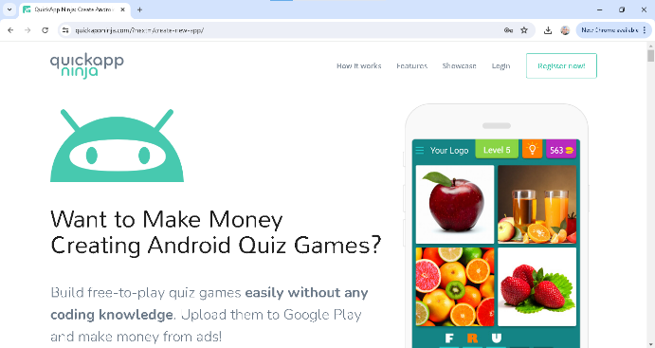
- Select one of the templates provided
Picture 2.
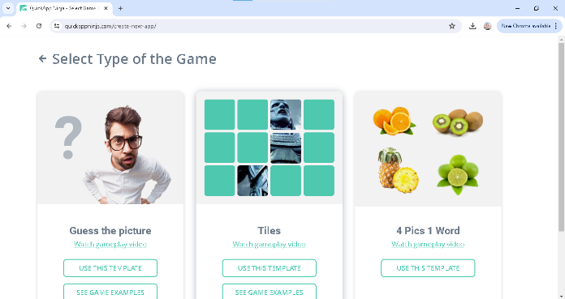
- Make questions and answers according to the template as attractive as possible
Picture 3.
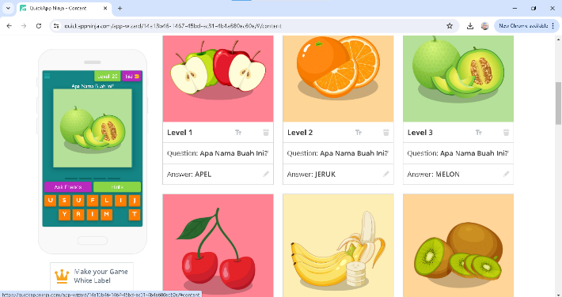
- Design the appearance of the game starting from the initial application appearance, logo, icon, color, sound, image, background, game title, etc.
Picture 4.
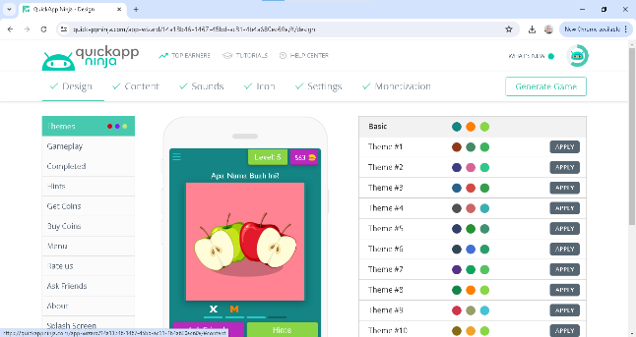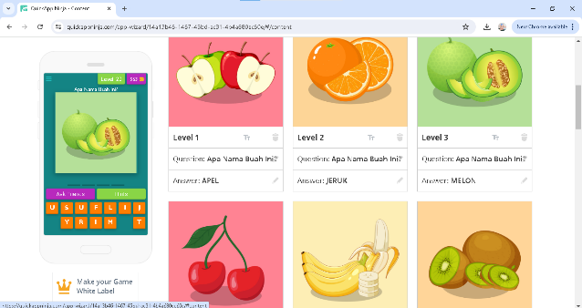
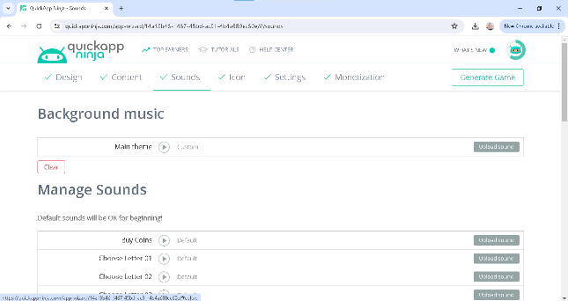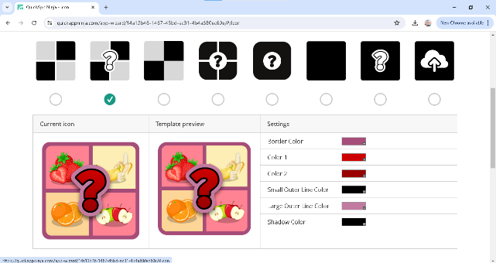
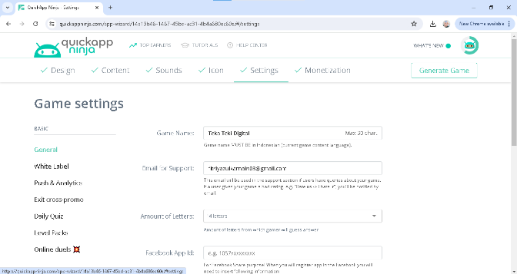

This design stage includes adapting learning media to learning achievement indicators in the independent curriculum and selecting interesting and fun learning media designs. This digital puzzle game-based learning media is a development of floor puzzle media to improve the ability to recognize letters in group B children at GMIM Eben Haezer Kapataran Kindergarten. Researchers developed learning media in the form of digital media, adapting to current developments, while utilizing digital developments as a learning medium for young children. The previous media used a floor puzzle mat that could be removed and had a safety level that was quite safe for children. This removable floor puzzle can also cause loss of puzzle pieces or cause damage so that the usage period does not last long. The following are learning media before being developed:

Picture 5. Learning Media Before Developing
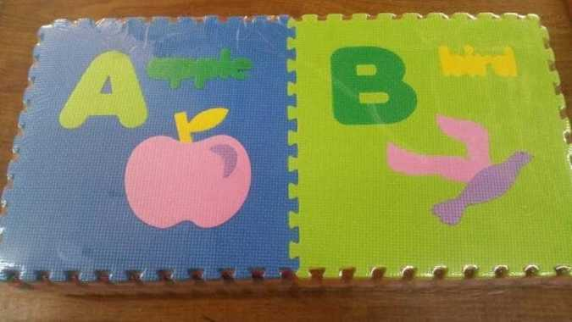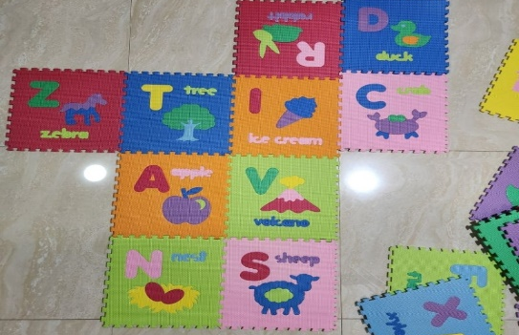
In the previous media development, namely floor puzzles, there were several features for children to play with, in this study, researchers only focused on one feature to improve children's linguistic intelligence, namely writing random letters. The digital puzzle game-based learning media that has been developed will be attached in full in the attachment, here are several pictures of the appearance of the digital puzzle game that has been developed:

Picture 6. Learning Media That Have Been Developed
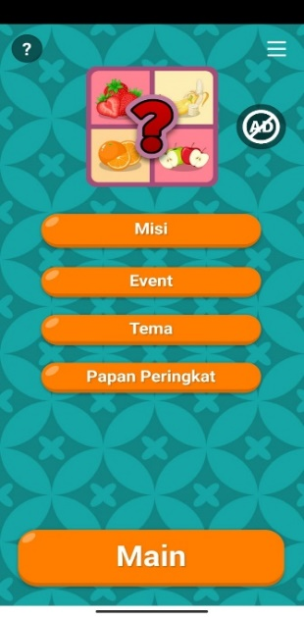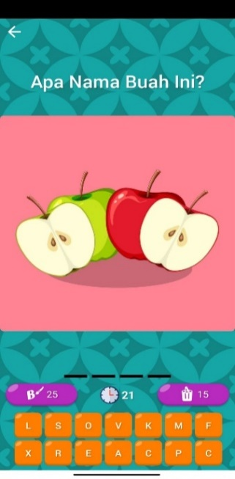

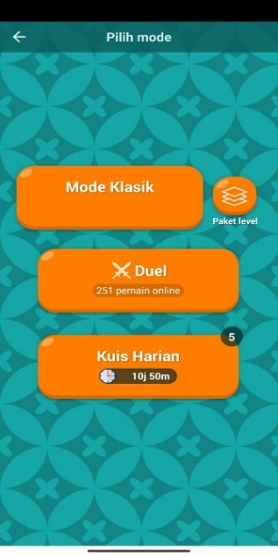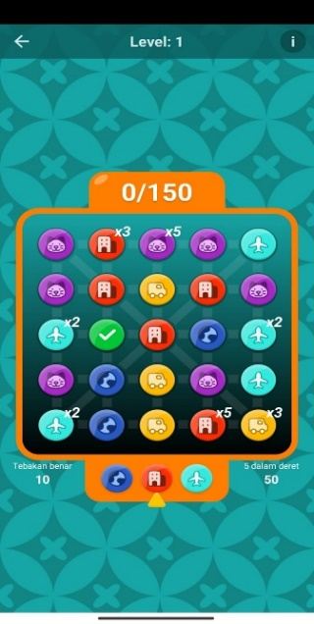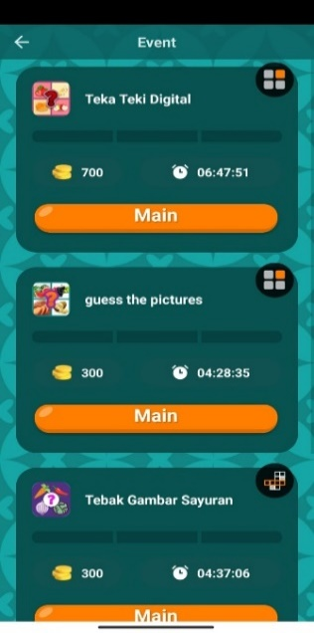
    - Development stage
Tahap The development stage in this research aims to see the validity of the media based on expert opinions to assess the validity, practicality, effectiveness of the learning media and materials that have been designed in the previous stage. Improvements are made in accordance with the assessment results and suggestions provided by the validator. The validity of the development of digital puzzle game-based learning media to improve the linguistic intelligence of early childhood, after being validated by validators from 3 expert teams, namely material experts and media experts. The following are the results of the validation test for learning media based on digital puzzle games: material experts obtained a percentage of $\frac{ 48 }{48}$ x 100% = 100%, media experts obtained a percentage of $\frac{ 47 }{48}$ x 100% = 97,92%. The learning media was declared very valid and worthy of being tested with revisions according to suggestions or input from a team of experts.
    - Implementation Stage
Data from the assessment of the practicality of teachers' responses to the learning media that has been developed has a score of 92.59% in the very practical category. Statement 1 with the interest assessment aspect received a score of 100%, statement 2 with the material assessment aspect received a score of 88.89% and statement 3 with the media appearance assessment aspect received a score of 88.89% with very practical criteria. The final total score for the practicality of learning media is $\frac{P1+P2+P3 }{3}$ so, $\frac{P1 \left(100\%\right) + P2 \left(88,89\%\right) + P3 (88,89\%) }{3}$ = $\frac{ 277,78\% }{3}$ = 92,59% (Very Practical).
The ability test was carried out 2 times, namely the first test before using digital puzzle game-based learning media (pretest) and the second test after using digital puzzle game-based learning media (posttest), here are the pretest results:

Table 4.10 Pretest Score Results
No | Child's Name | Assessment Indicators |  |  |  |  |  |  |  |  |  |  |  |  | Criteria
No | Child's Name | Number |  |  |  |  |  |  |  |  |  |  |  |  | Criteria
No | Child's Name | 1 | 2 | 3 | 4 | 5 | 6 | 7 | 8 | 9 | 10 | 11 | 12 |  | Criteria
1. | Rahim | 2 | 1 | 2 | 3 | 2 | 2 | 2 | 2 | 3 | 1 | 2 | 1 | 1,9 | Not enough
2. | Rahan | 2 | 1 | 2 | 3 | 2 | 2 | 2 | 2 | 2 | 1 | 2 | 2 | 1,9 | Not enough
3. | Rafael | 3 | 2 | 3 | 4 | 3 | 3 | 3 | 3 | 2 | 3 | 2 | 2 | 2,7 | Not enough
4. | Aulia | 2 | 2 | 2 | 2 | 2 | 2 | 2 | 2 | 2 | 2 | 3 | 1 | 2,0 | Not enough
5. | Angel | 2 | 1 | 1 | 3 | 2 | 2 | 2 | 3 | 3 | 1 | 2 | 2 | 2,0 | Not enough
6. | Attalah | 2 | 1 | 1 | 2 | 3 | 3 | 1 | 2 | 3 | 2 | 1 | 2 | 1,9 | Not enough
7. | Cindy | 2 | 1 | 1 | 2 | 2 | 2 | 2 | 2 | 3 | 2 | 1 | 2 | 1,8 | Not enough
8. | Erva | 2 | 1 | 2 | 1 | 2 | 2 | 2 | 2 | 2 | 1 | 2 | 3 | 1,8 | Not enough
9. | Khaira | 2 | 3 | 2 | 2 | 2 | 3 | 2 | 3 | 3 | 2 | 3 | 1 | 2,3 | Not enough
10. | Kirana | 2 | 1 | 1 | 2 | 2 | 2 | 3 | 2 | 3 | 1 | 2 | 1 | 1,8 | Not enough
11. | Adbit | 3 | 1 | 2 | 2 | 2 | 2 | 2 | 2 | 2 | 1 | 2 | 2 | 1,9 | Not enough
12. | Syabil | 2 | 1 | 2 | 3 | 2 | 2 | 1 | 2 | 2 | 1 | 1 | 3 | 1,8 | Not enough
13. | Intan | 2 | 1 | 2 | 3 | 3 | 2 | 2 | 2 | 3 | 1 | 2 | 1 | 2,0 | Not enough
14. | Dwi | 3 | 1 | 1 | 2 | 2 | 2 | 2 | 2 | 2 | 2 | 1 | 2 | 1,8 | Not enough
15 | Qowi | 2 | 2 | 1 | 2 | 2 | 2 | 3 | 1 | 2 | 2 | 1 | 2 | 1,8 | Not enough
Amount |  | 33 | 20 | 25 | 36 | 33 | 33 | 31 | 32 | 37 | 23 | 27 | 27 | 29,7
Average |  | 2,2 | 1,3 | 1,6 | 2,4 | 2,2 | 2,2 | 2,0 | 2,1 | 2,4 | 1,5 | 1,8 | 1,8 | 1,98 | Not enough
Category |  | K | K | K | K | K | K | K | K | K | K | K | K | Not enough
Based on the results of the pretest scores, it is known that 15 children got average scores with less criteria. The average obtained from the pretest score of 15 children was 1.98, within a score of 1.8 – 2.7 with poor assessment criteria.
Table 4.11 Posttest Score Results
No. | Child's Name | Assessment Indicators |  |  |  |  |  |  |  |  |  |  |  |  | Criteria
No. | Child's Name | Number |  |  |  |  |  |  |  |  |  |  |  |  | Criteria
No. | Child's Name | 1 | 2 | 3 | 4 | 5 | 6 | 7 | 8 | 9 | 10 | 11 | 12 |  | Criteria
1. | Rahim | 5 | 4 | 4 | 5 | 4 | 4 | 5 | 5 | 4 | 4 | 5 | 4 | 4,4 | Good
2. | Rahan | 3 | 4 | 3 | 5 | 3 | 3 | 3 | 4 | 3 | 3 | 4 | 3 | 3,4 | Enough
3. | Rafael | 5 | 5 | 5 | 4 | 5 | 5 | 5 | 5 | 4 | 5 | 4 | 5 | 4,7 | very well
4. | Aulia | 3 | 4 | 3 | 4 | 4 | 3 | 3 | 3 | 3 | 4 | 5 | 3 | 3,5 | Enough
5. | Angel | 4 | 4 | 4 | 5 | 4 | 4 | 4 | 5 | 5 | 4 | 4 | 4 | 4,2 | Good
6. | Attalah | 5 | 4 | 4 | 4 | 5 | 5 | 4 | 4 | 5 | 4 | 4 | 4 | 4,3 | Good
7. | Cindy | 4 | 4 | 3 | 4 | 3 | 3 | 4 | 3 | 3 | 4 | 4 | 3 | 4,1 | Enough
8. | Erva | 4 | 4 | 5 | 4 | 5 | 4 | 4 | 4 | 4 | 4 | 5 | 4 | 4,2 | Good
9. | Khaira | 5 | 5 | 4 | 4 | 4 | 4 | 4 | 5 | 5 | 4 | 5 | 4 | 4,4 | Good
10. | Kirana | 5 | 5 | 4 | 4 | 5 | 5 | 5 | 4 | 5 | 4 | 4 | 4 | 4,5 | Good
11. | Adbit | 5 | 5 | 5 | 4 | 4 | 5 | 5 | 5 | 4 | 5 | 5 | 4 | 4,6 | very well
12. | Syabil | 4 | 4 | 4 | 5 | 4 | 5 | 4 | 4 | 5 | 4 | 4 | 5 | 4,3 | Good
13. | Intan | 5 | 4 | 4 | 5 | 5 | 4 | 5 | 4 | 5 | 4 | 4 | 4 | 4,4 | Good
14. | Dwi | 5 | 4 | 4 | 4 | 5 | 5 | 4 | 4 | 4 | 4 | 5 | 4 | 4,3 | Good
15 | Qowi | 5 | 5 | 4 | 5 | 4 | 4 | 5 | 4 | 5 | 5 | 4 | 4 | 4,5 | Good
Amount |  | 67 | 65 | 60 | 66 | 64 | 63 | 64 | 63 | 64 | 62 | 66 | 59 | 63,5
Average |  | 4,4 | 4,4 | 4,0 | 4,4 | 4,2 | 4,2 | 4,2 | 4,2 | 4,2 | 4,1 | 4,4 | 3,9 | 4,2 | Good
Category |  | B | B | B | B | B | B | B | B | B | B | B | B | Good

The application of the use of digital puzzle game-based learning media in the learning process shows that it has increased, although there are some children who are still in the sufficient criteria. Based on the results of the posttest scores, it is known that there are still 3 children with sufficient criteria, 10 children with good criteria and 2 children with very good categories. The average obtained from the posttest score of 15 children was 4.2, within a score of 3.6 – 4.5 with good criteria. Overall, from the posttest, the increase in children's linguistic intelligence has been good and has increased.
Based on the results obtained, it can be concluded that the development of digital puzzle game-based learning media in improving children's linguistic intelligence is declared effective and has fulfilled 3 requirements, namely the posttest score with a score of 4.2 with good criteria, the average posttest score is above the pretest score. and the average posttest score is above the completion score.
    - Evaluation Stage
Learning media based on digital puzzle games needs to be evaluated, this is seen based on the implementation stages that have been carried out. The product that has been developed has shortcomings because there are several things that are less efficient in implementing the learning media. The results of the teacher's responses showed that in the digital puzzle game-based learning media, at the game stage, children were asked to play puzzle games alternately with their friends, but in practice this was less efficient if there were 5 (five) children on one device simultaneously. alternate. Therefore, the teacher uses another alternative, namely by providing 1 (one) device for only 2 (two) children to avoid commotion with the children and at the same time teach children to cooperate with their playmates.
From the results of validity, practicality and effectiveness at the development and implementation stages, digital puzzle game-based learning media is feasible.

Discussion
Based on previous research regarding learning media in the form of floor puzzles, children's ability to recognize letters is not just their ability to name them. However, the implementation of the research starts from the child's ability to name letters, the child is able to understand the relationship between letter shapes and objects and the child is able to name the letters in sequence. The floor puzzle media used to improve the ability to recognize letters produces fun learning in the classroom, because the puzzle media is used in the form of a fun game.(Lotulung 2016)
Digital puzzle game learning media is very interesting to develop because previous media have not utilized existing media developments. There are several advantages of digital puzzle game learning media compared to previous media. One of the main advantages of digital puzzle game learning media is the visualization of problems. real. Based on the game's pattern, players are required to learn so they can solve existing problems. The game status, instructions and tools provided by the game will actively guide players to dig up information so they can enrich their knowledge and strategies when playing. This digital puzzle game learning media can be used as an alternative learning medium for Early Childhood Education (PAUD) teachers in changing conventional learning methods into game simulation learning methods, so that they can develop children's creativity, because educational games have elements of challenge, accuracy and reasoning power. and ethics.(Vitianingsih 2016)
- CONCLUSION
Based on the problem formulation and results of development research, it is concluded that: The validity of developing learning media based on digital puzzle games to improve the linguistic intelligence of early childhood, after being validated by validators from 3 expert teams, namely material experts with a percentage of 100%, and media experts with a percentage of 97, 92%, which means digital puzzle game-based learning media to improve the linguistic intelligence of early childhood is declared "valid" and the product is ready to use. The practicality of developing learning media based on digital puzzle games to improve the linguistic intelligence of early childhood, after data analysis based on the results of the assessment sheet, the practicality of teachers' responses to the learning media that has been developed has an average score of 92.59% in the very practical category. The effectiveness of developing learning media based on digital puzzle games to improve the linguistic intelligence of early childhood, based on the results of pretests and posttests that have been carried out, states that learning media based on digital puzzle games is effective for children. The pretest result obtained was 1.98 with poor assessment criteria and the posttest result obtained was 4.2 with good criteria.
The author would like to express his deepest gratitude to all parties who have contributed to the preparation and completion of this research. All the support and assistance provided was very helpful and played an important role in completing this research. The author hopes that this research can be useful and contribute to the development of science.

REFERENCES
ANWAR, DESI. 2003. KAMUS LENGKA BAHASA INDONESIA. surabaya: AMeLIA.
Armstrong, Thomas. 2018. 4th Edition ADVANCE UNCORRECTED COPY-NOT FOR DISTRIBUTION.
Faizah, Silviana Nur. 2020. “Hakikat Belajar Dan Pembelajaran.” At-Thullab : Jurnal Pendidikan Guru Madrasah Ibtidaiyah 1(2):175. doi: 10.30736/atl.v1i2.85.
Firdaus, Muthiara, Muryanti, and Elise. 2020. “Games Edukasi Bahasa Inggris Untuk Pengembangan Kosakata Bahasa Inggris Pada Anak Usia Dini.” Jurnal Pendidikan Tambusai 4(2):1216–27.
Gabriela, Novika Dian Pancasari. 2021. “Pengaruh Media Pembelajaran Berbasi Audio Visual Terhadap Peningkatan Hasil Belajar Sekolah Dasar.” Mahaguru: Jurnal Pendidikan Guru Sekolah Dasar 2(1):104–13. doi: 10.33487/mgr.v2i1.1750.
Hasbi, Adiarti, Rahmita. 2020. “Toolkit Pemanfaatan Literasi Digital Dalam Pembelajaran Anak Usia Dini.” Kementerian Pendidikan Dan Kebudayaan 1–45.
Hildayah, Dewi. 2019. “Penggunaan Media Visual, Auditif, Dan Kinestik Untuk Meningkatkan Hasil Belajar Siswa.” Prosiding Seminar Nasional Pendidikan FKIP 2(1):137–46.
Howard gardner. 2013. MULTIPLE INTELLIGENCES. 1st ed. edited by Pray. jakarta: daras books.
Jaya, Farida. 2019. “Buku Perencanaan Pembelajaran-Full.Pdf.” 2019 152.
Kurniasih, Eem. 2019. “Media Digital Pada Anak Usia Dini.” Jurnal Kreatif 9(2):87–91.
Latif, A., W. Rohmiyanti, I. Syafira, S. Wahiddatul, and A. D. Haryanto. 2021. “Penggunaan Media Pembelajaran Berbasis Game Edukasi Sebagai Upaya Meningkatkan Minat Belajar Siswa Sekolah Dasar.” SEMAI: Seminar … 809–25.
Lotulung, Indra Liny. 2016. “Penggunaan Media Puzzle Lantai Untuk Meningkatkan Kemampuan Mengenal Huruf Pada Anak Kelompok B Di Tk Gmim Eben Haezer Kapataran.” Jurnal Ilmiah Wahana Pendidikan 19(5):1–23.
Nirwana, Evi Selva. 2021. “Pengembangan Media Pembelajaran Berbasis Game Android Untuk Anak Usia 5-6 Tahun.” Jurnal Obsesi : Jurnal Pendidikan Anak Usia Dini 6(3):1811–18. doi: 10.31004/obsesi.v6i3.1684.
Rachman, Tahar. 2018. “Permendikbud_Nomor_146_Tahun_2014.” Angewandte Chemie International Edition, 6(11), 951–952. 10–27.
Rahayu, Puji. 2019. “Pengaruh Era Digital Terhadap Perkembangan Bahasa Anak.” Al-Fathin: Jurnal Bahasa Dan Sastra Arab 2(1):47. doi: 10.32332/al-fathin.v2i2.1423.
Ramilda, ayu rahma. 2021. APLIKASI MOBILE GAME EDUKASI ANIMAL WORLD UNTUK MENINGKATKAN KECERDASAN LINGUISTIK VERBAL ANAK USIA DINI DI RA BABUL JANNAH KOTA BENGKULU. Vol. 53. bengkulu: universitas islam negeri fatmawati sukarno.
Savitri, Savitri. 2023. “Perancangan Game Edukasi Susun Huruf Bahasa Inggris Untuk Mengenal Hewan Bagi Anak Usia Dini.” TIN: Terapan Informatika Nusantara 4(3):218–22. doi: 10.47065/tin.v4i3.4174.
Septiawati, Dewi, Nunuk Suryani, and Herry Widyastono. 2021. “Penggunaan Game Edukasi Terhadap Kemampuan Kosakata Anak Tunarungu.” CoMBInES - Conference on Management, Business, Innovation, Education and Social Sciences 1(1):246–57.
Sugiarto. 2021. “Teka Teki Bergambar Sebagai Upaya Menstimulus Penguasaan Kosa Kata Anak Usia Dini.” Mubtadiin 7(2):227.
sugiyono. 2011. “Metode Penelitian Kuantitatif Kualitatif Dan R&d. Intro ( PDFDrive ).Pdf.” Bandung Alf 143.
Susilowati, Nenden. 2014. “Penggunaan Media Manipulatif Untuk Meningkatkan Kemampuan Mengenal Konsep Bilangan Pada Anak Usia Dini (Studi Kasus Di POS PAUD MELATI Kecamatan Regol Kota Bandung).” Empowerment : Jurnal Ilmiah Program Studi Pendidikan Luar Sekolah 3(2):152–61.
Suyasa, I. Made, and I. Nyoman Sedana. 2020. “Mempertahankan Eksistensi Media Cetak Di Tengah Gempuran Media Online.” Jurnal Komunikasi Dan Budaya 1(1):56–64. doi: 10.54895/jkb.v1i1.314.
Syarifah, Syarifah. 2019. “Konsep Kecerdasan Majemuk Howard Gardner.” SUSTAINABLE: Jurnal Kajian Mutu Pendidikan 2(2):176–97. doi: 10.32923/kjmp.v2i2.987.
Vitianingsih, Anik Vega. 2016. “Game Edukasi Sebagai Media Pembelajaran PAUD.” Jurnal INFORM 1(1):1–8.
Winaryati, Eny. 2021. Cercular Model of RD & D Model RD&D Pendidikan Dan Sosial.
Winda, Elvis, Nepi Apriana, and Alimni Dahlan. 2023. “Ar-Raihanah : Jurnal Pendidikan Islam Anak Usia Dini Volume 3 Nomor 2 Desember 2023 , Pages 257-265 ISSN : 2830-5868 ( Online ); ISSN : 2614-7831 ( Printed ); Peran Guru Dalam Mengembangkan Kognitif Anak Di TK Al-Fadilah Kota Bengkulu.” 3:257–65.
Wiyani, Muhamad Irham Dan Novan Ardy. 2013. Psikologi Pendidikan (Teori Dan Aplikasi Dalam Proses Pembelajaran). edited by rose kusumaning Ratri. jogjakarta: AR-RUZZ MEDIA.
Yaumi, Muhammad. 2012. Pembelajaran Berbasis MultiPle Intelligences. 1st ed. jakarta: PT dian rakyat.

