Hasil Output Analisis Data dengan SPSS
- Deskripsi Data Motivasi dan Nilai Siswa

Frequencies
Notes
Output Created |  | 25-JUN-2024 08:34:21
Comments
Input | Data | D:\olah data\uji N Gain.sav
Input | Active Dataset | DataSet1
Input | Filter | <none>
Input | Weight | <none>
Input | Split File | <none>
Input | N of Rows in Working Data File | 205
Missing Value Handling | Definition of Missing | User-defined missing values are treated as missing.
Missing Value Handling | Cases Used | Statistics are based on all cases with valid data.
Syntax |  | FREQUENCIES VARIABLES=Pre  /STATISTICS=STDDEV MINIMUM MAXIMUM MEAN MODE SUM  /ORDER=ANALYSIS.
Resources | Processor Time | 00:00:00,02
Resources | Elapsed Time | 00:00:00,01

Statistics
Pre Test
N | Valid | 205
N | Missing | 0
Mean |  | 81.76
Mode |  | 80
Std. Deviation |  | 3.909
Minimum |  | 75
Maximum |  | 90
Sum |  | 16760

Pre Test
 |  | Frequency | Percent | Valid Percent | Cumulative Percent
Valid | 75 | 24 | 11.7 | 11.7 | 11.7
Valid | 80 | 100 | 48.8 | 48.8 | 60.5
Valid | 85 | 66 | 32.2 | 32.2 | 92.7
Valid | 90 | 15 | 7.3 | 7.3 | 100.0
Valid | Total | 205 | 100.0 | 100.0

Statistics
Post Tes
N | Valid | 205
N | Missing | 0
Mean |  | 83.56
Mode |  | 85
Std. Deviation |  | 4.671
Minimum |  | 75
Maximum |  | 100
Sum |  | 17130

Post Tes
 |  | Frequency | Percent | Valid Percent | Cumulative Percent
Valid | 75 | 12 | 5.9 | 5.9 | 5.9
Valid | 80 | 75 | 36.6 | 36.6 | 42.4
Valid | 85 | 92 | 44.9 | 44.9 | 87.3
Valid | 90 | 14 | 6.8 | 6.8 | 94.1
Valid | 95 | 10 | 4.9 | 4.9 | 99.0
Valid | 100 | 2 | 1.0 | 1.0 | 100.0
Valid | Total | 205 | 100.0 | 100.0

Descriptive Statistics Motivasi
 | N | Range | Minimum | Maximum | Mean | Std. Deviation | Variance
M1 | 101 | 2 | 3 | 5 | 4.84 | .418 | .175
M2 | 101 | 3 | 2 | 5 | 4.86 | .510 | .261
M3 | 101 | 2 | 3 | 5 | 4.82 | .498 | .248
M4 | 101 | 2 | 3 | 5 | 4.84 | .463 | .215
M5 | 101 | 1 | 4 | 5 | 4.88 | .325 | .106
M6 | 101 | 4 | 1 | 5 | 2.50 | 1.426 | 2.032
M7 | 101 | 2 | 3 | 5 | 4.60 | .584 | .342
M8 | 101 | 2 | 3 | 5 | 4.79 | .516 | .266
Valid N (listwise) | 101

- Hasil Uji Prasyarat dan Hipotesis

Regression

Notes
Output Created |  | 28-JUN-2024 09:27:22
Comments
Input | Data | D:\olah data\uji N Gain.sav
Input | Active Dataset | DataSet1
Input | Filter | <none>
Input | Weight | <none>
Input | Split File | <none>
Input | N of Rows in Working Data File | 205
Missing Value Handling | Definition of Missing | User-defined missing values are treated as missing.
Missing Value Handling | Cases Used | Statistics are based on cases with no missing values for any variable used.
Syntax |  | REGRESSION  /MISSING LISTWISE  /STATISTICS COEFF OUTS R ANOVA  /CRITERIA=PIN(.05) POUT(.10)  /NOORIGIN  /DEPENDENT Post  /METHOD=ENTER Pre  /SCATTERPLOT=(*SRESID ,*ZPRED)  /RESIDUALS NORMPROB(ZRESID)  /SAVE RESID.
Resources | Processor Time | 00:00:01,28
Resources | Elapsed Time | 00:00:00,61
Resources | Memory Required | 3008 bytes
Resources | Additional Memory Required for Residual Plots | 336 bytes
Variables Created or Modified | RES_2 | Unstandardized Residual

Variables Entered/Removedª
Model | Variables Entered | Variables Removed | Method
1 | Pre Test^{b} | . | Enter

a. Dependent Variable: Post Tes
b. All requested variables entered.

Model Summary^{b}
Model | R | R Square | Adjusted R Square | Std. Error of the Estimate
1 | .649ª | .421 | .419 | 3.562

a. Predictors: (Constant), Pre Test
b. Dependent Variable: Post Tes

ANOVAª
Model |  | Sum of Squares | df | Mean Square | F | Sig.
1 | Regression | 1875.345 | 1 | 1875.345 | 147.835 | .000^{b}
1 | Residual | 2575.143 | 203 | 12.685
1 | Total | 4450.488 | 204

a. Dependent Variable: Post Tes
b. Predictors: (Constant), Pre Test

Coefficientsª
Model |  | Unstandardized Coefficients |  | Standardized Coefficients | t | Sig.
 |  | B | Std. Error | Beta | t | Sig.
1 | (Constant) | 20.154 | 5.221 |  | 3.860 | .000
1 | Pre Test | .776 | .064 | .649 | 12.159 | .000

a. Dependent Variable: Post Tes

Residuals Statisticsª
 | Minimum | Maximum | Mean | Std. Deviation | N
Predicted Value | 78.32 | 89.95 | 83.56 | 3.032 | 205
Std. Predicted Value | -1.728 | 2.109 | .000 | 1.000 | 205
Standard Error of Predicted Value | .273 | .582 | .338 | .098 | 205
Adjusted Predicted Value | 78.29 | 90.09 | 83.56 | 3.029 | 205
Residual | -7.199 | 13.923 | .000 | 3.553 | 205
Std. Residual | -2.021 | 3.909 | .000 | .998 | 205
Stud. Residual | -2.027 | 3.925 | .000 | 1.003 | 205
Deleted Residual | -7.242 | 14.039 | .002 | 3.592 | 205
Stud. Deleted Residual | -2.043 | 4.073 | .001 | 1.010 | 205
Mahal. Distance | .202 | 4.447 | .995 | 1.297 | 205
Cook's Distance | .000 | .112 | .005 | .011 | 205
Centered Leverage Value | .001 | .022 | .005 | .006 | 205
a. Dependent Variable: Post Tes

Charts
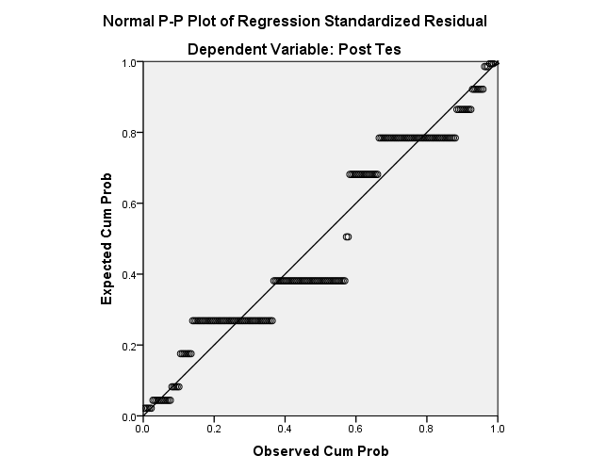

Oneway

Notes
Output Created |  | 28-JUN-2024 09:32:39
Comments
Input | Data | D:\olah data\uji N Gain.sav
Input | Active Dataset | DataSet1
Input | Filter | <none>
Input | Weight | <none>
Input | Split File | <none>
Input | N of Rows in Working Data File | 205
Missing Value Handling | Definition of Missing | User-defined missing values are treated as missing.
Missing Value Handling | Cases Used | Statistics for each analysis are based on cases with no missing data for any variable in the analysis.
Syntax |  | ONEWAY Post Pre BY Kelompok  /STATISTICS HOMOGENEITY  /MISSING ANALYSIS.
Resources | Processor Time | 00:00:00,00
Resources | Elapsed Time | 00:00:00,03

Test of Homogeneity of Variances
 | Levene Statistic | df1 | df2 | Sig.
Post Tes | .008 | 1 | 203 | .927
Pre Test | .654 | 1 | 203 | .420

ANOVA
 |  | Sum of Squares | df | Mean Square | F | Sig.
Post Tes | Between Groups | 707.076 | 1 | 707.076 | 38.344 | .000
Post Tes | Within Groups | 3743.412 | 203 | 18.440
Post Tes | Total | 4450.488 | 204
Pre Test | Between Groups | 186.038 | 1 | 186.038 | 12.882 | .000
Pre Test | Within Groups | 2931.766 | 203 | 14.442
Pre Test | Total | 3117.805 | 204

Explore

Notes
Output Created |  | 18-JUN-2024 09:29:15
Comments
Input | Data | D:\olah data\uji N Gain.sav
Input | Active Dataset | DataSet0
Input | Filter | <none>
Input | Weight | <none>
Input | Split File | <none>
Input | N of Rows in Working Data File | 205
Missing Value Handling | Definition of Missing | User-defined missing values for dependent variables are treated as missing.
Missing Value Handling | Cases Used | Statistics are based on cases with no missing values for any dependent variable or factor used.
Syntax |  | EXAMINE VARIABLES=NGain_Skor BY Kelompok  /PLOT BOXPLOT STEMLEAF  /COMPARE GROUPS  /STATISTICS DESCRIPTIVES  /CINTERVAL 95  /MISSING LISTWISE  /NOTOTAL.
Resources | Processor Time | 00:00:01,64
Resources | Elapsed Time | 00:00:00,89

Kelas

Case Processing Summary
 | Kelas | Cases
 | Kelas | Valid |  | Missing |  | Total
 | Kelas | N | Percent | N | Percent | N | Percent
NGain_Skor | Eksperimen | 101 | 100.0% | 0 | 0.0% | 101 | 100.0%
NGain_Skor | Kontrol | 104 | 100.0% | 0 | 0.0% | 104 | 100.0%

Descriptives
 | Kelas |  |  | Statistic | Std. Error
NGain_Skor | Eksperimen | Mean |  | .1571 | .02670
NGain_Skor | Eksperimen | 95% Confidence Interval for Mean | Lower Bound | .1041
NGain_Skor | Eksperimen | 95% Confidence Interval for Mean | Upper Bound | .2101
NGain_Skor | Eksperimen | 5% Trimmed Mean |  | .1525
NGain_Skor | Eksperimen | Median |  | .2500
NGain_Skor | Eksperimen | Variance |  | .072
NGain_Skor | Eksperimen | Std. Deviation |  | .26833
NGain_Skor | Eksperimen | Minimum |  | -.50
NGain_Skor | Eksperimen | Maximum |  | 1.00
NGain_Skor | Eksperimen | Range |  | 1.50
NGain_Skor | Eksperimen | Interquartile Range |  | .25
NGain_Skor | Eksperimen | Skewness |  | .254 | .240
NGain_Skor | Eksperimen | Kurtosis |  | 1.301 | .476
NGain_Skor | Kontrol | Mean |  | .0324 | .01758
NGain_Skor | Kontrol | 95% Confidence Interval for Mean | Lower Bound | -.0025
NGain_Skor | Kontrol | 95% Confidence Interval for Mean | Upper Bound | .0672
NGain_Skor | Kontrol | 5% Trimmed Mean |  | .0406
NGain_Skor | Kontrol | Median |  | .0000
NGain_Skor | Kontrol | Variance |  | .032
NGain_Skor | Kontrol | Std. Deviation |  | .17923
NGain_Skor | Kontrol | Minimum |  | -.50
NGain_Skor | Kontrol | Maximum |  | .50
NGain_Skor | Kontrol | Range |  | 1.00
NGain_Skor | Kontrol | Interquartile Range |  | .20
NGain_Skor | Kontrol | Skewness |  | -.671 | .237
NGain_Skor | Kontrol | Kurtosis |  | 1.439 | .469

NGain_Skor

Stem-and-Leaf Plots

NGain_Skor Stem-and-Leaf Plot for
Kelompok= Eksperimen

Frequency Stem & Leaf

2,00 Extremes (=<-,50)
7,00 -3 . 3333333
,00 -2 .
,00 -2 .
,00 -1 .
,00 -1 .
,00 -0 .
,00 -0 .
37,00 0 . 0000000000000000000000000000000000000
,00 0 .
,00 1 .
,00 1 .
1,00 2 . 0
34,00 2 . 5555555555555555555555555555555555
6,00 3 . 333333
,00 3 .
,00 4 .
,00 4 .
9,00 5 . 000000000
5,00 Extremes (>=,67)

Stem width: ,10
Each leaf: 1 case(s)

NGain_Skor Stem-and-Leaf Plot for
Kelompok= Kontrol

Frequency Stem & Leaf

7,00 Extremes (=<-,33)
5,00 -2 . 55555
,00 -2 .
,00 -1 .
,00 -1 .
,00 -0 .
,00 -0 .
61,00 0 . 0000000000000000000000000000000000000000000000000000000000000
,00 0 .
,00 1 .
,00 1 .
16,00 2 . 0000000000000000
11,00 2 . 55555555555
3,00 3 . 333
,00 3 .
,00 4 .
,00 4 .
1,00 5 . 0

Stem width: ,10
Each leaf: 1 case(s)

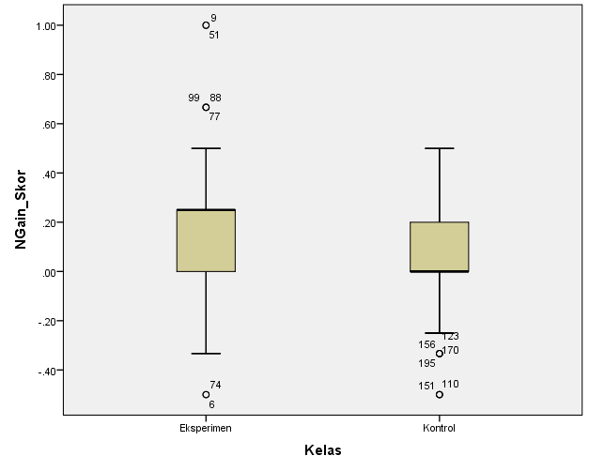

Explore

Notes
Output Created |  | 18-JUN-2024 09:29:32
Comments
Input | Data | D:\olah data\uji N Gain.sav
Input | Active Dataset | DataSet0
Input | Filter | <none>
Input | Weight | <none>
Input | Split File | <none>
Input | N of Rows in Working Data File | 205
Missing Value Handling | Definition of Missing | User-defined missing values for dependent variables are treated as missing.
Missing Value Handling | Cases Used | Statistics are based on cases with no missing values for any dependent variable or factor used.
Syntax |  | EXAMINE VARIABLES=NGain_Percent BY Kelompok  /PLOT BOXPLOT STEMLEAF  /COMPARE GROUPS  /STATISTICS DESCRIPTIVES  /CINTERVAL 95  /MISSING LISTWISE  /NOTOTAL.
Resources | Processor Time | 00:00:00,58
Resources | Elapsed Time | 00:00:00,42

Kelas

Case Processing Summary
 | Kelas | Cases
 | Kelas | Valid |  | Missing |  | Total
 | Kelas | N | Percent | N | Percent | N | Percent
NGain_Percent | Eksperimen | 101 | 100.0% | 0 | 0.0% | 101 | 100.0%
NGain_Percent | Kontrol | 104 | 100.0% | 0 | 0.0% | 104 | 100.0%

Descriptives
 | Kelas |  |  | Statistic | Std. Error
NGain_Percent | Eksperimen | Mean |  | 15.7096 | 2.67000
NGain_Percent | Eksperimen | 95% Confidence Interval for Mean | Lower Bound | 10.4124
NGain_Percent | Eksperimen | 95% Confidence Interval for Mean | Upper Bound | 21.0068
NGain_Percent | Eksperimen | 5% Trimmed Mean |  | 15.2457
NGain_Percent | Eksperimen | Median |  | 25.0000
NGain_Percent | Eksperimen | Variance |  | 720.019
NGain_Percent | Eksperimen | Std. Deviation |  | 26.83317
NGain_Percent | Eksperimen | Minimum |  | -50.00
NGain_Percent | Eksperimen | Maximum |  | 100.00
NGain_Percent | Eksperimen | Range |  | 150.00
NGain_Percent | Eksperimen | Interquartile Range |  | 25.00
NGain_Percent | Eksperimen | Skewness |  | .254 | .240
NGain_Percent | Eksperimen | Kurtosis |  | 1.301 | .476
NGain_Percent | Kontrol | Mean |  | 3.2372 | 1.75752
NGain_Percent | Kontrol | 95% Confidence Interval for Mean | Lower Bound | -.2484
NGain_Percent | Kontrol | 95% Confidence Interval for Mean | Upper Bound | 6.7228
NGain_Percent | Kontrol | 5% Trimmed Mean |  | 4.0598
NGain_Percent | Kontrol | Median |  | .0000
NGain_Percent | Kontrol | Variance |  | 321.242
NGain_Percent | Kontrol | Std. Deviation |  | 17.92323
NGain_Percent | Kontrol | Minimum |  | -50.00
NGain_Percent | Kontrol | Maximum |  | 50.00
NGain_Percent | Kontrol | Range |  | 100.00
NGain_Percent | Kontrol | Interquartile Range |  | 20.00
NGain_Percent | Kontrol | Skewness |  | -.671 | .237
NGain_Percent | Kontrol | Kurtosis |  | 1.439 | .469

NGain_Percent

Stem-and-Leaf Plots

NGain_Percent Stem-and-Leaf Plot for
Kelompok= Eksperimen

Frequency Stem & Leaf

2,00 Extremes (=<-50)
7,00 -3 . 3333333
,00 -2 .
,00 -2 .
,00 -1 .
,00 -1 .
,00 -0 .
,00 -0 .
37,00 0 . 0000000000000000000000000000000000000
,00 0 .
,00 1 .
,00 1 .
1,00 2 . 0
34,00 2 . 5555555555555555555555555555555555
6,00 3 . 333333
,00 3 .
,00 4 .
,00 4 .
9,00 5 . 000000000
5,00 Extremes (>=67)

Stem width: 10,00
Each leaf: 1 case(s)

NGain_Percent Stem-and-Leaf Plot for
Kelompok= Kontrol

Frequency Stem & Leaf

7,00 Extremes (=<-33)
5,00 -2 . 55555
,00 -2 .
,00 -1 .
,00 -1 .
,00 -0 .
,00 -0 .
61,00 0 . 0000000000000000000000000000000000000000000000000000000000000
,00 0 .
,00 1 .
,00 1 .
16,00 2 . 0000000000000000
11,00 2 . 55555555555
3,00 3 . 333
,00 3 .
,00 4 .
,00 4 .
1,00 5 . 0

Stem width: 10,00
Each leaf: 1 case(s)

