Teaching Pa'gellu' Dance to International Students
Reni Lolotandung¹, Trivena², Hakpantria³, Tadius ⁴, Mersilina Luther Patintingan⁵, Irnes Bulan Dari⁶, Bhakti Sharma⁷, Eliza Prall⁸
¹ Universitas Kristen Indonesia Toraja ; renilolotandung@ukitoraja.ac.id
² Universitas Kristen Indonesia Toraja ; trivena@ukitoraja.ac.id
³ Universitas Kristen Indonesia Toraja ; hakpantria@ukitoraja.ac.id
⁴ Universitas Kristen Indonesia Toraja ; tadius@ukitoraja.ac.id
⁵ Universitas Kristen Indonesia Toraja ; mersilina@ukitoraja.ac.id
⁶ Universitas Kristen Indonesia Toraja ; irnes@gmail.com
⁷ University of Western Australia ; 23191845@student.uwa.edu.au
⁸ University of Western Australia ; 23456501@student.uwa.edu.au

ARTICLE INFO |  | ABSTRACT
Keywords:  International Students;  Pa’gellu’ Dance;  Teaching  (List three to five pertinent keywords specific to the article; yet reasonably common within the subject discipline; use lower case except for names). |  | The Indonesian Language for Foreign Speakers (BIPA) program at the Christian University of Indonesia Toraja (UKI Toraja) is designed to teach the Indonesian language to non-native speakers while introducing them to Toraja culture. A significant aspect of this cultural introduction involves teaching the Pa'gellu' dance, a traditional dance of the Toraja people. This study aims to explore the pedagogical approach used in teaching the Pa'gellu' dance to international students at UKI Toraja, detailing the learning stages such as Introduction and Theory, Basic Practice, Technique Refinement, Costume and Performance, Cultural Integration, Evaluation, and Staging. The research employs a descriptive approach, focusing on 17 students from the University of Western Australia in Denpasar, Bali. An observation sheet was utilized to assess the effectiveness of the Pa'gellu' dance instruction. The findings indicate that the learning objectives were met, as students successfully recognized and practiced the dance, culminating in a brief performance. Although the teaching methods for foreign students are similar to those used for regular students, the instruction provided is less comprehensive. The instructor employed various methods, including lectures, demonstrations, practice sessions, drills, simulations, and performance-based activities. Despite some challenges, the international students were able to master the basic elements of the Pa'gellu' dance.
Article history:
Received 2021-08-14
Revised 2021-11-12
Accepted 2022-01-17
 |  | This is an open access article under the CC BY-NC-SA license.
Corresponding Author:
First name Last name
Affiliation 1; e-mail@e-mail.com
- INTRODUCTION
The globalization of education has increased the need for cross-cultural exchange and understanding (Shadiev, Wang, & Huang, 2021). In this context, it is crucial to teach traditional cultural elements to international students in order to foster mutual respect and appreciation among diverse cultural groups (Tiawati, Rahmat, Kemal, & Chen, 2022). Indonesian Language for Foreign Speakers (BIPA) is one of the programs at the Christian University of Indonesia Toraja (UKI Toraja) designed to teach the Indonesian language to foreign speakers. BIPA students typically come from cultural backgrounds different from the culture and language they are learning (Yulianeta & Amandangi, 2021). Thus, in addition to learning the Indonesian language, foreign students also learn the culture of the Toraja tribe, including traditional dance (Hakpantria, Trivena, Mersilina Luther Patintingan, & Nanda Saputra, 2022).
One of the efforts to introduce Toraja culture is through the teaching of the Pa'gellu' dance, a traditional dance of the Toraja people in Indonesia, to international students in the BIPA (Indonesian Language for Foreign Speakers) program at the Christian University of Indonesia (UKI) Toraja (Ode & Alamiah, 2024). The Pa'gellu' dance is a ceremonial dance of the Toraja community, performed to celebrate joyful occasions such as house inaugurations, welcoming guests, harvest festivals, moving into a new house, and the Rambu Tuka' ceremony (thanksgiving event) .
The Pa'gellu' dance is a group dance typically performed by young women who have reached adulthood in odd numbers, such as 3, 5, 7, or 9, featuring 12 types of movements including Pa’tabe’, Pa'gellu Tua, Pa'dena'-dena’, Pa’langkan-langkan, Penggirik tang tarru', Pa'lolok pao, Pangrapa Pentalun, Pa'tulekke, Passiri, Pa'kaka bale, Pangrampanan, and Pa'tutu’ kaka bua (Pala’langan, 2014). The movements of this dance vary depending on the region where it is performed. These are traditional movements that remain quite simple, often with similar gestures and repetition. The dance originated from the community's expression of joy after returning victorious from the battlefield, where they would dance to celebrate their success. Pa'gellu' is known for its intricate movements, colorful costumes, and symbolic meaning. Although considered complex, the basic movements in Pa'gellu', such as tiptoeing (ma’ kadetten) and the graceful yet staccato hand movements (dira’pak), are relatively easy to follow for someone learning Pa'gellu' with intensive practice.
Additionally, the Pa'gellu' dance is a traditional Toraja dance in which the patterns and movements embody the values upheld by the Toraja people. The dance movements carry philosophical meanings and values, including religious, social, entertainment, communication, and economic aspects, all of which are related to the function of art and the life of the community. For the Toraja people, this dance represents pride and an expression of joy for the abundant blessings granted by God Almighty (Trivena et al., 2024). Therefore, introducing the Pa'gellu' dance to foreign students is expected not only to serve as an engaging cultural learning medium but also to help preserve and promote the rich cultural heritage of the Toraja community on an international stage.
This research aims to describe the pedagogical approach in teaching the Pa'gellu' dance to international students at UKI Toraja by outlining the learning steps employed, including Introduction and Theory, Basic Practice, Technique Deepening, Costume and Performance, Cultural Integration, Evaluation, and Staging. By delving deeper into the teaching of the Pa'gellu' dance to foreign students, this study aims to highlight the benefits of integrating traditional arts into language and cultural education for international students. Additionally, this research discusses the broader implications for cultural preservation and international cultural exchange (Evans, Kensington-Miller, & Novak, 2021).
Based on the background explained, the research problem in this study is: how is the learning process of the Pa'gellu' dance for foreign students, and what are the inhibiting and supporting factors? This study aims to understand and introduce the Pa'gellu' dance and to comprehend the learning process of the Pa'gellu' dance. The benefits of this research are to serve as a reference for other academics, as a resource for preserving the traditional dance of Toraja, and to enhance readers' knowledge. Additionally, the results of this research can be used as a guide in introducing the dances of Tana Toraja Regency to foreign nationals, particularly the Pa'gellu' dance.’

- METHODS
The research method used in this study is qualitative research with a descriptive approach (Sugiyono, 2019). Descriptive research is employed to understand how the Pa'gellu' dance is taught to international students. The research location is in Denpasar, Bali, with 17 students from the University of Western Australia as the subjects of the study. The instrument used to assess the implementation of the Pa'gellu' dance lessons for foreign students is an observation sheet (Kurniati et al., 2023). The activities observed during the Pa'gellu' dance lessons for foreign students include the following
Tabel 1. Activities in the Learning of the Pa'gellu' Dance
No. | Activities | Materials | Description
1. | Introduction and Theory | History and Meaning of the Pa'gellu' Dance | Students are encouraged to understand the historical background, philosophy, and meaning of the Pa'gellu' dance.
1. | Introduction and Theory | Components of the Pa'gellu' Dance | Explanation of the accompanying music, costumes, and props used in this dance.
2. | Basic Practice | Basic Movements | Students learn the basic movements of the Pa'gellu' dance, including foot steps, hand positions, and facial expressions.
2. | Basic Practice | Coordination, and Rhythm | Practice to improve coordination of movements with the accompanying music.
3. | Technique Deepening | Advanced Movements | Students learn more complex movements and special techniques in the Pa'gellu' dance.
3. | Technique Deepening | Choreography | Introduction to the complete choreography and practice to master the entire dance.
4. | Costumes and Performance | Costume Introduction | Students learn about the costumes used in the Pa'gellu' dance, including how to wear them.
4. | Costumes and Performance | Performance Simulation | Performance practice with costumes and props, as well as simulation of performing in front of an audience.
5. | Evaluation | Progress Evaluation | Periodic evaluations to assess students' progress in mastering the Pa'gellu' dance.
6. | Workshop/Performance | Collaborative Performance | Students are given the opportunity to perform with local dancers at cultural events, enhancing their learning experience.

In addition to observing the applied learning aspects, data collection was also carried out through interviews and documentation. The obtained data were then analyzed through the stages of reduction, data presentation, and conclusion drawing.
- FINDINGS AND DISCUSSION
This study aims to describe the aspects of learning the Pa'gellu' dance for foreign students. Data collection activities were conducted over a period of 2 weeks, during which foreign students learned the Pa'gellu' dance from dance theory to performance, taught by a dance instructor and students who are also Pa'gellu' dancers from UKI Toraja. The following is a summary of the research findings.

2.1. Introduction and Theory

The first learning activity for foreign students in the Pa'gellu' dance program is the introduction and theory. This activity is conducted in a classroom setting with a 45-minute time allocation, starting with a brief introduction followed by the presentation of the material. The material covered includes the history and meaning of the Pa'gellu' dance and its components. In the first part, students are introduced to the historical background, philosophy, and meaning of the Pa'gellu' dance, while the second part covers the accompanying music, costumes, and props used in the dance. The following is an image from the presentation of the material in the classroom.
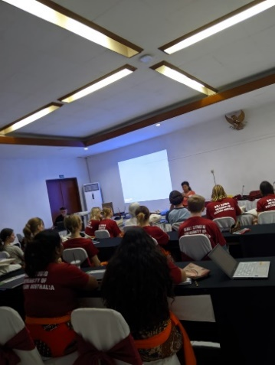

Figure 1. Presentation of the Introduction and Theory of the Pa'gellu' Dance in the classroom by a dance instructor from UKI Toraja

The presentation of the material was supported by showing images and videos of Toraja dancers performing the Pa'gellu' dance through an LCD projector to help students better understand the material presented. This introduction and theory aim to provide an overview of the Toraja people and their culture, as well as a brief introduction to the Pa'gellu' dance, to broaden the perspective and interest of foreign students regarding the Pa'gellu' dance. The foreign students listened and engaged with enthusiasm, and some students asked questions related to the material presented. The following are some of the students' questions:

A : What is the daily life of the Toraja people like?

B : When and where is this dance performed?

C : Is it difficult to perform this dance?

2.2. Basic Practice

The second activity is basic practice. In this aspect, students are taken outside the classroom to learn the basic movements, coordination, and rhythm of the Pa'gellu' dance. This is important for teaching movements such as foot steps, hand positions, and facial expressions, as well as practicing to improve the coordination of movements with the accompanying music. This activity is conducted over 3 sessions, with each session lasting 45 minutes. The basic movements taught include ma’ kadetten (tiptoeing) and ma’ra’pak (staccato and graceful hand movements), as these movements are performed from the beginning to the end of the dance without stopping. Initially, students found it challenging, especially with the tiptoeing (ma’ kadetten) because the body weight during this movement is supported on the toes, requiring intensive practice. Additionally, students also struggled to synchronize with the hand movements (ma’ra’pak). The following is an image of students engaging in basic practice:

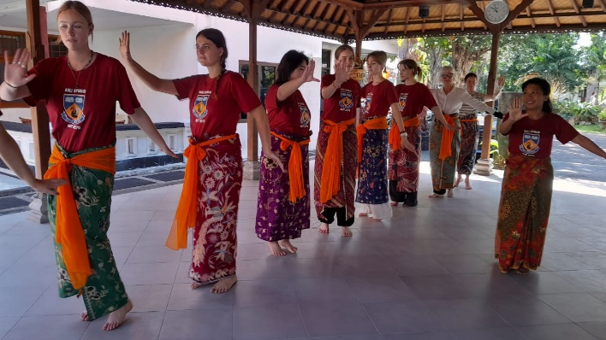

Figure 2. Basic Practice Activities for Ma’kadetten and Ma’ra’pak Movements in the Pa'gellu' Dance

2.3 Technique Deepening

In this learning activity, students practice more complex movements and special techniques in the Pa'gellu' dance, as well as an introduction to the complete choreography and practice to master the entire dance. This activity is conducted over 7 sessions, each lasting 45 minutes. The 12 movements in the Pa'gellu' dance are taught progressively, starting with Pa’tabe’, Pa'gellu Tua, Pa'dena'-dena’, Pa’langkan-langkan, Penggirik tang tarru', Pa'lolok pao, Pangrapa’ Pentallun, Pa'tulekke, Passiri, Pa'kaka bale, Pangrampanan, and Pa'tutu’ kaka bua. The twelve movements are not taught all at once; instead, 2-3 movements are taught in each session with several repetitions to facilitate memorization by the foreign students. In the 7th session, all movements are combined and practiced with multiple repetitions from the first to the twelfth movement.

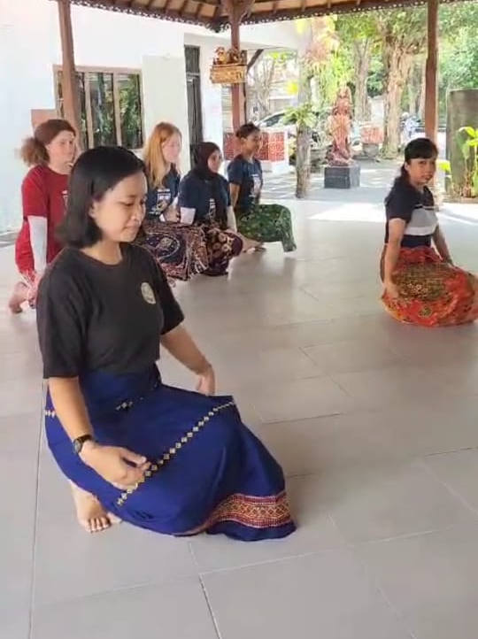

Figure 3. Technique Deepening of the 12 Movements in the Pa'gellu'

2.4 Costumes and Performance

This activity is conducted over 2 sessions, during which the instructor demonstrates the costumes used in the Pa'gellu' dance, including how to wear them. Additionally, the various parts of the Pa'gellu' dancer's costume are explained, including the garments worn, accessories such as the kandaure and head decorations made of beads, as well as the meaning of the colors and motifs present on the Pa'gellu' dance costume.

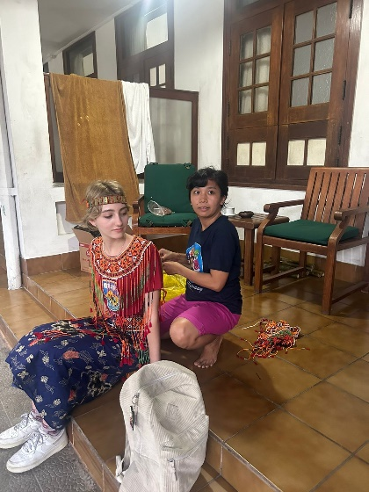

Figure 4. Costume Fitting and Introduction for Pa'gellu' Dancers

In this session, students also engage in a final rehearsal using the costumes and accompanied by the supporting music before the final performance. Foreign students demonstrate their commitment during this final rehearsal to deliver their best performance in the last session and to correct any mistakes or parts they have not yet memorized. The instructor also continues to provide reinforcement and appreciation for the progress made by the foreign students.

2.5 Evaluation

Evaluation activities are conducted periodically at each session with the goal of assessing students' progress in mastering the Pa'gellu' dance. Additionally, through these evaluation activities, students receive feedback on their performance, allowing them to identify mistakes in their movements and make improvements in subsequent sessions. This is expected to result in significant progress in the learning of the Pa'gellu' dance by the foreign students.

2.6 Workshop/Performance

This learning activity is the final part of the entire learning process. Foreign students perform the Pa'gellu' dance from start to finish, accompanied by the instructor, with complete costumes and drum music. This performance is witnessed by an audience consisting of students and faculty from UKI Toraja and the University of Western Australia. The workshop and performance also serve as the concluding event for the cultural and language introduction program for foreign students.

After completing 14 sessions of learning, foreign students were assessed on their ability to demonstrate the results of their Pa'gellu' dance training. Foreign students were able to perform the Pa'gellu' dance in groups in front of the instructor and regular students, accompanied by music. Their abilities were evaluated by the instructor through a final assessment that covered several criteria of the Pa'gellu' dance, including affective, cognitive, and psychomotor aspects. The learning outcomes for foreign students in Pa'gellu' dance differ from those of regular classes, but the differences are not significant. Although their scores did not reach the maximum, foreign students were still able to meet the three aspects of the assessment in Pa'gellu' dance learning.

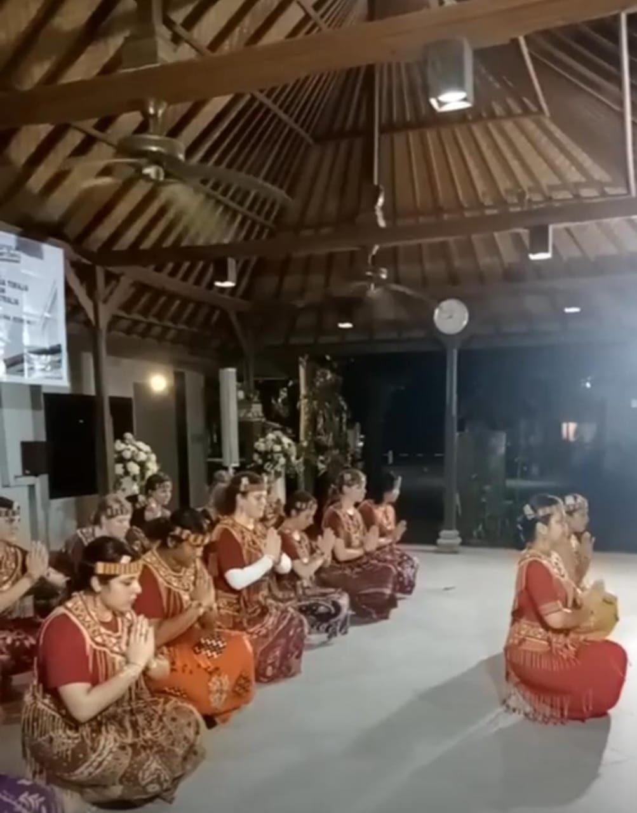

Figure 4. Pa'gellu' Dance Performance

Additionally, the results achieved have met the initial learning objectives, as students were able to recognize and practice the Pa'gellu' dance by performing a short presentation. Essentially, the implementation of Pa'gellu' dance learning for foreign students and regular students is not significantly different, although it is not as comprehensive as the dance education provided to regular students. Foreign students are only taught the Pa'gellu' dance, while regular students are taught several types of Indonesian dances. Considering that foreign students have limited exposure to Indonesian dance, the focus is on one type of dance to facilitate mastery (Boonstra & Rae, 2023). This is also due to cultural differences, particularly in dance traditions between the students' home regions and Toraja, which present varying levels of difficulty.

Several teaching methods were also employed by the instructor in the Pa'gellu' dance learning activities, including the lecture method, demonstration method, practice method, drill method, simulation method, and performance method (Tiawati et al., 2022). The lecture method was used to introduce the Pa'gellu' dance and explain the meaning behind each movement. This method was chosen to ensure that foreign students first understand the theory, which fosters interest and motivation in performing the Pa'gellu' dance. The lecture method is commonly used to introduce and explain the meaning behind the Pa'gellu' dance movements. Its use helps students, including those not from the local culture, to grasp the theory and deeper cultural context before they start learning the physical movements . In line with this, research conducted by Sadili et al. indicates that the lecture method is used in dance education to orally convey the meaning and origins of the dances being taught (Sadli, Sekarningsih, & Budiman, 2022). This can also enhance their interest and motivation in exploring and dancing the Pa'gellu' dance more deeply. This method serves as an important foundation before they engage in the physical practice and application of the movements (Rizal, 2023).

The drill method is a teaching approach focused on repetitive and intensive practice of the Pa'gellu' dance movements. Research conducted by Sudirman et al. states that the drill method facilitates students' understanding of a subject, particularly when the emphasis is on practice and hands-on training (Sudirman & Zain, 2023). In the context of dance education, this method is highly effective for helping students master basic techniques and improve the accuracy and speed of their movements (Putri, Wardiah, & Nurdin, 2023). Consistent repetition allows students to internalize the movements until they become automatic, which is crucial for dance performances (Purnamasari & Masunah, 2020). Through drill, students can correct mistakes, enhance body coordination, and build the muscle memory necessary for dancing efficiently and expressively (Pangesti & Wadiyo, 2021). The simulation method involves creating scenarios or settings that resemble real conditions, where students can practice the Pa'gellu' dance as if they were in an actual performance. In this method, students not only practice movements but also learn to express the emotions and messages conveyed by the dance (Dou, Jia, & Ge, 2021). Simulations may include stage settings, costume usage, and interaction with an audience (even if simulated) (El Raheb, Stergiou, Katifori, & Ioannidis, 2019). This method is important for helping students understand the performative context of the Pa'gellu' dance, increase their confidence, and prepare them for real-life performances.
- CONCLUSION
This study demonstrates that the Pa’gellu’ dance learning method at UKI Toraja involves lectures, demonstrations, practice, drills, simulations, and performances. The process begins with the introduction of theory, followed by basic practice, deepening of techniques, the use of costumes, and concludes with evaluation and performances. International students successfully mastered the basics of the dance, despite facing some challenges. This learning approach is effective in introducing and preserving Toraja culture, as well as supporting international cultural exchange.

REFERENCES
Boonstra, S., & Rae, P. (2023). The aesthetics of intercultural method: from process to procession in new Indonesian and Indo-Australian dance. Inter-Asia in Motion, 93–111. https://doi.org/10.4324/9781003434160-7
Dou, X., Jia, L., & Ge, J. (2021). Improvisational Dance-Based Psychological Training of College Students’ Dance Improvement. Frontiers in Psychology, 12, 663223. https://doi.org/10.3389/FPSYG.2021.663223/BIBTEX
El Raheb, K., Stergiou, M., Katifori, A., & Ioannidis, Y. (2019). Dance Interactive Learning Systems. ACM Computing Surveys (CSUR), 52(3). https://doi.org/10.1145/3323335
Evans, T., Kensington-Miller, B., & Novak, J. (2021). Effectiveness, efficiency, engagement: Mapping the impact of pre-lecture quizzes on educational exchange. Australasian Journal of Educational Technology, 37(1), 163–177. https://doi.org/10.14742/AJET.6258
Hakpantria, Trivena, Mersilina Luther Patintingan, & Nanda Saputra. (2022). Budaya Longko As a Character Building of Student Speech. Lakhomi Journal Scientific Journal of Culture, 3(2), 84–88. https://doi.org/10.33258/lakhomi.v3i2.718
Kurniati, F., Taryana, T., Badaruddin, S., Studi, P., Seni, P., Indonesia, U. P., & Bandung, K. (2023). PEMBELAJARAN TARI RAKYAT BAGI MAHASISWA ASING. Ringkang, 3(3), 528–536.
Ode, W., & Alamiah, R. (2024). INDONESIAN CULTURAL DIPLOMACY THROUGH THE PA’GELLU DANCE (TORAJA DANCE) IN JAPAN. International Journal of Accounting, Management, Economics and Social Sciences (IJAMESC), 2(3), 1073–1079. https://doi.org/10.61990/IJAMESC.V2I3.259
Pala’langan, Z. L. (2014). Nilai-nilai sosial tari pa’gellu’ dalam kehidupan masyarakat Toraja Kecamatan Rindingallo, kabupaten Toraja Utara, Sulawesi Selatan. Universitas Negeri Yogyakarta.
Pangesti, Y. S., & Wadiyo, W. (2021). Applications Of Demonstrations And Drill Methods For Music Ensemble Practise In Junior High School Student In The Social Interaction Perspective. Jurnal Seni Musik, 10(1), 5–10. https://doi.org/10.15294/JSM.V10I1.46584
Purnamasari, I., & Masunah, J. (2020). The Learning Method of Traditional Dance on Hard-Hearing Students. 129–133. https://doi.org/10.2991/ASSEHR.K.200321.030
Putri, H. D., Wardiah, D., & Nurdin, N. (2023). Pembelajaran Tari Siwar Menggunakan Metode Drill pada Kegiatan Ekstrakurikuler di Mts Negeri 1 Lahat. Indonesian Research Journal on Education, 3(1), 188–197. https://doi.org/10.31004/IRJE.V3I1.140
Rizal, K. A. dan S. (2023). Strategi pembelajaran seni tari pada ekstrakulikuler di smpn 13 kota serang. Seni Makalangan, 10(2), 41–50. https://doi.org/10.26742/MKLNG.V10I2.3396
Sadli, N. M., Sekarningsih, F., & Budiman, A. (2022). Tari Topeng Klana Udheng Sebagai Materi Awal Pembelajaran Tari Topeng Di Sanggar Mulya Bhakti. Ringkang: Kajian Seni Tari Dan Pendidikan Seni Tari, 2(1), 144–153. Retrieved from https://ejournal.upi.edu/index.php/RINK_TARI_UPI/article/view/44421%0Ahttps://ejournal.upi.edu/index.php/RINK_TARI_UPI/article/download/44421/18453
Shadiev, R., Wang, X., & Huang, Y. M. (2021). Cross-cultural learning in virtual reality environment: facilitating cross-cultural understanding, trait emotional intelligence, and sense of presence. Educational Technology Research and Development, 69(5), 2917–2936. https://doi.org/10.1007/S11423-021-10044-1/METRICS
Sudirman, S., & Zain, M. I. (2023). Application of The Drill Method to Improving Science Learning Outcomes. Jurnal Penelitian Pendidikan IPA, 9(4), 1886–1891. https://doi.org/10.29303/JPPIPA.V9I4.3649
Sugiyono. (2019). Metode Penelitian Kuantitatif, Kualitatif dan R&D. Bandung: Alfabeta.
Tiawati, R. L., Rahmat, W., Kemal, E., & Chen, W. (2022). THE IMPORTANCE OF GUIDANCE IN UNDERSTANDING CULTURAL DISCOURSE IN THINKING AND SPEAKING FOR FOREIGN STUDENTS IN BIPA PROGRAM. Journal of Pragmatics and Discourse Research, 2(1), 39–47. https://doi.org/10.51817/JPDR.V2I1.203
Trivena, T., Kabanga, T., Hakpantria, H., Langi, W. L., La’biran, R., Sanda, & Nyho, M. (2024). Character Education Values in Traditional Dance Extracurricular Activities in Elementary Schools. International Journal of Religion, 5(9), 470–478. https://doi.org/10.61707/by04h351
Yulianeta, Y., & Amandangi, D. P. (2021). Learning to Write Descriptive Texts Based on Batik Culture of BIPA Students at the Indonesian Embassy in London. PAROLE: Journal of Linguistics and Education, 11(1), 29–40. https://doi.org/10.14710/parole.v11i1.29-40

