The Development of Interactive Learning Media Based on Discovery Learning Oriented to Students’ Concept Understanding dan Mathematical Disposition

Tiara Saharani¹, Agus Maman Abadi ²
¹ Mathematics Education Department, Faculty of Mathematics and Natural Science,
Universitas Negeri Yogyakarta; tiarasaharani.2022@student.uny.ac.id
² Mathematics Education Department, Faculty of Mathematics and Natural Science,
Universitas Negeri Yogyakarta; agusmaman@uny.ac.id

ARTICLE INFO |  | ABSTRACT
Keywords:  Learning media;  Discovery learning;  concept understanding; mathematical disposition |  | The use of learning media that can increase the active involvement of students so as to realize optimal mathematics learning and develop various mathematical competencies. This research aims to describe the characteristics and produce interactive learning media products based on discovery learning oriented to concept understanding and mathematical disposition of students that are valid, practical, and effective This research is a research and development using the ADDIE development model. The research subjects were 35 students of class XI SMA Negeri 4 Yogyakarta. The results showed (1) the interactive learning media produced has characteristics: components refer to discovery learning steps, facilitate students' concept understanding ability and mathematical disposition, used by students through laptops and smartphones; (2) learning media meets the validity criteria. Interactive learning media meets the criteria of practicality. The percentage of learning implementation is 92.3% with a very practical category. Interactive learning media meets the effectiveness criteria. The results of the Wilcoxon test obtained the average concept understanding test results greater than the KKTP (75) and the one sample-t test average mathematical disposition questionnaire results greater than the minimum score of high criteria (102). Of the proportion test, it was found that the percentage of students who obtained the concept understanding score reached KKTP (75) ≥75% and the mathematical disposition questionnaire score (102) ≥75%. Students who completed the concept understanding test 88.5% and mathematical disposition 94.2%. Based on analysis results, there is an increase in concept understanding ability and mathematical disposition after applying interactive media in learning.
Article history:
Received 2021-08-14
Revised 2021-11-12
Accepted 2022-01-17
 |  | This is an open-access article under the CC BY-NC-SA license.
Corresponding Author:
Tiara Saharani
Mathematics Education Department, UNY; tiarasaharani.2022@student.uny.ac.id
- INTRODUCTION
Mathematics learning is learning that has very complex and powerful activities in improving various individual abilities. Mathematics equips students with a powerful set of specialized tools to change and understand the world (Andamon & Tan, 2018; Skemp, 1987). In order to learn mathematics optimally and develop various mathematical competencies, the ability to understand concepts becomes a fundamental ability. Understanding mathematical concepts is a skill that needs to be developed by every individual who learns mathematics and becomes a tool to develop other mathematical competencies and in solving problems in real life (Hendriana, Rohaeti, & Sumarmo, 2017; Nasution, Sinaga, & Mukhtar, 2019). Students can understand mathematics only if they understand concepts and the meaning or interpretation of a concept (NCTM, 1989). Understanding the concepts listed is one of the goals of learning mathematics in Decree of the Head of BSKAP No. 8 of 2022 (Kemendikbudristek, 2022) and listed in the Graduate Competency Standards Number 5 of 2022 (Kemendikbudristek, 2022).
Based on the results of the study internasional Trends in Mathematics and Science Study (TIMMS) in 2015 showed that achievements in the geometric shapes and measures Indonesia ranks 44th with a score of 394 out of 49 countries. Based on this data, the field of geometry needs to be considered in mathematics learning. One of the geometry materials whose understanding of the concept needs to be improved is the circle material (Damrau, 2023; New Sari & Armanto, 2022; Trianingsih et al., 2019).
In addition to understanding concepts, one of the affective aspects that can support effective and optimal mathematics learning is mathematical disposition. Disposition can encourage a person to engage in activities (Doig, Wiliiams, Swanson, Ferri, & Drake, 2019). Disposition is one of the important goals in education in addition to knowledge and skills (Pastor & Charalambous, 2023). Mathematical disposition is also a goal in mathematics learning as stated in the Decree of the Head of BSKAP No. 8 of 2022 (Kemendikbudristek, 2022). Mathematical disposition refers to an interest or pleasure in mathematics, as well as an appreciation for it. Mathematical disposition is not just an attitude, but includes the tendency to think and act positively when learning mathematics (Mentz, Beer, & Bailey, 2019; Minarti, Alghadari, & Hutajulu, 2020; NCTM, 1989).
This low understanding of concepts and mathematical disposition is caused by several factors, one of which is the lack of student involvement in the process of concept discovery (Trianingsih et al., 2019). Technology can be the best alternative to increase student involvement in the process of discovering concepts in learning. Technology plays a significant role when learning mathematics, students are able to develop their deeper understanding of mathematics with the right use of technology (NCTM, 2000). Mathematics learning using information and communication technology will be richer and a complex learning environment and potentially more active, effective, and productive mathematics learning (Moore, 2012; Smaldino, Russel, Heinich, & Molenda, 2002; Sutherland, 2007). One of the uses of technology in learning is the use of technology-based learning media.
Learning media provide real experiences that are important in helping students understand abstract mathematical concepts in learning (Smaldino et al., 2002). Learning media is something that is used in learning that functions as an intermediary in order to convey content or information that can arouse students' thoughts, pleasure, willingness, and motivation in learning (Mashuri, 2019). The use of interactive learning media can support students' understanding of concepts and positive involvement of students in the learning process, Firdha & Zulyusri (2022) Interactive learning media is a type of media that is fun and encourages student involvement and activeness in the learning process.
Discovery learning is learning that is designed so that learners can make the discovery of the concept in question for themselves (Hammer, 1997 ; Andelkovic & Maricic, 2023). Smaldino et al. (2008) Technology and media can help drive discovery or inquiry in discovery learning. Learning discovery learning have a positive impact on students' understanding of concepts (Gunawan, Kosim, & Lestari, 2020; Koto, 2020; Maifi, Anwar, & Ahmad, 2021; Swasti, Hutapea, & Suanto, 2022). Discovery learning can support learning media to focus more on facilitating the ability to understand concepts and mathematical dispositions. Ispring that is integrated with powerpoint widely used in the manufacture of media with geometric materials (Firdha & Zulyusri, 2022; Maryana, Suaedi, & Nurdin, 2019). Use Geogebra Learning has a significant impact on improving students' mathematical abilities (Baye, Ayele, & Wondimuneh, 2021; Yuliardi, Juandi, Maizora, & Mahpudin, 2021).
From previous research, there has been no development of interactive learning media based on discovery learning that is oriented to understanding students' mathematical concepts and dispositions on circle materials in high school. Therefore, the purpose of this research is to describe the characteristics and produce interactive learning media based on discovery learning oriented to understanding the concepts and mathematical dispositions of students on circle materials in high school that are valid, practical, and effective.
- METHODS
This type of research is research and development (Research and Development) with the ADDIE (Analysis, Design, Development, Implementation, Evaluation) development model. The ADDIE flowchart is described in figure 1.
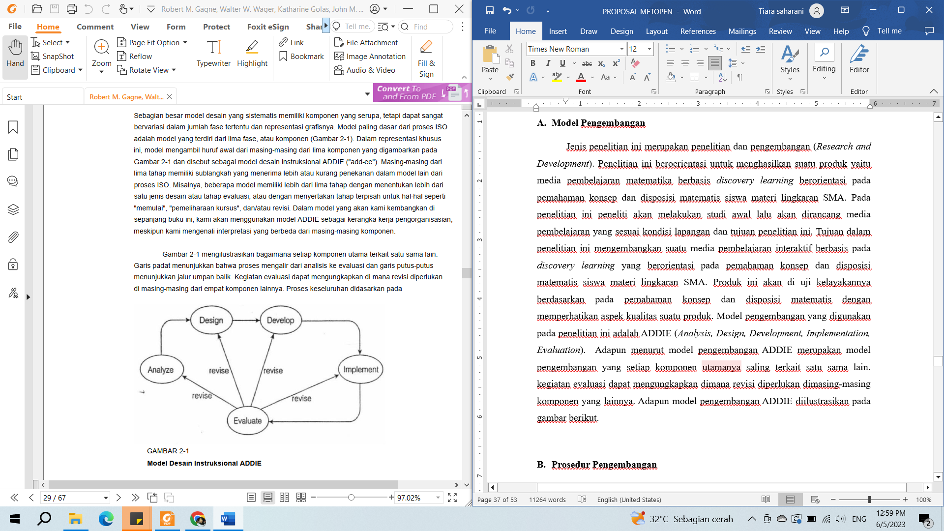
Figure 1. ADDIE Development Model
In the Analyze stage, analysis is carried out to develop products that are in accordance with the needs and conditions of the field. The analysis consists of analyzing needs, curriculum, student characteristics, school situation, and preparing a work plan. The Design stage, designing learning media in accordance with the previous analysis. The Development stage is the development of products, research instruments, learning tools, validation of media and instruments, and small-scale trials. The Implementation stage, conducting an initial ability test of understanding concepts and mathematical dispositions, conducting large-scale interactive learning media trials in the classroom, conducting a test of understanding concepts and mathematical dispositions, as well as media assessments by teachers and students. In the Evaluation stage, media assessments are carried out based on the practicality and effectiveness of the media developed.
This research was carried out at SMA Negeri 4 Yogyakarta for the 2023/2024 school year. The test subjects in this study are grade XI students. This study was conducted by three data collection methods to evaluate the feasibility of the media, namely: concept comprehension test, observation, and questionnaire. The research instruments consisted of a questionnaire to assess validity, a questionnaire to assess practicality, and a mathematical disposition questionnaire. concept comprehension test sheets, and learning implementation observation sheets. Data analysis techniques are carried out to determine validity, practicality, and effectiveness. The formula for creating categories on the questionnaire to assess validity and practicality was adapted from (Widoyoko, 2017) and obtained the media validation category by material experts in table 1.
Table 1. Validity Category of Material Experts
Score Interval | Validity Category
$$67,2≤V<80$$ | Very Valid
$$54,4≤V<67,2$$ | Valid
$$41,6≤V<54,4$$ | QuiteValid
$$28,8≤V<41,6$$ | Less Valid
$$16≤V<28,8$$ | Invalid

The category of media validation by media experts is explained in table 2.
Table 2. Validity Category of Media Experts
Score Interval | Validity Category
$$71,4≤V<85$$ | Very Valid
$$57,8≤V<71,4$$ | Valid
$$44,2≤V<57,8$$ | QuiteValid
$$30,6≤V<44,2$$ | Less Valid
$$17≤V<30,6$$ | Invalid

Media is declared valid if it reaches the valid or very valid category. Categories of media practicality assessment by teachers in table 3.
Table 3.Categories of Practicality by Teachers
Score Interval | Categories Practicality
$$84≤V<100$$ | Very Practical
$$68≤V<84$$ | Practical
$$52≤V<68$$ | Quite Practical
$$36≤V<52$$ | Less Practical
$$20≤V<36$$ | Impractical
The category of media practicality assessment by students is in table 4.
Table 4.Categories of Practicality by Students
Score Interval | Categories Practicality
$$71,4≤P<85$$ | Very Practical
$$57,8≤P<71,4$$ | Practical
$$44,2≤P<57,8$$ | Quite Practical
$$30,6≤P<44,2$$ | Less Practical
$$17≤P<30,6$$ | Impractical
The media is declared practical if it reaches the practical or very practical category. This implementation analysis sheet has two answer options, namely "yes" and "no". The score given is that the "yes" answer is given a score of 1 and the "no" answer is given a score of 0. Calculation of the percentage of observations, here is the formula used:
Value(%) = $\frac{Score}{Maximum Score}×100\%$
The effectiveness analysis technique was carried out with media criteria to facilitate the understanding of concepts and mathematical dispositions if they met the effectiveness criteria, namely: (1) The average concept understanding test of students achieved the Learning Goal Achievement Criteria (KKTP) set by the school, which was 75 and the mathematical disposition achieved a minimum score on the high criteria (102), (2) the percentage of many students who obtained a score of KKTP (75) ≥75% and mathematical disposition (102) ≥75%, and (3) there was an increase in the average ability to understand concepts and mathematical dispositions after learning using interactive learning media.

- FINDINGS AND DISCUSSION
The results of the development of interactive learning media using the ADDIE model are presented as follows.
- Analyze Stage
At this stage of analysis, it is carried out as a basis for developing media in accordance with conditions, needs, curriculum, school situations, and student characteristics. Based on observations and interviews, the questionnaire results of the analysis revealed that the understanding of concepts and mathematical disposition was still low. Learning has not provided student-centered opportunities and has never used interactive learning media that is used directly by students in mathematics learning for discovery. Students have used technology such as mobile phones in schools. However, in mathematics learning, students have not taken advantage of this technology to further optimize learning. The schools studied use the independent curriculum, so that the media developed refers to the learning outcomes of the independent curriculum.
Based on the results of the characteristic analysis, most students have difficulty understanding mathematical concepts, especially in the field of geometry and measurement. Therefore, the media developed in the field of geometry of circular matter. Students can operate computers and mobile phones. The classrooms have been facilitated with electrical power and equipped with infocus/projectors in each classroom. The school also allows students to access laptops and cellphones for learning. These facilities can be optimized by using interactive learning media that can be used directly by students so that students can be actively involved in learning mathematics. Based on the results of the analysis, interactive learning media based on discovery learning is needed to facilitate students' understanding of concepts and mathematical dispositions.
- Design Stage
Based on the results of the previous analysis, product design and learning will be carried out. The stages of designing products and designing learning are carried out by designing product content and orientation based on discovery learning, as well as oriented to understanding concepts and mathematical dispositions. At this stage, interactive learning media, teaching modules, research instruments and validation sheets are designed.
- Development stage
The development stage, develop products in accordance with the learning design, compile instruments, learning tools and also carry out a validation process and limited trials. Interactive learning media is developed using microsoft powerpoint software, ispring suite 10, geogebra. The first component of the developed learning media is the opening page as shown in figure 2.
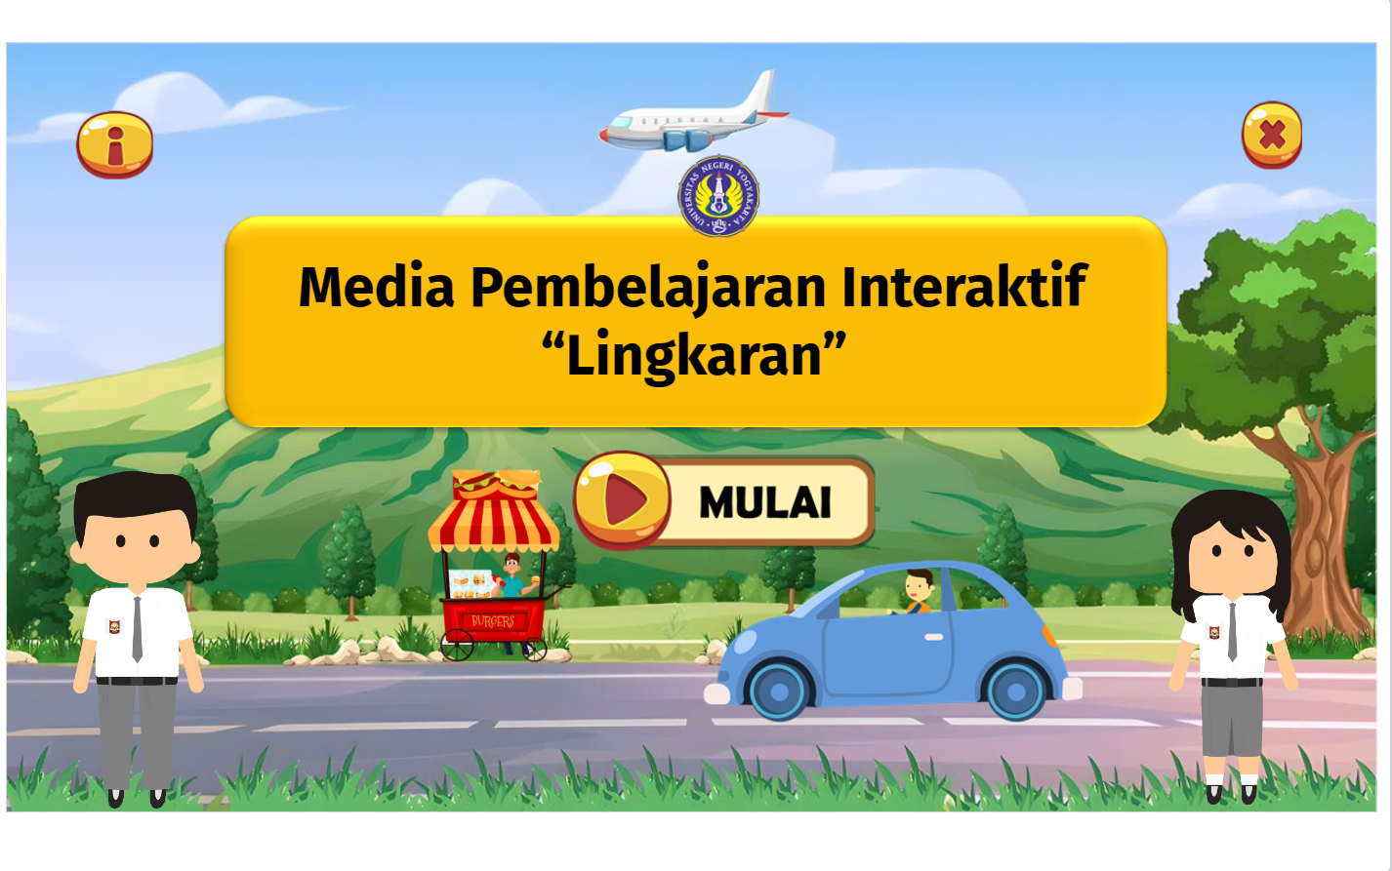
Figure 2. Opening Page View
The opening page contains the title of the application, namely the interactive learning media circle, the exit/exit button, the hint button and the start button that leads to the main menu. The main menu page contains features that can be accessed in the media, namely, competencies, receptions, concept maps, materials, videos, examples, quizzes, and developer profiles as shown in figure 3.
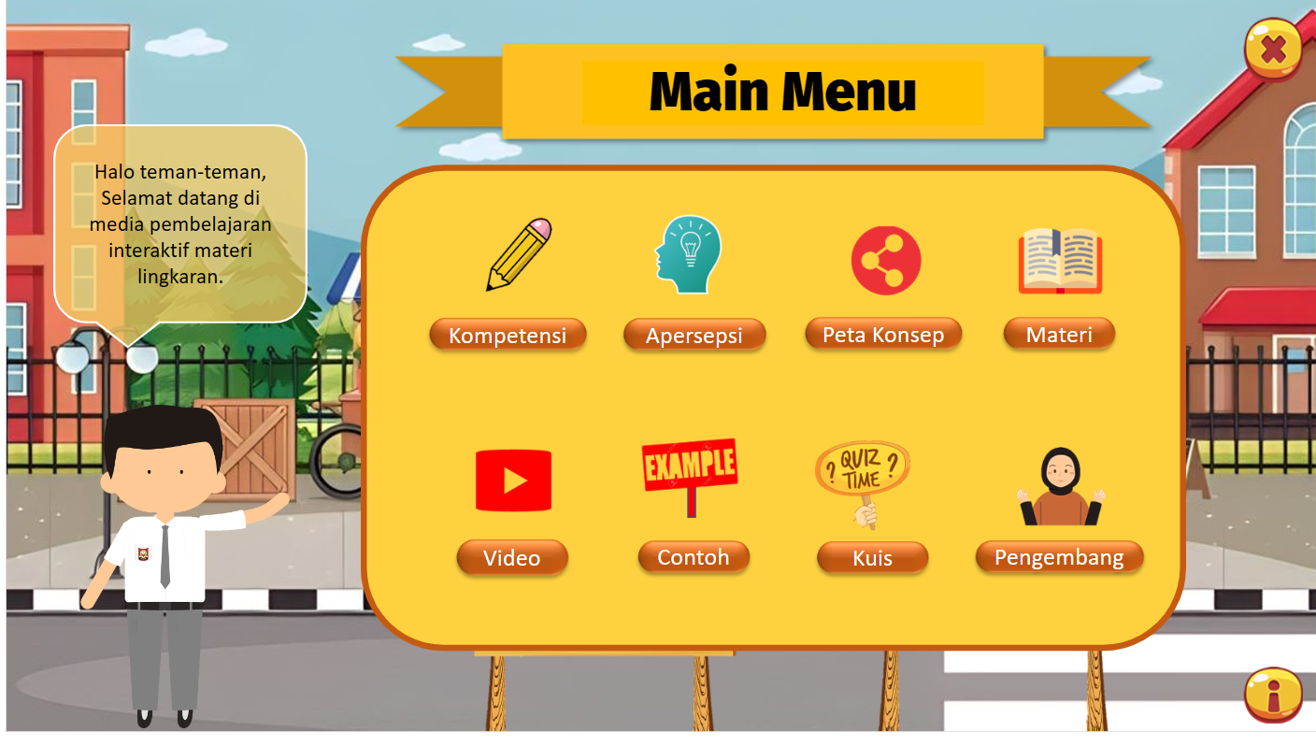
Figure 3. Main Menu Display
The aperception page contains buttons and an interactive display equipped with an interactive circle animation regarding the elements in the circle as shown in figure 4.
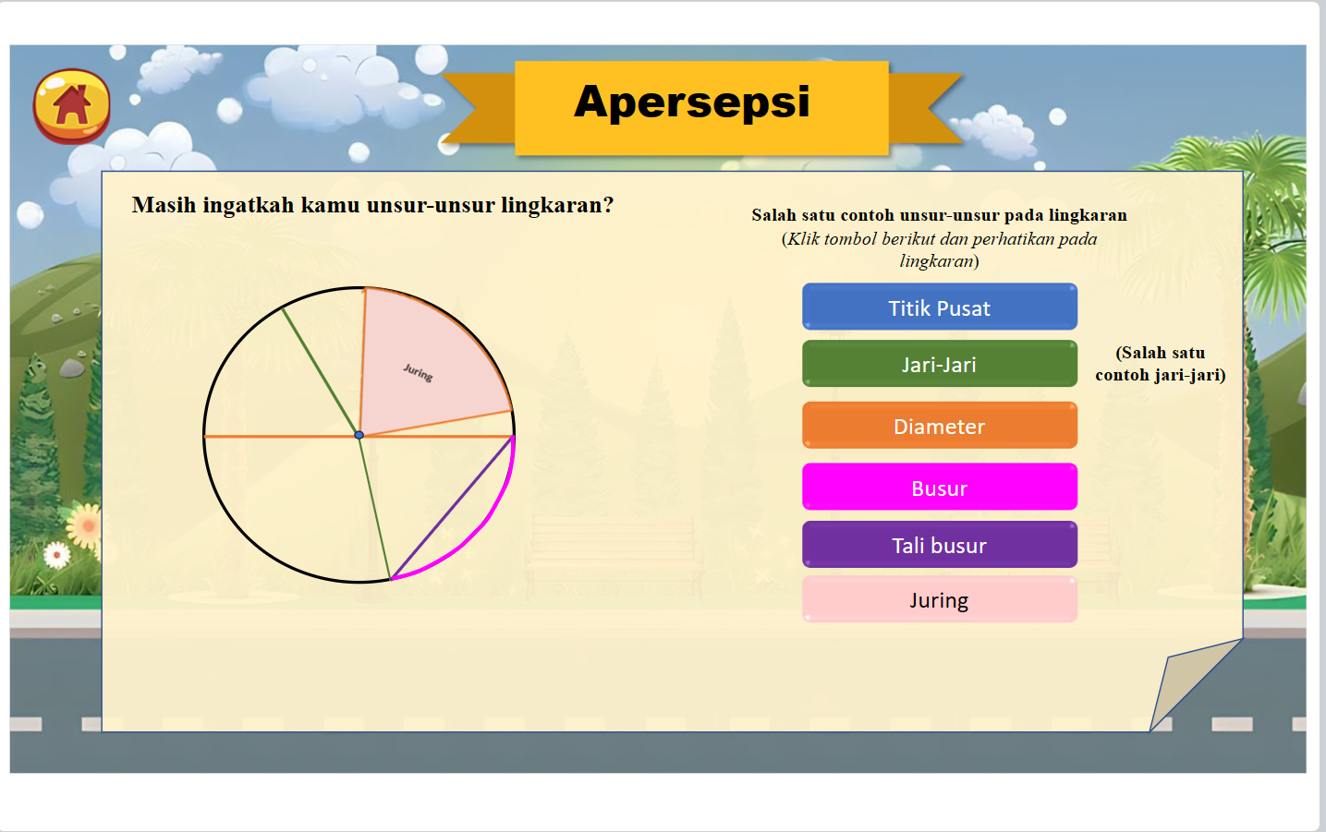
Figure 4. Aperceptual Display
In the material, there is a series of learning activities that are arranged based on the steps and principles of discovery learning as well as indicators of understanding concepts and mathematical dispositions as shown in figure 5.
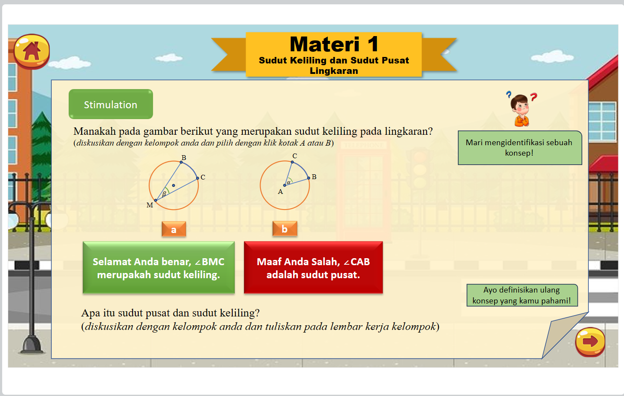
Figure 5. Material Display
In the material, there are interactive buttons and also activities to conduct experiments using geogebra and video as shown in figure 6.
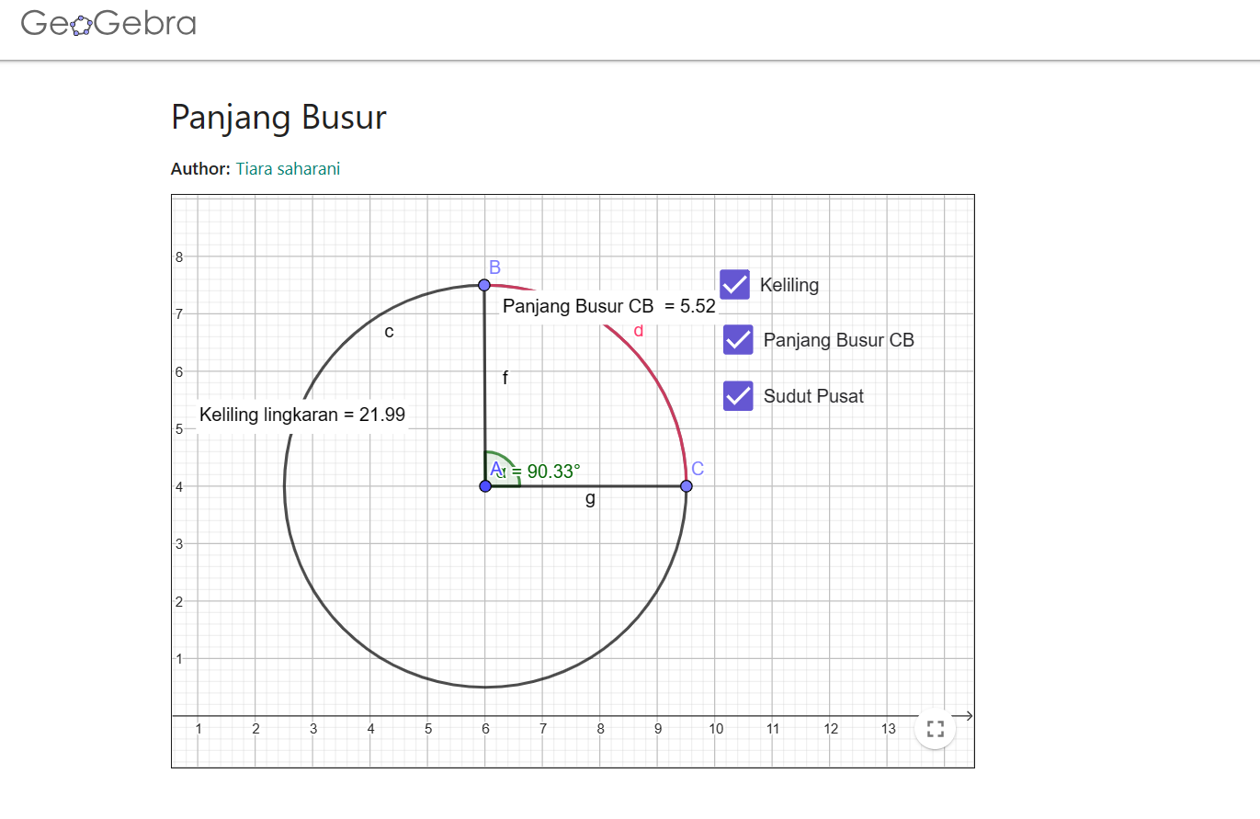
Figure 6. Geogebra Display
The media is also equipped with sample questions and interactive quizzes where students can find out the results of the quiz and send it to the teacher's email.
After creating the media, validation is carried out. The validation results are presented in table 3.
Table 3. Product Validation Results and Research Instruments
No. | Validation Components | Validation Results
1 | Concept Comprehension Test Questions | Valid
2 | Mathematical Disposition Questionnaire | Sangat Valid
3 | Media by Media Experts | Sangat Valid
4 | Media by Material Experts | Valid
5 | Teaching Module | Sangat Valid
6 | Observation Sheet | Valid
7 | Practicality Questionnaire by Teachers | Sangat Valid
8 | Practicality Questionnaire by Students | Sangat Valid
9 | Readability Questionnaire | Sangat Valid
10 | LKPD | Sangat Valid
Based on the results of the validation, it can be found that the learning media products developed, concept comprehension test questions, mathematical disposition questionnaires, teaching modules, observation sheets, teacher and student practicality questionnaires, readability questionnaires and LKPD obtained valid or very valid categories, therefore the media and instruments were declared valid so that they were suitable for use.
Limited trials or small-scale trials are carried out to determine the readability and practicality of learning media before being widely tested in the classroom. This limited trial was carried out to 6 students from class XI. The results of the limited trial are presented in table 4.
Table 4. Limited trial results
Aspects | Acquisition | Maximum score | Category
Implementation of Learning Implementation | 88% | 100% | Practical
Practical assessment by teachers | 95 | 100 | Very Practical
Assessment of practicality by students | 72 | 85 | Very Practical
Readability Assessment | 61,33 | 70 | Very Practical
Based on the results of the limited trial, it was obtained that the media was declared practical and feasible to be implemented in large-scale trials in the classroom.
- Implementation Stage
Interactive learning media based on discovery learning was tested on a large scale in class XI F5 SMA Negeri 4 Yogyakarta consisting of 35 students. Large-scale trials were carried out as many as seven meetings. Two meetings were held for pre-test and post-test and 5 meetings were held for learning. The teacher did the opening activity, then proceeded to the core activity. In the core activity, learning is carried out by utilizing the use of discovery learning-based media.
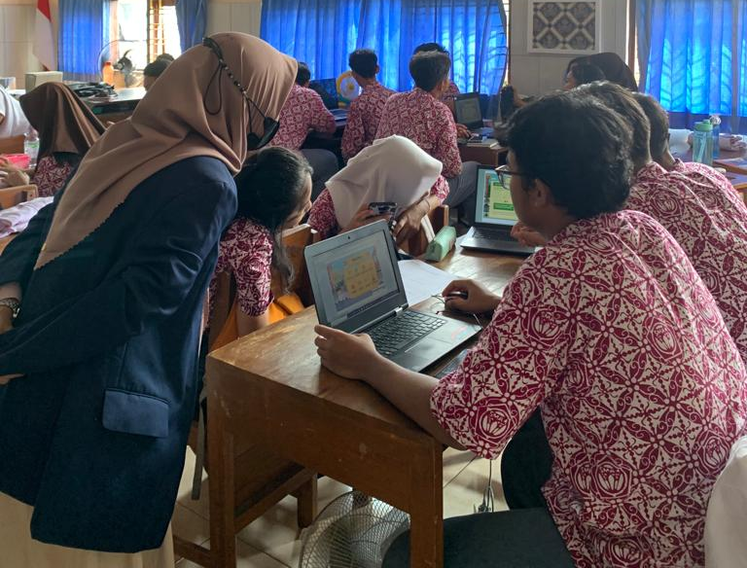
Figure 7. Use of Media By Students
Students carry out discovery activities with experiments carried out with geogebra. After conducting the experiment, students process data and discuss with friends to be able to find the concept in question. After discussing with the group, verification activities are carried out with students watching a video and writing proof. In addition, students take interactive quizzes contained in the learning media. After that, the teacher asked the students to present the results of the discussion.
- Evaluation stage
Evaluation activities consist of evaluation activities on the practicality and effectiveness of media or products. The results of the implementation of learning are presented in the following table.
Table 5. Learning Implementation
Meeting to | Teacher Activity Score | Student Activity Score | Percentage
1 | 32 | 31 | 90%
2 | 39 | 39 | 95,12%
3 | 33 | 32 | 90,27%
4 | 31 | 30 | 92,42%
5 | 31 | 31 | 93,93%
Rata-rata |  |  | 92,3%
Category |  |  | Very Practical

The practicality assessment by the teacher obtained a score of 94 out of a maximum score of 100 with the category "Very Practical". The assessment of practicality by students obtained an average score of 65.6 out of the maximum score in the "practical" category. Based on these results, the media reached the practical and very practical categories, it was concluded that the media that had been used was declared practical.
Based on Hotelling's T^{2 test}, the value and significance value of $T^{2}=76,93$p-value = 2.2e-16 were obtained. Therefore it is obtained $T^{2}=76,93> \frac{\left(n-1\right)p}{\left(n-p\right)}F_{p.(n-p) }=6,75$ and p-value = 2.2e-16 < 0.05 then it is rejected. Thus, it can be concluded that the average concept understanding and mathematical disposition are not the same as the criteria set, namely KKTP concept understanding 75 and mathematical disposition 102. Further tests will be carried out. The ability to understand the concept was carried out by the wilcoxon signed rank test. Based on the results of the wilcoxon test above, it is known that p-value =0.0001534 < 0.05. Based on this, it H_0 rejected so that the average result of the student's concept understanding test was greater than 75 (KKTP). Based on these results, learning with the application of learning media developed is effective from the ability to understand concepts. Meanwhile, based on the results of the concept comprehension proportion test, a score of H0 $H_{0}Z=1,861>Z_{a}=1,65.$ was obtained Therefore, H0 was rejected so that it can be concluded that the proportion of student concept comprehension test results that reached KKTP (75) is more than 75%. And based on the results of the wilcoxon test on the pretest and posttest, the result of p-value = 2.535e-07 = 0.0002535 < 0.05 was obtained. Based on this, it was rejected so that there was a difference in the average ability to understand concepts before and after learning using interactive learning media. There is an increase in the ability to understand concepts after the application of interactive learning media. $H_{0}$.
The statistical descriptive results of filling out the mathematical disposition questionnaire are presented in the following table 6.
Table 6. Descriptive statistics of mathematical dispositions
Description | Value
Many Students | 35
Highest Scores | 130
Lowest Rate | 90
Percentage of students who complete | 94,2%
Grade Point Average | 111,8
Category | High
Based on the results of the one sample t-test above, it is known that the < is 1.690 and $t_{hitung}=23,89t_{tabel} =$the p-value = 2.2e-16 < 0.05. Based on this, it was rejected so that the average score of the student's mathematical disposition questionnaire was greater than 102 (the minimum score in the high category). Based on these results, learning with the application of learning media developed is effectively reviewed from mathematical disposition. Based on the results of the calculation above with a significance of 0.05, a value of $H_{0} Z=2,626>Z_{a}=1,65.$ H0 was obtained Therefore, H0 was rejected so that it can be concluded that the proportion of the results of the mathematical disposition questionnaire of students who reached a score of 102 was more than 75%. Based on the results of the pair sample t-test above, it is known that p-value = 8.571e-08 = 0.00008571 < 0.05. Based on this, it was rejected so that there was a difference in the average mathematical disposition before and after learning using interactive learning media.$H_{0}$
Based on the results of the research, the interactive learning media developed meets the three criteria of effectiveness in facilitating understanding of mathematical concepts and dispositions. Based on these results, it can be seen that interactive learning media meets the criteria for effectiveness.
Interactive learning media meets the validity criteria reviewed from the results of validation of media, research instruments, and learning tools. Suggestions and inputs to the media, tools, and research instruments are highly regarded and improved. According to Nieveen (1999) A product is said to be valid if it has relevance to the theory and has a framework and components that are compatible with each other. According to Sugiyono (2012) If it is theoretically correct, in this case, the measurement results using a measuring device guided by it will be considered valid.
Based on the results of the assessment of the practicality of interactive learning media by teachers, the assessment of the practicality of interactive learning media by students, and the results of the percentage of learning implementation using media, the media is declared practical to use. In line with Firdha & Zulyusri (2022) which reveals that interactive learning media is a learning medium that can be fun and can foster active participation of learners in the learning process. In addition, according to Sutherland (2007) Mathematics learning using technology will be richer and a complex learning environment and potentially more productive mathematics learning. According to Santoso et al. (2022) Interactive learning media is an interactive tool that is used for fun and efficient learning so that learning goals are achieved.
Based on the results of the research and final product review, the interactive learning media developed meets the criteria of effectiveness in facilitating students' ability to understand concepts and mathematical dispositions. This is in line with Moore (2012) which reveals that the effectiveness and quality of teaching can be greatly improved through the use of technology. Other opinions according to Widodo & Wahyudin (2018) One of the roles of learning media is as a means that helps to produce effective learning conditions, connections between learning components so that the expected learning situation is created, helps understand something abstract so as to reduce verbalism and increase students' understanding. According to Firdha & Zulyusri (2022) Revealing learning media is a means that is able to communicate or channel various learning messages that provide effectiveness and efficiency that help students in gaining an understanding of learning materials. Media developed based on learning discovery learning. According to Smaldino et al. (2008) Learning discovery learning fostering a deeper understanding of content through student engagement with learning. Research Juandi et al. (2021) obtain results that use Geogebra In learning, it has a significant impact on improving students' mathematical skills.
- CONCLUSION
The conclusions of this study are (1) Circle-based interactive learning media discovery learning oriented to understanding the concept and mathematical disposition of students on high school circle material has the characteristics of activities on the media based on the principles and learning steps discovery learning with stages stimulation, problem statement, data collection, data processing, verification, dan generalization. Media accessed using computers, laptops or handphone in online. The learning media developed consists of competency features, perceptions, concept maps, materials, videos, sample questions, and interactive quizzes. (2) Interactive learning media meets the validity criteria reviewed from the validation results. (3) Interactive learning media met the practicality criteria as reviewed from the results of filling out the media practicality sheet by the teacher obtained a score of 94 out of 100, the result of filling out the media practicality sheet by students obtained a score of 65.6 out of 85, and the result of the observation sheet of learning implementation of 92.35% exceeded 85% and obtained the category of "Very practical". (3) Interactive learning media meets the criteria for effectiveness reviewed from the results of the concept comprehension test and filling out the student's mathematical disposition questionnaire.
Suggestions for further research, interactive learning media based on discovery learning oriented to understanding the concept and mathematical disposition of students on the circle material in high school is expected to be a reference for education practitioners or teachers as well as the wider community to improve their understanding of mathematical concepts and students' mathematical disposition. Learning media is limited to circle materials. In the next research, it is hoped that learning media can be developed on other materials to achieve the goal of learning mathematics.

REFERENCES
Andamon, J. C., & Tan, D. A. (2018). Conceptual understanding, attitude and performance in mathematics of Grade 7 Students. International Journal of Scientific and Technology Research, 7(8), 96–105.
Andelkovic, S., & Maricic, S. (2023). the Effects of Discovery-Based Learning of Differentiated Algebra Content on the Long-Term Knowledge of Students in Early Mathematics Education. Facta Universitatis, Series: Teaching, Learning and Teacher Education. https://doi.org/10.22190/futlte230611024a
Baye, M. G., Ayele, M. A., & Wondimuneh, T. E. (2021). Implementing GeoGebra integrated with multi-teaching approaches guided by the APOS theory to enhance students’ conceptual understanding of limit in Ethiopian Universities. Heliyon, 7(5), e07012. https://doi.org/10.1016/j.heliyon.2021.e07012
Damrau, M. (2023). Understanding the Generality of Mathematical Statements An Experimental Study at the Transtion from School to University. Germany: Springer Spektrum.
Doig, B., Wiliiams, J., Swanson, D., Ferri, R. B., & Drake, P. (2019). Interdisciplinary Mathematics Education. Switzerland: Springer.
Firdha, N., & Zulyusri, Z. (2022). Penggunaan iSpring Dalam Pengembangan Media Pembelajaran Interaktif. Diklabio: Jurnal Pendidikan Dan Pembelajaran Biologi, 6(1), 101–106. https://doi.org/10.33369/diklabio.6.1.101-106
Gunawan, Kosim, & Lestari, P. A. S. (2020). Instructional materials for discovery learning with cognitive conflict approach to improve vocational students’ achievement. International Journal of Instruction, 13(3), 433–444. https://doi.org/10.29333/iji.2020.13330a
Hammer, D. (1997). Discovery learning and discovery teaching. Cognition and Instruction, 15(4), 485–529. https://doi.org/10.1207/s1532690xci1504_2
Hendriana, H., Rohaeti, E. E., & Sumarmo, U. (2017). Hard Skills dan Soft Skills Matematik Siswa. Bandung: PT. Refika Aditama.
Juandi, D., Kusumah, Y. S., Tamur, M., Perbowo, K. S., & Wijaya, T. T. (2021). A meta-analysis of Geogebra software decade of assisted mathematics learning: what to learn and where to go? Heliyon, 7(5), e06953. https://doi.org/10.1016/j.heliyon.2021.e06953
Kemendikbudristek. (2022a). Keputusan Kepala Badan Standar, Kurikulum, dan Asesmen Pendidikan Kementerian Pendidikan, Kebudayaan, Riset, dan Teknologi Nomor 008/H/KR/2022. Jakarta.
Kemendikbudristek. (2022b). Permendikbudristek Nomor 5 Tahun 2022 Standar Kompetensi Lulusan. Jakarta.
Koto, I. (2020). Teaching and Learning Science Using YouTube Videos and Discovery Learning in Primary School. Mimbar Sekolah Dasar, 7(1), 106–118. https://doi.org/10.17509/mimbar-sd.v7i1.22504
Maifi, Y. K., Anwar, & Ahmad, A. (2021). Students’ understanding of mathematical concepts and their self-confidence through a discovery learning model. Journal of Physics: Conference Series, 1882(1). https://doi.org/10.1088/1742-6596/1882/1/012081
Maryana, Suaedi, & Nurdin. (2019). Pengembangan Media Pembelajaran Matematika Menggunakan Powerpoint Dan Ispring Quizmaker Pada Materi Teorema Pythagoras. Jurnal Penelitian Matematika Dan Pendidikan Matematika, 2(2), 53–61.
Mentz, E., Beer, J. de, & Bailey, R. (2019). Self-directed learning for the 21st Century Imlications for Higher Education. South Africa: AOSIS.
Minarti, E. D., Alghadari, F., & Hutajulu, M. (2020). Mathematical disposition ability and critical thinking: Evaluation of middle school students. Journal of Physics: Conference Series, 1657(1). https://doi.org/10.1088/1742-6596/1657/1/012017
Moore, K. D. (2012). Effective Instructional Strategies From Theory to Practice. United States of America: SAGE Publications Ltd.
Nasution, N., Sinaga, B., & Mukhtar, M. (2019). Developing Learning Media Assisted-flash Macromedia Software by Applying Discovery Model to Improve Students’ Concept and Self Regulated Learning on Senior High School. American Journal of Educational Research, 7(2), 161–165. https://doi.org/10.12691/education-7-2-7
NCTM. (1989). Curriculum and Evaluation Standards for School Mathematics. Reston, Va: NCTM.
NCTM. (2000). Principle and Standards for School Mathematics. Reston, Va: NCTM.
Nieveen, N. (1999). Design Approaches and Tools in Education and Training: Prototyping to Reach Product Quality. Netherlands: ICO and springer science +business media, B.V. Retrieved from https://link.springer.com/chapter/10.1007/978-94-011-4255-7_10
Novita Sari, D., & Armanto, D. (2022). Matematika Dalam Filsafat Pendidikan. AXIOM : Jurnal Pendidikan Dan Matematika, 10(2), 202. https://doi.org/10.30821/axiom.v10i2.10302
Praetorius, A.-K., & Charalambous, C. Y. (2023). Theorizing Teaching Current Status and Open Issues. Switzerland: Springer.
Santoso, A. N., Ellis Salsabila, & Haeruman, L. D. (2022). Pengembangan Media Pembelajaran Interaktif berbasis Android dengan Model Discovery Learning pada Materi Teorema Pythagoras Kelas VIII SMP Negeri 20 Jakarta. Jurnal Riset Pembelajaran Matematika Sekolah, 6(2), 39–50. https://doi.org/10.21009/jrpms.062.06
Skemp, R. R. (1987). The Psychology of Learning Mathematics. Hillsdale, New Jersey: Lawrence Erbaum Associates Publishers.
Smaldino, S. E., Lowther, D. ., & Russel, J. D. (2008). Instructional Technology and Media for Learning Ninth Edition. Pearson Merril Prentice Hall.
Smaldino, S. E., Russel, J. D., Heinich, R., & Molenda, M. (2002). Instructional Media and technologies for Learning (Eighth Edi). Upper Saddle River,New Jersey: Pearson Education Inc.
Sugiyono. (2012). Metode Penelitian Kuantitaif, Kualitatif, dan R & D. Bandung: Alfabeta. Bandung: Alfabeta.
Sutherland, R. (2007). Teaching for Learning Mathematics. London: Open Universty Press (Mc Graw Hill).
Swasti, M., Hutapea, N. M., & Suanto, E. (2022). Desain Media Pembelajaran Interaktif Berbasis Model Discovery Learning Materi Segiempat dan Segitiga Untuk Memfasilitasi Kemampuan Pemahaman Matematis. PRISMA, Prosiding Seminar …, 5, 87–97. Retrieved from https://journal.unnes.ac.id/sju/index.php/prisma/article/view/54345%0Ahttps://journal.unnes.ac.id/sju/index.php/prisma/article/download/54345/21156
Trianingsih, A., Husna, N., & Prihatiningtyas, N. C. (2019). Pengaruh Model Discovery Learning terhadap Pemahaman Konsep Matematis Siswa pada Materi Persamaan Lingkaran di Kelas XI IPA. Variabel, 2(1), 1. https://doi.org/10.26737/var.v2i1.1026
Widodo, S. A., & Wahyudin. (2018). Selection of Learning Media Mathematics for Junior School Students. Turkish Online Journal of Educational Technology - TOJET, 17(1), 154–160. Retrieved from https://eric.ed.gov/?id=EJ1165728
Yuliardi, R., Juandi, D., Maizora, D. S., & Mahpudin, A. (2021). Analisis Keterampilan Representasi Matematika Siswa Melalui Pembelajaran Matematika Berbasis Aplikasi Android. Kreano, Jurnal Matematika Kreatif-Inovatif, 12(1), 178–188. Retrieved from http://journal.unnes.ac.id/nju/index.php/kreano

