Revitalization Strategy of Local Wisdom Value Tri Tangtu for College Students at University
Runik Machfiroh^{1, a}, Ida Rohayani², Dicky Hidayat^{1, b}, Kaede Shirakane³
¹ Telkom University, Jl. Telekomunikasi. 1, Bandung, 40257; ªrunikmachfiroh@telkomuniversity.ac.id, ^{b}dickyhidayat@telkomuniversity.ac.id
² Senior High School 3, Jl. Belitung No.8, Merdeka, Kota Bandung, 40113; idarohayani@telkomuniversity.ac.i
³ Chikushi Jogakuen University, Fukuoka 818-0118, Japan; ue2017201@chikushi-u.ac.jp

ARTICLE INFO |  | ABSTRACT
Keywords:  character;  college student;  ecology;  local wisdom value;  sustainable development goals;  (List three to five pertinent keywords specific to the article; yet reasonably common within the subject discipline; use lower case except for names). |  | The main problem in rebuilding the character of local wisdom values in the younger generation, particularly among students in the 4.0 toward 5.0 era, is due to students' ignorance of local wisdom values, unsupportive curriculum, and generational differences in local wisdom understanding. Tri Tangtu, one of the West Java Indigenous wisdom, controls societal structures to maintain harmony in life and ecology. This study aims to explain Tri Tangtu comprehensively and determine a revitalization strategy to motivate students to preserve and comprehend Tri Tangtu. The research method is qualitative through deep analysis of the complexity of problems in revitalizing Tri Tangtu for students. The data collection uses interviews with purposive sampling techniques with students from Telkom University, located in Bandung, Indonesia, as the subject of this research. The results indicate that there has been a degradation in instilling local wisdom values in students, and the general understanding of local wisdom is limited to prohibitions or taboos. The novelty of this study is the Tri Tangtu revitalization strategy through new media. The conclusion recommends that the curriculum must contain local wisdom values such as social programs, community involvement, and technology utilization to maintain local wisdom values as an integral part of student's cultural identity.
Article history:
Received 2021-08-14
Revised 2021-11-12
Accepted 2022-01-17
 |  | This is an open-access article under the CC BY-NC-SA license.
Corresponding Author:
Runik Machfiroh
Affiliation 1; runikmachfiroh@telkomuniversity.ac.id

INTRODUCTION
The rapid transformation of technology (disruptive) signifies social change. Along with the transformation that is taking place, Indonesians must prepare not only technological infrastructure but also human resources, especially the youth generation, as an essential subject in the social environment. Adolescents (14 -17 years), as one of the subjects in social interaction, require a human resource development plan as a candidate for the golden generation in 2025. The young generation, as future leaders of the country, must possess excellent character (Nuryadi & Widiatmaka, 2023)

The noble value of culture lies in the local wisdom of Indonesian society. According to the Law of Republic Indonesia Number 11 of 2020 on Job Creation article 1 paragraph 30, local wisdom is noble values that apply in society living order to protect and manage the environment in sustainability. However, the local wisdom that has grown and developed in Indonesian society all this time has yet to be vital in building the character of the young generation, especially in nature conservation. One medium for the revitalization of local wisdom is developing and exploring the values of Tri Tangtu Sundanese local wisdom to increase ecological awareness. It is essential to preserve the inherited values of local wisdom within indigenous cultures, highlighting the roles of customary councils and the community in safeguarding these traditions (Perbawasari et al., 2023)

Based on the BPBD West Java of 2020, up to 1000 disaster incidents have increased in the last ten years. The disaster incidents can be seen in Figure 1.

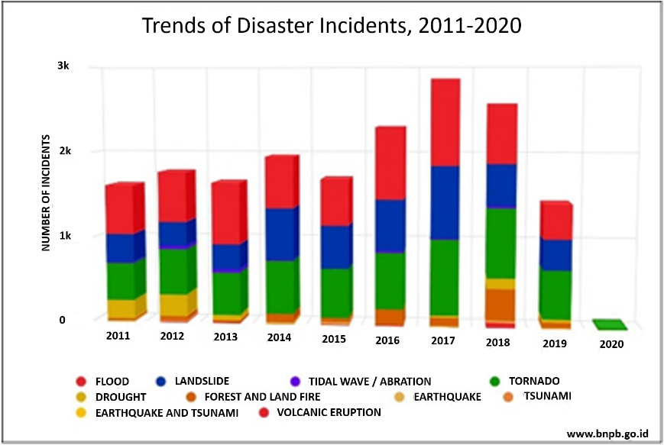
Figure 1 Disaster Incidents Trend (Accessed on January 31, 2020, http://www.bnpb.go.id)
The occurrence of natural disasters in West Java is one manifestation of the lack of natural balance. The balance of nature here relates to the harmony between human life and nature and how culture becomes a medium for harmonization. This is by the science of anthropology known as the triangulation relationship between humans, nature, and culture. When humans try to manage a condition in their environment by creating a culture and vice versa, nature will create the culture for the human that is alive in that nature (Bruce et al., 2007; Daeng, 2000).
The local Sundanese cultural philosophy Tri Tangtu has begun to fade among the Sundanese ethnic community, especially the younger generation. Masyarakat di Kampung Naga memiliki filosofi dalam penanggulangan bencana yang dinamai Tri Tangtu Bumi sebagai regional planning (Rahmatullah & Saraswati, 2021). According to Sumardjo (2018), Tri Tangtu is a Sundanese philosophy with three definite life guidelines: Batara Tunggal, which consists of Batara Keresa, Batara Kawasa, and Batara Bima Karana. This philosophy follows the conditions of Indonesia that the territory of Indonesia consists of mountains, maritime, and agriculture. In contrast to the view of Indrawardana (2012) that from an ecological, cultural perspective, the Sundanese usually live in the mountains, so they are often called "mountain people." However, the reality is that Sunda is divided into three regions: mountainous areas, coastal areas, and plains for agriculture. There are prohibitions on cutting down trees, breaking stones, and polluting rivers.
This philosophy is a noble value that must be common in maintaining the balance of nature and the environment. Local people generally place traditional wisdom as the best means, tool, and medium for maintaining the environment in the best possible way(Masruri & Fauroni, 2013; Rahmatullah & Saraswati, 2021). Therefore, the initial stage of this research is to map the extent of student knowledge related to Tri Tangtu Sundanese local wisdom and then a strategy for revitalizing Tri Tangtu local wisdom values.
Previous research Machfiroh (2011) conducted research on the revitalization of national character through the role of civic education in the development of Macapat's local culture. The results of the research indicate that Macapat culture has an important position and has a tight relation in developing national character. Adhering to the importance and relevance of local wisdom development to build national character, this research will examine the Tri Tangtu local wisdom revitalization strategy in building national character. Apart from that, as a form of novelty in this research, the researcher emphasizes that the final goal of national character building through understanding Tri Tangtu culture is awareness of maintaining nature and the environment. According to that strategy, this research discovered an appropriate educational model for local wisdom values to internalize the local wisdom Tri Tangtu values through new media.

METHODS
The research method is the qualitative method because this research explains and analyzes the phenomenon of Tri Tangtu as a local wisdom value in West Java comprehensively. The reason for using the qualitative method is that researchers gain in-depth insight into the complexity of problems in revitalizing the character of Tri Tangtu local wisdom values for students. This research explains and analyzes in depth the Tri Tangtu phenomenon as a local wisdom value related to ecology in West Java and how to revitalize this value for developing student character.

Participants
The subjects of this study were college students at the Faculty of Creative Industries and the Faculty of Business Economics at Telkom University, located in Bandung, West Java, Indonesia. The reason for selecting the subjects in this study was the tendency of students in the two faculties to keep up to date, for example, their daily behavior and lifestyle.
The total respondents of the open interview are 42 college students, male and female, 20 people and 22 people, respectively. The student respondents came from the Faculty of Creative Industries, 39 students, and from the Faculty of Economics and Business are three students.

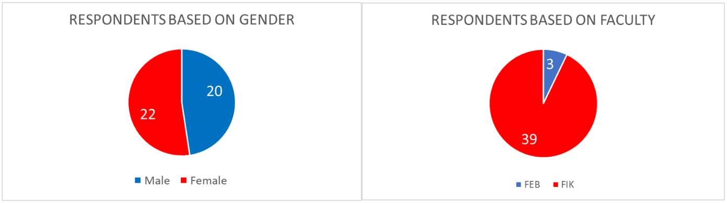
Figure 2. Respondent Data Based on Gender and Faculty
There were 17 respondents out of a total of 42 respondents who came from West Java and 25 respondents consisting of various regions (Figure 3).
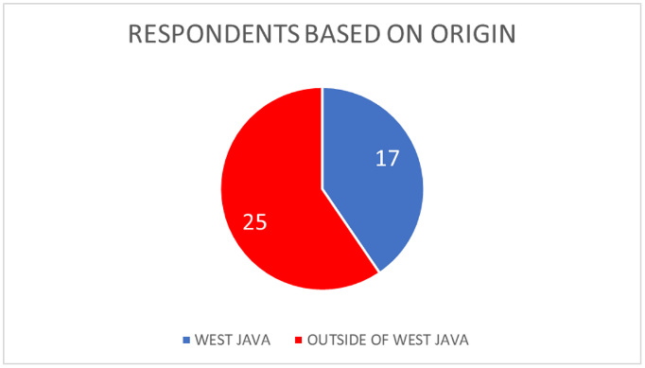
Figure 3. Respondent Data Based on Origin

Data Collection
The data collection technique is participatory observation, which involves researchers in Tri Tangtu-related activities or events, allowing researchers to directly observe social interactions, symbolic roles, and the influence of local wisdom values in a real context. In addition, documentation such as books and other materials pertaining to Tri Tangtu can be used to discern the patterns, themes, and interpretations of Tri Tangtu.

Data Analysis
Data validation uses triangulation of data from interviews to students, Data validation uses triangulation of data from interviews with students, cross-checked with interviews with community leaders/Tri Tangtu experts and validated from Google Form, observations made and existing documentation, going through several steps to gather comprehensive information about Tri Tangtu local culture and the local wisdom values that are inherent in Tri Tangtu. This allowed for the study of a strategy for reviving Tri Tangtu's local wisdom values to achieve sustainable development. The systematic steps taken are as follows:
Interview transcription: in-depth interviews with students and community leaders have been recorded, processing Google Form data: Strengthening data has been processed via Google Form.
Coding: labeling of several significant questions that come up during the interview and documentation process.
Document and data analysis: analyzing existing documents to enhance the meaning and analyzing available data related to Tri Tangtu;
Categorization: creating categories to organize data into certain category frameworks that are relevant to the research. This helps in seeing the relationships and patterns between the categories that appear in the form of a matrix.
Narrative Development: tell the research findings in a way that reflects the experiences and knowledge of students regarding Tri Tangtu. This may offer a comprehensive and contextual image.
Verification and interpretation: re-confirming the validity of the data obtained and re-interpreting the existing data holistically and deriving significant meaning from it.
Results: Results are related to the plan for reviving Tri Tangtu's traditional wisdom values through new media and are given both narratively and diagrammatically.

FINDINGS AND DISCUSSION

Overview results of the mini-survey via Google Form
This research used qualitative methods because researchers gained in-depth insight regarding the complexity of problems in revitalizing the character of Tri Tangtu local wisdom values for students. Apart from that, this research explains and analyzes the Tri Tangtu phenomenon as a local wisdom value related to ecology in West Java and how to revitalize this value for developing student character. Data collection techniques used were through interviews and reinforced through Google forms. Meanwhile, the respondents of open interviews are 42 students, consisting of 20 male respondents and 22 female respondents. In addition, interviews were conducted with community leaders or local wisdom experts to provide an in-depth understanding of how people understand, experience, and apply Tri Tangtu values in daily life.

Knowledge of Local Wisdom in Each Region
Based on the results of interviews with students, it was concluded that they only knew the meaning of local wisdom. Most only knew local wisdom from their respective regions, mostly oral culture, such as Pamali (prohibitions). However, the results of interviews and documentation show that male students know more about local wisdom and several local wisdom activities in their respective areas, such as papajar, botram, tri tangtu, mapai cai, and sedekah laut.
The results of the respondent data based on gender, 4 out of 22 female students did not know about local wisdom in their area, compared to 1 out of 20 male students who did not respond. West Javan respondents from the Faculty of Creative Industries four had no local wisdom, and one did not respond.
Based on the faculty origin, it turned out that four people who did not know local wisdom in their area and one who did not fill in were students from the Faculty of Creative Industries, all of whom came from West Java. However, it is strengthened by the results of interviews with two community leaders who still use local wisdom. In that case, it is stated that the meaning of local wisdom is not only limited to values and activities, but local wisdom is a form of wisdom in behavior to achieve the sustainability of life. Therefore, it can be concluded that the knowledge of local wisdom in each region is generally understood and has not reached the depth of the philosophical meaning of existing local wisdom because it is difficult to convey to young people often.

Local Wisdom that Contains Values to Protect the Environment
Based on the results of interviews, it turns out that only a few students know about local wisdom that contains ecological values such as Tri Tangtu, Mapai Cai, Panyawangan, and Wiru Jagad. While based on the respondent's data, 12 students know the local wisdom in their area about the environment. The local wisdom includes Mapai Cai, Gawir, and Cikondang, not allowed to fish in Sangiang.
This aligns with the observations and documentation that the West Java region is very strong in local wisdom related to ecology, and many terms depend on the area's coverage. If the results from interviews with community leaders turn out to be local wisdom for protecting the environment, many terms related to forests, mountains, seas, rivers, agriculture, and so on have their own terms. However, talking about the environment is talking about balance and sustainability, where the earth is divided into three regions, namely mountains, land, and coast. Therefore, local wisdom related to ecology or environmental protection is very necessary for the sustainability of human life on earth and harmony with nature.

Local Wisdom Value Education Method for Young Generation
The interview results show a gap in understanding the value of local wisdom due to generational differences. Based on the observations and interviews with students and community leaders, we concluded that appropriate media, including social media, videos, web animated videos, or new media, is needed to convey and instill local wisdom values for the younger generation. So far, it has been limited to oral traditions such as telling stories directly without any media and witnessing them directly to participate in local wisdom activities in their respective regions.
Based on 42 respondents, there was one respondent who did not answer. However, 41 respondents gave their opinion regarding the education strategy of local wisdom values for the younger generation. The average opinion is to educate the value of local wisdom to the younger generation through social media and cultural acculturation.
Therefore, it can be concluded that in this research, it was found that the gap in understanding the value of local wisdom, the main problem apart from generational differences, is the method of transferring values, so a strategy is needed to rebuild local wisdom values through new media.

Knowledge of “Tri Tangtu”
Based on interviews, we conclude that students' understanding of Tri Tangtu could have been higher. They do not know the meaning of Tri Tangtu; many of them have yet to hear of the name. The results of the Tri Tangtu community leaders are local wisdom values that are very philosophical and essential in sustainable environmental balance, especially in the division of social institutions. This is in line with the results of a mini-survey via Google form of the 42 respondents, it recorded that only five people knew about "Tri Tangtu,", only one person understood what "Tri Tangtu” was about, and three of them had only heard of the term, namely a philosophy of life with guidance on three things, Batara Tunggal, which consist of Batara Kawasa, and Batara Bima Karama. Batara Keresa means Desire, Batara Kawasa means Power or Strength, and a community uses Batara Karana to divide the world into three parts, from top to middle and bottom.
Village communities usually divide their settlement into three main areas, the upper world, which is represented by a sacred forest on a hill; the middle world, represented by housing, rice fields, and plantations; the underworld, which is represented by the forbidden forest through everyday life, namely the pattern of upbringing in the family, school, and environment. In "Tri Tangtu," the values taught are in the form of polite values, starting from intelligent behaviour in a society passed down from generation to generation by previous parents.
Therefore, we concluded that a strategy is needed to rebuild the values of Tri Tangtu's local wisdom, especially for students. The strategy is necessary because students, as the young generation, are continuing to be balanced and sustainable in social and environmental institutions, considering that currently, globally, there has been a problem related to climate change.

Understanding of Local Culture
Based on the results of research through interviews, observations, and electronic mini-surveys show that knowledge of local wisdom in each region is generally understood but not yet in depth. According to a study using electronic interviews, 37 out of 42 respondents were generally familiar with local wisdom. Only 12 responders, nevertheless, demonstrated an awareness of local wisdom. Respondents provided their reasons for local wisdom and their ability to identify local wisdom in their area. As a result, the diversity of society reflects the diversity of Indonesian culture, demonstrating that Indonesia is a pluralistic nation with a wide variety of traditions (Aspinall & Mietzner, 2019). Local wisdom or local genius, which is information and experience that has become ingrained in local communities as the standard in how they behave and act, is a social order or capital that comprises noble values (Aprianto et al., 2008; Azhar et al., 2015; Hidayati, 2017). According to the findings of in-depth interviews, the local wisdom in the respondents' area mainly relates to the merged locals' knowledge, values, and traditions. According to Hutchison (2018), the community has internalized its knowledge and experience, reflected in how it behaves and interacts with the environment, nature, and other factors. Local wisdom models behaviour in meeting daily demands (Eriawaty et al., 2022).
Based on the results of this study, only 12 out of 42 respondents could describe local wisdom linked to protecting the environment and teaching moral principles. This indicates a need for more knowledge and understanding of local wisdom, particularly those that deal with the environment. The local wisdom Mapai Cai, Gawir, and Cikondang are not allowed to fish in Sangiang. Furthermore, Tri Tangtu is among others that can be listed. Local knowledge is crucial to a community's social capital when managing its natural resources(Rahmatullah & Saraswati, 2021). The two primary purposes of local wisdom are to satisfy the community's need for water for life and livelihood and to sustain peaceful relations. Although it leans more toward abstinence, such as abstention from fishing with tools, abstinence from tossing Sampang, and maintenance of springs, this local wisdom related to environmental preservation is social capital, particularly for nature management(Ilahi & Weishaguna, 2022).
The local wisdom currently practiced includes knowledge of the region's past, a preserved local culture, and local skills, such as those needed to make an instrument for environmental protection, plant local resources, and engage in local social practices such as Sedekah Bumi. Local wisdom includes five social dimensions: local knowledge, local culture, local skills, local resources, and local social processes (Aprianto et al., 2008). The same universal principles of mutual assistance, cooperation, and resource preservation apply to local wisdom, particularly in the context of the existing local culture.

Understanding of Local Wisdom and Tri Tangtu Cultural Education Strategies
Based on 42 respondents, just five recognized Tri Tangtu, and only one of those five knew what it meant; the other three had merely heard the term; this shows the low rate of knowledge regeneration regarding Tri Tangtu's local culture. Natural disasters in West Java or Indonesia exemplify an unstable environment. Harmony between human life and nature, how culture serves as a medium for harmonization related to the balance of nature in this context. The local Sundanese cultural ideology "Tri Tangtu," particularly among the younger generation, has begun to wane.
Sumardjo (2010) claims that Tri Tangtu, a Sundanese philosophy, comprises three definite rules for living: Batara Tunggal, which comprises Batara Keresa, Batara Kawasa, and Batara Bima Karana. This philosophy aligns with Indonesia's condition that its land comprises mountains, the ocean, and agarics. It is crucial to preserve the inherited values of local wisdom within indigenous cultures, emphasizing the roles of customary councils and the community in safeguarding these traditions (Permana, 2015)
According to Indrawardana's (2012) statement, the Sundanese people have historically been referred to as "mountain people" since they live in these mountainous regions, which are generally considered environmentally and culturally diverse. Natural disasters frequently happen due to a lack of balance in nature, one of which is because there is no balance between humans, nature, and local culture. However, according to research findings, the Tri Tangtu philosophy is already extinct and poorly understood by the public or the younger generation. This is consistent with the anthropological studies known as the triangulation relationship between people, the environment, and culture (Bruce et al., 2007; Daeng, 2000).
Based on the analysis above and the research results, the findings of this research are that a strategy is needed to re-grow or revitalize the value of the local wisdom of Tri Tangtu as there has been a gap in the past due to generational differences and the media used has only included oral traditions or stories/legends. Generation Z's understanding of media involves information technology. However, according to studies on local wisdom that particularly examine a novel, character dialogue in the book reflects myth (Ohia, 2023). Aside from that, previous research in Africa shows that oral traditions, via festivals, dance, and song, can bring people together for peace and unity. This contrasts with Indonesia, where the younger generation finds written works and oral storytelling less appealing, and engaging media is required. This is consistent with earlier studies' findings that Generation Z education has shifted to digitalization in the 21st century (Apaut & Suparman, 2021; Ariefin et al., 2022), Apart from that, the results of Mustafa (2023) show that social media has succeeded in promoting Bayt Al-Qur'an Al-Akbar tourism for the younger generation. Character education involves components of knowledge, awareness or will, and actions to implement community education values in realizing the life of the nation by instilling character education(Masruri & Fauroni, 2013) . The difference with this research is that the new media used to transfer knowledge and cultural values of Tri Tangtu is not just social media but requires audio-visuals so that the imagination and understanding of the younger generation are deeper. The researcher's description of the Tri Tangtu local wisdom revitalization educational strategy is as follows:
According to the previous analysis and research findings, the current generation must be educated via distinctive media to revive or revitalize the native Tri Tangtu culture. The researcher's description of the Tri Tangtu local wisdom revitalization education strategy can be seen in Figure 4.

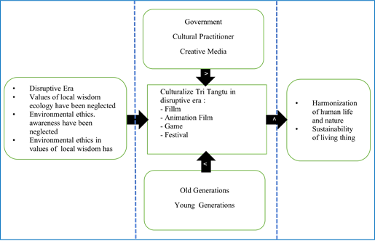
Figure 4. Processed by Researchers
According to Figure 4, intervention and habituation can be used to rebuild the local wisdom values of the Tri Tangtu local culture for the community and the younger generation. The following explanation of the intervention and habituation processes by (Budimansyah, 2010) as follows:
Intervention is the process of formal character education carried out in a structured way in formal activities like schools. In contrast, Habituation is the process of creating different situations and conditions (persistent-life situations) in the form of reinforcement that can be carried out at home, school, and the environment by becoming accustomed to acting by values that have been internalized and personalized through the process of feeling and thinking.
According to the previous state, there are two methods of character education: habituation and formal intervention. Habituation occurs in families and communities where people are used to self-behaving according to values through feeling and thinking as a character building. Social media must participate in the digital era by organizing events, contests, and animated narrative media.

CONCLUSION
The generational gap in understanding what it means to value Tri Tangtu's local wisdom is the specific cause of the lack of understanding among students regarding its value. Therefore, to facilitate the transformation of values in accordance with the type of Generation Z that prefers digital technology, a strategy is required to revitalize the values of Tri Tangtu local wisdom through new media. Based on the findings in this research, it is recommended that the curriculum must include local wisdom values such as social programs, community involvement, and the use of technology to maintain local wisdom values as an integral part of students' cultural identity at Telkom University.

REFERENCES
Apaut, V. A., & Suparman, S. (2021). Membangun Disiplin Rohani Siswa pada Generasi Z Melalui Jurnal Membaca Alkitab [Building Students’ Spiritual Discipline of Generation Z through Bible Reading Journalling]. Diligentia: Journal of Theology and Christian Education, 3(2), 110–125.
Aprianto, Y., Pardede, I. A., & Fernando, E. R. (2008). Kearifan lokal dalam mewujudkan pengelolaan sumberdaya air yang berkelanjutan. IPB (Bogor Agricultural University).
Ariefin, D., Wiriadinata, A. Y., Effendi, D. T., Prihatiningsih, U., & Turnip, G. (2022). Generation Z’s Attitude towards Bible Study in the Disruption Era. International Conference on Theology, Humanities, and Christian Education (ICONTHCE 2021), 279–282.
Aspinall, E., & Mietzner, M. (2019). Nondemocratic pluralism in Indonesia. J. Democracy, 30, 104.
Azhar, A., Basyir, M. D., & Alfitri, A. (2015). Hubungan pengetahuan dan etika lingkungan dengan sikap dan perilaku menjaga kelestarian lingkungan. Jurnal Ilmu Lingkungan, 13(1), 36–41.
Bruce, M., Setiawan, B., & Rahmi, D. H. (2007). Pengelolaan sumberdaya dan lingkungan. Gadjah Mada University Press.
Budimansyah, D. (2010). Tantangan globalisasi terhadap pembinaan wawasan kebangsaan dan cinta tanah air di sekolah. Jurnal Penelitian Pendidikan, 11(1), 8–16.
Daeng, H. (2000). Manusia, kebudayaan, dan lingkungan: tinjauan antropologis. Pustaka Pelajar.
Eriawaty, E. T. D., Widjaja, S. U. M., & Wahyono, H. (2022). Rationality, Morality, Lifestyle And Altruism In Local Wisdom Economic Activities Of Nyatu Sap Artisans. Journal of Positive School Psychology, 5781–5797.
Hidayati, D. (2017). Memudarnya nilai kearifan lokal masyarakat dalam pengelolaan sumber daya air. Jurnal Kependudukan Indonesia, 11(1), 39–48.
Hutchison, E. D. (2018). Dimensions of human behavior: Person and environment. Sage Publications.
Ilahi, T., & Weishaguna. (2022). Kajian Tri Tangtu di Buana Konservasi Air Situ Sipatahunan: Studi Kasus: Situ Sipatahunan, Kabupaten Bandung. Bandung Conference Series: Urban & Regional Planning, 2, 626–635. https://doi.org/10.29313/bcsurp.v2i2.3752
Indrawardana, I. (2012). Kearifan lokal adat masyarakat Sunda dalam hubungan dengan lingkungan alam. Komunitas, 4(1).
Machfiroh, R. (2011). Revitalisasi karakter bangsa melalui pendidikan kewarganegaraan dengan pengembangan budaya lokal: Studi kasus budaya macapat di kota Surakarta. Universitas Pendidikan Indonesia.
Masruri, S., & Fauroni, R. (2013). PERAN MODAL SOSIAL FILSAFAT TRI TANGTU SILIH DALAM PEMBERDAYAAN EKONOMI MASYARAKAT DI DESA ALAMENDAH RANCABALI BANDUNG. INFERENSI, 7, 275. https://doi.org/10.18326/infsl3.v7i2.275-296
Mustafa, E. A. A. (2023). The Thirst for Islamic Knowledge in the Digital Era. Digital Muslim Review, 1(1), 54–67.
Nuryadi, M., & Widiatmaka, P. (2023). Developing Students’ Nationalism Character through Video-Based Learning in Pancasila Education in the Disruption Era. JPI (Jurnal Pendidikan Indonesia), 12, 519–527. https://doi.org/10.23887/jpiundiksha.v12i3.55267
Ohia, B. F. (2023). Suspense and dialogue as aspects of aesthetics in the plot of Elechi Amadi’s trilogy. Linguistics, 6(3), 64–76.
Perbawasari, S., Rahmat, A., Bakti, I., & Subekti, P. (2023). Establishment of Healthy Living Characters and The Inheritance of Local Wisdom Values in Miduana Indigenous Communities. Journal of Law and Sustainable Development, 11, e2095. https://doi.org/10.55908/sdgs.v11i12.2095
Permana, R. (2015). MAKNA TRI TANGTU DI BUANA YANG MENGANDUNG ASPEK KOMUNIKASI POLITIK DALAM FRAGMEN CARITA PARAHYANGAN. Jurnal Kajian Komunikasi, 3, 173–191. https://doi.org/10.24198/jkk.vol3n2.8
Rahmatullah, Z., & Saraswati. (2021). Kajian Mitigasi Bencana Berbasis Kearifan Budaya Lokal di Kampung Adat Naga Desa Neglasari Kecamatan Salawu Kabupaten Tasikmalaya. Jurnal Riset Perencanaan Wilayah Dan Kota, 1, 99–106. https://doi.org/10.29313/jrpwk.v1i2.372
Sumardjo, J. (2018). Revitalisasi kearifan lokal Sunda. Jurnal Budaya Nusantara, 1(2), 106–116.

