SCHOOL CREATIVITY BUILDING RELATIONSHIPS WITH PARENTS IN TREATING THE PROBLEMS OF FACILITIES AND INFRASTRUCTURE
Sri Widayati¹, Suryanti², Wiryanto³
¹ sriwidayati@unesa.ac.id
² Suryanti@unesa.ac.id
^{3.}wiryanto@unesa.ac.id

ARTICLE INFO |  | ABSTRACT
Keywords:  school creativity,  problematic,  facilities and infrastructure |  | The purpose of this study was to describe the creativity of an elementary school institution in establishing relationships with parents in overcoming the problems of facilities and infrastructure before and during the COVID-19 pandemic and post-pandemic. Completeness of facilities and infrastructure will support the achievement of learning objectives. This research is descriptive and qualitative with the subject of this research being SDN Kota Baru IX, Bekasi City. Data collection techniques use interviews, observation, and documentation with data analysis using triangulation. The results of this study reveal that online learning at SDN Kota Baru IX, Bekasi City does not experience difficulties, this is supported by the various creative ideas of teachers under the auspices of the PMPS (School Education Quality Assurance) team which is well coordinated with parents. Parents fully support online learning by providing various facilities such as wifi, android/ios-based cellphones, and laptops. Parenting education is the key to bridging communication with parents. This research implies that schools that have good cooperation with parents will have an impact on the success of school programs in dealing with various situations.
Article history:
Received 2022-06-9
Revised 2022-06-12
Accepted 2022-06-15
 |  | This is an open-access article under the CC BY-NC-SA license.
Corresponding Author:
Sri Widayati
sriwidayati@unesa.ac.id

INTRODUCTION

Institutional relationships with parents are very important. Where in the education tri center according to Ki Hajar Dewantara that the three elements that support the success of education are family, environment, and school(Mudana 2019)(Bariyah 2019)(Agustini 2018)(Huda and M 2019)(Nadziroh 2018)(Siregar, Gandamana, and Putri 2019)(Purnomo 2020)(Ikfina 2021)(Amen 2018)(Putrianti, Wijayanti, and Listiyani 2020)(Word 2020)(Malisi 2021). Parents have a very big role in the education of a child. In addition to parents as early educators, where the role of parents is as the first foundation for children in obtaining an education (Wulandari, Zikra, and Yusri 2017) (Wigunawati 2019). The role of parents is the main driver of the success of a school.

School is an educational institution. Educational institutions in Indonesia consist of non-formal and formal educational institutions. Formal educational institutions, among others, start from elementary school to high school. Indonesian citizens (WNI) have the right to obtain basic education (Zivara 2022). In Indonesia, what is meant by basic education is compulsory education for 9 years, namely from elementary school (SD) to junior high school (SMP) (Asean 2021).

Regarding elementary schools, there are public elementary schools and private elementary schools. Where the State Elementary School is referred to as SDN. Procurement of facilities and infrastructure in public schools is the full responsibility of the government (Novita 2017)(Alfarisi 2021)(Nurstalis, Ibrahim, and Abdurrohim 2021)(Izzati 2020)(Rohiyatun 2019)(Herawati and Bangsa 2020)(Muslimin and Kartiko 2021). Of course, during the COVID-19 pandemic, many changes occurred in all sectors, including in the field of education. One of them is the temporary elimination of face-to-face meetings (offline) and the implementation of online learning (Jamaluddin et al. 2020) (Anon 2021) (Harahap, Dimyati, and Purwanta 2021) (Aji et al. 2020). Meanwhile, during the current post-pandemic period, where face-to-face meetings begin again, there is a re-adjustment between the pre-pandemic, pandemic, and post-pandemic periods.

Regarding infrastructure, there are also changes, where some of the school facilities and infrastructure are not used and there are facilities and infrastructure that must be maintained during the pandemic, as well as adjustments during the post-pandemic period. School facilities and infrastructure are one of the most important components to support the success of an educational institution in dealing with various times (Marhamah et al. 2021) (Syaikhon and Rihlah 2019) (Amalia 2019). Without adequate facilities and infrastructure, it will be one of the factors that an institution is not fully developed (Rohiyatun 2019) (Nawati, Sadjiarto, and Rina 2021) (Sada 2016) (Amalia and Maryati 2021) (Triyono 2019) (Firdausi, Marsidin, and Sabandi 2020)(Siregar and Tambunan 2020)(Amalia 2019)(Marhamah et al. 2021)(Zahrawati and Ramadani 2021).

This is in line with the duties of the Directorate of Elementary Schools regarding infrastructure according to Permendikbud No. 9 of 2020, namely: 1. to facilitate basic school infrastructure and special education services in elementary schools; 2. carry out the preparation of norms, standards, procedures, and criteria in the fields of students, infrastructure, and governance as well as assessments in elementary schools and special service education in elementary schools, 3. carry out facilitation of empowerment and strengthening of implementation capacity in the field of students, infrastructure, and governance and assessment of primary and special services education in primary schools; 4. carry out the provision of technical guidance and supervision in the fields of students, infrastructure, and governance as well as assessments in primary schools and special education services in elementary schools (Basic 2022).

In addition, the implementation of national education must ensure equity and improve the quality of education amid global changes. This is so that Indonesian citizens become human beings who fear God Almighty, have a noble character, are intelligent, productive, and highly competitive in national and international relations. To ensure the achievement of these educational goals, the government has mandated the preparation of eight national education standards as regulated in Government Regulation of the Republic of Indonesia No. 19 of 2005 concerning National Education Standards. National education standards are the minimum criteria regarding the education system in all jurisdictions of the Unitary State of the Republic of Indonesia. The implementation of learning in national education is centered on students so that they can: a) learn to have faith and fear God Almighty, b) learn to understand and live, c) learn to be able to implement and act effectively, d). learn to live together and be useful to others, e). learn to build and find identity through an active, creative, effective, and fun learning process (Basic 2022)

METHODS

This article is descriptive qualitative research. The subject of this research is SDN Kota Baru IX, Bekasi City, West Java. Data collection techniques through observation, interviews, and documentation. Interviews were conducted with teachers and the documents analyzed were from photos, videos on YouTube, and news articles about institutions. Data analysis uses data triangulation, where the data obtained is then sorted based on certain materials. The data that has been sorted based on the material is then analyzed and concluded.

FINDINGS AND DISCUSSION

A. Changes in the Learning System Before, Covid-19 Pandemic, and Post Pandemic Affect Facilities and Infrastructure

Since the onset of COVID-19, the Indonesian government has taken a breakthrough in the form of PPKM. PPKM is the Enforcement of Restrictions on Community Activities(Yunida 2021)(Miharja et al. 2021)(Taofik Krisdiyanto 2021)(Ilyas 2021)(Andriyani et al. 2021)(YAKHAMID and ZAQI 2021)(Permatasari 2021). This was done by the government due to the increasing spread of COVID-19 in various regions in Indonesia. The existence of this PPKM action has an impact on all fields including education (Yunida 2021) (Yunida 2021) (Andriyani et al. 2021). Because of this PKKM, the learning system that was originally face-to-face (offline) turned into an online system (Azhari and Fajri 2021) (Rasmitadila et al. 2020) (Irawan, Dwisona, and Lestari 2020) (Simamora 2020) (Soni 2020)(Fuada and Marhamah 2021)(Mailizar et al. 2020)(Almaiah, Al-Khasawneh, and Althunibat 2020). Of course, not all institutions are ready for this learning system. For an effective online learning system, many things are needed. In addition to the educators who understand technology, namely how to operate various kinds of hardware devices, and operate various applications as well as the need for facilities such as the availability of laptop/computer facilities, Android/Ios-based mobile phones, networks (WIFI) and strong signals (Shadiqien 2020) (Aisyah and Muhammad Alif Kurniawan 2021)(Sunardi 2021)(Kharisma, Roesminingsih, and Suhanadji 2020)(Hardiansyah et al. 2021)(Febrianti, Sudradjat, and Sari 2020)(Siregar and Hanifah 2021). Likewise, with students, each student must have a laptop or mobile phone based on Android/Ios, have a network (WIFI) and the location has a strong signal.

At the SDN Kota Baru IX institution, Bekasi City when online learning was implemented, the school, especially the principal and the PMPS (School Education Quality Assurance) team immediately sought information and proposed the submission of facilities and infrastructure to support the online learning system. Of course, this proposal must be submitted to the local education office. In the end, this proposal was approved, resulting in obtaining several laptops and adding a wifi network as well as submitting hand sanitizer, liquid soap, masks, temperature thermometers, as well as making several sinks as part of 3M. During the Covid-19 period, the term 3M was defined as; 1. Wearing a mask properly, 2. Keeping your distance and avoiding crowds, 3. Washing your hands with soap to avoid virus contamination.

SDN Kota Baru IX, Bekasi city is one of the schools selected as the best SPMI (Internal Quality Assurance School) school from all educational institutions in the province of West Java. Being one of the best SPMI schools, the institution must ensure that the quality of the facilities and infrastructure is complete and in a very suitable condition for use. In addition, as one of the best SPMI schools, it must be able to provide examples to surrounding institutions not only from the point of view of facilities and infrastructure but in terms of curriculum, programs, learning tools, implementation, and evaluation of learning. In essence, all school management is the main factor in the assessment of a school's ranking as the chosen SPMI institution. The appearance of the infrastructure of SDN Kota Baru IX, Bekasi City can be seen in Picture 1 below

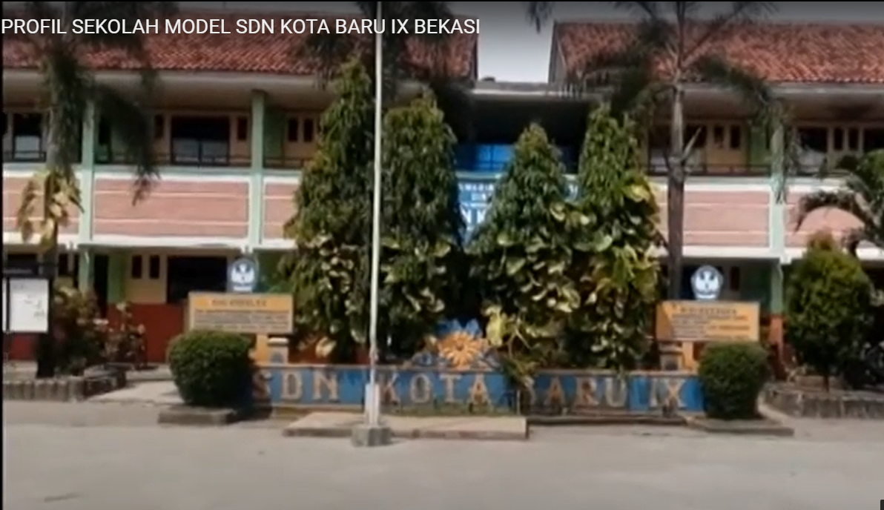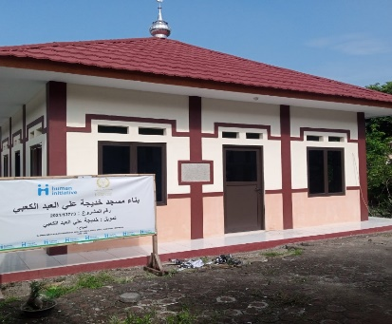

Picture 1. Infrastructure in the form of school buildings and prayer rooms donated from the Foundation at SDN Kota Baru IX

From Picture 1, it can be seen that there are many classrooms at SDN Kota Baru IX, as well as a fairly large school field. The number of classrooms can be seen from the two-story building. The building looks very usable.

In implementing online learning, teachers at SDN City IX have a high initiative in upholding their profession as teachers. The teachers took the initiative to buy themselves a variety of equipment that can support online learning to run smoothly. One of them is providing an additional camera tool for a laptop so that the video is clearer, buying pulses of data packages to make it easier to have a network and signal when the teacher is not studying at school, the teacher buying a Zoom package or uses Gmeet by using the learner @ id account he has. This shows that the teachers at SDN City IX do not solely rely on the facilities and infrastructure available at the school. This high initiative can be used as an example for teachers in Indonesia. This can be seen in Picture 2 below:

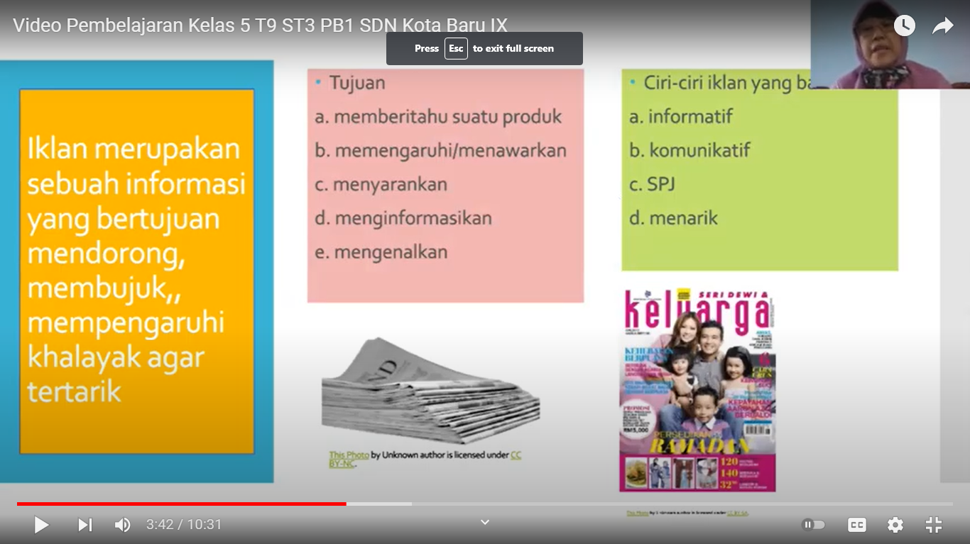

Picture 2. A teacher at SDN Kota Baru makes a learning video

Through picture 2, we can see that the teacher at the SDN Kota Baru IX school, Bekasi City is doing as much as possible during the learning process that occurred during the COVID-19 pandemic by making a learning video with certain materials uploaded via YouTube. This is an alternative to learning if it is not done directly online via Zoom or Gmeet.

During the post-pandemic period, learning is back offline with learning time that is still limited to 2-3 hours per day. For approximately 1-2 weeks, the child begins to return to offline learning during the post-pandemic period. The school made observations on each student per class. From the evaluation results, it turns out that several classes have learning loss. The PMPS (School Education Quality Assurance) team at SDN Kota Baru IX, Bekasi City decided to focus on material that was lost in each class to be given face-to-face (offline) and other materials were provided online, especially via links.

Before the pandemic, all facilities and infrastructure were routinely maintained and during the pandemic, school infrastructure facilities that were rarely used such as tables, chairs, cupboards, classrooms, and other rooms became unkempt and partially damaged. Lots of cobwebs, and dust on tables, chairs, cupboards, classrooms, and other spaces that were not used during the pandemic. Since the post-pandemic began, all facilities and infrastructure have been better maintained. Classrooms and other rooms are clean again, free of dust and cobwebs. The use of the sink persists, and the 3M behavior habits are maintained.

B. COOPERATION AND OPEN CONCEPT WITH STUDENT PARENTS

One of the success factors for school achievement is the creation of good cooperation with parents and the surrounding environment. Parental support and the surrounding environment will shape the desired learning goals for students to be achieved more quickly (Septiana 2018) (Rizkyani, Adriany, and Syaodih 2020) (Ramdani, Hufad, and Supriadi 2018) (Mamluah and Maulidi 2021). SDN Kota Baru IX, Bekasi City is very aware of this, so the school always invites parents of school students to discuss various program ideas proposed by the school. From the results of discussions and evaluations with parents of students, in general, parents, appreciate all activities carried out by schools that can involve all students to participate, such as various competitions held at school. According to parents, through competition activities, their children will actualize as much as possible, accompanied by the emergence of self-confidence, courage, cooperation, and learning to accept defeat. Many graduates from SDN Kota Baru IX, Bekasi City excel at the next institutional level and information from teachers at subsequent institutions conveys that graduates on average have courage and high self-confidence.

Based on this, the school held a variety of competition ideas which were then conveyed to the parents, the students' parents gave donations in the form of trophies, both the winners and those who did not receive trophies as appreciation for participating in the competition activities. In addition, the school is committed to implementing the concept of honesty in program delivery, implementation, and evaluation of the program. One example of the idea of ​​a Ramadhan cottage activity is where parents provide funds managed by the school for the purchase of tools, trophies, and necessities during the Ramadhan cottage. The school provides facilities to parents in the form of stalls to sell takjil (the sellers are parents). After the Ramadhan cottage activities were completed, the school reported to the parents of the students.

Another example of openness and parental support is when there is a foundation that is willing to assist in the form of building materials for the construction of a new prayer room, but the costs for the procurement of craftsmen and the daily operations of the handymen are delegated to the school. For the procurement and operational costs of the artisans to establish a new prayer room, the school holds a Blessing Friday program (infaq), donors from parents (obtained from communication with parents of students), and part of the boss's funds that can be allocated. Due to the high level of openness and support from parents, a larger percentage of the funds for the procurement of construction workers and their operations are obtained from parents. The description of the new prayer room as a result of donations from the Foundation and the collaboration of parents and students support can be seen in Picture 1.

A form of trust and gratitude from parents in this institution is to work together to create an action stage. The making of this action stage is very supportive so that children are always more confident to perform, with no need to wait for the year-end farewell event. In addition, with the action stage, it is easier for schools to make as many competitions as possible without worrying about the cost of the stage. The form of the hybrid action and learning stage during the pandemic can be seen in Picture 4 below:

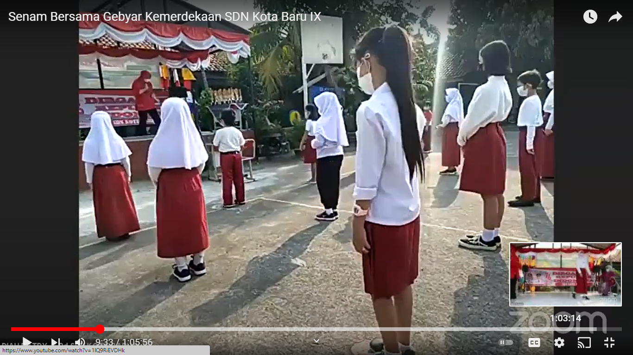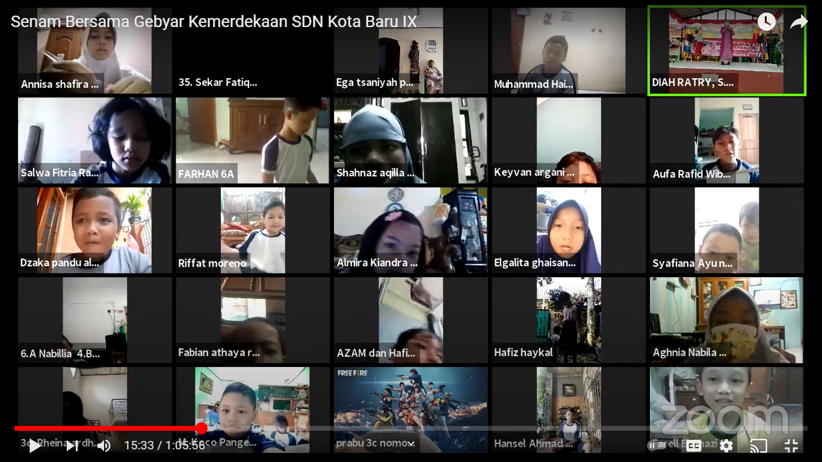

Picture .4. Celebration of the 76th Republic of Indonesia's Anniversary with Hybrid gymnastics

In Picture 4, it can be seen the support from parents, and enthusiasm from students and educators in celebrating the 76th Indonesian Independence Day. Pictures 4 and 5 also show that SDN Kota Baru IX, Bekasi City is making maximum efforts so that the teaching and learning process continues as optimally as possible, even during the COVID-19 pandemic.

At the beginning of the pandemic, the PMPS (School Education Quality Assurance) team conducted parenting education about the importance of the wifi network for smooth online learning. In parenting, it is explained that parents are given an understanding that the existence of wifi is not only to facilitate access for children to play games but also to ensure that children can receive online learning and do various tasks more easily. The existence of a variety of daily tasks that are made regularly will prevent children from playing games all the time. This is what makes parents aware and must provide support in the form of an optimal wifi network for their children.

The existence of parental awareness is the main supporter of online learning at SDN Kota Baru IX running smoothly. The main element of smooth and harmonious communication between institutions and parents cannot be separated from the role of the PMPS (School Education Quality Assurance) team as the driving force. After receiving parenting education about the importance of wifi, it also affects all parents seeking mobile or laptop facilities for their children, so that there are no difficulties in implementing online learning at SDN Kota Baru IX, Bekasi city.

CONCLUSION

The COVID-19 pandemic has had a profound impact on all fields, including education. A very striking change in the field of education is the change in the teaching system which was originally face-to-face (offline) learning before the pandemic turned into online learning (online. There are additional facilities and infrastructure such as laptops, a network (wifi), additional external cameras, laptops, etc. to support online learning. The end of the pandemic period and the start of the post-pandemic period does not eliminate online learning. Online learning supports face-to-face learning in the post-pandemic period.

The provision of facilities and infrastructure related to 3M, the addition of a sink outside the classroom, liquid soap, temperature thermometer, hand sanitizer, and masks are obligations that must be carried out in the online learning system. Facilities and infrastructure related to 3M during the pandemic will continue to be used during the post-pandemic period.

Online and hybrid learning at SDN Kota Baru IX, Bekasi City did not experience difficulties, this was supported by the various creative ideas of teachers under the auspices of the PMPS (School Education Quality Assurance) team which was well coordinated with the parents. Parenting education is the key to bridging communication with parents.

REFERENCES
Afilliany. 2020. “Kurangnya Sarana Dan Prasarana Menghambat Penerapan Inovasi Pendidikan.” Komposiana.Com. Retrieved (https://www.kompasiana.com/afrilliany04235/6245d6a85a74dc7fba6ca632/kurangnya-sarana-dan-prasarana-menghambat-penerapan-inovasi-pendidikan?page=all).
Agustini, Ni Made Sri. 2018. “TRIPUSAT PENDIDIKAN SEBAGAI LEMBAGA PENGEMBANGAN TEORI PEMBELAJARAN BAGI ANAK.” MAGISTRA: Media Pengembangan Ilmu Pendidikan Dasar Dan Keislaman 9(2). doi: 10.31942/mgs.v9i2.2543.
Aisyah, Siti, and Muhammad Alif Kurniawan. 2021. “Penggunaan Media Pembelajaran Daring Pada Masa Pandemi COVID-19.” Jurnal Riset Madrasah Ibtidaiyah (JURMIA) 1(1). doi: 10.32665/jurmia.v1i1.195.
Aji, Wahyu, Fatma Dewi, Universitas Kristen, and Satya Wacana. 2020. “Dampak Covid-19 Terhadap Implementasi Pembelajaran Daring Di Sekolah Dasar.” Edukatif: Jurnal Ilmu Pendidikan 2(1):55–61. doi: https://doi.org/10.31004/edukatif.v2i1.89.
Alfarisi, Salman. 2021. “Analisis Perencanaan Sarana Dan Prasaranan Pendidikan Islam.” Rayah Al-Islam 5(01). doi: 10.37274/rais.v5i1.401.
Almaiah, Mohammed Amin, Ahmad Al-Khasawneh, and Ahmad Althunibat. 2020. “Exploring the Critical Challenges and Factors Influencing the E-Learning System Usage during COVID-19 Pandemic.” Education and Information Technologies 25(6). doi: 10.1007/s10639-020-10219-y.
Amalia, L., and M. Maryati. 2021. “PENGELOLAAN SARANA DAN PRASARANA PENDIDIKAN DI MADRASAH ALIYAH NEGERI 2 KARAWANG.” PeTeKa.
Amalia, Zahra. 2019. “Implementasi Kebijakan Pengelolaan Sarana Dan Prasarana Sekolah Di MAN Prambon Nganjuk.” Jurnal Dinamika Manajemen Pendidikan 3(1). doi: 10.26740/jdmp.v3n1.p17-24.
Amin, Alfauzan. 2018. “Sinergisitas Pendidikan Keluarga, Sekolah Dan Masyarakat; Analisis Tripusat Pendidikan.” At-Ta’lim : Media Informasi Pendidikan Islam 16(1).
Andriyani, Lusi, Armyn Gultom, Khofifah Ketiara, Jl K. H. Ahmad Dahlan, Kecamatan Ciputat Timur, Kota Tanggerang, Jl K. H. Ahmad Dahlan, Kecamatan Ciputat Timur, and Kota Tanggerang Selatan. 2021. “Dampak Sosial Ekonomi Kebijakan Pemberlakuan Pembatasan Kegiatan Masyarakat ( PPKM ) Di Indonesia.” Seminar Nasional Penelitian LPPM UMJ.
Anon. 2021. “Dampak Youtube Pada Kegiatan Belajar Daring Anak Usia Dini Di Tengah Pandemi Covid-19.” Jurnal Interaksi : Jurnal Ilmu Komunikasi 5(2). doi: 10.30596/interaksi.v5i2.6755.
Arifianto, Bambang. 2022. “Hanya Miliki 3 Ruangan, Kelas Di SD Cibungur Kelas Jauh Cijuhung Terpaksa Disekat Lemari Dan Triplek.” Pikiran-Rakyat.Com. Retrieved (https://www.pikiran-rakyat.com/bandung-raya/pr-013634048/hanya-miliki-3-ruangan-kelas-di-sd-cibungur-kelas-jauh-cijuhung-terpaksa-disekat-lemari-dan-triplek).
Asean. 2021. “Kenapa Wajib Belajar 9 Tahun Wajib Di Indonesia? Apakah Penting?” Https://Indonesiar.Com. Retrieved (https://indonesiar.com/kenapa-wajib-belajar-9-tahun-wajib-di-indonesia-apakah-penting/).
Azhari, Budi, and Iwan Fajri. 2021. “Distance Learning during the COVID-19 Pandemic: School Closure in Indonesia.” International Journal of Mathematical Education in Science and Technology. doi: 10.1080/0020739X.2021.1875072.
Bariyah, Siti Khusnul. 2019. “Peran Tripusat Pendidikan Dalam Membentuk Kepribadian Anak.” Jurnal Kependidikan 7(2). doi: 10.24090/jk.v7i2.3043.
Dasar, Direktorat Sekolah. 2022. “No Title.” Direktorat Sekolah Dasar. Retrieved (https://ditpsd.kemdikbud.go.id/hal/sarana-dan-prasarana).
Dewi, Nur Shinta. 2020. “Riset: Sinyal Jaringan Seluler Masih Belum Merata Di Indonesia.” Retrieved (https://www.digination.id/read/016133/riset-sinyal-jaringan-seluler-masih-belum-merata-di-indonesia).
Febrianti, Clara, Adjat Sudradjat, and Retno Sari. 2020. “Perancangan E-Learning Sebagai Media Pembelajaran.” Jurnal Infortech 2(2). doi: 10.31294/infortech.v2i2.9111.
Firdausi, Mustika, Sufyarma Marsidin, and Ahmad Sabandi. 2020. “Analisis Kebijakan Dan Pengelolaan Pendidikan Dasar Terkait Kebijakan Standar Sarana Dan Prasarana Di Sekolah Dasar.” EDUKATIF : JURNAL ILMU PENDIDIKAN 2(2). doi: 10.31004/edukatif.v2i2.119.
Firman, Firman. 2020. “PENDIDIKAN ISLAM DAN MORALITAS.” Jurnal Al-Qalam: Jurnal Kajian Islam & Pendidikan 6(1). doi: 10.47435/al-qalam.v6i1.132.
Fuada, Syifaul, and Marhamah Marhamah. 2021. “Read Aloud Video Sebagai Media Pembelajaran Daring Pada Masa Pandemi Covid-19 Di TK Aisyiyah Sidoharjo - Wonogiri.” International Journal of Community Service Learning 5(2). doi: 10.23887/ijcsl.v5i2.33577.
Hafsah, Sofia. 2016. “Kurangnya Sarana Dan Prasarana, Problematika Dalam Pendidikan.” Kompasiana.Com. Retrieved (https://www.kompasiana.com/shoviahafsah/5859df592123bd4617cfd065/kurangnya-sarana-dan-prasarana-problematika-dalam-pendidikan).
Harahap, Saripah Anum, Dimyati Dimyati, and Edi Purwanta. 2021. “Problematika Pembelajaran Daring Dan Luring Anak Usia Dini Bagi Guru Dan Orang Tua Di Masa Pandemi Covid 19.” Jurnal Obsesi : Jurnal Pendidikan Anak Usia Dini 5(2). doi: 10.31004/obsesi.v5i2.1013.
Hardiansyah, Muhammad Agus, Iwan Ramadhan, Suriyanisa Suriyanisa, Beliana Pratiwi, Nurita Kusumayanti, and Yeni Yeni. 2021. “Analisis Perubahan Sistem Pelaksanaan Pembelajaran Daring Ke Luring Pada Masa Pandemi Covid-19 Di SMP.” Jurnal Basicedu 5(6). doi: 10.31004/basicedu.v5i6.1784.
Haryanto, Agus Tri. 2020. “Pengguna Internet RI Meningkat, Tapi Akses Internet Belum Merata.” Inet.Detik.Com. Retrieved (https://inet.detik.com/law-and-policy/d-5250733/pengguna-internet-ri-meningkat-tapi-akses-internet-belum-merata).
Herawati, Neti, and Universitas Kader Bangsa. 2020. “Analisis Pengelolaan Sarana Dan Prasarana Pendidikan Di Sekolah Dasar Negeri 20 Tanjung Raja Kabupaten Ogan Ilir.” Jurnal Pendidikan Tambusai 4(2).
Huda, Zainul, and Ahmadi M. 2019. “TRIPUSAT PENDIDIKAN ISLAM YANG INTEGRATIF DALAM PENGEMBANGAN PROGRAM PENDIDIKAN ISLAM DI SEKOLA.” Edupedia 3(2). doi: 10.35316/edupedia.v3i2.256.
Ikfina, Ficky Dewi. 2021. “PERAN TRIPUSAT PENDIDIKAN DALAM MEMBENTUK KARAKTER SISWA DI MADRASAH IBTIDAIYAH NAHDLATUL ULAMA’ KABUPATEN TULUNGAGUNG.” BASICA: Journal of Arts and Science in Primary Education 1(1). doi: 10.37680/basica.v1i1.758.
Ilyas, Fadli. 2021. “Analisis Swot Kebijakan Pembatasan Sosial Berskala Besar (Psbb) Dan Pemberlakuan Pembatasan Kebijakan Masyarakat (Ppkm) Terhadap Dampak Ekonomi Di Tengah Upaya Menekan Laju Pandemi Covid-19.” Jurnal Akrab Juara 6 (3).
Irawan, Andi Wahyu, Dwisona Dwisona, and Mardi Lestari. 2020. “Psychological Impacts of Students on Online Learning During the Pandemic COVID-19.” KONSELI : Jurnal Bimbingan Dan Konseling (E-Journal) 7(1). doi: 10.24042/kons.v7i1.6389.
Isnaini, Nurul, Fizian Yahya, and Muhammad Sabri. 2021. “Peran Manajemen Sarana Dan Prasarana Dalam Meningkatkan Mutu Pendidikan Di MI NW 1 Kembang Kerang.” Jurnal Manajemen Dan Budaya 1(1). doi: 10.51700/manajemen.v1i1.76.
Izzati, nur laila. 2020. “Manajemen Sarana Dan Prasarana Pendidikan Di Madrasah Aliyah Negeri 1 Kota Malang.” Orphanet Journal of Rare Diseases 21(1).
Jamaluddin, Dindin, Teti Ratnasih, Heri Gunawan, and Epa Paujiah. 2020. “Pembelajaran Daring Masa Pandemik Covid-19 Pada Calon Guru : Hambatan, Solusi Dan Proyeksi.” Karya Tulis Ilmiah UIN Sunan Gunung Djjati Bandung 1–10.
Kharisma, Novia Nur, Maria Veronika Roesminingsih, and Suhanadji Suhanadji. 2020. “Gambaran Kebutuhan Pembelajaran Daring Pkbm Budi Utama Surabaya Pada Masa Pandemi Covid-19.” Jurnal Pendidikan Nonformal 15(1).
Kurniawati, Aprilia. 2019. “Sarana Dan Prasarana Pendidikan Yang Kurang Memadai.” Koranbogor.Com.
Madani, Mohamad Amin. 2021. “Atap Ruang Kelas Sekolah Runtuh Akibat Hujan Deras.” Republika Co.Id. Retrieved (https://www.republika.co.id/berita/qv1zi0283/atap-ruang-kelas-sekolah-runtuh-akibat-hujan-deras).
Mailizar, Abdulsalam Almanthari, Suci Maulina, and Sandra Bruce. 2020. “Secondary School Mathematics Teachers’ Views on e-Learning Implementation Barriers during the COVID-19 Pandemic: The Case of Indonesia.” Eurasia Journal of Mathematics, Science and Technology Education 16(7). doi: 10.29333/EJMSTE/8240.
Malisi, F. F. 2021. “Penanaman Pendidikan Karakter Melalui.” SKRIPSI Mahasiswa UM.
Mamluah, Siti Khomsiyatul, and Achmad Maulidi. 2021. “Pembelajaran Jarak Jauh (PJJ) Di Masa Pandemi COVID-19 Di Sekolah Dasar.” Jurnal Basicedu 5(2):869–77. doi: 10.31004/basicedu.v5i2.800.
Manunggal, Galih. 2020. “Atap Sekolah Dasar Negeri 1 Loram Wetan Runtuh, Gudang Dan UKS Roboh.” Antvklik.Com. Retrieved (https://www.antvklik.com/headline/atap-sekolah-dasar-negeri-1-loram-wetan-runtuh-gudang-dan-uks-roboh).
Marhamah, Siti, Agnita Yolanda, Ruri Aditya Sari, and Nurismilida Nurismilida. 2021. “Pengaruh Fasilitas Belajar Terhadap Prestasi Belajar Mahasiswa Pada Perguruan Tinggi.” Edu Cendikia: Jurnal Ilmiah Kependidikan 1(2). doi: 10.47709/educendikia.v1i2.1023.
Mawardi, Isal. 2019. “Atap Sekolah Runtuh, Siswa SD Cicau 01 Belajar Di Kantor Desa.” Detiknews. Retrieved (https://news.detik.com/berita/d-4417654/atap-sekolah-runtuh-siswa-sd-cicau-01-belajar-di-kantor-desa).
Miharja, Marjan, Emil Salim, Gunawan Nachrawi, Rachmat Dwi Putranto, and Anggoro Hendrawan. 2021. “Implementation of Emergency Public Activity Restrictions (PPKM) in Accordance With Human Rights and Pancasila Principles.” BIRCI-Journal (15).
Mudana, I. Gusti Agung Made Gede. 2019. “MEMBANGUN KARAKTER DALAM PERSPEKTIF FILSAFAT PENDIDIKAN KI HADJAR DEWANTARA.” Jurnal Filsafat Indonesia 2(2). doi: 10.23887/jfi.v2i2.21285.
Muslimin, Tri Adi, and Ari Kartiko. 2021. “Pengaruh Sarana Dan Prasarana Terhadap Mutu Pendidikan Di Madrasah Bertaraf Internasional Nurul Ummah Pacet Mojokerto.” Munaddhomah: Jurnal Manajemen Pendidikan Islam 1(2). doi: 10.31538/munaddhomah.v1i2.30.
Nadziroh, Ikfina. 2018. “Pengaruh Tripusat Pendidikan Terhadap Akhlakul Karimah Siswa X Madrasah Aliyah Ma’arif Udanawu Blitar.” IAIN Tulungagung 1(1).
Nasrudin. 2018. “Manajemen Sarana Dan Prasarana Pendidikan Dalam Proses Pembelajaran Di SD Negeri Ngrukeman Tamantirto Kasihan Bantul.” Tesis S2 Magister Administrasi Pendidikan Sekolah Pascasarjana Universitas Muhammadiyah Surakarta.
Nawati, Iis, Arief Sadjiarto, and Lelahester Rina. 2021. “Kesiapan Sarana Dan Prasarana Dalam Meningkatkan Mutu Pendidikan Untuk Menghadapi Revolusi Industri 4.0.” Jurnal Manajemen Dan Supervisi Pendidikan 5(1). doi: 10.17977/um025v5i12020p315.
Novita, Mona. 2017. “Sarana Dan Prasarana Yang Baik Menjadi Bagian Ujung Tombak Keberhasilan Lembaga Pendidikan Islam.” NUR EL-ISLAM : Jurnal Pendidikan Dan Sosial Keagamaan 4(2).
Nurfasha, Sy. Rizani. 2021. “Kreativitas Guru Ditengah Keterbatasan Sarana Dan Prasarana Pendidikan.” OFS Preprint.
Nurstalis, Nusi, Tatang Ibrahim, and Nandang Abdurrohim. 2021. “Peran Manajemen Sarana Dan Prasarana Dalam ‎Meningkatkan Mutu Pembelajaran Di SMP Islam Cendekia ‎Cianjur.” Jurnal Isema: Islamic Educational Management 6(1).
Oce. 2021. “Satu Ruang Dua Kelas, Satu Bangku Dua Siswa.” Radarmojokerto.Jawapos.Com. Retrieved (https://radarmojokerto.jawapos.com/berita-daerah/mojokerto/26/05/2021/satu-ruang-dua-kelas-satu-bangku-dua-siswa/).
Permatasari, Desi. 2021. “Kebijakan Covid-19 Dari PSBB Hingga PPKM Empat Level.” Kompaspedia.
Pujilaksono, Bagas. 2019. “Atap Sekolah Runtuh, Di Mana Nadiem Makarim?” Tagar.Id. Retrieved (https://www.tagar.id/atap-sekolah-runtuh-di-mana-nadiem-makarim).
Purnomo, Singgih Aji. 2020. “Manajemen Pendidikan Islam Ditinjau Dari Tripusat Pendidikan.” Jurnal Media Informasi Dan Komunikasi Ilmiah 2(1).
Putrianti, Flora Grace, Astuti Wijayanti, and Laily Rochmawati Listiyani. 2020. “Pencegahan Cyberbulliying Dengan Ajaran Ki Hadjar Dewantara.” PLAKAT (Pelayanan Kepada Masyarakat) 2(2). doi: 10.30872/plakat.v2i2.4970.
Radarnusantara. 2017. “29 Sekmod SPMI Ikuti Ekspose Yang Di Gelar LPMP Jabar.” Radarnusantara. Cm. Retrieved (https://www.radarnusantara.com/2017/12/29-sekmod-spmi-ikuti-ekspose-yang-di.html).
Raharjo, Budi. 2021. “Akses Internet Dinilai Belum Merata.” Republika.Id. Retrieved (https://www.republika.co.id/berita/qsfsci415/akses-internet-dinilai-belum-merata).
Ramdani, Febriant Musyaqori, Achmad Hufad, and Udin Supriadi. 2018. “PROGRAM INTERNALISASI NILAI PENDIDIKAN KARAKTER PADA ANAK USIA DINI.” SOSIETAS 7(2). doi: 10.17509/sosietas.v7i2.10355.
Rasmitadila, Rusi Rusmiati Aliyyah, Reza Rachmadtullah, Achmad Samsudin, Ernawulan Syaodih, Muhammad Nurtanto, and Anna Riana Suryanti Tambunan. 2020. “The Perceptions of Primary School Teachers of Online Learning during the Covid-19 Pandemic Period: A Case Study in Indonesia.” Journal of Ethnic and Cultural Studies 7(2). doi: 10.29333/ejecs/388.
Rizkyani, Fatimah, Vina Adriany, and Ernawulan Syaodih. 2020. “Kemandirian Anak Usia Dini Menurut Pandangan Guru Dan Orang Tua.” Edukid 16(2):121–29. doi: 10.17509/edukid.v16i2.19805.
Rohiyatun, Baiq. 2019. “STANDAR SARANA DAN PRASARANA PENDIDIKAN.” Jurnal Visionary : Penelitian Dan Pengembangan Dibidang Administrasi Pendidikan 4(1). doi: 10.33394/vis.v4i1.1974.
Sada, Juabdin Heru. 2016. “Problematika Sarana Dan Prasarana Pendidikan.” Jurnal Pendidikan Islam 7(September).
Septiana, Nila Zaimatus. 2018. “Digital Storytelling Untuk Mengembangkan Aspek Spiritual Anak Taman Kanak-Kanak ( Tk ) Al-Hidayah Bakung 01 Kabupaten Blitar.” Realita Vol. 16(2):129–40.
Seputarbandungraya. 2018. “29 Sekolah Model SPMI Di Kabupaten Dan Kota Di Jawa Barat.” Seputarbandungraya.Com. Retrieved (https://www.seputarbandungraya.com/2018/01/20-sekolah-model-spmi-di-kabupaten-dan.html).
Shadiqien, Shen. 2020. “EFEKTIVITAS KOMUNIKASI VIRTUAL PEMBELAJARAN DARING DALAM MASA PSBB (Studi Kasus Pembelajaran Jarak Jauh Produktif Siswa SMK Negeri 2 Banjarmasin).” Jurnal Mutakallimin : Jurnal Ilmu Komunikasi 3(1). doi: 10.31602/jm.v3i1.3573.
Simamora, Roy Martin. 2020. “The Challenges of Online Learning during the COVID-19 Pandemic: An Essay Analysis of Performing Arts Education Students.” Studies in Learning and Teaching 1(2). doi: 10.46627/silet.v1i2.38.
Siregar, Machrija Wahyuni, and Puja Hanifah. 2021. “Penerapan Metode Lean UX Pada Pengembangan Aplikasi E-Learning Berbasis Web Di SMAS AL-FITYAN.” 9thApplied Business and Engineering Conference.
Siregar, Sarmauli Heryanti, and Abai Manupak Tambunan. 2020. “DINAMIKA METODE MENGAJAR GURU MENGGUNAKAN SARANA DAN PRASARANA SEKOLAH.” Equity In Education Journal 2(2). doi: 10.37304/eej.v2i2.1859.
Siregar, Waliyul Maulana, Apiek Gandamana, and Suci Rahmania Putri. 2019. “Tripusat Pendidikan Sebagai Penguatan Pendidikan Karakter Anak Sekolah Dasar.” Seminar Nasional Pendidikan Dasar Universitas Negeri Medan.
Soni, Vishal Dineshkumar. 2020. “Global Impact of E-Learning during COVID 19.” SSRN Electronic Journal. doi: 10.2139/ssrn.3630073.
Sunardi, Andhina Ika. 2021. “Manajemen Pembelajaran Bahasa Inggris Melalui Daring Di Akademi Manajemen Administrasi Yogyakarta.” OPTIMAL 18(2).
Syaikhon, Muhammad, and Jauharotur Rihlah. 2019. “STRATEGI PENGEMBANGAN PENDIDIKAN AGAMA ISLAM PADA ANAK USIA DINI DI TK TAAM ADINDA MENGANTI GRESIK.” Al-Insyiroh: Jurnal Studi Keislaman 5(1). doi: 10.35309/alinsyiroh.v5i1.3393.
Taofik Krisdiyanto, Erry Maricha Oki Nurharyanto. 2021. “Analisis Sentimen Opini Masyarakat Indonesia Terhadap Kebijakan PPKM Pada Media Sosial Twitter Menggunakan Naïve Bayes Clasifiers.” Jurnal CoreIT: Jurnal Hasil Penelitian Ilmu Komputer Dan Teknologi Informasi 7(1).
Triyono, Agus. 2019. “Upaya Melengkapi Sarana Dan Prasarana Pendidikan Madrasah.” Jurnal El-Hamra (Kependidikan Dan Kemasyarakatan) 4(1).
Widarti Gularsih Sukino, Muhammad Ahsan Samad, Nasir Mangngasing, and Abdul Rivai. 2019. “Manajemen Mitigasi Bencana Kota Palu Palu City Disaster Mitigation Management.” Journal of Public Administration and Government 1(2). doi: 10.22487/jpag.v1i2.26.
Wigunawati, Eustalia. 2019. “Filsafat Pendidikan Driyakara Dalam Menjawab Tantangan Era Industri 4.0.” Regula Fidei: Jurnal Pendidikan Agama Kristen 4(1).
Wulandari, Welda, Zikra, and Yusri. 2017. “Peran Orangtua Dalam Disiplin Belajar Siswa.” Jurnal Penelitian Guru Indonesia 2(1).
YAKHAMID, REZKY YAYANG, and NAUFAL ABDUL RAFI ZAQI. 2021. “Efektivitas PPKM Darurat Dalam Penanganan Lonjakan Kasus Covid-19.” Seminar Nasional Official Statistics 2021(1). doi: 10.34123/semnasoffstat.v2021i1.848.
Yunida, Helvy. 2021. “Pengaruh Ppkm Darurat Dan Protokol Kesehatan 5 M Terhadap Penurunan Covid-19.” Journal of InnovationvResearch and Knowledge 1(4).
Zahrawati, Fawziah, and Andi Nur Ramadani. 2021. “Problematika Implementasi Kurikulum 2013 Terhadap Proses Pembelajaran Pada Masa Pandemik Covid-19.” Bidayatuna: Jurnal Pendidikan Guru Madrasah Ibtidaiyah 4(1).
Zebua. 2022. “‘ Atap SD Di Kulon Progo Mendadak Runtuh, Penjaga Sekolah: Suaranya Bergemuruh.’” Kompas.Com. Retrieved (https://yogyakarta.kompas.com/read/2022/05/04/210606878/atap-sd-di-kulon-progo-mendadak-runtuh-penjaga-sekolah-suaranya).
Zivara, Dinda. 2022. “Penjelasan Mengenai Hak Warga Negara Mengikuti Pendidikan Dasar.” Www.Bantumedia.Com. Retrieved (https://www.bantulmedia.com/pendidikan/4040/penjelasan-mengenai-hak-warga-negara-mengikuti-pendidikan-dasar/).

