A CULTURALLY RESPONSIVE TEACHING TO IMPROVING CREATIVE THINKING SKILLS AND GLOBAL DIVERSITY
Ai Juliani, Anna Permanasari¹, Yuyun Elizabeth Patras²
¹ Pascasarjana Universitas Pakuan; aijuliani777@gmail.com
² Pascasarjana Universitas Pakuan; anna.permanasari@unpak.ac.id
³ Pascasarjana Universitas Pakuan; ; yuyunpatras64@gmail.com

ARTICLE INFO |  | ABSTRACT
Keywords:  Culturally responsive teaching;  Creative thinking;  Globally diverse character;  Independent curriculum |  | This research aims to provide alternative solutions in implementing the culturally responsive teaching approach (CRT) of flat building materials, which can improve the creative thinking skills and globally diverse dispositions of primary school students. This study uses a quasi-experimental research method with a non-equivalent pretest-posttest control group design. The subjects of this study were fifth grade students of one of the state primary schools in Bogor city, with a total of 26 students in each control class and experimental class, so that the total sample size was 52 students. Sampling was done using a non-random technique, namely purposive sampling. Implementation of learning is carried out using observation sheets. Learning outcomes for creative thinking skills use a description test that includes four indicators of creative thinking skills. Characters of global diversity using questionnaires and student responses using questionnaires and student magazines. Based on the analysis, the results of observations of the learning implementation show that learning takes place very well according to the steps of the CRT approach. The analysis results for creative thinking skills show the average performance of N-Gain in the high category. The global diversity character for the experimental class is better with a difference of 10.8%. Student responses fell into the very good category and the journal results showed that learning with CRT generated positive responses. From this study, it can be concluded that the CRT approach is effective in improving the creative thinking skills and global diversity character of primary school students.
Article history:
Received 2021-08-14
Revised 2021-11-12
Accepted 2022-01-17
 |  | This is an open access article under the CC BY-NC-SA license.
Corresponding Author:
First name Last name
Affiliation 1; e-mail@e-mail.com
- INTRODUCTION
The objectives of Indonesian education are in line with the direction of educational development in the 21st century, which is to build competencies useful for solving problems through critical, innovative and creative thinking, for the sake of living together in peace and harmony among the people (Romlah, Muhammad Nur, 2018). The need for knowledge is important to meet the demands of the current era and to prepare for life in the future, one of which is creating innovative things, namely the ability to think creatively. It is hoped that students will be trained to express many new ideas and concepts in solving problems (Rahayu et al., 2019). Based on the results of interviews with six primary school teachers about students' creative thinking skills, it was concluded that students' creative thinking skills were still low. Students still have difficulty coming up with alternative answers to the problems presented. This cannot be separated from the teacher's ability to implement meaningful and creative learning that is integrated across the cognitive and affective domains.
On the other hand, the rapid flow of globalization and the increasingly rapid growth of technology have not only had positive consequences, but also several negative consequences, one of which is a crisis of identity and character among the young generation of this country (Lestari & Hermawati, 2022) . This is evidenced by recent phenomena related to the rise of youth crime, such as fights, bullying and other intolerant acts. Based on the results of the 2023 education report card for one of the primary schools in Bogor City, the awareness of the importance of Pancasila students' character values is still low (average score 49.42%). Ramadan (2018) said that character education should be carried out as early as possible from primary school age because character is fundamental to the success of students' character development. Culture-based character education is very similar to global character diversity as explained by Patras et al. (2023) and has a great influence on children's thinking patterns as learners. The results of a survey of 70 Grade 5 students in one of the public schools in Bogor City showed that there were at least five different tribes among them, including Sundanese, Batak, Betawi, Padang and Javanese. However, it is a great pity that this diversity does not receive attention in education. One aspect that can develop cultural identity as a means of preserving culture, especially among the younger generation, is through education (Rahmawati et al., 2020).
Based on the above description, developing creative thinking skills and globally diverse characters is very important for research and development at the primary education level. One approach that requires students to develop 21st century skills and create meaningful learning that is connected to the student's culture is the Culturally Responsive Teaching (CRT) approach. Vavrus (2012) explains that CRT is an expression of multicultural education. A culturally responsive teacher who contributes to paying attention to students' learning needs. CRT produces good practice as expressed by Akmal (2021) who states that active student involvement in learning will give rise to values instilled through life experience and a sense of empathy for the environment so that teachers can not only convey theory but also convey values of activities.
The theme of flat shapes around the mathematics subject is very close to the efforts to build creative thinking skills and at the same time a character with global diversity, if developed based on local cultural values. The PISA 2022 results show that Indonesian children's math scores are still low, especially in their creative thinking competencies. Based on the above explanation, the problem to be solved is: “How can learning using the CRT approach improve the creative thinking skills and global diversity character of primary school students?
- METHODS
The research was conducted by developing teaching materials that were followed up using a quasi-experimental method with a pretest posttest control group design, to see the effectiveness of the development results, involving subjects for the control class and the experimental class. The treatment for the control class was learning using the PBL model without CRT, while the experimental class followed CRT-based learning. The study was conducted according to five procedural phases including: planning, implementation, data processing and analysis, reporting and dissemination of research results.
- FINDINGS AND DISCUSSION
This research aims to determine the implementation of problem-based learning with a culturally responsive teaching approach (CRT) in learning flat forms, improving students' creative thinking skills, global diversity of character, and students' responses to problem-based learning with a CRT approach. in one of the primary schools in Bogor City. The study was conducted in the even-numbered semester of the 2023/2024 academic year and was divided into a control class in class V-A and an experimental class in class V-B. The data collected in this study is quantitative data in the form of pre- and post-test results and qualitative data in the form of student journals. An overview of the data obtained includes the mean, median, mode, standard deviation and percentage.
This survey data is supplemented with data from observations of the implementation of problem-based learning using the CRT approach, questionnaires on global diversity characteristics, and student responses to problem-based learning using the CRT approach. Presented below are the results of the calculation of the pre-test (before treatment) and post-test (after treatment) data in the control class and the experimental class.
- Implementation of problem-based learning with the CRT approach on flat building materials
The learning activities were carried out three times each in the control class and the experimental class (three sessions). At each meeting, the teacher is observed by another teacher (observer) to assess the implementation of the planned learning process. The learning implementation is carried out in several steps, including:
- Preparation phase
In this phase, the researcher plans learning by creating learning modules. The teaching module consists of learning planning, teaching materials, learning media, student activity sheets and assessments. The teaching modules are divided based on the learning objectives to be achieved. In addition, the educational modules are structured based on the problem-based learning (PBL) model with a CRT approach. Not only is the learning structured with elements of student culture, but the teaching materials and assessments also incorporate elements of student culture, so that CRT plays a comprehensive role in the educational modules created. The activity sheets for students are prepared by including aspects of creative thinking skills.

- Implementation phase
The implementation phase consists of the learning implementation activities that were previously planned. In this phase, the researcher acts as a teacher who carries out the learning according to the teaching module that has been created. Implementation takes place by taking into account students' learning styles, based on content, processes and outcomes, to create differentiated learning, as recommended in the independent curriculum. The learning implementation is divided into three meetings, each with different sub-material. During the first meeting, the teacher provided submaterial on calculating the area and perimeter of flat shapes. In the second meeting, the teacher conveyed the concept of calculating the combined area of flat shapes and in the last meeting, the students tried to express the concept of the perimeter and combined area of flat shapes through traditional games, namely sondah and margala /galaksin with the concept of learning outside the classroom. Learning is carried out by activating all students so that their involvement in learning is very high. As Astria & Kusuma (2023) explain, improving creative thinking skills means paying attention to interactions with students in order to increase student activity.

- Evaluation and reflection phase
After the learning activities have been carried out, the next step is for the teacher to evaluate and reflect on what has been learned. This is done to see the learning performance and find out the strengths and weaknesses of the learning carried out so that notes can then be taken as a follow-up plan for future improvements.
Problem-based learning with the CRT approach is only carried out in the experimental classroom. Observation activities were carried out per meeting with a total of 17 observation aspects. The results of observations of the implementation of problem-based learning using the CRT approach are as follows:
Table 1 Results of learning observations using the CRT approach
No. | Activity | 1 |  | 2 |  | 3
No. | Activity | Yes | No | Yes | No | Yes | No
1. | Introduction | 4 | 0 | 4 | 0 | 4 | 0
2. | Core | 9 | 0 | 9 | 0 | 9 | 0
3. | Closing | 4 | 0 | 4 | 0 | 4 | 0
Amount |  | 17 | 0 | 17 | 0 | 17 | 0
Percentage |  | 100% | 0% | 100% | 0% | 100% | 0%

Based on the above table, the implementation of problem-based learning activities using the CRT approach according to the aspects perceived by the teacher was achieved 100%. Apart from the checklist data, the observer's comments on the implementation of learning are as follows:
- The positive impact of teachers on students is commendable
- Teachers' enthusiasm in teaching contributes to a positive learning atmosphere
- Good at guiding students in providing material
- Teachers create a nurturing atmosphere in which students feel comfortable asking questions
- Good at asking questions related to student culture
- Teachers ensure good assessments through different types of assessments
- Teachers are able to form groups that suit the circumstances of students (heterogeneous groups with different cultures)
- The communication style is clear and attracts the general attention of the students
- I admire and appreciate excellent teaching skills
- The teacher's classroom management strategy is commendable

Learning takes place in groups. Each group solves the problems listed on the student activity sheet. The learning steps using the CRT approach are implemented as follows:
- Understanding cultural diversity

Understanding students' cultural diversity is achieved through a personalized approach to students by completing surveys. This is done to find out the student's background in terms of culture, values and customary traditions. Through this activity, data on the diversity of the students in the classroom is obtained, so that it becomes a source of reference when creating teaching modules that are implemented directly with the students. In addition, when learning takes place, students introduce their culture to friends in the classroom. Each student mentioned their cultural or ethnic origin. Demonstrate everyday language use such as counting and other unique things specific to their culture.

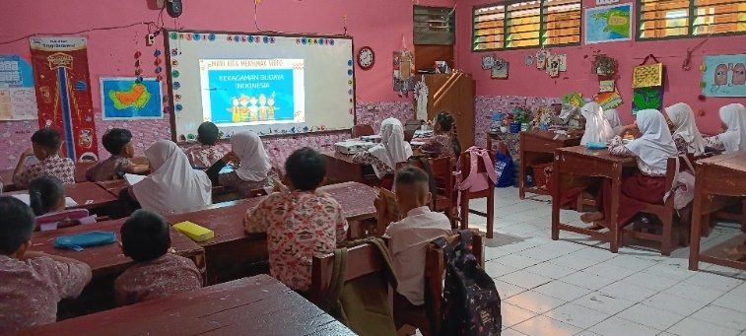

Figure 1. Activities to recognize cultural diversity

In the learning process, students are again invited to get acquainted with the different cultures that exist in Indonesia. This activity broadens their understanding that Indonesia is very rich in culture. Even though there are differences, they are still one, namely Indonesia, as Indonesia's motto says: "Unity in Diversity".
- Create an inclusive classroom environment

Teachers create a culturally friendly classroom environment. The culture that students bring as an identity is included in learning, so that students feel recognized and valued for their existence. Even though it is a minority culture in the classroom, this culture is still emphasized in learning and becomes a new insight for students towards each other. Every student has the right to introduce his or her culture into the classroom. Activities to introduce culture are carried out at the beginning of the learning process. One of the activities carried out is maintaining attendance in regional languages.

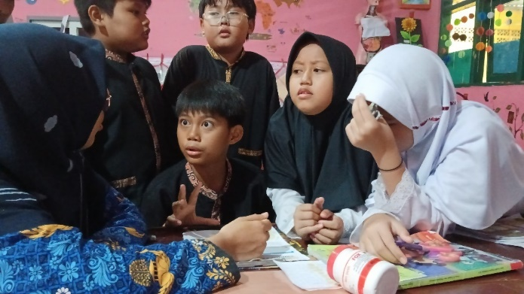

Figure 2. Discussion activities with study groups

Students study in groups, which makes it easier for them to discuss. The grouping is done heterogeneously. that is, one group strives to consist of different cultural resources. Each student discusses to solve problems and introduces their culture. Students discuss based on their learning experiences and habits to enrich each other's knowledge.
- Linking teaching materials to students' lives

In learning activities, teachers link learning materials that are adapted to the cultural diversity of students. Each student's culture plays a role in learning activities, starting from teaching materials and evaluation questions. The cultures involved in learning activities according to the initial survey results are Sundanese, Batak, Betawi, Padang and Javanese. Not only does the student's culture form the core of the learning content, but other supporting cultures are also used to supplement it. Cultural elements highlighted in the learning activities include regional languages, batik motifs, traditional houses, regional songs, traditional food and local traditional games.

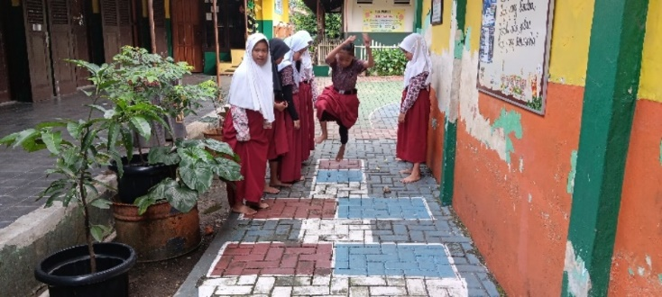

Figure 3. Sondah game

Students learn contextually. The problems presented are relevant to everyday life because they contain cultural elements. The learning process is carried out by involving students' culture, starting from teaching materials, learning media and evaluation questions. Learning activities also include various activities that can increase student activity, including traditional game simulations. Traditional games are a cultural heritage with symbolic meaning. play, play equipment and speech or songs. Traditional games make children physically and spiritually strong, social-emotional, optimistic, curious, experimental and promote leadership. Traditional games can be used to educate generations of Indonesian students in the Pancasila Student Profile program. Therefore, it is important that educational institutions participate in preserving Indonesian culture, which is being displaced by technological advancement (Cahya Saputri & Katoningsih, 2023).
- Use appropriate strategies

The learning process involves various learning strategies, including group discussions, to solve the problems presented. Presentations are given to convey the results of problem solving. Learning takes place outside the classroom to practice the learning content, namely traditional games.

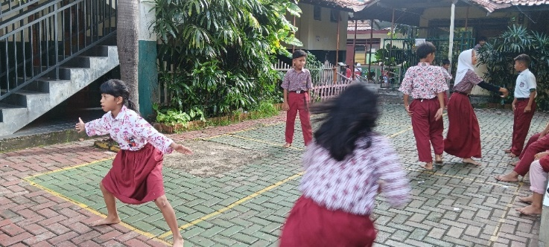

Figure 4. Margala/galaksin game

Each student has a different profile, one of which is related to learning style. Teachers present learning with differentiated strategies so that students' learning needs can be met. As explained by Nurzaki Alhafiz (2022), each student's diverse learning styles need to be adapted with different learning. Differentiated learning is a process or philosophy of effective teaching that provides a variety of ways to understand new information for all students in their different classes, including ways to: master the content; process, build or discuss ideas; and developing learning products and assessment measures so that all students from diverse backgrounds in the classroom can learn effectively. Teachers provide education as optimally as possible to meet the learning needs of all students. In this case it concerns kinesthetic, audio or visual learning styles or a combination of both. Learning strategies should take into account students' willingness to learn. An attempt is made to facilitate the development of the right and left brain so that it is balanced, as stated by Adilah & Minsih (2022) that integrating right and left brain processes and building neural structures in a balanced manner, as well as developing future-oriented neural pillars. An active brain is a very good condition for receiving knowledge
- Please provide an honest review

Teachers assess student progress with different types of assessments from both cognitive and affective domains. Evaluation takes place during the learning process and afterwards.

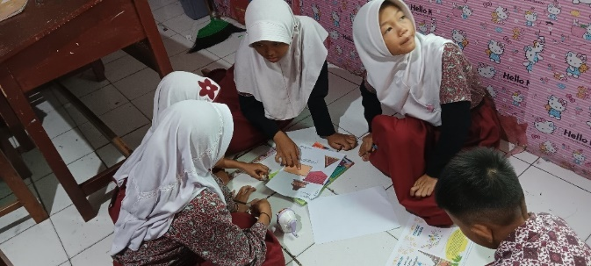

Figure 5. problem-solving activities

Assessment takes place as fairly as possible by looking at the capabilities of each student. Involvement in the learning process and the end result complement each other. Each student has abilities in different aspects, so that the final result of his performance is his own and cannot be compared with each other.

Based on the above explanation, the first research question concerns the implementation of problem-based learning with a culturally responsive teaching approach in learning plane figures, which is going very well. Implementing good education will have an impact on students' learning outcomes. Further student learning outcomes related to improving creative thinking skills will therefore be discussed in Part B.
- Students' learning outcomes are related to improving creative thinking skills

Investigating problem-based learning with a culturally responsive teaching approach (CRT) on flat materials to improve fifth grade students' creative thinking skills and globally diverse dispositions using a quasi-experimental method with a non-equivalent pretest-posttest control group design. This study was conducted in the experimental class and the control class with different treatments. The experimental class uses a PBL learning model with a CRT approach, while the control class only uses a PBL model without a CRT approach.

Before the treatment, students are given a pretest to determine their initial skills. After treatment, students are asked post-test questions to determine improvement in learning outcomes. The pretest and posttest were administered with the same questions in the experimental class and the control class. Descriptive statistics were obtained from the pre-test and post-test results, which are shown in Table 2. below:

Table 2. Comparison of pretest-posttest results
Data | Experimental class |  | Control class
Data | Pretest | Posttest | Pretest | Posttest
min | 22 | 64 | 20 | 54
max | 56 | 96 | 44 | 92
mean | 37.15 | 81.92 | 32.23 | 72.38
median | 35 | 84 | 31 | 69
Standard deviation | 10.869 | 8.863 | 6.179 | 11.427
Variance | 118.135 | 78.554 | 38.185 | 130.566

Improvement of creative thinking skills in flat-form material for Class five students can be seen as follows based on the results of n-gain test:

Table 3. Results of n-gain test for control class and experimental class
Class | Statistical parameters | N | Value |  | N-Gain | Category
Class | Statistical parameters | N | Pretest | Post test | N-Gain | Category
Experimental | mean | 25 | 37.15 | 81.92 | 0.71233 | Tall
Control | mean | 25 | 32.23 | 72.38 | 0.59245

In addition, the data can be read via the following table diagram:

Figure 6. Graph of the results of the test for creative thinking skills

Based on the reinforcement test performed, the experimental group achieved high criteria, while the control class achieved average criteria. From the test results, it can be said that the class that received problem-based learning using the CRT approach experienced greater improvement in creative thinking skills than the class that studied without using the CRT approach.

The effectiveness of using the problem-based learning (PBL) model with the CRT approach in the experimental classroom is quite effective with an n-gain rate of 71%. On the other hand, the control class using the problem-based learning (PBL) model without CRT achieved an n-gain rate of 59% in the same category, namely quite effective. Even though both meet the same criteria, the experimental class is 12% better in terms of the n-gain percentage obtained. Thus, it can be concluded that classes using the PBL model with the CRT approach are more effective than classes using the PBL model alone.

Based on the results of the analysis for each indicator of creative thinking skills, it can be presented in the following table:

Table 3. Percentage of learning outcomes for each creative thinking indicator
Question number | Indicator | Control class |  |  |  | Experimental class
Question number | Indicator | Pre test | Post test | n-gain | Category | Pre test | Post test | n-gain | Category
1a | Fluency | 38.46 | 84.23 | 0.74 | Tall | 38.46 | 85.00 | 0.76 | Tall
1b
2a | Originality | 32.31 | 67.31 | 0.48 | Currently | 38.08 | 69.23 | 0.50 | Currently
2b
3a | Flexibility | 34.62 | 75.00 | 0.62 | Currently | 39.62 | 78.46 | 0.62 | Currently
3b
4a | Elaboration | 27.88 | 67.69 | 0.57 | Currently | 34.81 | 80.96 | 0.71 | Tall
4b
5a
5b

Based on the results of the analysis of learning outcomes on creative thinking skills regarding the perimeter and area of flat shapes, the average result for the fluency indicator for the control class was 84.23% and the experimental class was 85%. The N gains for both classes, compared between the pretest and posttest scores, both meet high criteria. It turned out that students came up with many ideas in a short time. The control and experimental classes were actively involved in communicating ideas orally and in writing during the learning process and at the final test.

The post-test results in the control class and the experimental class for creative thinking skills on the fluency indicator (the ability to think fluently) show significant differences. The control class wrote the answers briefly and in less detail, while the students in the experimental class tended to write answers that were quite complete and fluent, as evidenced by writing the answers completely and relevantly. As explained by Nasution, n. R., & surya (2017) state that students who master the fluency indicators are characterized by providing relevant answers and a smooth flow of thoughts. Thus, it can be concluded that creative thinking skills for speaking proficiency indicators are better in the experimental class, namely the class receiving problem-based learning (PBL) with the CRT approach.

Indicators of originality or skills to generate unique ideas or ability to generate original ideas in the experimental class are better than the control class. Although both meet the average criteria, the performance rate in the experimental class is slightly higher than in the control class. Skills in generating unique ideas still need to be improved as this is the lowest performance among all indicators with n-gain values of 50% and 52% in the control class and experimental class.

For the second indicator of creative thinking skills, namely originality, it can be seen that students in the control class wrote answers that were still general, while those in the experimental class showed unique ideas, this can be seen in the answer to question 2a. Although the performance rate is not optimal, the experimental class is above the average of the control class. Students in the experimental class wrote answers that were unusual or different from students in the control class.

The indicator of flexibility of thinking (flexibility) in the research results showed that the experimental class was 3.46% superior to the control class. Experimental lessons can yield different answers. During the learning process, students are able to formulate alternative answers or solutions to the problems presented.

The flexibility indicators for creative thinking skills for the experimental class look better than those for the control class. This is proven by the answers written by students who can apply the formula correctly and provide alternative answers that are more varied. Meanwhile, the control class still looks stiff and has not implemented the concept well. Students with good flexibility indicators will provide varied answers (Hidayah et al., 2021).

Creative thinking skills in indicators develop ideas and add details or detail details of an object, idea or situation so that it becomes more interesting (elaboration) is the highest achievement of all indicators. The percentage difference in learning outcomes was 13.27%, superior to the experimental class. The n gain value shows that the control class is in the middle category while the control class is in the high category.

The last indicator is the development of creative thinking skills. Based on the post-test results, it appears that the control class has not been fully able to detail, adapt and use various ideas known in the questions. Meanwhile, the experimental class appears to have properly detailed and modified the information in the questions, resulting in more varied answers. This is as stated by Nasution, n. R., & surya (2017) state that with good elaboration, students will develop, enrich and expand an idea.

Based on the above explanation, it can be concluded that the increase in learning outcomes in creative thinking is generally better in the experimental class, namely the class that uses the CRT approach in learning. Moreover, the implications of what is learned also have an impact on the character of students, more specifically on the character of global diversity.
- Results of the post-learning global diversity character questionnaire

One of the objectives of research regarding the implementation of problem-based learning using the CRT approach is to determine the globally diverse nature of students. The results obtained based on the questionnaire are as follows:

Table 4. Data on the percentage that has achieved the character of global diversity
No. | Element | %  Control class | %  Experimental class
1. | Getting to know and appreciate culture | 80,00 | 91,2
2. | Intercultural communication and interaction | 85,60 | 96,8
3. | Reflection and responsibility for the experience of diversity | 74,4 | 91,2
4. | Social justice | 90,4 | 94,4
Mean (%) |  | 82,6 | 93,4

Beyond the learning outcomes measured in this study, one of the research questions is what the global diversity of student character is after learning with the CRT approach. Based on the results of the data analysis of the global diversity character questionnaire, there are differences in percentages in the control class and the experimental class. Overall, the control class achieved a percentage of 82.6%, while for the experimental class it was 93.4%. Thus, the percentage difference for the control class and the experimental class is 10.8%, which is superior to the experimental class.

Percentage differences occur per element. The elements tested for the character of global diversity consist of the following four elements:
- Getting to know and appreciate culture

This element consists of 5 statements that are tested. The comparison between the control class and the experimental class was made based on the performance percentage. The statement “I enjoy learning about other regional cultures” indicated 100% agreement from both classes. Meanwhile, the lowest percentage was found in the statement 'I am more interested in hearing stories about other cultures' (48% in the control class), in contrast to the experimental class, because the lowest percentage in this element was in the statement 'I enjoy learning'. on other cultural celebrations" at 76%. Overall, the percentage for the control class in the first element averaged 80%, while the experimental class was 91.2%, 11.2% better than the control class.
- Intercultural communication and interaction

The elements of intercultural communication and interaction consist of five statements. The statement with the highest percentage for the control class was the statement “I like to play with friends from different cultures,” while the experimental class received the maximum percentage (100%) for three statements, one of which was the same statement as the control class. class. However, the lowest percentage is in another explanation. The control class got 64% disagreeing with the statement "I only want to sit with friends who are from the same region as me", while the experimental class got 88% disagreeing with the statement "I feel happy when I see different types of food" to deny. from my own region". Overall, the average percentage for the second element was 85.6%, while the experimental class was 96.8%. This element is the highest performance level for the experimental class, compared to other elements.
- Reflection and responsibility for the experience of diversity

The third element tested, which concerns reflection and responsibility for the experience of diversity, achieved an average percentage of 74.4% for the control class and 91.2% for the experimental class. The difference between the two classes is quite high: 16.8% better than the experimental class.
- Social justice

The social justice element is the element with the highest average performance in the control class (90.4%), while in the experimental class it is 94.4%. The statement with the lowest performance on this item was the statement "I believe that not all cultures should be respected." This applies to both classes, the control class and the experimental class.

Cultivating characters with global diversity integrated into intracurricular education feels fun. Indirectly involving student culture helps cultivate a character of global diversity among students. Learning is carried out in a fun way as suggested by Cahya Saputri & Katoningsih (2023) that creating an interesting and enjoyable learning experience by involving children in activities will develop diverse characters worldwide.

Based on the above explanation, it can be seen that the percentage of global diversity character performance in the experimental class is generally higher than in the control class, with a difference of 10.8%. It can be concluded that achieving global character diversity is better in classrooms that use learning with a CRT.

In addition to achieving better learning outcomes and achieving excellent character, there are responses from students encouraging this improvement. Next, we will discover how students respond to problem-based learning with the CRT.
Based on the results of research conducted on the application of problem-based learning with a culturally responsive teaching approach on flat materials to enhance the creative thinking skills and globally diverse dispositions of fifth grade students, the following can be concluded:
- The implementation of problem-based learning with a culturally responsive teaching approach in learning flat shapes was very well executed. This is proven by the results of observations of learning implementation with 100% performance. From the observer's notes it appears that the response was very good with regard to the implementation of learning with CRT. The four steps of the CRT approach were fully implemented and the involvement of student culture was palpable in the teaching material, the learning process and the evaluation. With this CRT approach, the entire classroom culture becomes a target for learning.
- Students' creative thinking skills after problem-based learning (PBL) with culturally responsive teaching approach increased with n-gain test results for the experimental class of 0.7123, which means they are in the high category. The indicator of creative thinking skills that shows the greatest increase based on the pretest-posttest results is fluency.
- The percentage of students' global character diversity achieved after problem-based learning with a culturally responsive teaching approach is better in the experimental class than in the control class. The difference between the two classes is 10.8%. The element that received the highest percentage was intercultural communication and interaction with 96.8%.
- Student responses to problem-based learning with a culturally responsive teaching approach are very good. This is evident from the results of the questionnaire: 98.76% responded very well and another 1.24% responded well. In addition to completing questionnaires, students also write daily diaries containing responses with positive statements, including being happy, feeling comfortable, feeling involved in learning, getting to know each other's culture and giving honest assessments.

- Student problem-based learning questionnaire results using the CRT to flat-form materials
At the end of the research activities, namely after completing three problem-based learning meetings using the CRT, one of the tests conducted was the distribution of questionnaires on students' responses to what had been learned. The purpose of distributing the questionnaire was to find out students' reactions to what they had learned. The summary of the questionnaire is shown in diagram 5 below:

Figure 7. Results of student responses to learning using the CRT

What has been learned cannot be separated from the reactions of the students. In this study, researchers distributed questionnaires on students' responses to problem-based learning using the CRT that had been implemented. Based on the results of the analysis of the data obtained, it was found that 98.76% of students stated that teachers always taught according to the CRT, while the remaining 1.24% stated that they often did so. Overall, student responses were 99.69%, meaning students responded very positively to problem-based learning with the CRT.
In addition to completing questionnaires, students also write daily diaries about responses to learning using the CRT. The indicator of understanding students' cultural diversity indicates that the teacher introduces the culture of all students.
This is done by first mapping the cultural diversity in the classroom, so that the teacher knows what diversity exists in the classroom. All cultures in the classroom are involved in the different learning contents, so that all students feel that their existence is recognized. Students also get to know each other's cultures, so that they become closer and more harmonious. From this we learn to appreciate, respect and value the cultural diversity around us. This was also conveyed by Muñiz (2019), who stated that CRT is an important “window” into the cultural heritage and experiences of other people. In an increasingly diverse society, all students benefit from learning to respect their own cultural heritage and that of others.
The second indicator of the CRT approach is creating an inclusive class. Inclusive here means that teachers create a classroom environment that is culturally friendly and inclusive, in which students feel accepted and valued. As Abacioglu et al. (2020) explain in general, when teachers respond to their needs (culture), students feel valued, are better able to learn and are more engaged with the environment and learning materials. Creating inclusive classes is necessary to create a favorable situation. There is no sense of favoritism or feeling of being left out. M. Rhodes (2017) also explains that CRT practices create an environment of mutual respect and connection and that the use of collaboration and fair treatment of all students reflects elements of building inclusion. Elements that develop attitudes include norms and practices that help students develop positive attitudes toward the learning process by building on students' personal experiences and knowledge and by empowering students to make choices during the learning process.
All cultures in the classroom are involved in learning. Teachers also facilitate learning activities by involving activities related to culture, namely traditional games. The teacher chooses several traditional games adapted to the students' culture so that they can provide each other with information about their culture. The games gobak sodor/galaksin, galah, margala and sondah/engkek are the choices that appear in the game. The features of the game correspond to the material presented and also have the value of cultural diversity, since the names are different in each region.
The third CRT indicator is the use of an appropriate strategy. The teacher chooses the best strategy to accommodate cultural diversity in the classroom so that all students are actively involved. Based on the diaries written by the students, the teacher presents varied material. One strategy is for the teacher to present varied (differentiated) content so that all students feel fully involved. In addition, teachers present learning not only in the classroom, but also in combination with activities outside the classroom, with the aim of ensuring that students do not get bored. Learning is made comfortable so that students easily accept the taught material and ultimately feel proud of Indonesian culture because they realize how rich the Indonesian nation is. Besides being comfortable, it is no less important that teachers provide fun in the learning process. Primary school age is in the concrete operational stage of development, as stated by Khaulani et al. (2020) that the beginning stage of cognitive development of primary school students consists of concrete activities. At this stage, children are believed to be able to reason concrete things logically, but children are not yet able to reason abstract things. Hormones of happiness and joy should appear in learning to facilitate the access of new knowledge to students.
The last indicator is giving an honest assessment.
Teachers strive to treat students fairly. This is evidenced by the student's diary, which states that "my teacher treats all students fairly." Fair treatment, not only in assessments, but by involving all students, based on their abilities, in every learning activity. Assessment is carried out using a variety of techniques, both written and performance or skill based. Teachers do not hesitate to appreciate each student for their achievements, for example in the form of verbal speech, gestures or even rewards in the form of material gifts.

REFERENCES
Abacioglu, C. S., Volman, M., & Fischer, A. H. (2020). Teachers’ multicultural attitudes and perspective taking abilities as factors in culturally responsive teaching. British Journal of Educational Psychology, 90(3), 736–752. https://doi.org/10.1111/bjep.12328
Adilah, A. N., & Minsih, M. (2022). Pengembangan Media Pembelajaran Monokebu pada Siswa Sekolah Dasar. Jurnal Basicedu, 6(3), 5076–5085. https://doi.org/10.31004/basicedu.v6i3.3026
Akmal, A. U. (2021). Analisis Etnosains Dalam Pembelajaran IPA di SekolahDasar (SD) Kota Padang Dan Bukittinggi. Jurnal Inovasi Pendidikan Dan Pembelajaran Sekolah Dasar, 4(2), 68. https://doi.org/10.24036/jippsd.v4i2.111385
Astria, R., & Kusuma, A. B. (2023). Analisis Pembelajaran Berdiferensiasi Untuk Meningkatkan Kemampuan Berpikir Kreatif Matematis. Proximal: Jurnal Penelitian Matematika Dan Pendidikan Matematika, 6(2), 112–119. https://doi.org/10.30605/proximal.v6i2.2647
Cahya Saputri, P., & Katoningsih, S. (2023). Analisis Pengaruh Permainan Tradisional dalam Penguatan Kebhinekaan Global. Murhum : Jurnal Pendidikan Anak Usia Dini, 4(1), 392–405. https://doi.org/10.37985/murhum.v4i1.230
Hidayah, N. C., Ulya, H., & Masfuah, S. (2021). Analisis kemampuan berpikir kreatif siswa sekolah dasar berdasarkan tingkat kemampuan matematis [Analysis of the creative thinking ability of elementary school students based on the level of mathematical ability]. Jurnal Educatio FKIP UNMA, 7(4), 1368–1377. https://doi.org/10.31949/educatio.v7i4.1366
Khaulani, F., S, N., & Irdamurni, I. (2020). Fase Dan Tugas Perkembangan Anak Sekolah Dasar. Jurnal Ilmiah Pendidikan Dasar, 7(1), 51. https://doi.org/10.30659/pendas.7.1.51-59
Lestari, M. A., & Hermawati, E. (2022). Penggunaan Media Pembelajaran Ular Tangga Dalam Menanamkan Karakter Berkebhinekaan Global pada Siswa SDIT Darul Amanah. Journal of Innovation and Sustainable Empowerment, 2(1), 6–11. https://jise.uniku.ac.id/pub/index
M. Rhodes, C. (2017). A Validation Study of the Culturally Responsive Teaching Survey. Universal Journal of Educational Research, 5(1), 45–53. https://doi.org/10.13189/ujer.2017.050106
Muñiz, J. (2019). Culturally Responsive Teaching A 50-State Survey of Teaching Standards. New America, 1, 1–53. newamerica.org/education-policy/reports/culturally-responsive-teaching/
Nasution, n. R., & surya, e. (2017). Penerapan Model Pembelajaran Berbasis Masalah ( Problem Based Learning) Terhadap Kemampuan Berpikir Kreatif Matematika Siswa Nurul Rafiqah Nasution 1 , Edy Surya 2. Jurnal. Mahasiswa Pps Jurusan Pendidikan Matematika, Unimed., October.
Nurzaki Alhafiz. (2022). Analisis Profil Gaya Belajar Siswa Untuk Pembelajaran Berdiferensiasi Di Smp Negeri 23 Pekanbaru. Jurnal Cakrawala Ilmiah, 1(5), 1133–1142. https://doi.org/10.53625/jcijurnalcakrawalailmiah.v1i5.1203
Patras, Y. E., Juliani, A., Nurhasanah, N., Maksum, A., & Hidayat, R. (2023). A Review of Culture-Based Learning at Primary Level In Indonesia. 15(2020), 3923–3936. https://doi.org/10.35445/alishlah.v15i3.3525
Rahayu, E. L., Akbar, P., & Afrilianto, M. (2019). Pengaruh Metode Mind Mapping Terhadap Strategi Thinking Aloud Pair Problem Solving Terhadap Kemampuan Berpikir Kreatif Matematis. Journal on Education, 1(2), 271–278.
Rahmawati, Y., Ridwan, A., Faustine, S., & Mawarni, P. C. (2020). Pengembangan Soft Skills Siswa Melalui Penerapan Culturally Responsive Transformative Teaching (CRTT) dalam Pembelajaran Kimia. Jurnal Penelitian Pendidikan IPA, 6(1). https://doi.org/10.29303/jppipa.v6i1.317
Ramadan, Z. H. (2018). Pemahaman Kearifan Lokal Di Sekolah Dasar Sebagai Suatu Cara Membentuk Karakter Siswa. 84–93. https://ejournal.unri.ac.id/index.php/pigur/article/view/5415
Romlah, Muhammad Nur, W. W. (2018). Melatihkan Keterampilan Berpikir Kreatif Siswa Sd Melalui Permainan Mahasiswa Program Pascasarjana , Prodi Pendidikan Dasar , Universitas Negeri Surabaya , Dosen Pascasarjana , Prodi Pendidikan Dasar , Universitas Negeri Surabaya. 4(3).
Vavrus, M. (2012). Culturally Responsive Teaching. 21st Century Education: A Reference Handbook, July, II-49-II–57. https://doi.org/10.4135/9781412964012.n56

