Appendix 7: Photos of teaching speaking process at IAIN Palopo

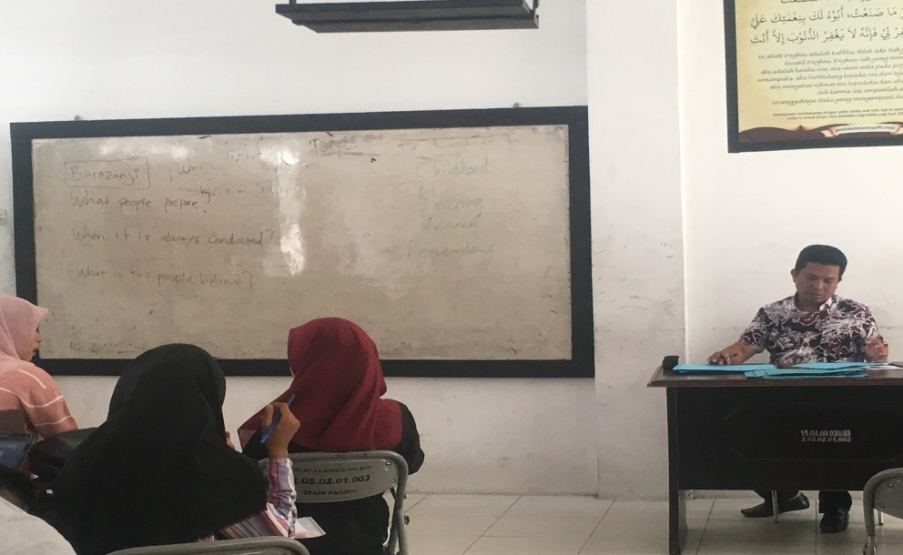

The lecturer prepared the speaking subject

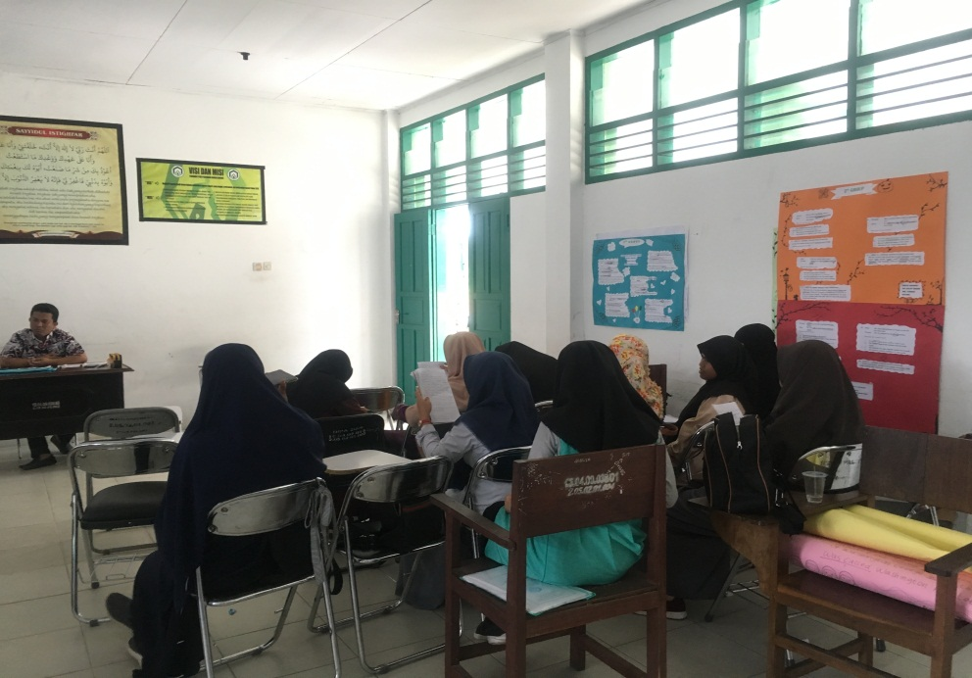

The lecturer gave explanation

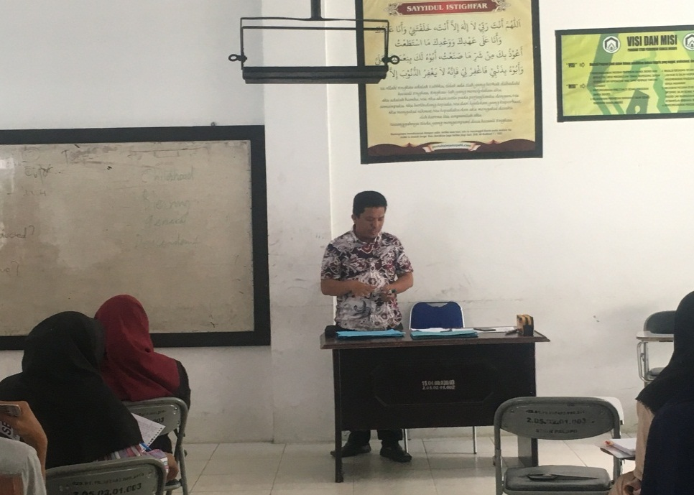

The lecturer explained topics
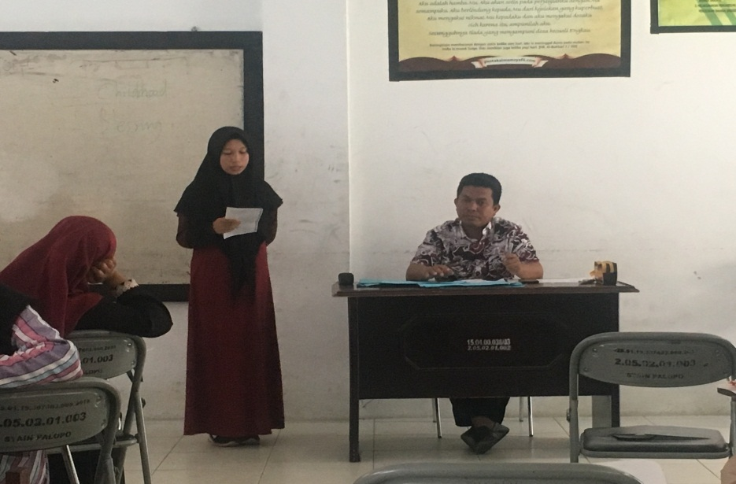

The students reported her answer sheet

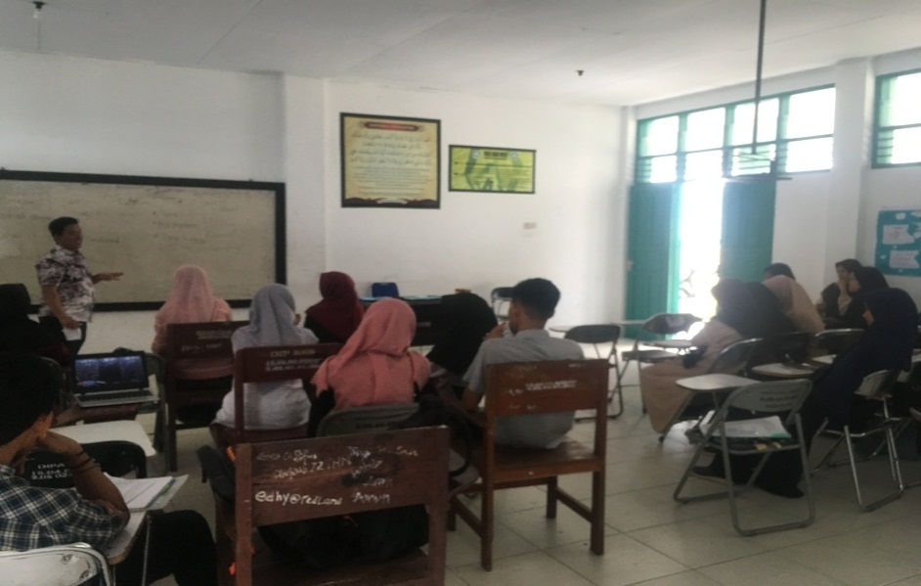

The lecturer gave evaluation toward students’ speech

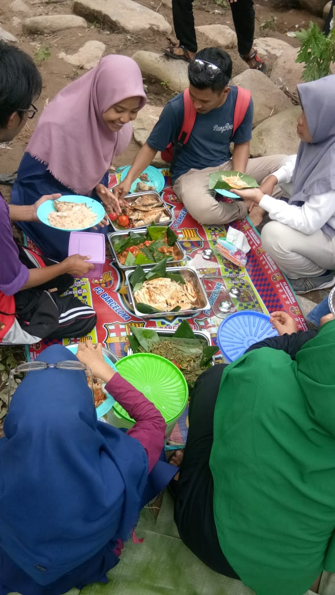

Teaching speaking in outdoor pursuit (cooking activities)

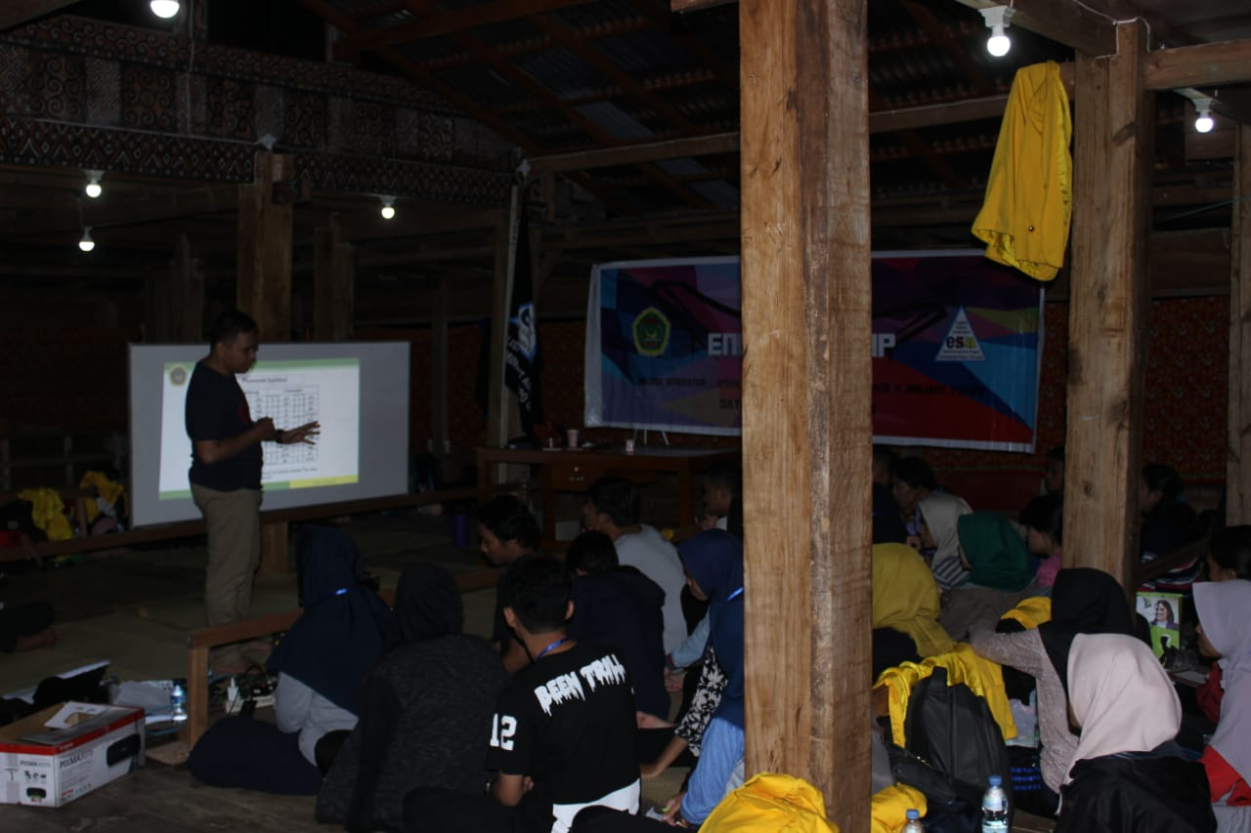

Teaching speaking process in outdoor

Institut Agama Islam Negeri Palopo, the first observation Monday 23th April 2019, 13:00 pm– 15:00pm
The First Observation Class
The aspects of Lecturer behavior | Observation data
- General Characteristics | Observation data
The lecturer supports student learning | Asked about students preparation in presentation
The lecturer is skillful with the basic  uses of technology | The lecturer used mix techniques such as operated laptop and used mobile phone to accessed materials
The lecturer is interested in and enjoy exploring new technologies that have potential value for virtual school  Environments. | The lecturer used technology potential value for virtual school environment such as learn in outdoor and explain something that relate to environment
The lecturer is flexible with his/her time. | The lecturer used flexible time, such as giving limitation in using time, like presentation time,
The lecturers have adept understanding of the varying learning styles of their students | The lecturer gave deep understanding toward style of students learning, explained students style in presentation (good performance by using good body language, lack of performance)
The lecturers establish a presence in the course to motivate students | By using speaking practice (speaking presentation
The lecturers use student and course  data, as well as other sources of information available to them to self-evaluate the pedagogical strategies they use | The lecturer, evaluated his pedagogical strategies in teaching such as teaching strategy , and look for interesting material.
The lecturers have extensive knowledge of and appreciation for the content area | The lecturer gave feedback after students presentation
Classroom Management Strategies
The lecturers use varied strategies to address inappropriate or abusive behavior of students in public forums of the course | The lecturer giving jokes to avoid inappropriate or abuse behavior of students in the classroom.
The lecturers monitor venues of public  communication in their course to identify students in personal crisis | The lecturer gave feedback after speech in the classroom.
Pedagogical Strategies: Assessment.
The lecturers use multiple strategies to  assess student learning | Students’ presentation
The lecturers use alternative assessment strategies that allow students the opportunity to represent their knowledge in ways that are personally meaningful. | Presentation section
The lecturers use alternative assessment strategies to accommodate the varying learning  styles of their students | Individual presentation
Pedagogical Strategies: Engaging Students with Content.
The lecturers use multiple strategies to  assess student learning | -
The lecturers build in course components to reflect the interests of students enrolled in the course | The lecturer gave simple topics in individual presentation
The lecturers are flexible in their use  of pedagogical strategies to accommodate varying learning styles. | Set up time in learning process
The lecturers establish strong relationships with  Mentors | The lecturer established communication with the students in teaching and learning process.
Pedagogical Practices: Making Course Meaningful for Students
The lecturers use strategies to connect with students | The lecturer gave support toward the students therefore, they have self-confident in presentation
The lecturers engage students in conversations about content and noncontact related topics  to form a relationship with each student | The lecturer were close between the students
The lecturers encourage and support  Communication between students | The lecturer asked to the students before presentation, (students’ stimulation in presentation)
The lecturers seek out and make available variety of supplemental support tools to meet the diverse needs of students | -
Pedagogical Strategies: Providing Support
The lecturers monitor student progress  closely and interact with students to determine where gaps in knowledge may Exist. | The lecturer gave chance to students to prepare concept of speech before individual presentation
Pedagogical Strategies:
Communication & Community
The lecturers facilitate the formation of community by encouraging content and non-content related conversations among students | The lecturer communicated toward the students in the classroom discussion.
The lecturers interact with students using multiple channels of communication (telephone, IM, etc)provide support. | The lecturer interacted with his students by using mobile phone if he gave some exercises to the students
The lecturers provide students with quick feedback to maintain their motivation for completing the course | The lecturer gave feedback, when the students made mistake in their presentation
Technology
The lecturers purposefully tie the use of tools built into the course environment to state benchmarks and standards to support student learning of content | -
The lectures consider issues of student access to technology when integrating web based components into their course | The students look for speech material that taken on internet then the students presented in individual.
The lecturers use their content knowledge and knowledge of students to drive the integration of technology. | The lecturer asked the students to make concept that presented by the students

Institut Agama Islam Negeri Palopo, the second observation Monday 24th April 2019, 09:00 – 11:00 pm
Thesecond oservation class
The aspects of Lecturer behavior | Observation data
- General Characteristics | Observation data
The lecturer supports student learning | The lecturer called students one by one to know students’ condition
The lecturer is skillful with the basic  uses of technology | The lecturer used mix techniques such as operated laptop to accessed materials then the students make simple speech in the front of class
The lecturer is interested in and enjoy exploring new technologies that have potential value for virtual school  Environments. | The lecturer used technology potential value for virtual school environment such as learn in outdoor and explain something that relate to environment
The lecturer is flexible with his/her time. | The lecturer used flexible time, in teaching speaking such as giving exercises to the students.
The lecturers have a deep understanding of the varying learning styles of their students | The lecturer gave deep understanding toward style of students learning, explained students style in presentation (good performance by using good body language)
The lecturers establish a presence in the course to motivate students | The lecturer builds outdoor activities in learning process.
The lecturers use student and course  data, as well as other sources of information available to them to self-evaluate the pedagogical strategies they use | The lecturer, evaluated his pedagogical strategies in teaching such as teaching strategy , and look for interesting material.
The lecturers have extensive knowledge of and appreciation for the content area | The lecturer, evaluated his pedagogical strategies in teaching such as teaching strategy , and look for interesting material.
Classroom Management Strategies
The lecturers use varied strategies to address inappropriate or abusive behavior of students in public forums of the course | The lecturer gave punishment toward students who bother to others
The lecturers monitor venues of public  communication in their course to identify students in personal crisis | The lecturer gave feedback after speech in the classroom
Pedagogical Strategies: Assessment.
The lecturers use multiple strategies to  assess student learning | Students’ presentation and students ‘speech
The lecturers use alternative assessment strategies that allow students the opportunity to represent their knowledge in ways that are personally meaningful. | The lecturer gave presentation activity toward students, speech, and group discussion
The lecturers use alternative assessment strategies to accommodate the varying learning  styles of their students | Individual presentation, then asked the students to prepare speech topics
Pedagogical Strategies: Engaging Students with Content.
The lecturers use multiple strategies to  assess student learning | The lecturer gave assessment toward students by using presentation, speech, and group discussion.
The lecturers build in course components to reflect the interests of students enrolled in the course | The lecturer gave simple topics in individual presentation (learn in outdoor pursuit)
The lecturers are flexible in their use  of pedagogical strategies to accommodate varying learning styles. | The lecturer is flexible in teaching, therefore the students are happy and relax in learning speaking.  Set up time in learning process
The lecturers establish strong relationships with  Mentors | The lecturer look for students who did not come yet, and ask the students who did not come last meeting
Pedagogical Practices: Making Course Meaningful for Students
The lecturers use strategies to connect with students | The lecturer gave support toward the students therefore, they have self-confident in presentation
The lecturers engage students in conversations about content and noncontact related topics  to form a relationship with each student | The students are close with the lecturer in learning process.
The lecturers encourage and support  Communication between students | The lecturer asked to the students before presentation
The lecturers seek out and make available variety of supplemental support tools to meet the diverse needs of students | The lecturer prepared some medias in teaching speaking such as cakes, clip chards, papers.
Pedagogical Strategies: Providing Support
The lecturers monitor student progress  closely and interact with students to determine where gaps in knowledge may Exist. | The lecturer gave chance to students to prepare concept of speech before individual presentation
Pedagogical Strategies:
Communication & Community
The lecturers facilitate the formation of community by encouraging content and non-content related conversations among students | The lecturer communicated toward the students in the classroom discussion
The lecturers interact with students using multiple channels of communication (telephone, IM, etc)provide support. | He interacted with his students by using mobile phone if he gave some exercises to the students.
The lecturers provide students with quick feedback to maintain their | He gave feedback after students’ presentation.
Technology
The lecturers purposefully tie the use of tools built into the course environment to state benchmarks and standards to support student learning of content
The lectures consider issues of student access to technology when integrating web based components into their course | The students look for speech material that taken on internet then the students presented in individual presentation
The lecturers use their content knowledge and knowledge of students to drive the integration of technology. | The lecturer asked the students to make concept that presented by the students

Institut Agama Islam Negeri Palopo, the third observation Thursday25th of April 2019, 13:00-14:40

The aspects of Lecturer behavior | Observation data
General Characteristics | Observation data
The lecturer supports student learning | The lecturer gave applause, when the students presented their speech
The lecturer is skillful with the basic  uses of technology | The lecturer used mix techniques such as operate laptop and used mobile phone to accessed materials
The lecturer is interested in and enjoy exploring new technologies that have potential value for virtual school  Environments. | The lecturer used technology potential value for virtual school environment such as learn in out door and explain something that relate to environment.
The lecturer is flexible with his/her time. | The lecturer used flexible time, such as giving limitation in using time, like presentation time.
The lecturers have adept understanding of the varying learning styles of their students | The lecturer gave deep understanding toward style of students learning, explained students style in presentation (good performance by using good body language, good performance)
The lecturers establish a presence in the course to motivate students | By using speaking practice (speaking presentation)
The lecturers use student and course  data, as well as other sources of information available to them to self-evaluate the pedagogical strategies they use | The lecturer called students one by one to present their topics
The lecturers have extensive knowledge of and appreciation for the content area | lecturer gave feedback after students presentation (Barasanji)
Classroom Management Strategies
The lecturers use varied strategies to address inappropriate or abusive behavior of students in public forums of the course | The lecturer gave rebuke by using joke toward the students
The lecturers monitor venues of public  communication in their course to identify students in personal crisis | The lecturer gave feedback after speech in the classroom
The lecturers use multiple strategies to  assess student learning | Students’ presentation
The lecturers use alternative assessment strategies that allow students the opportunity to represent their knowledge in ways that are personally meaningful. | Presentation section
The lecturers use alternative assessment strategies to accommodate the varying learning  styles of their students | Individual presentation
Pedagogical Strategies: Engaging Students with Content.
The lecturers use multiple strategies to  assess student learning | -
The lecturers build in course components to reflect the interests of students enrolled in the course | The lecturer gave simple topics in individual presentation (Barasanji story)
The lecturers are flexible in their use  of pedagogical strategies to accommodate varying learning styles. | The lecturer is flexible in teaching, therefore the students are happy and relax in learning speaking.  Set up time in learning process
The lecturers establish strong relationships with  Mentors | The lecturer look for students who did not come yet, and ask the students who did not come
Pedagogical Practices: Making Course Meaningful for Students
The lecturers use strategies to connect with students | The lecturer gave support toward the students therefore, they have self-confident in presentation
The lecturers engage students in conversations about content and noncontact related topics  to form a relationship with each student | The students are close with the lecturer in learning process.
The lecturers encourage and support  Communication between students | The lecturer asked to the students before presentation (were you ready, command )
The lecturers seek out and make available variety of supplemental support tools to meet the diverse needs of students | -
Pedagogical Strategies: Providing Support
The lecturers monitor student progress  closely and interact with students to determine where gaps in knowledge may Exist. | The lecturer gave chance to students to prepare concept of speech before individual presentation
Pedagogical Strategies:
Communication & Community
The lecturers facilitate the formation of community by encouraging content and non-content related conversations among students | The lecturer communicated toward the students in the classroom discussion
The lecturers interact with students using multiple channels of communication(telephone, IM, etc)provide support | He interacted with his students by using mobile phone if he gave some exercises to the students.
The lecturers provide students with quick feedback to maintain their motivation for completing the course | Every students’’ presentation, he gave feedback, when the students made mistake in their presentation
Technology
The lecturers purposefully tie the use of tools built into the course environment to state benchmarks and standards to support student learning of content | -
The lectures consider issues of student access to technology when integrating web based components into their course | The students look for speech material that taken on internet then the students presented in individual presentation
The lecturers use their content knowledge and knowledge of students to drive the integration of technology. | The lecturer asked the students to make concept that presented by the students

Students’ perception at IAIN Palopo

Student 1

I was happy in learning speaking; because my lecturer was relax in teaching speaking, he took care toward the students, “ I really like his style in teaching, because he taught creatively therefore I did not get bored learn speaking subject and respected to him because he was my lecturer.” He really motivated in learning speaking, because the lecturer taught really simple therefore he had motivation in learning speaking. the lecturer was really creative and friendly and presented new things in teaching speaking” he was really active in learning speaking because every meeting the lecturer gave speech exercises and presentation toward the students then gave score toward students’ speech. I was active in presentation then the lecturer gave me chance to prepare my speech. I was really happy because I can communicate in English right now, even though my English is not fluent but I was proud to communicate in English.

Student 2
I was happy join in learning speaking subject, because the lecturer was relax in teaching speaking in the classroom. She said that “I really like my lecturer’s style in teaching because he taught creatively therefore I am not bored to follow the speaking materials that presented by the lecturer” in teaching I really obeyed my lecturer because he was my lecturer” she had motivation in practicing speaking in English because the material was really simple, and the lecturer taught friendly and presented new materials. Every meeting “we were given the tasks to be presented therefore we more be active” then the lecturer provide sassessment of each presentation and give the way the presentation of the material displayed. On the other hands my lecturer gave chance to prepare materials that presented by the students. I had self-confident to speak English such as explain something in English or communicated in English.

Student 3
I enjoy learning speaking subject; because my lecturer was relax in teaching speaking in the classroom. I really like my lecturer’s style in teaching because he taught creatively therefore I am not bored to follow the speaking materials that presented by the lecturer” in teaching I really obeyed my lecturer because he was my lecturer” he had motivation in practicing speaking in English because the material was really simple, and the lecturer taught friendly and presented new materials. Every meeting “we were given the tasks to be presented therefore we more be active” then the lecturer provides assessment of each presentation and give the way the presentation of the material displayed. On the other hands the lecturer gave chance to prepare materials that presented by the students. I had self-confident to speak English such as explain Something in English or communicated in English.

